- NORTH CAROLINA
mlDlJNN
Dunn City Council Regular Meeting Tuesday,December10,2024

Where communi(J h ins!
6:30 p.m.,Dunn Municipal Building


e _ J
AGENDA
Call to Order - Mayor William P. Elmore, Jr. Invocation - Reverend Roy Johnson Pledge of Allegiance
- Adjustment and Approval of the December 10, 2024 meeting agenda
PRESENTATIONS
- Swearing in - NC House Representative Howard Penny, Jr. - District 53
PUBLIC COMMENT PERIOD
- Each Speaker should limit comments to 3 minutes and must sign up on sheet available on the podium within the Council Chambers prior to the start of the meeting. Total comment period limited to 30 minutes.
CONSENT ITEMS
- Minutes - October 8, 2024 - Work Session
- Minutes - October 22, 2024 - Regular
- Minutes - October 29, 2024 - Special Call
- Temporary Closing of Streets - Martin Luther King, Jr. Parade
- Consideration of Resolution Authorizing the Disposition of Personal Property - Recreation
- Budget Amendment - Fiber line - Surveying Service
- Capital Project Ordinance Budget Amendment - Machine & Welding Outfall Sewer Project
- Budget Amendment to purchase Valve Exerciser
- Consideration of BRIC Grant - Phase 1 Agreement
- Adopt Schedule of 2025 Council Meetings
ITEMS FOR DISCUSSION AND/OR DECISION
- Conditional Zoning CZ-08-24 - Parcel containing 330 Jernigan Road- PIN: 1527-06-9321.000
  - Public Hearing
  - Decision
- Rezoning RZ-04-24 - 402 George Perry Lee Road - PIN: 1527-82-6665.000
  - Public Hearing
  - Decision
- Consideration of Ordinance to Demolish house-125 Spring Branch Rd -PIN: 1516-74-5198.000
- Consideration of Ordinance to Demolish house-824 E Divine St. - PIN: 1516-84-4796.000
- Consideration of Ordinance to Demolish house-407 W Johnson St. - PIN: 1516-69-3809.000
- Consideration of Ordinance to Demolish house-410 S Fayetteville Ave.-PIN-1516-56-0439.000
- Voluntary Annexation Petition ANX-03-24 - 504 Moon Circle, Owned by Gabrielle Jones
- Award of Contract - Body Worn Cameras & Storage - Budget Amendment
- Award Bid - Pearsall Street
- Award Bid - Water/Sewer SRF
- Consideration of FY 25/26 Paving Project - Engineering RFQ Recommendation
- Administrative Reports
  - City Manager's Report/Update on Council Goals
  - Financial Report/Assessment Update
  - Department Reports
Public Information Public Works/Public Utilities
Parks & Recreation/Police Planning & Inspections
- Announcements
- Information
- Closed Session - If called, the General Statute(s) allowing the Closed Session will be cited in the motion
ADJOURNMENT
"This institution is an equal opportunity provider and employer"

Adjustment and Approval of the December 10, 2024 Meeting Agenda

Recommendation:
Motion to adopt the December 10, 2024, meeting agenda as presented Or
Motion to adopt the December 10, 2024, meeting agenda as presented with the following changes:

Additions: (Assi_{gn} Number on the Agenda such as 28a)

Removal of the following item(s):

Move Item of Business from one section to another section (such as moving Itemfrom Consent Items to Itemsfor Discussion and/or Decision)

Public Comment Period
Ado12.ted 8-4-05

CITY OF DUNN CITY COUNCIL PUBLIC COMMENT POLICY

The City Council for the City of Dunn does hereby adopt a Public Comment Policy to provide at least one period for public comment per month at a regular meeting of the City Council. This policy shall remain in effect until such time that it is altered, modified, or rescinded by the City Council.
All comments received by the City Council during the Public Comment Period shall be subject to the following procedures and rules:
I. Anyone desiring to address the City Council must sign up and register on a sign- up sheet available on the podium within the City Council chambers prior to the Mayor calling the meeting to order. The sign-up sheet shall be available thirty (30) minutes prior the beginning of the City Council meeting in the City Council Chambers. Once the Mayor has called the meeting to order, the City Clerk shall collect the sign-up sheet and deliver it to the Mayor. The speaker shall indicate on the sign-up sheet his or her name, address and matter of concern.
- The Public Comment Period shall be for thirty (30) minutes.

- Comments are limited to three (3) minutes per speaker. A speaker can not give their allotted minutes to another speaker to increase that person's allotted time.

- Each speaker must be recognized by the Mayor or presiding member of the City Council as having the exclusive right to be heard. Speakers will be acknowledged in the order in which their names appear on the sign up sheet. Speakers will address the City Council from the podium at the front of the room and begin their remarks by stating their name and address.
- Individuals who sign up but can not speak because of time constraints, will be carried to the next regular meeting of the City Council and placed first on the Public Comment Period.
- During the Public Comment Period, a citizen, in lieu of or in addition to speaking may pass out written literature to the City Council, City Staff and audience.
- Groups supporting or opposing the same position shall designate a spokesperson to address the City Council in order to avoid redundancy.
- After the citizen has made his or her remarks, he or she will be seated with no fmiher debate, dialogue or comment.

- The Public Comment Period is not intended to require the City Council to answer any impromptu questions. Speakers will address all comments to the City Council as a whole and not one individual Council member. Discussions between speakers and members of the audience will not be allowed. The City Council will not take action, or respond to questions about, issues raised during the Public Comment Period at the same meeting.

- Speakers shall refrain from discussing any of the following: matters which concern the candidacy of any person seeking public office, including the candidacy of the person addressing the City Council; matters which involve pending litigation; matters which have been or will be the subject of a public hearing; and matters involving specific personnel issues related to disciplinary matters. If the speaker wishes to address specific personnel issues related to disciplinary matters, he or she should take their comments to the City Manager, who shall share the comments with the City Council.

- Speakers shall be courteous in their language and presentation.

- The Mayor and City Manager shall determine, on a month to month basis, where the Public Comment Period will appear on the monthly agenda when developing the agenda, prior to its publication.

- The Public Comment Period shall only be held during the regularly scheduled monthly meeting of the City Council. There shall not be a Public Comment Period at any other meetings of the City Council, unless specifically approved by the City Council.

ml)lJNN
- _{NORTH} _{CAROLINA} City Council Agenda Item

Meeting Date: December 10, 2024 .
I I I
SUBJECT TITLE | Minutes - October 8, 2024- Work Session
PRESENTER/DEPARTMENT | City Clerk Matti
ATTACHMENT(S) | Draft Minutes
PUBLIC HEARING PUBLISH DATES I | N/ A

PURPOSE:

BACKGROUND:

BUDGET IMPACT:

Motion to approve Minutes as presented.
RECOMMENDED MOTION/ACTION REQUESTED OF COUNCIL

Dunn City Council Regular Meeting Tuesday, October 8, 2024
6:30 p.m., Dunn Municipal Building
Minutes

PRESENT: Mayor William P. Elmore Jr., Council Members Raquel McNeil, April Gaulden, Billy N. Tart, Alan Hargis, and Dr. David L. Bradham.
ABSENT: Mayor Pro Tern J. Wesley Sills

Also present: City Manager Steven Neuschafer, Assistant City Manager Billy R. Godwin, Finance Director Cary McNallan, Chief of Police Cary Jackson, Administrative Support Specialist Sydney McKay, City Attorney Tilghman Pope, and City Clerk Melissa R. Matti.
CALL TO ORDER AND INVOCATION
Mayor Elmore opened the meeting at 6:30 p.m. Council Member Bradham gave the invocation and led in the
Pledge of Allegiance.
AGENDA ADJUSTMENT AND APPROVAL
Motion by Council Member Bradham and second by Council Member Gaulden to adopt the October 10, 2024 meeting agenda. Motion unanimously approved.
ITEMS FOR DISCUSSION AND/OR DECISION
Halloween Resolution
Motion by Council Member Tart and second by Council Member Gaulden to approve the Halloween Resolution. Trick or treating is suggested to be from 5 to 8 p.m. on October 31st. Motion unanimously approved. A copy of Halloween Resolution (R2004-35) as Attachment #1.
Consideration of Friendly Road Development Agreement
RP Wellons Land & Development, LLC
City Manager Neuschafer explained that this project has been discussed a couple different times, but this is a proposed agreement that will come back to the council for a decision after it's been publicized later this month. Tonight they went over the agreement and the work that is proposed and gave supporting documents. Essentially, it's an agreement between the City of Dunn and RP Wellness Land and Development, LLC that stipulates since they already have some work to do on Friendly Rd. as part of their development that the city is asking them to extend and do some more work This agreement sets out the amount of work and the total cost for the city not to exceed. A copy of the slide show is incorporated into these minutes as Attachment #2.

Managers' Office Update
Town Hall Meeting
Police Chief Jackson & Captain Butler
Chief Jackson shared that they had a really good response/turnout for the Town Hall Meeting. There were approximately 30 in attendance from the business community that showed up to speak with us and talk about their concerns. The Town Hall meeting was a good start. We need to continue to have follow up meetings. The Police Department offers meetings every month, like coffee with a cop and we try to pick a different business ever month for folks to come and express concerns. A copy of the Manager's Office Update complete slide show is incorporated into these minutes as Attachment #3.

Sewer System Status City Manager Neuschafer
Manager Neuschafer shared the status of where we're at after recent storms and rains that we've had the last
several months. The three months that are highlighted for 2024 - our plant is rated for an average of 3.75 million gallons a day. For the last three months we have really been close to that limit. But last month, we were over that limit for the first time in a number of years just because we had so much rain from the storm and from previous time.

Wastewater Treatment Plant City Manager Neuschafer
Manager Neuschafer advised council that the wastewater treatment plant is at substantial completion. It's essentially done, other than a punch list. The Machine Welding outfall line is under construction right now. We've got an effluent line (that's the pipeline that goes from the wastewater treatment plant to the Cape Fear rive) that's been bid and we're currently negotiating with some property owners for easements.

Eastside Pump Station City Manager Neuschafer
Manager Neuschafer informed the council that they handed out 90% design drawings today so that's getting close to being bid as well and we have negotiated with all the property owners for easements. Each of those projects have to be bid and awarded by the end of this calendar year. These next few months will be pressed as far as time goes to get those bids awarded and the easements under control as far as being able to award the projects to the contractors because that's one of the stipulations, that you have the property and the easements under the city's control to be able to hand those off to the contractors. Those two projects that we're still negotiating we're just giving you a heads up that we still have not finished all of that work yet. So we are coming to a time crunch for these two last projects. Manager Neuschafer explained that ifwe don't get these last two projects done in a timely manner, we may lose our funding. He went on to say that help's hard to find right now. If you're not able to get control of your project and process it in time, they'll just give the money to somebody else that can get it done. He explained that we've been pressing the engineers to get their work done, so we have to have these bids awarded by the end of the year. Also, we have to have all these projects completed by the end of 2026 as far as construction. Each of the contractors we've talked to about timelines haven't said that there's any real issues with the actual construction timeline. It's more just being able to get the award and be able to get started as far as materials, parts, and things like that. There is not the concern anymore with having materials available.

NCDOT
Assistant City Manager Godwin
Assistant City Manager Godwin explained that he and Mr. Neuschafer had had a meeting with DOT to talk about some general routine maintenance issues on DOT right of ways here in the city. They met with the Division Engineer, his deputy, and their Maintenance Engineer and covered a number of topics. They brough some things to their attention like the stop lights on Broad Street particularly at Broad and Wilson, which is a city stop light. But, Broad and North Clinton, are not really synchronized and therefore they get backed up. So, we put that on their radar to look at. They agreed to have one of their signal people come in and take a look at that.

A council member said that they had had people talk about an issue at the corner of Cumberland and 301. If you're coming from Fayetteville and coming into town, there's an arrow to the left. If you want to turn left, you can do that but if you're going toward Clinton on 421 and you get there and somebody's turning left on 301, there is no arrow and it is a big problem.. Sometimes those people have to sit there. That's one of the main complaints that they get - the lack of a left arrow. The same thing on Broad and N. Clinton.

They also took them information on W. Cumberland St. at the shopping center where Ace Hardware is. There's a stoplight where Wayne Avenue crosses. But when you go to the next block at Watauga there is not a stop light and if anyone comes out of that neighborhood by Canterbury, it's really hard to make a turn particularly because of the traffic. There's no light But, then you go down to Wayne Avenue and there's a light there but there's very little traffic flow so we asked them what would be the likelihood of getting a stoplight at Watauga and Cumberland St. Basically the answer was of course they'll look into it. They also said it would help them if the city really wanted that it would be useful for us to formally request a light there and it helps them internally with processing.

Another matter that was brought up was can we ask DOT to draw lines on 421. There are no lines on 421. They've all been worn out Mr. Godwin answered that we can certainly ask that. That was one of the things that he was going to bring up on Granville Street. Yes, we can certainly put that in the request too. So there is a consensus authorizing the staff to prepare a letter formally requesting a stoplight at Watauga, if that's the will of the council.
1-95 Update
Assistant City Manager Godwin
We casually asked the DOT officials, what is the correlation between infrastructure improvement like for example bridge widening and things like that with economic development. They said that anything's possible. But the gist of it was if there's a large enough economic development project that's in the works that required additional DOT type infrastructure,

all those decisions must come from the top down. Basically, from Raleigh down. They're not bottom-up decisions. The 1- 95 construction update as of yesterday, the local contractor sent me an e-mail with some updated timelines. Starting with the Pope Rd - Spring Branch Road. The bridge is out, obviously. To replace the bridge and reopen that bridge is 18 months. If you've been out in that direction, all the ramps north and southbound are closed at that intersection. Now where the Spring Branch Road or Pope Rd. is, that corridor from there to 421, the traffic flow is going to be from basically a parallel corridor. You can get from Spring Branch Road to the 421. It won't be a side street. It'll be a thoroughfare and the timeline on the northbound connector from Pope Road to 421 they anticipate reopening that connector in about 90 days. And when they say approximately, you know weather permitting and things like that. So, based on their timeline - approximately 3 months. In essence, they anticipate having the ability of opening the connector between on the northbound side from Pope Road to 421 including the construction of a roundabout on that side. Basically, just on the other side of the bridge they are installing the drainage and grading. The southbound ramp from 421 to Spring Branch or Spring Branch 421 are going to stay open, well the southbound from Cumberland St. will stay open until the spring and then it to will close. You'll be able to continue to get on 95 Sat 421. We're about another 120 days till the spring whatever they call the spring and then that will be closed for about 90 days while that connector is completed. I think the biggest take away is that the bridge is going to be out for 18 months and hopefully in about 90 days - three months, the northbound lane will be open connecting Hope Rd. Spring Branch Rd. with 421.
Announcements/Information
Mayor Elmore announced upcoming events and activities.
Adjournment
With no further business to discuss Mayor Elmore adjourned the meeting at 7:45 p.m.

Attest:

Melissa R. Matti, CMC, NCCMC City Clerk
William P. Elmore Jr. Mayor

- _{NORTH} _{CAROLINA} City Council Agenda Item
lnDlJNN

Meeting Date: December 10, 2024
I
SUBJECT TITLE | Minutes - October 22, 2024- Regular
PRESENTER/DEPARTMENT | I City Clerk Matti
ATTACHMENT(S) | Draft Minutes
PUBLIC HEARING PUBLISH DATES I | N/A

I

PURPOSE:

BACKGROUND:

BUDGET IMPACT:

Motion to approve Minutes as presented.
I
RECOMMENDED MOTION/ACTION REQUESTED OF COUNCIL

Dunn City Council Regular Meeting Tuesday, October 22, 2024
6:30 p.m., Dunn Municipal Building
Minutes
PRESENT: Mayor William P. Elmore Jr., Mayor Pro Tern J. Wesley Sills, Council Members April Gaulden, Raquel McNeil, Billy N. Tart, Alan Hargis, and Dr. David L. Bradham.

Also present: Assistant City Manager Billy R. Godwin, Finance Director Cary McNallan, Chief of Police Cary Jackson, Planning Director Alyssa Garcia, Parks and Recreation Director Brian McNeil!, Public Works Director Dwayne Williams, Water Plant Manager Ian Stroud, Wastewater Plant Manager Donrie Dukes, Administrative Support Specialist Sydney McKay, City Attorney Tilghman Pope, and City Clerk Melissa R. Matti.
Absent: City Manager Steven Neuschafer, Human Resources Director Connie Jernigan, Collections and Distribution Manager Billy Cottle,
CALL TO ORDER AND INVOCATION
Mayor Elmore opened the meeting at 6:30 p.m. and gave the invocation. Afterwards, Council Member Sills led in the Pledge of Allegiance.

AGENDA ADJUSTMENT AND APPROVAL
Motion by Council Member Tart and second by Council Member Gaulden to adopt the October 22, 2024 meeting agenda with the following changes #1 remove item five budget amendment Fairground Road - Utility Extension: #2 Adding subdivisions "a" and "b" to Item #8 Consideration of Friendly Road - Development Agreement - RP Wellons Land & Development, LLC. Motion unanimously approved.

PUBLIC COMMENT PERIOD
The Public Comment Period was opened by Mayor Elmore at 6:33 p.m.

James and Shirley McNeil 1300 Meadowlark Road
Shirley McNeil shared her concerns is about the water in her driveway and walkway at her mailbox. The water runs down Meadowlark Road down the hill right down to her mailbox. They came out a while ago and put some rocks there. The rocks are just about gone. When she goes to her mailbox she has to walk in water. Walking in all that water and it runs right down where she has to. pull out of the driveway. Someone came out and they acted like it's her water; but it's coming down from Meadowlark Road down to where she lives on the corner of Chelsea and Meadowlark. Mayor Elmore told her that Asst. Manager Godwin will get her address and said they can call him sometime in the next day or so to set up a time to go out and look at the property.
Having no comments, the Public Comment period was closed.

CONSENT ITEMS
  - Minutes of the September 10, 2024 City Council Meeting
  - Reading of Veterans Day Proclamation
  - Budget Amendment - Painting Carr Street Water Tower
Mayor Elmore called on Assistant City Manager Godwin who is a veteran from Dunn and works for the city to read the Veterans Day Proclamation. He then asked the audience if there was anyone present that had served in the military. If so, please stand. He thanked them for their service.
Motion by Council Member Hargis and second by Council Member McNeil to approve all consent items. Motion unanimously approved. A copy of Veterans Day Proclamation {P2024-1OJ, and Budget Amendment - Painting Carr Street Water Tower (BA-2024-33) are incorporated into these minutes as Attachment #1.

Public Hearing
SUP-06-24 - Townhomes N Powell Avenue
City Attorney Tilghman Pope said that he had previously informed the council when this matter came before them the first time that he had a conflict of interest so he is going to recuse himself and Mr. Godwin is going to assist you with this matter.

Mayor Elmore opened the public hearing and turned it over to Assistant City Manager Godwin to conduct the public hearing.

Mr. Mayor, Members of Council, citizens and those who are present here tonight. at this time we are getting ready to engage in a public hearing for the Special Use Permit and prior to doing that I'm just going to go over some basic procedural protocols that you do when we consider a Special Use Permit. I would point out that a Special Use Permit is a quasi-judicial proceeding, not a legislative decision proceeding and what that means is, there are certain very stringent rules that have to be followed and it's based on evidence that's presented not just how you feel.

The next matter is case number SUP-06-24. It is a request by Brickyard Management, LLC and Donald Curry of Curry Engineering on behalf of General Utility Company for a Special Use Permit to allow the use of townhomes on approximately 18 acres of the subject parcel PIN# being 1516-93-1325.000; PIN# 1517-03-0036.000 and PIN#l507-92- 4674.000 all located offN Powell Ave. The property is zoned mixed-use Conditional Zoning. The meeting on this matter as judicial in nature and will be conducted in accordance with special due process safeguards as set forth in the North Carolina general statutes. All persons here who wish to testify, we're going to ask you to come to the podium to be sworn in and meet with an oath for your affirmation. After that you'll be able to sit back at your seats. At this time anybody with standing will actually participate as a party. That would certainly include the applicant. Just come forward to the podium to be sworn in. Put your left hand on the Bible and raise your right. Do you swear or affinn that the testimony you're about to give shall be the truth, the whole truth, and nothing but the truth so help you God? Yes. Thank you. Please be seated.

A Special Use Permit must be reviewed in accordance with the findings of fact listed in the city's Uniform Development Ordinance. The Council must determine that all findings of fact have been met in order to approve the request for Special Use Permit. The Council will hear testimony from staff, the applicant, their expert witnesses if any, and any opponent of the proposal with standing to testify. The evidence presented in this testimony must be used to make the determination of whether each of the six (6) findings of fact are met. Anyone speaking against the application must have standing in accordance with the general statutes. When the Council makes a motion, they should specify the findings of fact that are or are not met in their motion. We will first hear from Planning Director, Alyssa Garcia, then from the applicant and any of their witnesses, and then from any opponents with standing. Parties may cross examine witnesses after the witness testifies when questions are called for. If you want the City Council to see written evidence such as reports, maps or any exhibits that you might have, then you'll need to have someone that's familiar with that evidence ask that that evidence be introduced at the end of the testimony. We cannot accept reports from anyone that's not here and not able to testify. If there are any attorneys who are here to speak on behalf of a client, you should not give factual testimony but just summarize your client's case. And if you are an attorney and you prepared to plan to testify, please identify yourself for the record. I will now open the case SUP-06-24 Special Use Permit application and ask for testimony from our Planning Director, Ms. Alyssa Garcia.

Good evening, Mr. Mayor, Members of the Council. I am Alyssa Garcia, the Planning Director for the City of Dunn and we have a brief slideshow to go over the facts for this project and for your consideration. As Mr. Godwin mentioned, this is for SUP-06-24. The applicant is Brickyard Management with Donald Curry of Curry Engineering on behalf of the General Utility Company and Sorrell Jackson, LLC. They are requesting consideration of its Special Use Permit for townhomes located at North Powell Ave. north of West Cumberland and south of North Ashe Ave. The acreage for the parcel indicated for Phase One to include the townhomes is approximately 18 acres. This request was originally heard as a Conditional Zoning by Council over the summer. Under the Conditional Zoning, there were specific conditions regarding the number of townhomes maximum and certain design standards that are being carried forward with the Special Use Permit. There are no changes in those conditions. With that approval, the townhomes are permitted by right. Under the mixed-use, only by the issuance of a Special Use Permit which is why the applicant is here for your consideration this evening. To give an idea of the location, the subject parcel is currently vacant wooded lands. To the north, there is wooded lands, farmland, and some single family residential. To the east of the parcel is commercial and industrial uses. To the west, there are wooded lands. To the south there are wooded lands, commercial uses, and single-family residential parcels. As Mr. Godwin alluded to, Special Use Permits are permitted through general statute. They may be issued to authorize specific development with ce1tain standards more strict than that granted under the Conditional Zoning or the

standard zoning district. Special Use Permits are granted by the Council to only those standards pe1mitted in the UDO as outlined through the Special Use Permit concerning district use regulations and special uses. The uses specified as special uses in the table shall be permitted only after consideration and approval of the Special Use Permit by Council and though it is small to see, this is where the townhomes are called out as permitted and mixed-use zoning and through the Special Use Permit process the Special Use Criteria that must be met in order to grant that motion. There are six (6) items specifically outlined in the UDO that include 1) The use will not materially endanger the public health or safety if located where proposed and developed according to the plan as submitted and approved. 2) The use must meet all required standards of this ordinance or the UDO. 3) The use will not substantially injure the value of adjoining or abutting properties. 4)There will be adequate utilities, access roads, drainage, sanitation, and other necessary facilities that will be on site or are going to be brought with that development. 5)There will be the establishment of the proposed use that shall not impede orderly development and improvement of the surrounding properties, and 6) The requested use will be in conformity and harmony with the cities adopted comprehensive plan(s).

The applicant has provided a written response to each item addressed above, which is included in the staff report and at the conclusion of this presentation. (The slide show was malfunctioning at this point) There are key conditions that were outlined from the rezoning case and as it was a mixed-use development. There shall be no more than 120 townhomes permitted, and the maximum development would have 180 units. The minimum lot width for single family attached for the townhomes shall be no less than 20 feet. The single family attached units shall be front loaded, rear loaded, or at least have a single car garage. Those are key conditions that were from the original approval as well as carry forward to the Special Use for its consideration. We did have some conditions prepared specific to the Special Use. One of those we carried forward and made sure to highlight. These setback requirements Council had identified that they wished a 10-foot side yard setback for the single-family attached and that does carry forward and is outlined on their plans. No single­ family residential lot in this development will be less than 6,000 square feet and the construction of the pedestrian boardwalk listed to the south on this plan will be constructed during Phase One of the development. We do have copies of the plan, if you would like to see them. I have them on larger scale than what is included in the staff report and on the presentation. It is consistent with the phasing schedule and all items approved through the Conditional Zoning as well.

Director Garcia was asked if these units are these going to have garages or will they have at minimum a single carport. She responded that at a minimum a single car garage would be provided with the parking spaces available on the driveway as well. The following slides post the conditions of approval were copies of these statements of justification and some imagery of the property on site. As previously mentioned, it is currently vacant wooden land across North Powell. There are some industrial commercial uses to the south. There are residential and a shopping center directly abutting the property. At this time, this concludes the presentation. The applicant is here as well to speak on their request for consideration. Are there any questions from council?

Assistant Manager Godwin asked if any of the parties have questions of Ms. Garcia. Ms. Garcia was asked if it was her intention to introduce the application and the staff report into evidence. She responded, Yes, Sir. It is my intention. It shall be so received and is now part of the record. and I think a couple of the things you were alluding to the conditions of approval or actually in the staff report were correct and they will be signed pending approval. If it is approved or not to cancel the copy that you have loose is the one that we should be using. The copy that's bound in the binder had a couple of typos. Is that what the difference is? She responded, Yes. That's the only difference and that was just a typo we were correcting to make it consistent with the Conditional Zoning that the council approved sometime back in the summer as Alyssa alluded to so the staff report in the packet has been accepted into evidence.
One last call for questions of Ms. Garcia by Council or any of that the applicants. The submitted master plan was also submitted into evidence as well as the phasing schedule for the Special Use Permit consideration shall be so received. It is so received. You can have a seat and you'll be subject to recall and just stand by alright. Thank you.
At this time, we'll hear from the applicant and any other proponents of the Special Use Permit and as I said if there is any attorneys that are here on behalf of the applicant I would ask that you come up first and identify yourself. I would ask the applicant to come forward and state your name please.

Good evening, Mr. Mayor, Members of the Council. My name is Don Curry with Curry Engineering and Brickyard Management - 205 S Fuquay Ave. in Fuquay Varina. We appreciate the opportunity to be here with you tonight and I appreciate your consideration of this Special Use Permit. As Alyssa mentioned, we were here not too long ago going through the Conditional Rezoning, which was approved. Again, thank you for that approval and now we're here as the next step for the townhome piece, in particular for the Special Use Permit. We're glad to be here. I just wanted to touch on a couple of quick things just as updates from the rezoning this last time. We were here a couple months ago as Alyssa mentioned. We don't have any proposed or requested changes from the rezoning. Our layout is consistent with the Rezoning conditions, so I'm glad to say that we did get some additional info1mation from our surveys. We've received

topographic surveys since we were here with the rezoning. We did make a few adjustments that you may recall from the earlier layout from the rezoning. This layout has a few changes since we received the survey. Things that I think are improvements overall. There's a better circulation with this layout. We had a slightly adjusted count between the single­ family detached and attached but still within the required split that we talked about. So, we're currently at 86 single­ family and 63 townhomes. So again, still within that range that that we agreed to stay within. We also have some additional clarity on the stormwater management. We're showing 4 stormwater ponds right now, previously we were showing 2 with our earlier layout. So again, just wanted to bring you up to speed on what that looks like. That's in your packet with our layout plans. I want to call your attention to that also just an update on kind of where we are with the overall design. Our traffic study is underway. We talked about that at the rezoning. We've met with DOT and city staff for our scoping meeting and our traffic consultant is working on that right now. Sheriff Coates was here at the rezoning and expressed some concern on the roadway connections to North Powell. I've had a conversation with Sheriff Coates and he explained that what we were doing with our restricted access on one driveway and full access on the other he seemed to think that was a good plan and I emailed him a copy of our layout and also offered to meet with him and his neighbors on some evening at their Community Center if needed to talk about it. He said he appreciated that. Our final subdivision design with our construction documents is underway right now. We're working on that currently. That's just kind of a update on where we're at. I did want to touch briefly on the justification statements that are in our package. Those six (6) statements that Alyssa mentioned. I know they're in there for you. I just want to touch on them real quick and then I'll be quiet and sit down.

Mr. Curry was asked, You were saying that there was some small change in the development process or since you got the survey. What was it. I know it is probably in here, but this was just laid on us when we got here tonight. What's that difference?
Mr. Curry responded, The then difference that you'll notice, and you really have to look at them side by side to know this. But we had a couple of cul-de-sacs in the old layout and because of the topography, we ended up connecting some of those roadways together. I think it's an improvement because we have better circulation throughout the development instead of cul-de-sacs. I think that's really the main change. Everything else is substantially similar. Our open space and our trail and things like that you'll notice are very consistent.
Council asked for clarification regarding this site plan that's in the package, if that's the current one that he's referring to - the revised one, is that correct? He responded, Yes Sir that's correct. That's why we're moving forward with you and working on final design based on that right now. We like it. I think it's a good layout. We like it. Thank you for those questions.
I'm just going to hit on these statements real quickly statement #1 The use will not materially endanger the public health or safety if located were proposed and developed according to the plan as submitted and approved. The location use in our proposed layout is consistent with the city's published land planning documents and the recently approved rezoning. Our proposed design will move forward in a manner that meets approved standards for public safety, including proper construction materials and design requirements and we'll also obtain all the permits that we need in order to make sure that happens.
#2 The use meets all required standards of this ordinance. In fact, as our proposed single family attached and detached lots meet all the required standards of the City of Dunn ordinances. It also complies with DOT and DEQ standards and will continue to comply with those as we finalize design. As I mentioned, we've already been talking to DOT working on the traffic study and so that's already underway.

#3 The use will not substantially injure the value of adjoining or abutting property. The proposed use does not injure the value of adjoining property. Our proposed use appropriately preserves existing environmentally sensitive areas and use utilizes existing utility infrastructure and the proposed development is actually expected to increase adjacent property values just due to the new construction and price point relative to existing properties.
#4 Adequate utilities, access roads, drainage sanitation and other necessary facilities have been or are being provided and that is the case for this this subdivision. We have access to water, sewer and natural gas and we also have access to existing roadway infrastructure for this development and we'll extend that infrastructure into the development to serve it with water and sewer extension permits. This will also serve adjoining properties. We'll be stepping to the properties to the north with those utilities as well.
#5 The establishment of the proposed use shall not impede the orderly development and improvement the surrounding property. Our proposed layout takes into account adjacent potential development to the north as I just mentioned by providing a street connection and utility stubs for future connectivity. They're about lessening the burden of

developing the adjacent parcel and providing improved emergency vehicular access and utility redundancy so that statement is satisfied.

#6 The requested use will be in conformity with the city's adopted comprehensive plans. We really went over this a lot during the rezoning, but just to reiterate here according to the City of Dunn's Land Use Plan adopted in December 2022, the property is identified as medium density residential, which is consistent with the proposed housing type shown in this package consistent with our rezoning and now consistent with our Special Use Plan that we're requesting. And this also provides a range of housing types, which is important. Based on policy, six of the Land Use Plan where this. Our layout also complies with the allowed principal permitted uses listed in the City Code Article 4 Section 4.03 Establishment Zoning Districts and our Article 5 Section 5.06 Table of Permitted Uses. So we're consistent with all of those ordinance requirements, comp plan requirements, and all of our setbacks and density is also consistent with that. So that's the end of the statement. I just wanted you to I know again, it's in your packet. I just wanted to verbalize that to you. So just real quick, next steps - we submitted our major site plan preliminary plat to the city so that's under review and we're moving forward with construction documents so our full package which will come back to the city again. We'll also be submitting to DEQ, stormwater, DOT, and everybody else for permits. That's happening right now. Thank you for your time and again, thank you for your consideration. I'm glad to answer any questions.

The applicant was asked to verify that the conditions of approval that are in the staff report package are their desire and willingness to be bound to these conditions. The applicant responded, yes, Sir. Yes, the layout that we submitted for this Special Use Permit is consistent with all those conditions and that's our intent to keep it that way. It is duly noted in the record. Thank you.

Are there any questions of council for Mr. Curry? None noted.

At this time, the normal order of business would be to heard from opponents of the opposed Special Use Permit. None having been sworn. So therefore, there is no one with standing. Now to oppose to speak on behalf or to speak in opposition. Just for the record, is there's anyone here who came to speak against it? Very well. Let the record reflect there was no one in opposition. Now that everybody has testified, Mr. Mayor, Members of Council, both Mrs. Garcia as the Planning Director and Mr. Curry on behalf of the applicant one final call for questions of either of those individuals. I will point out that when we get to the decision/deliberation part, which is the next phase of this. Once the public hearing is closed, no new evidence can be admitted but these individuals can be called back to get clarification, that's not considered new evidence. They can be called back to clarify; they just can't put any additional evidence once the public hearing is closed. So, no further questions from council. Any conditions that the Council would like to place on the applicant? I just would point out that it has to be voluntary on the applicant's part. There being no further discussion during the public hearing or questions by the council. Mr. Mayor, I would entertain a motion to close the public hearing and enter the deliberation phase.

Motion by Council Member Hargis, second by Mayor Pro Tern Sills to close the public hearing and enter the deliberation phase. All in favor say aye. Any opposed? All in favor.

Mr. Curry, Mr. Mayor at this point in this Special Use Permit process we go into the deliberation phase and I will, with your permission briefly overview how that process will work. The council under statute and under the City's Uniform Development Ordinance has three (3) options in this regard. It can approve the application, it can deny the application, or it can approve with conditions to approve the Special Use Permit. Council must find that each of the following six (6) findings of fact are true based on competent material and substantial evidence presented during the hearing and placed in the record. If the council finds that all six (6) facts are true, then it must under the law approve the Special Use Permit Application and those six (6) are the six (6) things that are in your packet. Six (6) findings that Mister Curry was alluding to. I'll review them briefly.

Finding#1) That the use will not materially endanger the public health or safety if located where proposed and developed according to the plan is submitted and approved. Finding #2) That the use meets all required standards of the ordinance of the Uniform Development Ordinance. Finding #3) That the use will not substantially injure the value of adjoining or abutting property. Finding #4) That adequate utilities, access roads, drainage, sanitation, and other necessary facilities have been or are being provided. Finding #5) The establishment of the proposed use shall not impede the orderly development and improvement of surrounding property, and Finding #6) That the requested use will be in conformity with the city's adopted comprehensive plan.

Those are the six (6) findings. The Council would need to adopt all six (6) in order to approve the Special Use Permit. To deny the Special Use Pe1mit, the Council would need only find that one or more of those six (6) findings has not been established by competent material and substantial evidence presented during the hearing. As I said, the conditions must be

reasonable and appropriate and under North Carolina statute cannot include requirements for which the City does not have authority and the applicant as we said must consent. So, after the Council deliberates to your satisfaction the evidence that was presented, then you will vote on each of the six (6) fmdings individually and if they are all approved, voted in the affirmative meaning found in the affirmative for all six (6). Then it would be appropriate at that point to entertain a motion to approve the permit itself. So, you vote on the six (6) findings. If you vote in favor of all six (6) then, the final vote would be a motion to approve that Special Use Permit.

So, Mr. Mayor that's where we are at this point. OK thank you Billy for your presentation and help on this.

Justification statement #1) The use will not materially endanger the public health or safety if located we're proposed and developed according to the plan as submitted and approved.

Motion by Mayor Pro Tern Sills, second by Council Member Gaulden All in favor, motion carries. Justification Statement #2) The use meets all required standards of this ordinance.
Motion by Mayor Pro Tern Sills, second by Council Member Gaulden All in favor, motion carries. Justification Statement #3) That the use will not substantially injure the value of adjoining or abutting property. Motion by Mayor Pro Tern Sills, second by Council Member Gaulden All in favor, motion carries.
Justification Statement #4) Adequate utilities, access roads, drainage, sanitation and other necessary facilities have been or are being provided.
Motion by Mayor Pro Tern Sills, second by Council Member Gaulden All in favor, motion carries.

Justification Statement #5) The establishment of the proposed use shall not impede the orderly development and improvement of surrounding property.

Motion by Mayor Pro Tern Sills, second by Council Member Gaulden All in favor, motion carries. Justification Statement #6) The requested use will be in conformity with the City's adopted comprehensive plan. Motion by Mayor Pro Tern Sills, second by Council Member Gaulden All in favor, motion carries.
Motion by Mayor Pro Tern Sills, second by Council Member Gaulden to approve the Special Use Permit SUP-06-24 with conditions as printed. Any questions? Any discussion? All in favor, say aye. Any opposed? Motion unanimously approved. A copy of Special Use Permit {SUP-06-24), and slides are incorporated into these minutes as Attachment #2.

Mayor Elmore thanked Mr. Curry all for their investments and said that Dunn looks forward to working with them. He also thanked Assistant City Manager Godwin for conducting that part of the meeting.
Consideration of Friendly Road Development Agreement
RP Wellons Land & Development, LLC
Mayor Elmore advised that this is an ongoing project that the city has been working on for some time. There is a Development Agreement that's been put in place with the City and RP Wellons Land & Development group. He opened a public hearing and called on Assistant City Manager Godwin to make a presentation regarding the matter.

Assistant City Manager Godwin reminded Council of the special work session from a couple of weeks ago where they went into a little more detail about the proposed development agreement between the city and Wellons Land & Development, LLC. He explained that at this point the statute requires that a public hearing be conducted for development agreements. That's what's being conducted tonight to take public comment on the development agreement. Nothing has changed in the document that was presented to you a couple of weeks ago. It's the same development agreement, the numbers are all the same. He pointed out for the record that representatives of Wellons were present.
City Attorney Pope gave a recap of the development agreements in place. The RP Wellons Land & Development, LLC is developing a piece of property on this road and as a part of that they're required to do certain infrastructure improvements.

The City has requested that while they are conducting those infrastructure improvements they do some additional infrastructure improvements, which they're not required to do which would be at the cities expense. So, the Development Agreement is a contract between the City and RP Wellons Land & Development that enables the City to pay them to perform extra work over and above what they're required to do and the specifics of all of that are in the agreement. There's some curb and guttering and a variety of different things and it spells out what they're responsible for doing. It points out what the City is requesting them to do at the City's expense and then there's a smaller component that is a shared expense between the two parties and add to that this improvement, which will be the widening curb and gutter, and sidewalks on one side of the street that rnns from Maple to Powell.

Mayor Elmore explained that the improvements will be along that entire stretch of Friendly Road and opened a public hearing. He asked if there was anyone in favor, against, or anyone that might have questions concerning this matter, and asked that anyone that did to please come forward.

James Tripp
Regarding 106 Moses Tripp Lane.
Expressed concern with curb and gutter project on his property off Friendly Road.

Seth Thompson
The RP Wellons Land & Development, LLC
Presented their plan for the Seasons Development where they provided access taking away Moses Tripp Lane, but everything with the new road is coming off the extension of Powell Avenue. The new road will tie into where Mr. Tripp and the Yeatman's currently access their property. So, they'll have access from their property through their current easement though our new road that will come out onto Powell Avenue.

It was decided that James Tripp and Seth Thompson will get together and work this out between them and the City could be involved, if necessary to be sure that they get a curb cut in the area that they prefer or within the 25 foot easement that goes through there.

Motion by Mayor Pro Tern Sills and second by Council Member Hargis to approve the Development Agreement between the City of Dunn and The RP Wellons Land & Development, LLC. Motion unanimously approved. A copy of the Development Agreement is incorporated into these minutes as Attachment 3.

Sampson County Water Contract
Ian Stroud, Water Plant Treatment Manager informed the Council that this was a request to approve the Sampson County Water Purchase Contract. He said that the Sampson County Water & Sewer District had requested a contract to purchase an average one and a half million gallons of water per month. For one year, the sale of water will be metered through existing infrastructure located on Highway 55. The rate charged will reflect the FY25 fee schedule amount for the government bulk rate. The water plant has a capacity of 8,000,000 gallons a day and in 2023 averaged on average flow of 3.1205 million gallons a day. The amount of water Sampson County has requested will increase the average to approximately 3.17 running down so about 48,000 gallons per day of flow. This amount of flow will not negatively impact the operation of the water plant. The revenue from water sales for the water and sewer will increase approximately $4,125.00 per month based on an average usage of 1.5 million gallons per month. Ian was asked if they are currently purchasing water from us right now. He responded, no, they quit purchasing the water back in August of 2023. They put in some well systems, so they're producing some of their own water. But this is to supplement some issues that they're having on that side of their system.

Motion by Council Member Tart and second by Council Member McNeil to approve the Sampson County Water Purchase Contract. Motion unanimously approved. A copy of the Sampson County Water Contract is incorporated into these minutes as Attachment #4.

Administrative Reports
Assistant City Manager Godwin

Finance Director McNallan provided the following financial report for the period ending September 30, 2024:
- Finance Director McNallan provided the following financial report for the period ending September 2024:
- The City has $10,101,000 cash and investments, compared to $4,851,000 last year. The difference is at this time last year we had the wastewater treatment plant project going on and we hadn't been able to draw down our reimbursement of grant funds so we were we were still paying TA loving we were paying contract payments but we were floating that with our own cash so since that time we've caught up on the

reimbursements so that's why we have such more cash this year than last year and then we're three months into the year so our benchmark is 25%
  - Property Taxes collected for August was $422,000, compared to $171,000 last year.
  - We've had 483,000 collected for Sales Tax.
  - Our July receipts were $284,000. This is $8,500 less than the same time last year and for building permits for the month of September we had $14,039. To date, we've collected $28,000, which is about 17% of our budget.
  - In your package you have the Revenue and Expenditure Reports along with our Capital Projects Report. Reports were also received as follows: Planning and Inspections Report, Public Works Report, Public Utilities Report, Parks and Recreation Report and Police Report.

Announcements/Information
Mayor Elmore announced upcoming events and activities.

Mayor Pro Tern Sills apologized to any business downtown or their customers that were impacted Saturday with our tree trimming operation. Certainly, we will do an after-action report on that as to why the parking spaces were blocked off. But I apologize and we will not let that happen again to our business owners downtown.

Closed Session
Motion by Mayor Pro Tern Sills and second by Council Member Gaulden pursuant to G.S. 143-318.ll(a)(S) to go into closed to instruct the public body's staff on the position to be in negotiating the price and other material terms for the acquisition of an interest in real property at 7:40 p.m. Motion unanimously approved.

No decisions were made, and Closed Session adjourned at 8:15 p.m.

Attest:

Melissa R. Matti City Clerk
William P. Elmore Jr. Mayor

- _{NORTH} _{CAROLINA} City Council Agenda Item
=DUNN

Meeting Date: December 10, 2024
SUBJECT TITLE | I Minutes - October 29, 2024-Special Call
PRESENTER/DEPARTMENT | City Clerk Matti
ATTACHMENT{S) | Draft Minutes
PUBLIC HEARING PUBLISH DATES I | N/A

I I

PURPOSE:

BACKGROUND:

BUDGET IMPACT:

Motion to approve Minutes as presented.
RECOMMENDED MOTION/ACTION REQUESTED OF COUNCIL

Dunn City Council Regular Meeting Tuesday, October 29, 2024
5:30 p.m., Dunn Municipal Building
Minutes
PRESENT: Mayor William P. Elmore Jr., Mayor Pro Tern J. Wesley Sills, Council Members April Gaulden, Raquel McNeil (arrived late), Billy N. Tart, and Dr. David L. Bradham.
PRESENT: Alan Hargis

Also present: City Manager Steven Neuschafer, Assistant City Manager Billy R. Godwin, Finance Director Cary McNallan, Administrative Support Specialist Sydney McKay, City Attorney Tilghman Pope, and City Clerk Melissa R. Matti.
CALL TO ORDER AND INVOCATION
Mayor Elmore opened the meeting at 5:30 p.m. gave the invocation and led in the Pledge of Allegiance.

AGENDA ADJUSTMENT AND APPROVAL
Motion by Council Member Bradham and second by Council Member Gaulden to adopt the October 29, 2024 meeting agenda. Motion unanimously approved.
PRESENTATIONS
Randy McNeil
Davis Martin Powell & Associates
Randy McNeil explained the pros and cons of going above ground with the open cut on this project or boring and go underground with less disturbance.

This matter will be brought to council for a decision at the November 12, 2024 Regular Council Meeting. A copy of the Slide Show is incorporated into these minutes as Attachment #1.

Closed Session
Motion by Mayor Pro Tern Sills and second by Council Member Gaulden to go into closed at 5:50 p.m. Motion unanimously approved.

No decisions were made, and Closed Session adjourned at 6:27 p.m.

Attest:

Melissa R. Matti City Clerk
William P. Elmore Jr. Mayor

r■ffll)lJNN
- _{NORTH} _{CAROLINA} City Council Agenda Item

Meeting Date: December 10, 2024
I
SUBJECT TITLE | Special Event Permits - Martin Luther King, Jr. Parade
PRESENTER/DEPARTMENT | City Manager Neuschafer
ATTACHMENT(S) I | Permit Application
PUBLIC HEARING PUBLISH DATES

I

PURPOSE:
Request to hold a parade and rally in observance of National Holiday for Dr. Martin Luther King, Jr. on Monday, January 20, 2024 from 11 a.m. until 1 p.m.

This event is in observance of National Holiday for Dr.Martin Luther King, Jr.

BACKGROUND:

BUDGET IMPACT:

RECOMMENDED
MOTION/ACTION | Motion to approve the Special Event Permit in observance of National Holiday for
REQUESTED OF | Dr. Martin Luther King, Jr.
COUNCIL

£P J..,3 Special E':ffnt Permit Application, Page 3

Event Information £81
Pel5.

:-lo45
r2.1ns

Type of Event: O_Festival .Oconcert ORun/Walk .@_Parade
Oother-Type
Name of Event and Sponsoring Organization: H IPl-cQ.....l'-,J '-±I: lo.._,..,,.\-y M AA+; N
L ,- v1-- \<' N '?J Ol,o Se v: Is f\(c_.E-- Lo M tf\l\•,fu
Point of Contact for this Eve t: /
Namel< i" A-. rw\· \ \ M Telephone =t t . 2 b, ¢"°Sb'8
Email + --, \ \J r-J w",ll lfv\S. \ (, C...o tf\.1
Purpqse of Ev:nt ?&\ VC\.d_ <:!. !IV J f-< \l \ ,v o los-e,,-v tA-fv' e...,
o+ Na+i' of\J ( \-l-'-'t J A-"':g, 12r. M L\< ^{-.-}
Event Location: " J...,_ i3 .-,,.,_ J• S:l- "'---l-F jjb,,ll"- . 4o C 1 LL

Event Date(s) <...J tt\.,(\) "'-.4\f'! z_D J 2 0 Z..
Setup Date(s) ::r;ruv..fr:-'D-j "2D ZD:Z S:
1
-\(-e,e,,
\ouUre,

Actual Event Hours l \-t,\.lfv\ - 1,f v\l\
Setup/Assembly
Hours \ D l\rW\- ·\ l
Dismantle Date and Time l- f fl') #"1ut '-j 2_6, 20'2:£
I I
Projected Attendance Z D
Will there be the use of fireworks at this event? OYes J)1.No
Will alcohol be served or sold?0 Yes 12)_No
If yes, please provide required documentation.
Will Tent(s) be installed?0 Yes o
If yes, Size Number of Tents _
Ifa,pplicable, please attach Tents/Temporary Membranes Permit Application.
Will Inflatables be used? O_yes No
If yes, please attach Tents/Temporary Membranes Permit.
Will this event require signs/banners? OYes o
If yes, please attach Temporary Sign Permit Application.
Do you need access to city electrical outlets? Yes ONo Do you need access to water for your event? Q Yes No
Additional Fees may apply for water and electricity. You will be contacted to discuss.

Special Event Permit Application, Page 4

Applicant should include a detailed Traffic and Parking Plan.
Will your event require the closing of any City streets or parking lots? _@ves QNo
If yes, the application must be received 60 days in advance of the event.
Request to close any state-maintained roads must be handled through the NC Department of Transportation
List any street(s) and parking lots to be closed. Include street name with date and time to be
closed and reopened. Also inc a detailed Map showing streets to be closed. l Z. If'"I
:£ "K"c J Sbree-:± et1e.. u\\l s+, \0 M :b, \Z'<P
'.t>@crl:&l-r @.:rn1 :tts. ·, (.\e..., +o L}:lll E:,Enr.Jst l0"'
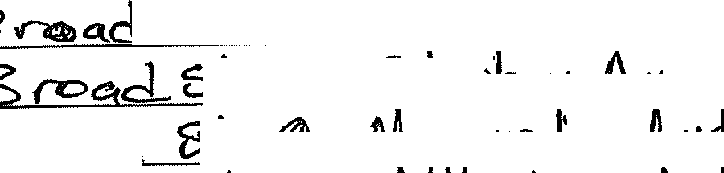
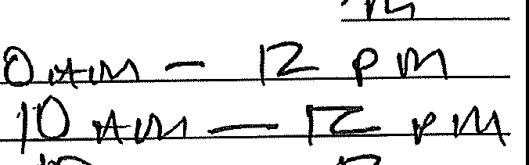
13ro.,J ;s.l-, <! 1 "Ii.I lf'O..._,I( /'t.ve.., 1.'D t1oM - CZ-- p tk-\
·1 tl M -
12-
. - '
--'---=-- ,, I\/,,_,, \ s.C)N Aue..
&r. - U,Mth/\1 - M
'B,\("Ii) fst (01 ,, 1Vl Ii 4J-1JC Ite. -lhlo
·}>\[Dorj + (Q _/ 'N'"' HM .f\vSk • 10 'A:t'V-\ J2.. Pt!l\
Please attach map/drawing accurately depicting proposed locations, activities, and traffic flow, with proposed parking plan.

As a condition to the issuance of a temporary Special Event Permit, the permittee shall indemnify and hold the City harmless from claims, demand or cause of action which may arise from activities associated with the special event.

By signing this permit, I acknowledge that I have read completely including all necessary ordinances and answered all questions truthfully and understand that the event should NOT be promoted until a Special Event Permit has been issued.
Submittal of an application does NOT guarantee approval and the $25 Fee is Non-Refundable.
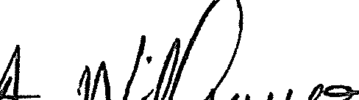
Violations could result in forfeiting the right to apply for future Special Events for a minimum of two (2) years.

Signature l Vf:J"-f rs, ·ok111. Date ·1 I - , _..P,i-
Please Return Com1J1eted Application with Fees to:
City of Dunn Planning Department 102 N Powell Ave
PO Box 1065
Dunn NC 28335
Telephone (910) 230-3505

Special Event Permit Application, Page 5

Checklist for Attachments
Please make sure all required permits and information with necessary permit payments are included. Check or mark n/a

LlABC Permit (if alcohol is to be served or sold) Orents/Temporary Membranes Permit Application
□
Noise Permit Oremporary Sign Permit
Ll'9of ofInsurance or Signed Waiver

WPlease be sure to include Map(s) or Drawing(s) showing location of event, activities,. requested street closures, parking and traffic patterns.

FOR OFFICE USE:
Planning Department:

Inspections Department:
;V/4
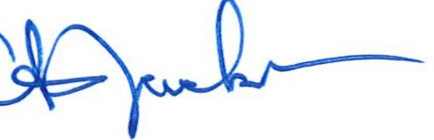
Police Department:

City Clerk, if required:

City Manager, if required:
Date Received: II / f'KlZOZJf:
Date Approved/Denied: _ Date of Notification to Applicant: _
Staff Name Staff Signature

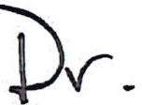
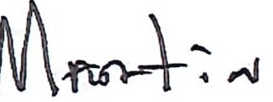
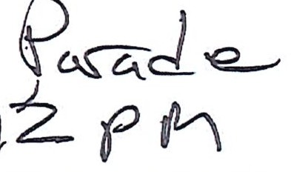
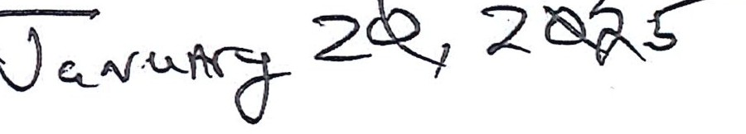
 < ) ... :: gis.hamett.org C

;-:;.;- :-·:·_:::tf- : ::".,:0·= ::.:•:
-,. rb i

- HYno:-11et;; -· -·
"••v-.,.. V ,-
:
•
. ·-· - - ...·.
"'.,, • •- iii m- •-•.,,.:"..:'---'-
7

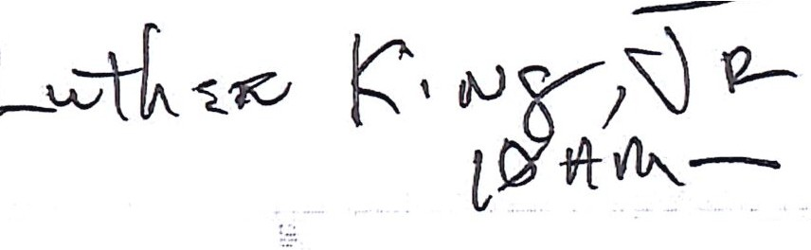
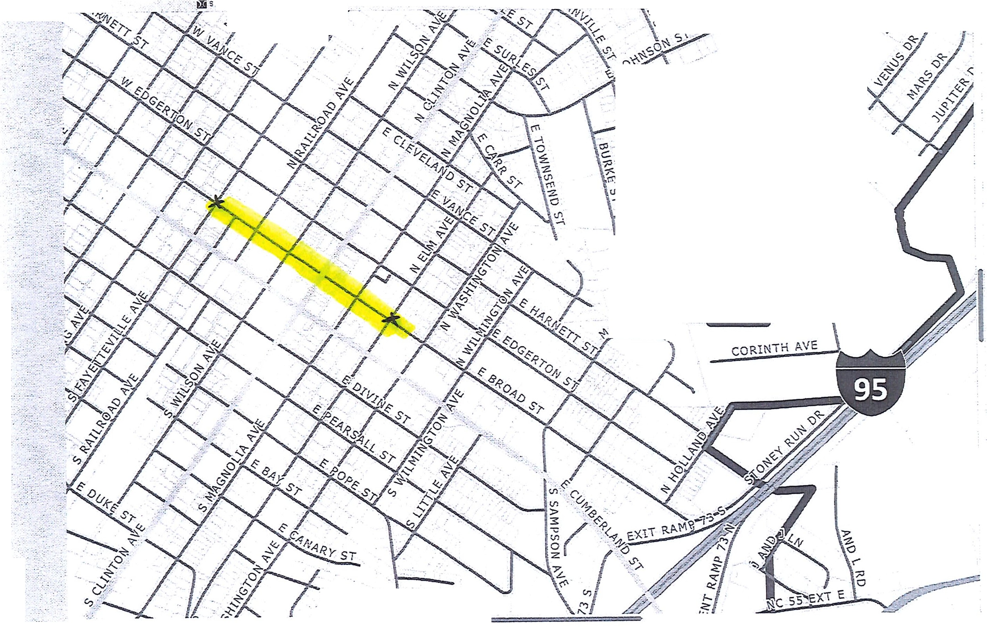

. " . ('.) + ro




CNE-ILC!P.


n

Bookmar s
_'OC>'Readingt.ist
:;_r· Shareef with You•· ·:
I·
C iploud Tabs·

- _{NORTH} _{CAROLINA} City Council Agenda Item
mlDlJNN

Meeting Date: December 10, 2024

SUBJECT TITLE | Consideration of Resolution Authorizing the Disposal of  Personal Property
PRESENTER/DEPARTMENT | Recreation Director Brian McNeill/Parks and Recreation
ATTACHMENT(S) | Yes
PUBLIC HEARING PUBLISH DATES

PURPOSE:

The City Council is being asked to adopt the attached resolution authorizing the City Manager to dispose of personal property by electronic means through www.GovDeals.com

BACKGROUND:

The City recently finalized a contract to purchase playground equipment in accordance with phase 2 renovation of Tart Park. The current playground equipment was originally purchased in 1999 and has been properly maintained and still in operable condition. All equipment has been disassembled to be reassembled by purchaser.

BUDGET IMPACT:

The City would receive payment for the items that no longer hold any value to the City, when sold.

RECOMMENDED
MOTION/ACTION | Motionto adopt the resolution declaring property surplus and authorizing
REQUESTED OF | the City Manager to dispose of personal property by electronic means through
COUNCIL | www.GovDeals.com

---CITY OF
iiiiiDUNN
NORTH CAROLINA
Where communifJ h13_Jinsl

RESOLUTION DECLARING CERTAIN PROPERTY OF THE CITY TO BE SURPLUS AND AUTHORIZING THE DISPOSITION OF SAID PROPERTY

WHEREAS, the City Council of the City of Dunn, North Carolina, has dete1mined that the City owns certain personal property that is no longer usable by the City; and

WHEREAS, each of the items described below, is declared to be surplus to the needs of the City:

Burk Playground Set

NOW, THEREFORE, BE IT RESOLVED by the Dunn City Council that the City Manager is hereby authorized to dispose of the listed items by electronic means through www.GovDeals.com. With appropriate notice, the date, place and time of the sale will be announced by the City Manager or his designee.

The City shall publish at least once and not less than 10 days before the date of the auction: the dates of the auctions and a copy of this Resolution or a notice summarizing its contents as required by North Carolina General Statute 160A-270(b).

Adopted this the 10th day of December, 2024.

William P. Elmore, Jr., Mayor

Attest:

Melissa Matti, City Clerk

_{NORTH} _{CAROLINA} City Council Agenda Item
=DUNN.

Meeting Date: December 10, 2024
I I
SUBJECT TITLE | Budget Amendment for Surveying Services
PRESENTER/DEPARTMENT | Steven Neuschafer/City Manager
ATTACHMENT(S} / | Budget amendment
PUBLIC HEARING PUBLISH DATES I | N/A

PURPOSE: To approve a budget amendment to appropriate funding for surveying services related to the installation of a fiber line between the Dunn Library and City Hall.

BACKGROUND: On August 13, 2024, the City Council approved a budget amendment to provide funds for the installation of a fiber line between the Dunn Library and City Hall. This fiber line would provide a connection to Harnett County's fiber line to allow for additional computer backup storage and accessibility. The contractor for this work has been selected and the NC Department of Transportation is requiring an official survey map of the proposed fiber line route in order to approve the crossings of the NCDOT roads. The city has contacted Davis Martin Powell and Associates to perform the surveying services at a cost of $13,400.
To fund the surveying services, staff are requesting a budget amendment to the General Fund and Water and Sewer Fund in the amounts of $8,616and $4,784 respectively, with funding being appropriated from reserves from each fund.

BUDGET IMPACT: The overall budget for the General Fund will increase by $8,616 and the Water and Sewer Fund will increase by $4,784.

I

Motion to approve the attached budget amendment for surveying services.
RECOMMENDED MOTION/ACTION REQUESTED OF COUNCIL

CITY OF DUNN BUDGET ORDINANCE AMENDMENT Department: Admin
Budget Amendment#: 20
FISCAL YEAR ENDING: 6/30/2025 Date: 12/10/2024

FUND | Acct# | LINE ITEM DESCRIPTION | Appropriation  Before Amendment | Amount of Amendment  Increase/ (Decrease) | Appropriation After Amendment
General Water and Sewer | 010-0500-4510  030-0710-4510 | Professional Services Professional Services | -  - | 8,616.00  4,784.00 | $ 8,616.00  4,784.00  -  -  -
EXPENDITURE TOTAL: $ $ 13,400.00 $ 13,400.00

FUND | Acct# | LINE ITEM DESCRIPTION | Appropriation Before  Amendment | Amount of  Amendment Increase/ (Decrease) | Appropriation After  Amendment
General | 010-0368-2001 | Fund Balance Reserves | $ 719,568.30 | $ 8,616.00 | $ 728,184.30
Water and Sewer | 030-0390-4000 | Fund Balance Reserves | $ 865,534.00 | $ 4,784.00 | 870,318.00
 |  |  |  |  | -
 |  |  |  |  | -
 |  |  |  |  | $ -
REVENUE TOTAL: $ 1,585,102.30 $ 13,400.00 $ 1,598,502.30

CERTIFICATION: I certify this requested budget amendment was approved by the City Council on:

City Manager: 12/10/2024
Finance Director: 12/10/2024
JUSTIFICATION: Allocate funding for survey work related to the fiber line between City Hall and the Library. The survey is required by the NCDOT.
FUNDING SOURCE: FY24 fund balance reserves.

- _{NORTH} _{CAROLINA} City Council Agenda Item
=DUNN

Meeting Date: December 10, 2024
SUBJECT TITLE | Capital Project Ordinance Budget Amendment - Machine & Welding Outfall Sewer Project
PRESENTER/DEPARTMENT | Cary McNallan/Finance Department
ATTACHMENT(S) / | Capital Project Ordinance Amendment
PUBLIC HEARING PUBLISH DATES I | N/ A

I

PURPOSE:
To approve a capital project ordinance amendment for the Machine and Welding Outfall Sewer Project.

BACKGROUND:
On May 28,2024,the City Council approved the capital project ordinance for the Machine and Welding Outfall Sewer Project with a total budget amount of $8,591,002, which was to be funded with $6,243,900 of State American Rescue Plan Act (ARPA) funds and $2,347,102 of general fund reserves.
One of the stipulations for receiving ARPA funds for sewer projects is that any new sewer user and connection fees generated for the city as a result of this project, and between the time that the project is complete and 12/31/26, are to be considered as ARPA Program Income. Program income is defined as gross income earned by a recipient from activities part, or all, of the cost of which is either borne as a direct cost towards meeting a grant. Program income received is required to be either returned to the grantor, or expended on similar, ARPA qualifying projects. It is also required that all ARPA funding, including program income, be committed or encumbered by 12/31/24.
Therefore, the attached capital project ordinance amendment updates the funding sources to include
$750,000 of ARPA Program Income which will be applied to the total construction costs of the project and will eliminate the need to return any ARPA funds to the grantor. Since estimating the anticipated program income is nearly impossible at this time, the $750,000 is expected to be a high estimate of the program income generated from now until 12/31/26. The final budget will be amended again once the project is complete and final amounts are determined.

BUDGET IMPACT:
Revenue and expenditure budgets for the project are adjusted to reflect current obligations and the amount of $750,000is recorded as ARPA Program Income to be applied to construction costs


l:llhilWlfthI.i
RECOMMENDED
MOTION/ACTION | Motion to approve the capital project ordinance amendment for the Machine and
REQUESTED OF | Welding Outfall Sewer Project.
COUNCIL

fil.H1DUNN
NORTH CAROLINA
Capital Project Ordinance Amendment I
Machine and Welding Outfall Sewer Line Improvements Project

WHEREAS, the City Council for the City of Dunn, on June 14, 2022, adopted the annual budget ordinance number 02022-08 for the fiscal year beginning July 1, 2022; and,

WHEREAS, the City Council, on March 8, 2022, approved a capital project ordinance for the Eastside Pump Station, Forcemain, and Outfall line Improvements; and,

WHEREAS, on March 8, 2022, a budget of $15,850,000 was approved for this project; and,

WHEREAS, on January 10, 2023, a budget amendment was approved that reduced the overall project budget by $8,856,100; and,

WHEREAS, on April 11, 2023, a budget amendment was approved to reflect a transfer of
$2,347,102 of funding from the General Fund; and,

WHEREAS, on May 28, 2024, an amendment to the original capital project ordinance was approved to eliminate the Outfall Line portion of the project, so that it could be accounted for and constructed as its own separate capital project, and changes to the revenue and expenditure budgets were adjusted accordingly; and,

WHEREAS, on May 28, 2024, the Machine and Welding Outfall Sewer Line Improvements Capital Project ordinance was established and approved; and,

WHEREAS, it is now necessary to amend this project to reflect adjustments to the project budget; and,

NOW THEREFORE, BE IT ORDAINED BY THE CITY COUNCIL OF THE CITY OF DUNN, NC, PURSUANT TO SECTION 13.2 OF CHAPTER 159 OF THE GENERAL STATUTES OF NORTH CAROLINA, THAT:

Section 1: Construction for the Machine and Welding Outfall Sewer Line Improvements capital sewer project is authorized to be undertaken until all project activity is completed, and is adopted as follows:
Section 2. The amount of funding appropriated, and amounts budgeted for construction and related costs are amended and approved as follows:

Where communi{_J 6e.3insl

fil.H1DUNN
NORTH CAROLINA

Funding A1n1ronriations | Previous  Budget | Budget  Amendments | Revised  Budget
SRFR-ARPA Grant Funds | $6,243,900 |  | $6,243,900
ARPA Program Income |  | $ 750,000 | $ 750,000
Transfer from the General Fund | $2,347,102 | $ (1,927,383) | $ 419,719
Total Funding | $8,591,002 | $ (1,177,383) | $7,413,619
Exnenditures:
Administration |  | $ 10,522 | $ 10,522
Easements |  | $ 57,751 | $ 57,751
Engineering | $ 500,000 | $ 57,500 | $ 557,500
Construction | $8,091,002 | $ (1,626,387) | $ 6,464,615
Contigency |  | $ 323,231 | $ 323,231
Total Expenditures $8,591,002 $ (1,177,383) $7,413,619

Section 3: Funds may be advanced from the General Fund for the purpose of making payments as due. Reimbursement requests should be made to the grantor agency in an orderly and timely manner.

Section 4: The Finance Director is directed to report periodically on the financial status of each project element in Section 2 and on the total revenues received or claimed.

Section 5: Within five (5) days after this ordinance is adopted, the City Clerk shall file a copy of this ordinance with the Finance Director.

Section 6: This capital project ordinance shall be effective immediately. Duly adopted this 10th day of December 2024.

William P. Elmore, Jr. Mayor
Attest:

Melissa R. Matti City Clerk

Where communi{_J 0B_Jinsl

_{NORTH} _{CAROLINA} City Council Agenda Item
mlDlJNN

Meeting Date: December 10, 2024

SUBJECT TITLE | I Budget Amendment for Valve Exerciser
PRESENTER/DEPARTMENT | Cary McNallan/Finance Department  Billy Cottle/Collection & Distribution System Manager
ATTACHMENT(S) / | Budget Amendment
PUBLIC HEARING PUBLISH DATES | IN/A

PURPOSE: To approve additional funds necessary to purchase the valve exerciser previously approved in 24/25 budget.

BACKGROUND: The City Council previously approved the purchase of the valve exerciser which will be used to work existing valves in the system. A valve exerciser will allow for regular maintenance of valves by opening and closing them, which will prevent sticking, corrosion, and debris buildup. This will ensure they function properly in an emergency and will also extend their lifespan.
The FY25 capital project budget, which was approved by the City Council in June 2024, included $70,000 for this equipment. A budget amendment of $17,765 is needed to account for an increase in product price from when the supplier switched vendors, and the price increased.

BUDGET IMPACT: The budget amendment will increase revenues by $12,365 in the Water and Sewer Fund which will be offset by an operating transfer from the Water and Sewer Fund to the Capital Project Fund. A balance of $5,400 that is currently in the capital project as contingency will be shifted to the capital outlay expense.

RECOMMENDED
MOTION/ACTION | Motion to approve the attached capital project ordinance amendment and operating
REQUESTED OF | budget amendment for the purchase of a valve exerciser.
COUNCIL

IICITY OF
WP.Yo

Capital Project Ordinance Amendment III FY24 & FY25 Water and Sewer Equipment

WHEREAS, the City Council for the City of Dunn, on June 13, 2023, adopted the annual budget ordinance number 02023-13 for the fiscal year beginning July 1, 2023; and,

WHEREAS, the City Council, on June 13, 2023, adopted the capital improvements plan for fiscal year 2023-24; and,

WHEREAS, on June 13, 2023, the City Council adopted a capital project ordinance for the FY24 Water and Sewer Vehicle and Equipment Project at a total cost of $416,000; and,

WHEREAS, on October 17, 2023, the City Council adopted a capital project ordinance amendment to increase the project's budget by $185,200; and,

WHEREAS, the City Council for the City of Dunn, on June 25, 2024, adopted the annual budget ordinance number 02024-13 for the fiscal year beginning July 1, 2024; and,

WHEREAS, the City Council, on June 25, 2024, adopted the capital improvements plan for fiscal year 2024-25; and,

WHEREAS, on November 12, 2024, the City Council adopted a capital project ordinance amendment to increase the project budget; and,

WHEREAS, it is necessary to amend the capital project ordinance to include additional funding for the purchase of a valve exerciser; and,

NOW THEREFORE, BE IT ORDAINED BY THE CITY COUNCIL OF THE CITY OF DUNN, NC, PURSUANT TO SECTION 13.2 OF CHAPTER 159 OF THE GENERAL STATUTES OF NORTH CAROLINA, THAT:

Section 1: The purchase of a valve exerciser will be completed and is authorized to be undertaken until all project activity is completed, and is adopted as follows:

Where communi{_J 0B_Jiml

!!:JP.Pc
CITY OF
Section 2. The amount of funding appropriated, and amounts budgeted for capital outlay are approved as follows:
Funding Ai;mronriations | Previous  Budget | Budget  Amendments | Revised  Budget
Installment Financing | $ 343,587.00 |  | $ 343,587.00
USDA Grant Funds | $ 40,822.00 |  | $ 40,822.00
Transfer from the General Fund | $ 6,106.71 |  | $ 6,106.71
Operating Transfer fr W&S Fund | $ 255,200.00 | $ 12,365.00 | $ 267,565.00
Total Funding | $ 645,715.71 | $ 12,365.00 | $ 658,080.71
Expenditures:
Capital Outlay-W&S Equipment | $ 70,000.00 | $ 17,765.00 | $ 87,765.00
Capital Outlay-WTP Equipment | $ 179,800.00 |  | $ 179,800.00
Public Utility Vehicles | $ 189,528.05 |  | $ 189,528.05
WTP Vehicles | $ 45,473.59 |  | $ 45,473.59
WWTP Vehicles | $ 155,514.07 |  | $ 155,514.07
Contigency | $ 5,400.00 | $ (5,400.00) | $
Total Expenditures $ 645,715.71 $ 12,365.00 $ 658,080.71

Section 3: Funds maybe advanced from the Water and Sewer Fund for the purpose of making payments as due.

Section 4: The Finance Director is directed to report periodically on the financial status of each project element in Section 2 and on the total revenues received or claimed.

Section 5: Within five (5) days after this ordinance is adopted, the City Clerk shall file a copy of this ordinance with the Finance Director.
Section 6: This capital project ordinance shall be effective immediately. Duly adopted this 10th day of December 2024.

William P. Elmore, Jr. Mayor
Attest:

Melissa R. Matti City Clerk

Where communifj 0e_Jinsl

CITY OF DUNN BUDGET ORDINANCE AMENDMENT

FISCAL YEAR ENDING: 6/30/2025
Department: Po/ice Budget Amendment#:
Date:

19
12/10/2024

FUND | Acct# | LINE ITEM DESCRIPTION | Appropriation Before Amendment | Amount of Amendment Increase/ (Decrease) | Appropriation After  Amendment
Water and Sewer W&S Capital W&S Capital | 030-0710-8500  069-0930-7430  069-0930-0002 | Oper Trfs to Capital Projects  Capital Outlay-W&S Ops Veh & Equip Contingency | 327,284.00  259,528.05  5,400.00 | 12,365.00  17,765.00  (5,400.00) | $ 339,649.00  277,293.05  -  -  -
EXPENDITURE TOTAL: $ 592,212.05 $ 24,730.00 $ 616,942.05

FUND | Acct# | LINE ITEM DESCRIPTION | Appropriation Before Amendment | Amount of Amendment Increase/ (Decrease) | Appropriation After  Amendment
Water and Sewer | 030-0378-0001 | Water Storage Rental | $ - | $ 3,500.00 | $ 3,500.00
Water and Sewer | 030-0381-0000 | Interest Income | $ 65,290.00 | $ 8,865.00 | 74,155.00
W&S Capital | 069-0399-1430 | Oper Trfs fr W&S Fund | $ 255,200.00 | $ 12,365.00 | 267,565.00
 |  |  |  |  | -
 |  |  |  |  | $ -
REVENUE TOTAL: $ 320,490.00 $ 24,730.00 $ 345,220.00

CERTIFICATION: I certify this requested budget amendment was approved by the City Council on:

City Manager: 12/10/2024
Finance Director: 12/10/2024
JUSTIFICATION: Allocate funding for the purchase of a valve turning machine.
FUNDING SOURCE: FY24 increase in water storage rental revenue and interest earnings.

- _{NORTH} _{CAROLINA} City Council Agenda Item
lmlDlJNN

Meeting Date: December 10, 2024
SUBJECT TITLE | Authorization to approve administration and engineering agreements
PRESENTER/DEPARTMENT I | City Manager Neuschafer
ATTACHMENT(S) | Yes
PUBLIC HEARING PUBLISH DATES | I NA

I

PURPOSE:
To authorize the Assistant City Manager, Billy Godwin to approve the contracts after review by City Attorney.

BACKGROUND:
The City adopted the Capital Budget and Budget Amendment for this project in August of 2024. The City of Dunn intends to make improvements to the Raw Water Pump Station located in Erwin, NC near the Cape Fear River. The City has received a Building Resilient infrastructure and Communities (BRIC) grant of $6,438,975 to be used towards the funding of this project. The City has also received a state funding appropriation in the amount of $7,1M that is to be used for water and sewer infrastructure projects, the use of a portion of the state funding to be allocated towards this project. The estimated cost of this project is $9,094,222.

This first phase of the project, what the planning agreement covers, will include grant administration and engineering. $1,154,790.

Withers is currently working on engineering agreement. Upon receipt, both agreements (engineering services and administration) will be reviewed by City Attorney prior to approval.

BUDGET IMPACT:
This Phase of the project will require approximately $329,940 from the City's approved funding.

Project EMA-20022-BR-001-0045 CFDA: 97.047

RECOMMENDED
MOTION/ACTION | Motion to authorize the Assistant City Manager to approve contracts after
REQUESTED OF COUNCIL | review by City Attorney.

AGREEMENT BETWEEN
MID-CAROLINA REGIONAL COUNCIL
and
CITY OF DUNN
for the provision of Technical Service Assistance:
FEMA BRIC Raw Water Project: Project & Grant Administration

This AGREEMENT, entered into on December 10, 2024 by and between Mid-Carolina Regional Council (hereinafter referred to as the "Council") and the City of Dunn, North Carolina (hereinafter referred to as the "Local Government"); WITNESSETH THAT:
WHEREAS, the Council is empowered to provide technical assistance by the North Carolina General Statutes and by resolution passed by the Council on April 17, 1972. Technical assistance shall consist of the provisions of services as described in Attachment A, which is herein made part of this AGREEMENT;
WHEREAS, the Local Government has requested the Council to provide such technical assistance to the Local Government and;
WHEREAS, the Council desires to cooperate with the Local Government in every way possible to the end that the proposed activities are carried out in an efficient and professional manner;

NOW, THEREFORE, the parties hereto do mutually agree as follows:
- Personnel
That during the period of this Contract, the Council will furnish the necessary trained personnel to the Local Government to perform the tasks outlined in Attachment A Work Program.
- Compensation
That for the purpose of providing funds for carrying out this Contract, the Local Government will pay the Council a flat rate percentage of five (5) percent of the project cost for project and grant administration not to exceed, $430,000.

The Council shall invoice the Local Government on a monthly basis for the services provided for the prior month during the entirety of the project. The first invoice shall be sent in December 2024 based on the schedule in Attachment A.
- Materials/Work Product
All work product will be property of the Local Government.
- Time of Performance
The contract shall begin December 10, 2024 until project completion or until terminated by either party according to the specification in item number 5.

City of Dunn Local Technical Assistance
FEMA BRIC Raw Water Project: Project & Grant Administration

- Termination/Modifications
The Local Government may from time-to-timemay request changes in the scope of work of services to be performed by the Council hereunder. Such changes, including any increases or decreases in the Council's compensation, which are mutually agreed upon by and between the Local Government and Council, shall be incorporated as written amendments to the Contract. The Local Government or the Council may terminate this AGREEMENT by giving a thirty (30) days written notice (electronic or paper).
- Interest of Members, Officers, or Employees of the Council, Members of the Local Government, or Other Public Officials
No member, officer, or employee of the Council or its agents; no member of the governing body of the locality in which the program is situated; and no other public official of such locality or localities who exercises any functions or responsibilities with respect to the program during his or her tenure or for one year thereafter, shall have any financial interests, either direct or indirect, in any contract or subcontract, or the proceeds thereof,for work to be performed in connection with the program assisted under this Agreement. Immediate family members of said members, officers, employees, and officials are similarly barred from having any financial interests in the program. The Council shall incorporate, or cause to be incorporated, in all such contracts or subcontracts, a provision prohibiting such interest pursuant to the purpose of this section.

- Nondiscrimination Clause
No person in the United States shall on the grounds of race, color, national origin, or sex be excluded from participation in, be denied the benefits of, or be subjected to discrimination with any program or activity funded in whole or in part with funds available under the Housing and Development Act of 1974, Section 109.
- Age Discrimination Act of 1975, as amended
No qualified person shall on the basis age be excluded from participation in, denied the benefits of, or otherwise be subjected to discrimination under any program or activity which receives benefits from federal financial assistance.
- Section 504, Rehabilitation Act of 1973, as amended
No qualified handicapped person shall, on the basis of handicap be excluded from participation in, be denied the benefits of, or otherwise be subjected to discrimination under any program or activity which receives or benefits from federal financial assistance.
- E-Verify Provision
Pursuant to G.S.143-48.5and G.S.147-33.95(9),the undersigned hereby certifies that the Contractor named below, and the Contractor's subcontractors, complies with the requirements of Article 2 of Chapter 64 of the NC General Statutes, including the requirement for each employer with more than 25 employees in North Carolina to verify the work authorization of its employees through the federal E-Verify system. E-Verify System Link: www.uscis.gov

2

City of Dunn Local Technical Assistance
FEMA BRIC Raw Water Project: Project &_Grant _A ministration
City of Dunn Mid-Carolina Regional Council

By: _ Title: City Manager
Date:
By: _ Title: Executive Director
Date:

This instrument has been pre-audited in the manner required by the Local Government Budget and Fiscal Control Act.

_,Finance Officer Date _

3

City of Dunn Local Technical Assistance
!='_EMA BB_IC Raw Water Project: FJoject & Grant Administration
ATTACHMENT A

CITY OF DUNN TECHNICAL SERVICE ASSISTANCE
FEMA BRIC Raw Water Project: Project & Grant Administration

- WORK PROGRAM/BUDGET

This is an agreement attached to and made part of the December 10, 2024 AGREEMENT between the City of Dunn, North Carolina (hereinafter referred to as "Local Government") and Mid-Carolina Regional Council (hereinafter referred to as "Council") providing for technical assistance for project and grant administration of the FEMA BRIC Raw Water Project. The basic services to be provided by Council are outlined below.
- WORK PROGRAM/SCOPE OF SERVICES

The intent of this AGREEMENT is for the Council to provide qualified professional personnel as technical assistance to the Local Government consistent with applicable federal laws, state laws, and City ordinances beginning December 10, 2024. Leveraging experience and resources possessed by Council staff, the Council will administer the FEMA BRIC Raw Water Project.
- SERVICES TO BE PROVIDED
The Council shall provide complete grant and project administration services for the FEMA 2022 BRIC Raw Water Project to include but not be limited to the items below:
  - Schedule, facilitate, follow-up all meetings related to the FEMA BRIC Raw Water project.
  - Act as the project liaison to the City of Dunn between FEMA, North Carolina Department of Public Safety, design professionals and all other parties as needed.
  - Prepare and send all correspondence, electronic or paper, on behalf of the City of Dunn.
  - Prepare and submit all documentation related to the project to the North Carolina Department of Public Safety and FEMA on behalf of the City of Dunn.
  - Prepare and submit all reporting and compliance documentation.
  - Prepare all procurement documents and complete the procurement process based on project guidelines.
  - Close out the grant project.

- PAYMENT SCHEDULE
The Council shall invoice the Local Government on a Monthly basis based on the following schedule:

First Invoice December 2024
Last Invoice December 2027

Payments shall be made monthly in equal installments for the duration of the project, estimated to be three
(3) years, with the final payment in December 2027 or upon project completion whichever is first.

4

- _{NORTH} _{CAROLINA} City Council Agenda Item
mlDlJNN

Meeting Date: December 10, 2024

SUBJECT TITLE | Resolution adopting the 2025 Regular Meeting Schedule and  Budget Retreat Date
PRESENTER/DEPARTMENT | City Manager Steven Neuschafer
ATTACHMENT(S) | Resolution

PURPOSE:
For Council to Consider and approve 2025 Meeting Schedule for the Dunn City Council.

BACKGROUND:
- The February meeting was moved to the third Tuesday to work better with the date of the Retreat.

BUDGET IMPACT:

RECOMMENDED
MOTION/ACTION | Motion to approve the Resolution adopting the 2025 Regular Meeting Schedule and
REQUESTED OF | Budget Planning Retreat for the Dunn City Council as presented.
COUNCIL

NORTH CAROLINA
.-----.CITY OF
iiiiiDUNN
1Uhere communi{_J hfJ_Jins/
RESOLUTION ADOPTING THE 2025 REGULAR MEETING SCHEDULE FOR THE CITY OF DUNN CITY COUNCIL
WHEREAS, the North Carolina General Statute 160A-71 allows the City Council to fix a specific time and place for their regular meetings; and
WHEREAS, the North Carolina General Statute 143-318.12(a) requires that the City Council's schedule of regular meetings be kept on file with the City Clerk.
NOW, THEREFORE, BE IT RESOLVED by the Mayor and City Council of the City of Dunn, North Carolina that the following meeting schedule be adopted:

Tuesday | January 14, 2025 | 6:30 p.m. | Dunn Municipal Building
Tuesday | January 28, 2025 | 6:30 p.m. | Dunn Municipal Building
Friday - | 2024-2025 Budget Retreat | 8:00 a.m. to | Lumina on Wrightsville Beach,
Saturday | February 7-8, 2025 | 5:00 p.m. | Wrightsville Beach, NC
Tuesday | February 25, 2025 | 6:30 p.m. | Dunn Municipal Building
Tuesday | March 11, 2025 | 6:30 p.m. | Dunn Municipal Building
Tuesday | March 25, 2025 | 6:30 p.m. | Dunn Municipal Building
Tuesday | April 8, 2025 | 6:30 p.m. | Dunn Municipal Building
Tuesday | April 22, 2025 | 6:30 p.m. | Dunn Municipal Building
Tuesday | May 13, 2025 | 6:30 p.m. | Dunn Municipal Building
Tuesday | May 27, 2025 | 6:30 p.m. | Dunn Municipal Building
Tuesday | June 10, 2025 | 6:30 p.m. | Dunn Municipal Building
Tuesday | June 24, 2025 | 6:30 p.m. | Dunn Municipal Building
Tuesday | July 8, 2025 | 6:30 p.m. | Dunn Municipal Building
Tuesday | August 12, 2025 | 6:30 p.m. | Dunn Municipal Building
Tuesday | August 26, 2025 | 6:30 p.m. | Dunn Municipal Building
Tuesday | September 9, 2025 | 6:30 p.m. | Dunn Municipal Building
Tuesday | September 23, 2025 | 6:30 p.m. | Dunn Municipal Building
Tuesday | October 14, 2025 | 6:30 p.m. | Dunn Municipal Building
Tuesday | October 28, 2025 | 6:30 p.m. | Dunn Municipal Building
Tuesday | November 11, 2025 | 6:30 p.m. | Dunn Municipal Building
Tuesday | December 9, 2025 | 6:30 p.m. | Dunn Municipal Building
Duly adopted by the City Council of the City of Dunn, meeting in regular session this the 10th day of December, 2024.

William P. Elmore, Jr., Mayor
Attest:

Melissa R. Matti, City Clerk

  - _{NORTH} _{CAROLINA} City Council Agenda Item
mlDlJNN

Meeting Date: December 10, 2024

SUBJECT TITLE | CZ-08-24: Conditional Rezoning requested of PIN 1527-06- 9321.000. This parcel is currently located in the R-20 zoning district. The requested zoning district is C-3-CZD.
PRESENTER/DEPARTMENT | Samantha Wullenwaber, Deputy Executive Director  & Local Government Services Director, Mid-Carolina COG
ATTACHMENT(S) | Conditional Rezoning Application, Conditional Rezoning Site Plan, Staff Report with proposed conditions and attachments.
PUBLIC HEARING PUBLISH DATES I | November 22nd & November 29th, 2024

PURPOSE:

- Public Hearing: A public hearing will be held to review and make a final decision on a Conditional Rezoning request. The subject parcel is PIN 1527-06-9321.000 at address 330 Jernigan Rd in Dunn's ETJ.

- Decision:

BACKGROUND:
A Conditional Zoning application was submitted by Republic Services of North Carolina to conditionally rezone a property adjacent to their existing site at 2435 and 2477 US 301 N in Dunn's ETJ from Residential (R-20} to Highway Commercial (C-3}. The site plan attached to the application shows details of the proposed expansion of the Republic Services site. The proposed expansion includes additional commercial truck parking and an outdoor storage and loading area.

BUDGET IMPACT: None

Motion to approve, deny, or approve with conditions case CZ-08-24.
RECOMMENDED MOTION/ ACTION REQUESTED OF COUNCIL

.DUNN  PLANNING AND INSPECTIONS  102 N Powell Ave • PO Box 1065 • Dunn, North Carolina28335  910) 230-3505 • CitvofDunn.or |  | Planning Staff Report Rezoning Case: CZ-08-24  Planning Board Meeting: November 4, 2024 Location: Jernigan Rd; PIN 1527-06-9321
Request: R-20 to C-3 CZD
The applicant requests rezoning PIN 1527-06-9321 from R-20 Residential Zoning District to C-3 Commercial Highway Conditional Zoning District. The request includes one parcel, all of which is located within Dunn's ETJ. The Conditional Zoning Master Plan proposes an expansion of the existing Republic Services commercial site located at addresses 2477 and 2435 US Highway 301 North. The expansion includes additional commercial vehicle parking and an outdoor storage and off-street and loading area.

[ Property Information:
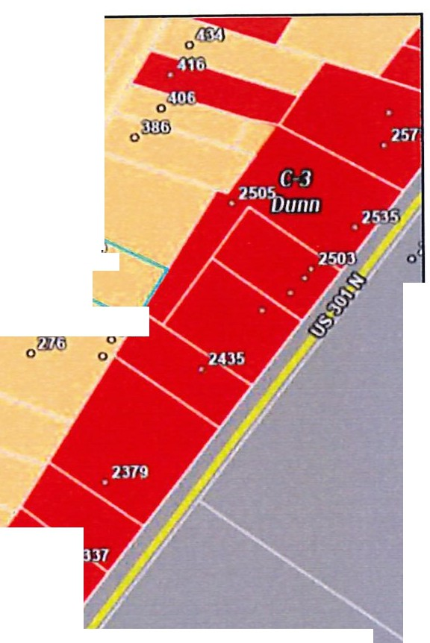
OWNER/APPLICANT: William Madison Bletner, Sr. (Owner);
Republic Services of NC, LLC. (Applicant)

0
ADDRESS/LOCATION: Refer to Location and Zoning Map. P.I.N.(s): mt1f)
1527-06-9321.000 mmm efJ
SIZE: The parcel is 1.012 acres. if--.ml.
PROPOSED -►- $'--. :...·
EXISTING ZONING: The subject parcel is currently zoned R-20. This SITE mm district is established primarily for residential
developments and related recreational,
religious and educational facilities.
otlll!)
ofH)
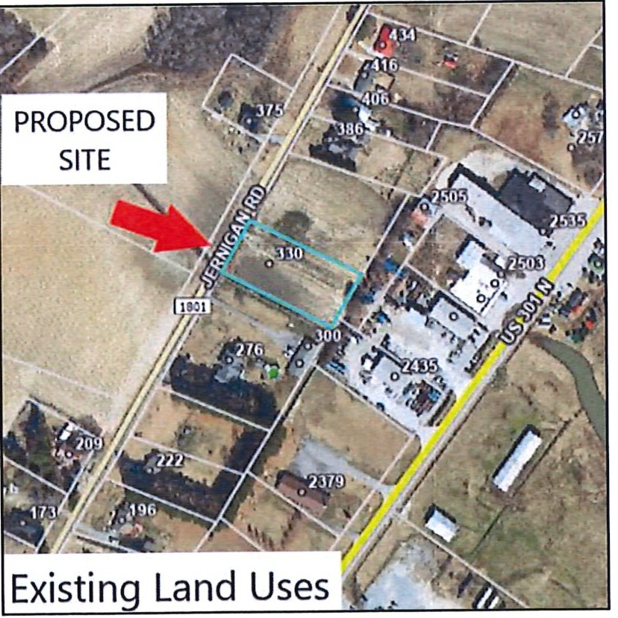
EXISTING LAND USE: The subject parcel is currently vacant. o® OOOD
OW!)
ouw

Existing Zoning

SURROUNDING LAND USE:

North: Vacant, Cleared land
East: Commercial
West: Vacant, Cleared land; Residential
South: Residential

DEVELOPMENT REVIEW:
Should the Conditional Zoning application be approved by Council, the applicant shall submit the Commercial Site Plan Development Permit application for review and approval.

DIMENSIONAL PROVISIONS FOR REQUESTED DISTRICT:

Minimum Standard | R-20 (Existing Zoning) | C-3 CZD (Proposed Zoning)
Front Yard Setback | 30 feet | N/A
Secondary Front/Street Side | 30 feet | 20 feet
Side Yard Setback | 10 feet | 20 feet
Rear Yard Setback | 25 feet | N/A
Lot Area | 20,000 square feet | 20,000 square feet
Lot Width | 75 linear feet | 75 linear feet
Maximum Impervious Surface | 30% | N/A

DEVELOPMENT POTENTIAL:

Existing Zoning (R-20) Proposed Zoning (C-3 I CZ)
2 dwelling units total (2 per a_crn) .58 Acres of Commercial Parking and Outdoor Storage and Off-Street Loading

FUTURE LAND USE PLAN CLASSIFICATION:

The future land use classification of the property is "Gateways & Corridors," as illustrated in Future Land Use Map. The proposed rezoning request is inconsistent with the adopted Land Use Plan.

Gateways & Corridors: Primarily comprised of single-family residential uses with scattered small-scale multifamily uses and townhomes. The character is defined by established, often historic neighborhoods, street connectivity, and pedestrian facilities that provide access to Downtown and Gateways & Corridors.

Associated plan goals and policies that may be considered include the following:

CITY OF DUNN
I l Tlllf L\.'\;f}l1SI \I\JI
... ,....,.i.....,,..uc.,.....,-.,,_...... -- -
-
_--,--,_.-\.,-.--.-,.-...-.,-"".._.........
r--....._....-..-.­....
....... ..... ..,..
-..c..,,... --.•
..,.-.......c.., "--
- _U.... l -,_-,....-..,-.--

§! ;t.l!.A. ••- ;

"1tidit i: 11ii"..i

.\lirJhlm lk-0,111 ttrsidtfltlal lk.pd.alohi

'\
'-
□-c..-­
□
- 0
-u,

Policy 2 of the Future Land Use Plan:
Strengthen Dunn's identity and enhance its character by encouraging high-quality design throughout the City.

Policy 2.1:

Policy2.3:
Screening and landscaped buffers should be used to minimize visibility of service areas, utilities, and parking lots, and to transition between new development and existing residential land uses; Shade-providing street trees should be included along street frontages where feasible.

Pursue public improvements and utilize regulatory standards to preserve or enhance aesthetics within and adjacent to the main corridors and gateways in the City; Establish and apply a highly visible gateway design which reflects Dunn's brand. Areas of greatest potential for gateway improvements include Interstate 95 interchanges, the U.S. 301/Ellis Avenue gateway on the north side, and other locations identified in the Dunn Strategic Plan.

IMPACTS ON LOCAL INFRASTRUCTURE AND FACILITIES

UTILITIES: TRAFFIC:
Water and sewer service is not needed for this development.

This development will not generate additional traffic per the applicant. This development will not allow for or create additional Republic Services truck routes per the applicant.

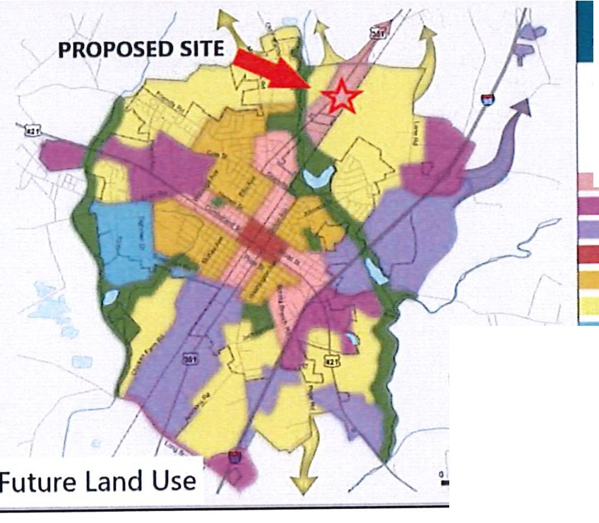
CONDITIONS
OF APPROVAL: See attached Conditions of Approval and Conditional Zoning Site Plan.

r ZONING ANALYSIS:

D Yes

0 Yes
IZI No

!Z1 No
The amendment, if small scale, is reasonable based upon surrounding conditions. REASONING:
The amendment, though small-scale, is unreasonable based upon surrounding conditions. Land uses surrounding this development are primarily residential. Expansion of this commercial use is incompatible with these surrounding land uses.

The impact to the adjacent property owners and the surrounding community is reasonable, and the benefits of rezoning outweigh any potential inconvenience or harm to the community.
REASONING:
The impact on the adjacent property owners and surrounding community and the benefits of the rezoning do not outweigh any potential inconvenience or harm to the community. However, as demonstrated on the Conditional Zoning Site Plan, the applicant willprovide improvements to public streets in the form of street trees. In addition, the applicant has elected to install additional screening beyond the minimum requirements of the UDO in the form of a 6-foot fence to mitigate potential visual and audible impacts on surrounding properties.

D Yes IZI No

D Yes 1Z1 No
The amendment is warranted due to changed or changing conditions in the area. REASONING:
The amendment is not warranted due to changing conditions in the area. No changes in the area deem this development as warranted.

The amendment achieves the purpose and is consistent with the Land Use Plan. REASONING:

The Future Land Use Map identifies this site within a Gateways & Corridors area. Rezoning to C-3 Highway Commercial CZD is inconsistent with the Future Land Use Map. This amendment does not achieve the purpose of and is partially inconsistent with both the Land Use Map and the Future Land Use Plan's Recommendation for General Land Use, Policy 2: Strengthen Dunn's identity and enhance its character by encouraging high-quality design throughout the City; Pursue public improvements and utilize regulatory standards to preserve or enhance aesthetics within and adjacent to the main corridors and gateways in the City; Establish and apply a highly visible gateway design which reflects Dunn's brand. Areas of greatest potential for gateway improvements include Interstate 95 interchanges, the U.S. 301/Ellis Avenue gateway on the north side, and other locations identified in the Dunn Strategic Plan.

While the proposed development does provide additional screening beyond the minimum requirements of the UDO and a peripheral landscape buffer with street trees along Jernigan Road, it is still inconsistent with the intent of General Land Use Policy 2 of the Land Use Plan. The proposed development is an expansion of a commercial use which is not an intended use for properties included in the Gateways & Corridors areas of the Future Land Use Map. This development would also deviate from some of the minimum requirements of the UDO; would not preserve, enhance, or contribute to highly visible aesthetics within and adjacent to main corridors and gateways to the City.

STAFF RECOMMENDATION:

In Case CZ-08-24, Planning staff recommends denial of the rezoning request from R-20 Residential District and C-3 Highway Commercial Conditional Zoning District. Staff finds the request is inconsistent with the City of Dunn's Future Land Use Plan which details a vision for "Gateways & Corridors" at this location. Staff also finds that the request is unreasonable and not in the public interest, as it is incompatible with the surrounding land uses and zoning.

Attachments: Conditions of Approval
Neighborhood Meeting Data Notification Mailing List Application

Conditions of Approval
CZ-08-24
CZ-08-24: Rezoning 1.012 acres from R-20 Residential District to C-3 Highway Commercial Conditional Zoning District to expand the Republic Services' site to accommodate additional commercial parking and outdoor storage and off-street loading.

The property delineated with Exhibit"A" is subject to the following conditions:

- Applicability_;_ All use and development of the property applicable to this Conditional Zoning (CZ-08-24) and as delineated in Exhibit "A" and Exhibit "B" shall occur consistent with the standards and requirements of the C-3 Highway Commercial Zoning District unless otherwise stated herein. If any standards herein are inconsistent with the Unified Development Ordinance, the conditions set forth herein shall supersede and apply to the development of the property delineated in Exhibit "A" and Exhibit "B." If not expressly stated herein the C-3 Highway Commercial Zoning District standards shall apply.

- Permitted and Prohibited Uses.

  - Parking and outdoor storage and off-street loading areas is limited to .48 acres of 14 commercial parking stalls and 2 roll-off dumpster storage and off-street loading areas which meet the 70-foot setback for off­ street loading areas per Article 6.05(F)(7)(3)(C) as shown on the Conditional Zoning Master Plan appearing in Exhibit "B".
  - A 5-foot easement of no access is required to extend the length of the property along Jernigan Road as shown on the Conditional Zoning Master Plan appearing in Exhibit "A".
  - A 32-foot cross-access easement is required for the applicant to access the subject property across PIN 1527-16-4428. 000.

- Development Standards.

  - Setback Standards. Minimum setback standards for this commercial development shall be:

Secondary Front: Side:
Rear:
20 feet
20 feet
N/A

  - Signage for this development shall be in accordance with the applicable sign regulations as set forth in Unified Development Ordinance and that the proper permit(s) be obtained prior to the installation of any permanent signs on the property. Note: This conditional approval is NOT approval for the size, shape, or location of any signs.

  - Surfacing Material: The surfacing of this development shall be crushed aggregate or gravel to be consistent with the existing site's surfacing material as shown on the Conditional Zoning Master Plan appearing in Exhibit "A".

  - Landscaping Buffer: The landscaping buffer surrounding the development shall contain 12 trees in addition to 52 shrubs as shown on the Conditional Zoning Master Plan appearing in Exhibit "A". Plant species will be chosen from the list of approved plantings in Appendix B of the City of Dunn UDO. Shrubs shall be a minimum of 3 gallons at plantings and reach a minimum height of 6 feet at maturity.

G. Other Conditions.

- The above-referenced no access easement and cross-access easement shall be recorded with the Harnett County Register of Deeds prior to issuance of a Development Permit. A copy of the recorded easement plat(s) shall be provided to the City of Dunn Planning Department prior to issuance of a Development Permit. A copy of the agreement between the property owner and the applicant regarding the cross-access easement shall be provided to the City of Dunn Planning Department no later than 90 days following approval of CZ-08-24 by the City Council in the event that the Conditional Rezoning application is approved.

- Use and Development Conditions. This conditional zoning and the site plan conditions of approval are not to be construed as all-encompassing of the applicable rules, regulations, etc., which must be complied with for any development. Other regulations, such as building, environmental, health, State agencies, and so forth, may govern the specific development. The developer is the responsible party to ensure full compliance with all applicable Federal, State, and local regulations.

EXHIBIT "A" OF CONDITIONS OF APPROVAL CONDITIONAL ZONING SITE PLAN

CFHFA.Al".9!!,_
-
ii.-vr,JlltOl'CC:)r,-..i,n- ""'1Q.f':O.O
_,.,., .U.Y'°':;u;:..

D:IIT'tlC IMIT'IC1-'TMXnc oo.-o,i.A14A.t,11% T-..Z:,,. _,.YOIU,,LIC1t101,?•...C..o,a.C)•CC)IUIXJIO

J. oa:n.oU11. w:111: ""C1..-IUl't/l"fOt:
-.:.-:.= -==M)

T,tt:,a..oo/OQJiUfl-'M'.lflll;UOMIOil'-l>Cr."•DCa.W-..C.V
': - .:O'="
=== -:==;-·
cocn.)CCIIClffl0IOSOl .'ntl: VCICU'T'Olll:'l'

s. V&,l,IISC, 1,:)'l'IC,,_c,cu,-
a,w.,I.OI.L'l'U"'C.TICCXllftioQOl'Cll,t. 4JttAU O,,
llr\L9fflNCJJ.T'l!CttWUKJCl.ooccMClr.0.C•l9Q.UIC

•• = -- = "'°"""' ai,,w:,a:
1 Marlwn:,,I ■ -=-nc COMDt::I
:=:= .f.UtilO TllUllti:a.lllt.W.WftTOUU

.a. • »ol.OCTIIC"VIIII-.J.&e •
- L:.PJMCu:c!'Oll lCICf'"twf:1,1 CCll;latC'TN lff

•_"J.t-,--l"ICII<
=.,,
'
-.:.:-=­;;r.:;r·
...
,=...,- ,,.,,.·It.
-loiftcf:W llCZl00tl"4
,.,._,,
-YCOIIII
,.-,,.:x,,-11.w

I.NO= •=.=..-..-:i, ,.

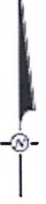

I NOT FOR CONSTRUCTION I

PARKING AND CONTAINER STORAGE
-
AREA
DUNN HAULING, REPUSUC SERVICES OF NORTH
..
""""C'AROLINA.LLC

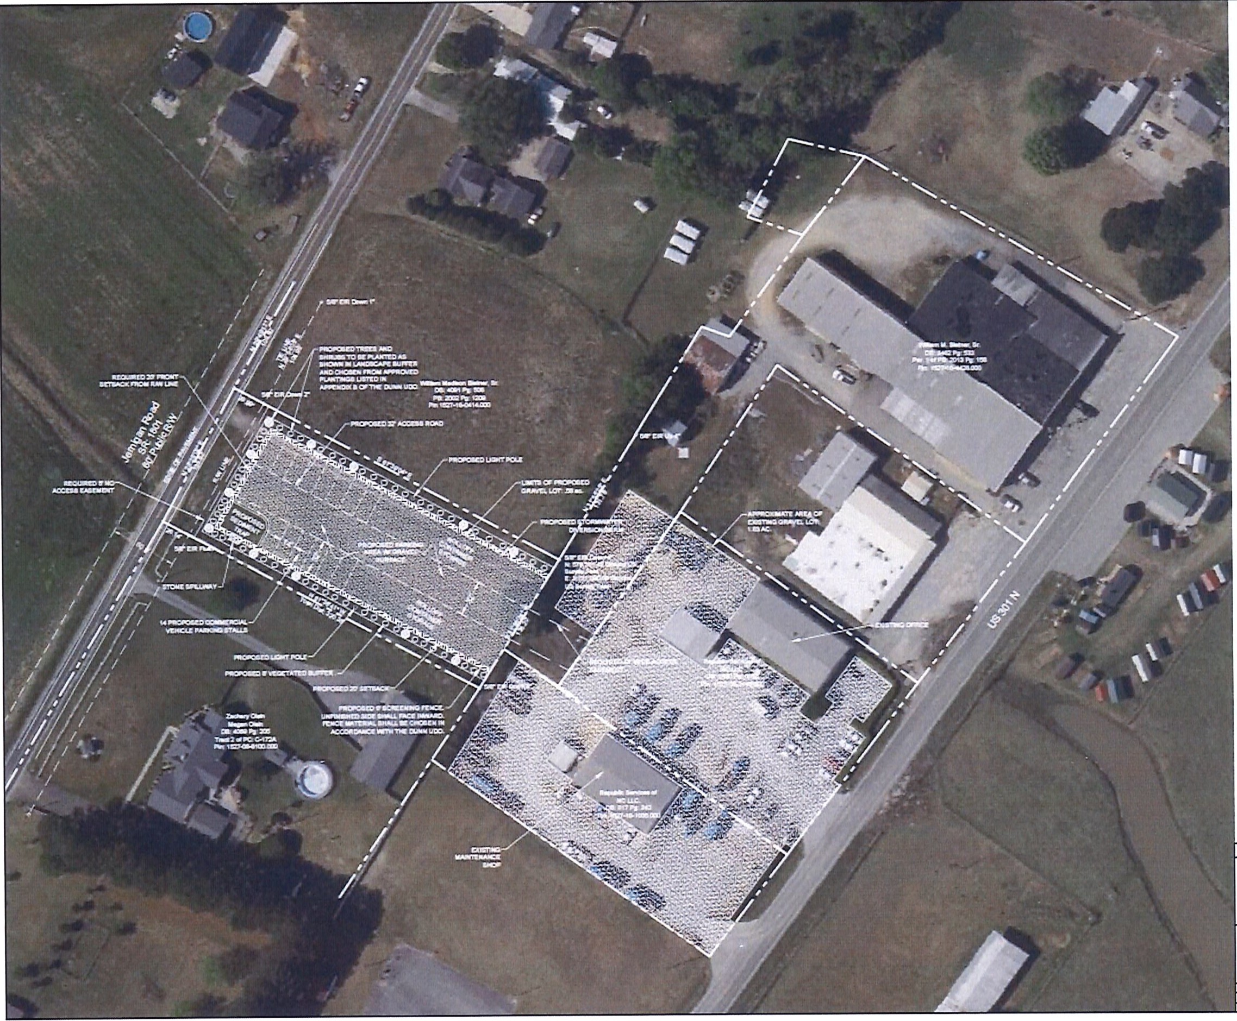
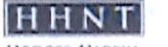
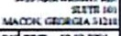

••>i-1'1.1'1 ltJl!W--"'R"..:11
-

-l◄OIX',hHAIIIU'I
'-IOl"lll"lllll'l-"f IIIIH l"C°'
1--A<o.cJ...--

SHEET 3 OF 3

EXHIBIT "B" OF CONDITIONS OF APPROVAL CONDITIONAL ZONING SITE PLAN

t. -,..o,,,,c.o.,=.S,-1-,WVn' 0'-11CI.
:. cccn.o-.r...,,.i.aim.OU'Tll.Ol:T'C u,:.,.
..- a.i:cnc.r.•A.AIC ICco,ci:cac:i

, trcn,,o ...a• ••cu:c.,. r : ,
ALl.0::lffl>CL'Tall"CSl60.'f"°1'USOC:-. f,IWJ,,WC
T0CNnT -:i AI.L

T'IC?ESGllllltlliOliUJl"'°W:-C OITIC,a,crTa •
-c=anc .tx=ll'T!IC --­ .
- " Al . -01x:11 .c:JOl'0..e1o
ttt-oac,,.'O -COC. ,Ut,:

s. wr.,,.wsc, T'tUNc,,01le) ICIW 11,,1.0,U.Qll,.Yatf'IOll'ICIXIDTll,QOl'Cll,l,TeaN,. A:iU..:-Ooo
llHU'Tll2MC1.ftcttWUKOOIICC:Ulom),Lll!ll.0.U,I,:,.
a Mt:UWT'O<,l. ,iQIIT'CCOA,IOCl l:.a;,:.,,a:
.aQ111t,1.'l':IW:: w.r,,cllllllnlTr..:JUr°"G,t:M
7 .....atWTl)Ol.ll:Cl.lattC T'ICCIIH.-::,
=::n •I.UO TttCat.QU.IIIC:Clr.'lfOll: S

,.. ue -.-.....•118w.!'T't:)....,eco11:. a:
DA--:;

a.-r:-T"O;
, :.
......

a:s;_ ,
-.::0, ,0.00IOL!IIICCOJT"..fll.
.c,.,..,-,..,x--,--a.w,.
f't.!I
-t,,olrouQC'-JILJi

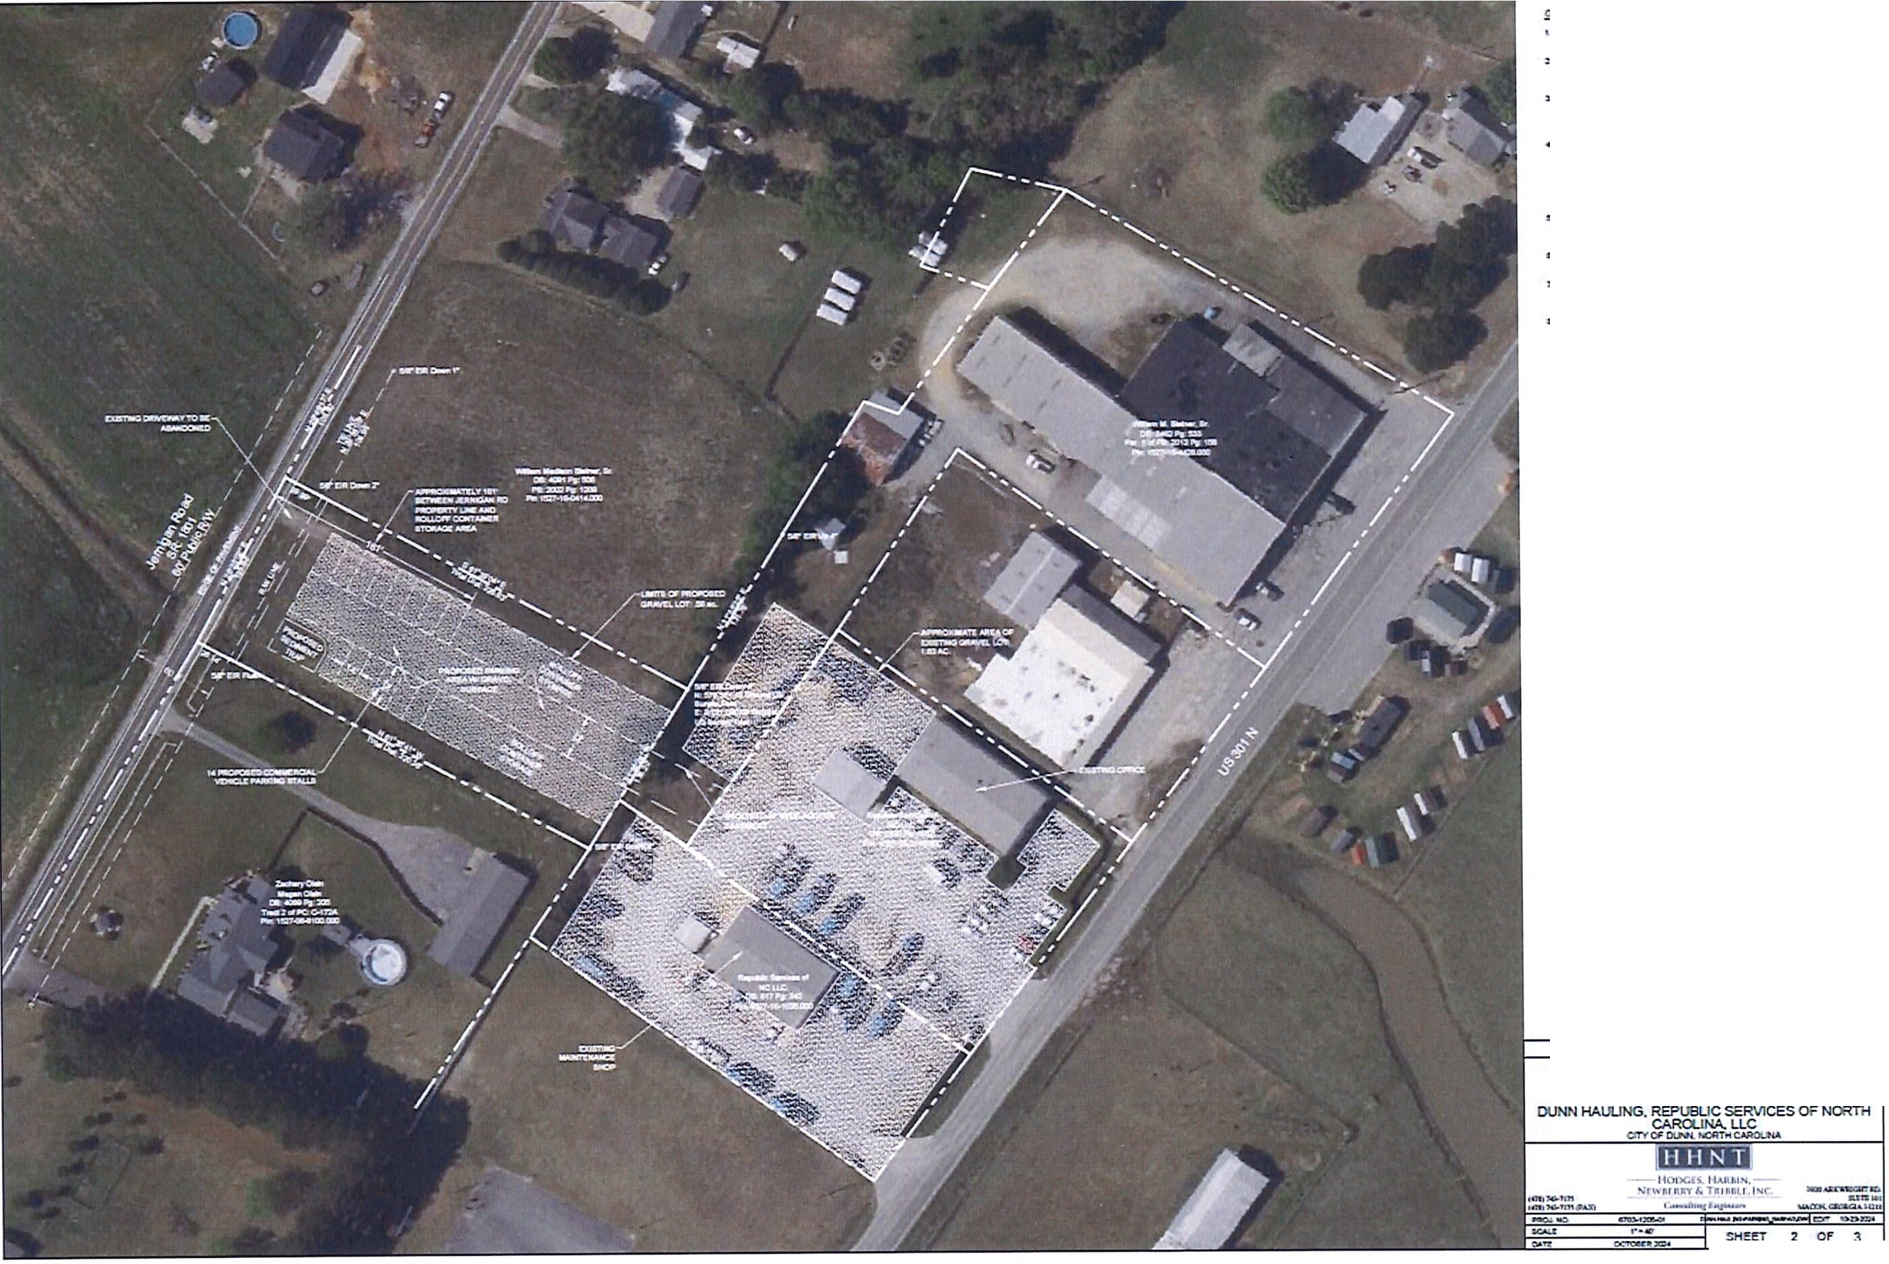
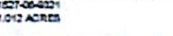


--"!, •·
LP' ICU..V.l'\.a:cf\,,UIIDC-=»Olt:lOtffO TIC Cl.-.04CTA.ttA..
l. loO MUiAJolltt..m:""'"0.- WU
Dt DUl:Ot:IT'ltl: l'C'llwrn.oMX:r:11-
1 • .ac-...a:•UCJ!fW_

INOT FOR CONSTRUCTIONI

PARKING AND CONTAINER STORAGE
AREA

SH!fT 2 Of 3

Mailing List

ADJOINING PROPERTY OWNERS
(Within 150 feet of requested change.)

NAME  - William & Joy Brown  Joyce Mclamb Trustee &  - Joyce S Mclamb Rev Trust  Zachary & Megan Olsin  - Brenda Herring Maynard  The Work Center Inc.  - c/o Johnny Hamilton  Warren Oil Company Inc.  Wendy Warren Spell  William M. Bletner Sr.  - Edward M. Best  lO. C&M Byrd Properties, LLC | MAILING ADDRESS | PIN NUMBER
 | 375 Jernigan Rd.  Dunn, NC 28334 | 1527-06--4643
 | 51 Neighbors Rd | 1527-06--6836
 | Dunn, NC 28334 | 1527-06--1362
 | 276 Jernigan Rd.  Dunn, NC 28334 | 1527-06--8100
 | 222 Jernigan Rd.  Dunn, NC 28334 | 1527-05--6995
 | 2379 US301 N  Dunn, NC 28334 | 1527-15--0900
 | 2340 US 301 N  Dunn, NC 28334 | 1527-15--1164
 | 2398 US301 N  Dunn, NC 28334 | 1527-15--6970
 | 2535 US301 N | 1527-16---4428
 | Dunn, NC28334 | 1527--16-0414
 | 386 Jernigan Rd  Dunn, NC 28334 | 1527-16--0599
 | 2491 US301 N  Dunn, NC 28334 | 1527-16--3331

- _{NORTH} _{CAROLINA} City Council Agenda Item
=DUNN

Meeting Date: December 10, 2024

SUBJECT TITLE | RZ-04-24: Rezoning requested of PIN 1527-82-6665.000, address 402 George Perry Lee Rd. The current zoning is Industrial 1-100. The requested zoning is R-20.
PRESENTER/DEPARTMENT | Samantha Wullenwaber, Deputy Executive Director  & Local Government Services Director, Mid-Carolina COG
ATTACHMENT(S) | Rezoning Application, Staff Report and attachments.
PUBLIC HEARING PUBLISH DATES I | November 22nd & November 29th, 2024

PURPOSE:

- Public Hearing: A public hearing will be held to review and make a final decision on a Rezoning request. The subject parcel is PIN 1527-82-6665.000 at address 402 George Perry Lee Rd in Dunn's ETJ.
- Decision: BACKGROUND:
A Rezoning application was submitted by property owner James Sherrill Sewell to rezone his property at 402 George Perry Lee Rd in Dunn's ETJ from Industrial (1-100) to Residential (R-20). The property is currently split-zoned and partially located in Dunn's zoning jurisdiction and partially located in Harnett County's zoning jurisdiction. Only the property located in Dunn's jurisdiction will be rezoned if the requested rezoning is granted.

BUDGET IMPACT: None

Motion to approve or deny case RZ-04-24.
RECOMMENDED MOTION/ ACTION REQUESTED OF COUNCIL

IICITY OF
WP.

CITY COUNCIL MOTION SHEET

City Council Meeting December 10, 2024

Rezoning Petition: RZ-04-24

Zoning request RZ-04-24 is inconsistent with the adopted City of Dunn Land Use Plan, however the rezoning request is reasonable given the following:
- The amendment, though small-scale, is reasonable based upon surrounding conditions. Land uses surrounding this development are primarily residential and a residential use is existing on the parcel.

- The impact on the adjacent property owners and surrounding community and the benefits of the rezoning outweigh any potential inconvenience or harm to the community.

- The amendment is warranted due to changing conditions in the area. The intended use of the parcel is not changing, though the zoning is currently Industrial 1-100.

Rr.i1DUNN  PLANNING AND INSPECTIONS  102 N Powell Ave • PO Box 1065 • Dunn, North Carolina 28335 (910) 230-3505 • CityofDunn.ore | City Council Staff Report Rezoning Case: RZ-04-24  Planning Board Meeting: December 3, 2024  Location: 402 George Perry Lee Road; PIN 1527-82-6665
Request: 1-100 to R-20
This is a request to rezone 1.37+/- of the 2.01+/- acre tract containing the address 402 George Perry Lee Road. The parcel is currently located in the 1-100 Industrial District in Dunn's jurisdiction and COMM Commercial District in Harnett County's jurisdiction. The requested zoning is R-20 Residential to allow for Residential Development of a single-family detached structure. A dwelling is currently on site and will be torn down. A new dwelling with a different footprint is proposed which does not meet the requirements of the nonconformities section of the Dunn UDO given the current Industrial zoning of the parcel.

[ Property Information:
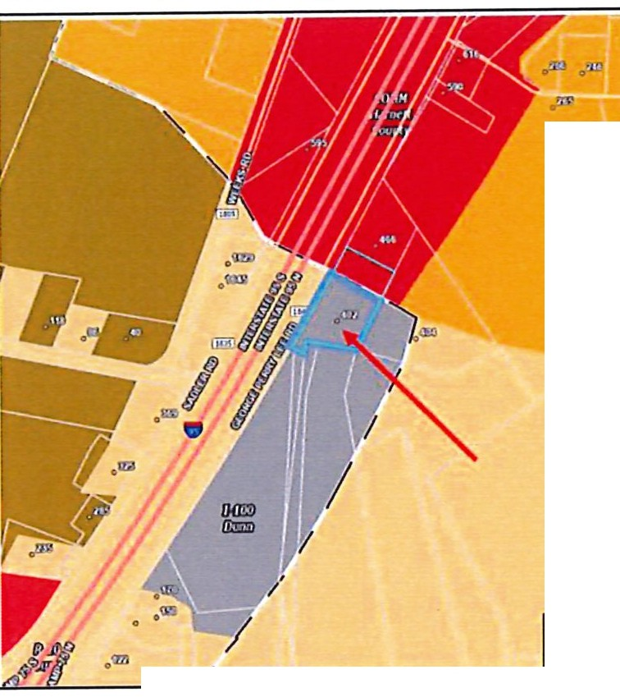

OWNER/APPLICANT: James S. Sewell (Owner/Applicant)
-.w:
.fy,!.
ADDRESS/LOCATION: Refer to Location and Zoning Map. ==
P.I.N.(s): ^{lllro1171}
lidef•
1527-82-6665.000

SIZE: The parcel total acreage is 2.01+/-, the
request is for 1.37+/- of that acreage. ·.""'
.-
EXISTING ZONING: The subject parcel is currently zoned 1-
100. The 1-100 permits all the industrial, =
manufacturing, wholesaling and
warehousing operations permitted in ·""
the 1-1O district, but permits those with fewer dimensional restraints.
Existing Zoning Map
EXISTING LAND USE: I
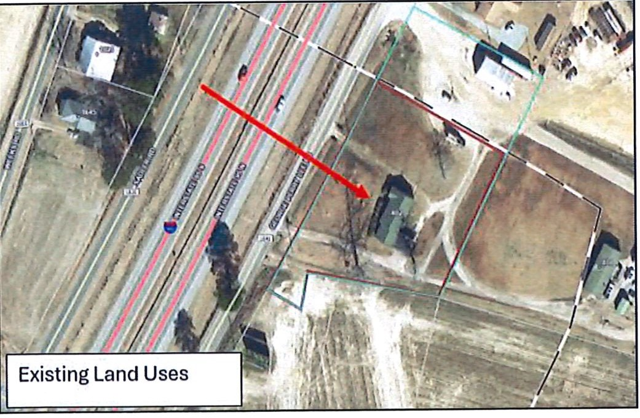
The subject parcel currently holds a 1,153 square foot single family residence.

SURROUNDING LAND USE:

North: Vacant, Cleared land

East: Residential, farm and wooded lands

West: Interstate 95

South: Farmland

DEVELOPMENT REVIEW:
Should the rezoning request be approved, the request for residential construction of a new 1,600 square foot single dwelling can proceed through the review processes as required by the City of Dunn.

DIMENSIONAL PROVISIONS FOR REQUESTED DISTRICT:

Minimum Standard | 1-100 (Existing Zoning) | R-20 (Requested Zoning)
Front Yard Setback | 50 feet | 30 feet
Secondary Front/Street Side | 50feet | 30 feet
Side Yard Setback | 30 feet | 10 feet
Rear Yard Setback | 50 feet | 25 feet
Lot Area | 100,000 square feet | 20,000 square feet
Lot Width | 300 linear feet | 75 linear feet
Maximum Impervious Surface | 50% | 30%

DEVELOPMENT POTENTIAL:

Existing Zoning (1-100) Proposed Zoning (R-20)
1 residential unit 1 residential unit

FUTURE LAND USE PLAN CLASSIFICATION:
CITY OF DUNN

The future land use classification of the property is "Highway Commercial," as illustrated in Future Land Use Map. The proposed rezoning request is
inconsistent with the adopted Land Use Plan.

1 l ll 111. L\'.'.11 l Sf' \Ill'
!',.=:::! "1
,..
c;..,•, .._l'w\_,
----,' -"p'""----'r,w.,.-....., ,
ro-..i .. _
..
··---
-....·,.J......_,._c.n..n..o,-._ ,.-..__.i.. _
--"-,-

Highway Commercial: These areas feature larger­ scale commercial uses, oriented along major thoroughfares and junctions that serve a local and regional market. This area includes retail, lodging, and services in multi-tenant developments often anchored by a large retailer or employer. While generally automobile oriented, efforts should be made to provide pedestrian and vehicle connectivity between parcels to avoid access related congestion. Light industry and multi-family developments may also be appropriate.
L
l...i.t\,11>, & Cynidoro

Jt-p&1.alhol

,-
. 0 □[_ --°.".,

Associated plan goals and policies that may be considered include the following:

Policy 1 of the Future Land Use Plan:
Manage future growth and encourage quality development through implementation of the Strategic Vision Plan, the Land Use Plan, the Unified Development Ordinance (UDO), and other plans and regulations adopted by City Council.

Policy 1.2:

Policy 1.5:
Support residential development at varying densities based on the Future Land Use Map, associated character area descriptions, and other relevant plans.

Encourage residential growth development in areas already served by utilities and services.

IMPACTS ON LOCAL INFRASTRUCTURE AND FACILITIES

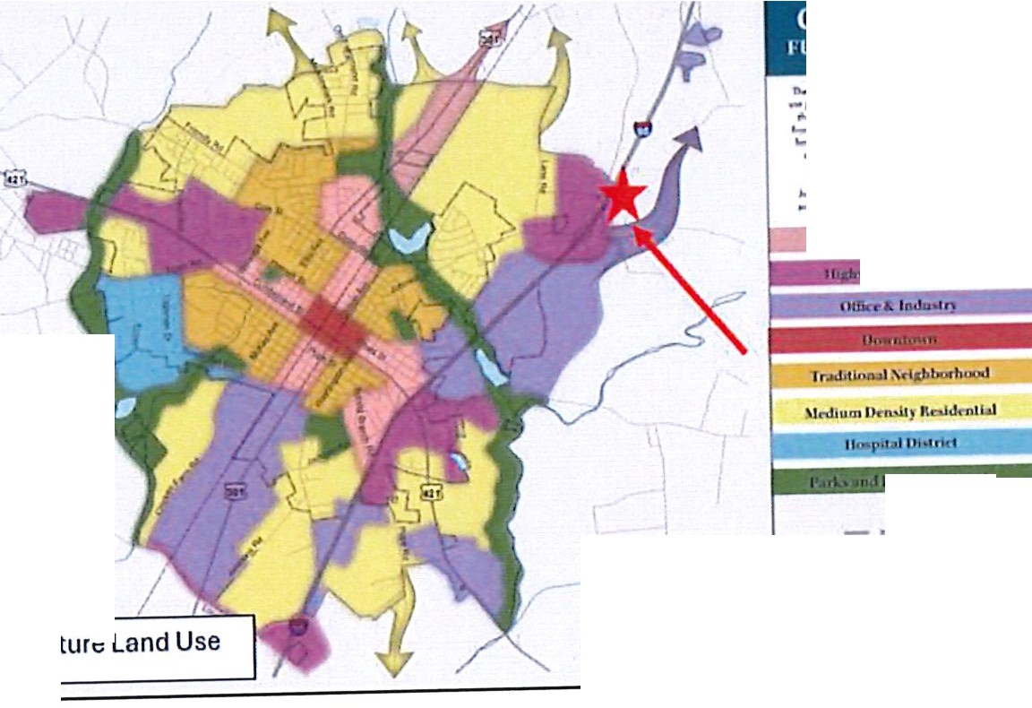
UTILITIES: TRAFFIC:
CONDITIONS OF APPROVAL:
Water and sewer service is not needed for this development.

This development will not generate additional traffic per the applicant.

The request is a standard rezoning and does not have applicable conditions.

f ZONING ANALYSIS:
IZl Yes 0 No The amendment, if small scale, is reasonable based upon surrounding conditions.
REASONING:
The amendment, though small-scale, reasonable based upon surrounding conditions. Land uses surrounding this development are primarily residential and the residential use was already existing on the parcel.

IZl Yes 0 No The impact to the adjacent property owners and the surrounding community is reasonable, and the benefits of rezoning outweigh any potential inconvenience or harm to the community.
REASONING:
The impact on the adjacent property owners and surrounding community and the benefits of the rezoning outweigh any potential inconvenience or harm to the community.

IZl Yes D No The amendment is warranted due to changed or changing conditions in the area.
REASONING:
The amendment is warranted due to changing conditions in the area. The intended use of the parcel is not changing, though the zoning is now 1-100.

D Yes IZl No The amendment achieves the purpose and is consistent with the Land Use Plan.
REASONING:

The Future Land Use Map identifies this site within a Highway Commercial area. Rezoning to R-20 is inconsistent with the Future Land Use Map. This amendment does not achieve the purpose of and is partially inconsistent with both the Land Use Map and the Future Land Use Plan's

STAFF RECOMMENDATION:

In Case RZ-04-24, Planning staff recommends approval of the rezoning requestfrom 1-100 Industrial District to R-20 Residential District as the current use of the property is residential and compatible and in harmony with the surrounding area. Staff finds the request is inconsistent with the City of Dunn's Future Land Use Plan which details a vision for "Gateways & Corridors" at this location and will recommend a three-part motion to substantiate the request. Staff also finds that the request is reasonable and in the public interest, as it is compatible with the surrounding land uses and zoning.

Attachments: Legal Ad Mailing List Application

jNOTICE OF PUBLIC HEARINGS
NOTICE IS HEREBY GIVEN that PUBLIC MEETINGS regarding two (2) Rezoning Applications will be held by a PUBLIC HEARING by the CITY COUNCIL OF THE CITY OF DUNN on December 10 at 6:30 P.M. in the COURTROOM of the DUNN MUNICIPAL BUILDING located at 401 EAST BROAD STREET for the purpose of considering the following items:

CONDITIONAL REZONING APPLICATION CZ-08-24
Republic Services of North Carolina, LLC (Applicant) William M.(Owner)
Parcel containing 330 Jernigan Road
PIN: 1527-06-9321.000
This is a request to rezone 1 {1) parcel containing 1.0 +/- acres on Jernagan Road. The parcel has a zoning of R-20 Residential District. The proposed rezoning is C-3/CZ Highway Commercial District Conditional Zoning to allow for Republic Services of North Carolina to expand their existing site fronting US HWY 301.

CONVENTIONAL REZONING APPLICATION RZ-04·24
James Sewell (Applicant/Owner)
A portion of the parcel containing 402 George Perry Lee Road
PIN: 1527-82-6665.000
This is a request to rezone 1.37+/- of the 2.01+/- acre tract containing the address 402 George Perry Lee Road. The parcel has zonings of 1-100 Industrial District and COMM Commercial District in Harnett County jurisdiction. The proposed rezoning is R-20 Residential District to allow for Residential Development of a single family detached structure. A dwelling is currently on site and will be torn down and rebuilt.

Copies of proposed items are available for review at the DEPARTMENT OF PLANNING during normal business hours Monday through Friday. Written comments may be addressed to:
CITY OF DUNN PLANNING DEPARTMENT
P.O. BOX 1065
DUNN, NC 28335

ADVERTISE:
November 29, 2024
December 6, 2024

Mailing List
Owner - TEW DAWN B & BROADWELL DANIEL ODELL
Mailing Address - 466 GEORGE PERRY LEE RD DUNN, NC 28334

Owner - DIXIELAND TIMBER COMPANY LLC
Mailing Address - 684 ALDERMAN MILL RD DUNN, NC 28334-7105

Owner - SWJ JOHNSON FARM LLC
Mailing Address - 140 WEST FRANKLIN ST UNIT 711 CHAPEL HILL, NC 27516

Owner - ROYAL CAROLYN MICHELE ET AL & JACKSON EMMA ANN ET AL
Mailing Address - 27 HUNTER CIR LITTLETON, NC 27850-9347

Owner - NC DEPARTMENT OF TRANSPORTATION
Mailing Address - 1546 MAIL SERVICE CENTER RALEIGH, NC 27611

Owner - NC DEPARTMENT OF TRANSPORTATION
Mailing Address - 1546 MAIL SERVICE CENTER RALEIGH, NC 27611

Owner - FOUR OAKS INVESTMENT LLC
Mailing Address - PO BOX 309 ZEBULON, NC 27597

Owner - RT RENTALS LLC
Mailing Address - 804 BEAMAN ST CLINTON, NC 28328

Owner - MAY ROGER T
Mailing Address - 101 CHELSEA LANE DUNN, NC 28334-0000

Owner - RT RENTALS LLC
Mailing Address - 804 BEAMAN ST CLINTON, NC 28328

Owner - RT RENTALS LLC
Mailing Address - 804 BEAMAN ST CLINTON, NC 28328


CITY OF
DUNN


lWr£cwl
NORTH CAROLINA
For Planning Department Use Only Case Number -------
Date Received -------
FeePaid -------
Board Meeting -------
City Council Meeting -------
REZONING APPLICATION

OWNERSHIP INFORMATION:
. IJJV/12 $ 5. 5µ0-!Cl/ /J ,/,
Applicant: -:u---------- Phone Number: ('/ (} )1_91 9 4-I1
Applicant's Legal Interest in Property: twr fa-{ /.ft>ftt,e., f1J fa,C Wt1- • f3¼. (f

lf,D .enrj
f<'fr UL flJ. 1J ai1n ,IC!}8JJ

Applicant's Address:
..._1\1\ ,) t t £AA) ,µ,l •
Property Owner: • · ). J

Owner's Address:
lf/J :J- Cr-UJr e • fe«') l«- JZ!.
- !A;trt. rJl 'J8JJ

Date Property Acquired: / q 8
Deed Reference: Bookl{/ 0() Page/ 9J1

Tax PIN Number),;'J'J_ b'1 oo
Size (Sq. Ft. or Acres) /. '17 Street Frontage (ft)_
Location/Address: lfd'(}., t:; r'f fr,r;t 1ld. J>p--- NC )-8'5'?'-/

Attach a legal description (Metes and Bollllds Description) of the area requested.

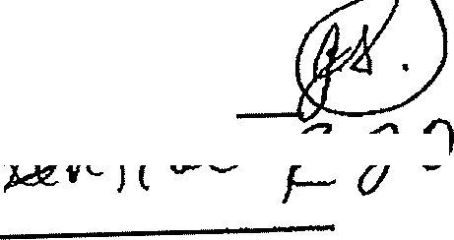
ZONING REQUEST:
  - Existing Zoning: :(A &U )fri().(

Requested Zoning: _ f Jl!j
" ·"'C Ii f:'1---/

_., ..:. _
  - Land Uses: ,,0w.f I Li'tr
    - Existing land uses on property to be rezoned: ---=-------""'---------

    - Existing or proposed land uses on all adjoining properties:
Vw )l1J
fal lrL((}Ald

North East
Vw-& tlillfr
South West
:£ 1<

2
  - Statement of Justification: (City Code, Article II of Section 22)
The proposed zone shall be greater than three (3) acres of land or... if smaller, the property adjoins and is contiguous to two (2) zoning districts after the proposed change.

Attach a statement justifying the requested map change based upon the following:
- The amendment, if smaU scale, is reasonable based upon smrnunding conditions.
- The impact of zoning is in the public interest and does not significantly harm the surrounding properties.
- The amendment is warranted due to changed or changing conditions in the area.
- The amendment achieves the purpose and is consistent with the Land Use Plan.
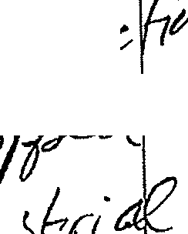
. t fuJ/1'1.e,., w .v;, ;;;,... ft..,,_ I Cf &o'5
tvrvl Vl1V:, t( dt.-1;.e /{_,/"t _( 11'-e,c,
'utftu_. Now /1-t- VLa ft/le, l<l 1,v
() p,1'j af fl f!C 1 61M' /J_ f;0 j<;
-fo f'((Jb c&f1 g-6 I , f 1<-4-rM
VJ lo &, 'ro &u,f t,JtU 5
'?-
fo f'Df<M1-; vruc{ ,11£i:lrr"

4
ADJOINING PROPERTY OWNERS
(WITHIN 100 FEET OF REQUESTED CHANGE)

NAME |  | MAILING ADDRESS | . | PINNUMBER
l. vaw11.- /J. f  1) a.11,/e ( --&-13 ,eti |  | if&& o/- P-er17 t  1)tt ii"- /\I{_ JB111 I\ , | l rJ_BJ- _1gt, oo
2.1),k,-e/ r;  f¼/Jt1/ , LlG |  | {J i Lf AI{/Jµ._fYl 4- IYlilL f6•(  f)lAfi ,Jt:--IJ1d sl( | /')th- g _1j{(J ooo
3. | - | - | ₋₋₋ - - .000
4. | - | - | - - - .000
5. | - | - | -- - - .000
6. | - | - | --- - - .000
7. |  | - | --- - - .000
8. | - | - | --- - - .000
9. | - | - | --- - - .000
10. | - | - | --- - - .000
11. | - | - | - - - .000
12. | - | - | --- - - .000

5

OWNER'S CERTIFICATION

I (We) do he1by certify that:

I am (We are) the owners or authorized agent of the prope1ty described in this application for rezoning and have attached copies of deed, title reports or other documents as proof of ownership.

I (We) have read the rezoning procedures, requirements and have truthfully completed this application for rezoning.

I (We) understand that the filing fees are non-refundable; the process to review rezoning cases includes public hearings and review by both the Planning board and the City Council. I (We) understand that any action to approve our request is at the discretion of the Planning Board and the City Council and additional requirements may be imposed as determined necessary.
di_ >. at , a -1.2.-2 t. l
V Signature Date

Swom to and subscribed before me this 2:2 nd day of rJ()4-c> bQ.r , 20 1.,1,(

Notary Public • "- My Commission Expires: lor \;) - d-


RECOMMENDED MOTION/ACTION REQUESTED OF COUNCIL

_{NORTH} _{CAROLINA} City Council Agenda Item
miDlJNN

Meeting Date: December 10, 2024
SUBJECT TITLE | Consideration of Ordinance to Demolish - 125 Spring Branch Road. (PIN# 1516-74-5198.000)
PRESENTER/DEPARTMENT | Assistant City Manager, Billy Godwin and Code Administrator, John Ganus
ATTACHMEN!( | Demolition Memorandum & Ordinance to Demolish
PUBLIC HEARING PUBLISH DATES I | November 29, 2024 / December 3, 2024

I

PURPOSE:
- Public Hearing: Consideration of Ordinance to Demolish Dilapidated Structure - (PIN# 1516-74- 5198.000). The Public Hearing was advertised on November 29, 2024 and December 3, 2024
- Purpose: Code Administrator, John E. Ganus, has conducted an inspection at 125 Spring Branch Road based upon his observations, the structure is unsafe, dilapidated and uninhabitable.
The owner of the property has failed to comply with Code Administrators order and according to
N.C.G.S. 1600-1123 the City Council has the power to proceed with the demolition of this property.
Should Council decide to proceed with the demolition of the structure at 125 Spring Branch Road an ordinance would need approval directing the Code Administrator to remove or demolish said structure.
BACKGROUND:
On March 21, 2023, the Housing Standards case was opened on the above property concerning the conditions of the structure and the living conditions. A request for inspection was issued and the inspection was scheduled on April I0, 2023. The owner did not show for the inspection. A second inspection request was scheduled for June 26, 2023, with no response from the owner. A potential buyer called but the sale did not happen. The structure is considered dilapidated, unsafe and uninhabitable in its present condition and was downgraded by the Harnett County Tax office as an outbuilding valued at $1,270.00. On April 15, 2024, an inspection was conducted with an Administrative Inspection Wan-ant. The structure had been gutted out and is structurally unsafe. A Complaint and Notice of Hearing was issued for May 27, 2024, by Certified and First-Class mailing with a copy posted on the structure. The Certified mailing was received by the owner on May I, 2024, per the USPS. The First-Class mailing was not returned. A Hearing was held to determine the fitness for human habitation of the dwelling, but the owners did not attend. Following the hearing, a Finding of Fact and Order was issued by Certified and First-Class mail with a copy posted on the structure. The Certified mailing was returned "Unclaimed" and the First-Class mailing was not returned. The Order required the owners to bring the structure into compliance with the City of Dunn Minimum Housing Code by demolishing the structure by a date not later than September 29, 2024. To date the owners have not complied with the order of the Code Administrator.

The Vacant, severely dilapidated structure poses hazards to the health and safety of the community due to defects increasing the potential for accidents and fires.

BUDGET IMPACT: None

Motion to adopt the ordinance directing the Code Administrator to proceed with the demolition of the structure located at 125 Spring Branch Road (PIN#1516-74- •••,........
5198.000)

imlDlJNN
PLANNING AND INSPECTIONS
102 N Powell Ave • PO Box 1065 • Dunn, North Carolina 28335 (910) 230-3505 • CityofDunn.org

MEMORANDUM

TO: FROM: DATE: RE:
Mayor, City Council, and Town Manager John E. Ganus, Code Administrator October 14, 2024
Request adoption of an Ordinance to Demolish and Remove the Dilapidated Dwelling at 125 Spring Branch Road (PIN - 1516-74-5198.000), Case# HC-23-02

BACKGROUND:
On March 21, 2023, the Housing Standards case was opened on the above property concerning the conditions of the structure and the living conditions. A request for inspection was issued and the inspection was scheduled on April 10, 2023. The owner did not show for the inspection. A second inspection request was scheduled for June 26, 2023, with no response from the owner. A potential buyer called but the sale did not happen. The structure is considered dilapidated, unsafe and uninhabitable in its present condition and was downgraded by the Hamett County Tax office as an outbuilding valued at $1,270.00. On April 15, 2024, an inspection was conducted with an Administrative Inspection Warrant. The structure had been gutted out and is structurally unsafe. A Complaint and Notice of Hearing was issued for May 27, 2024, by Certified and First-Class mailing with a copy posted on the structure. The Certified mailing was received by the owner on May 1, 2024, per the USPS. The First-Class mailing was not returned. A Hearing was held to determine the fitness for human habitation of the dwelling, but the owners did not attend. Following the hearing, a Finding of Fact and Order was issued by Certified and First-Class mail with a copy posted on the structure. The Certified mailing was returned "Unclaimed" and the First-Class mailing was not returned. The Order required the owners to bring the structure into compliance with the City of Dunn Minimum Housing Code by demolishing the structure by a date not later than September 29, 2024. To date the owners have not complied with the order of the Code Administrator.
PROBLEM:
The vacant, severely dilapidated structure poses hazards to the health and safety of the community due to defects increasing the potential for accidents and fire.

FINDINGS AND CONCLUSIONS:
The dilapidated structure is vacant and continues to deteriorate. The property was determined to be substandard in that it is only 33' wide by 143' depth consisting of 0.108 acres or 4,719 square feet. The total assessed value of the building is $1,270, per the county tax office.

It appears the owner has not intended to comply with the Order; therefore, it is recommended that the following Ordinance directing the Code Administrator to demolish and remove the dilapidated structure be adopted by the Council.

1(}/2ere communi{_J 0B_Jins!

POLICY IMPLICATIONS:
None.

FINANCIAL IMPACT:
It is unknown what the cost of demolition and clearance will be, however, a competitive bid process will be used to obtain the lowest responsible bid. Funds for such demolition and clearance are provided in the City budget. All related costs will constitute a lien against the real property.

CHECKLIST OF WHO HAS REVIEWED:
Steven Neuschafer, City Manager Billy Godwin, Assistant City Manager Slater Johnson, Building Inspector 3
Stephen Hodges, Code Enforcement Officer John E Ganus, Code Administrator

OWNERS OF RECORD
Stacey Harper 3916 Morvan Way
Raleigh, North Carolina 27612-3728

- A HEARING WAS HELD ON MARCH 25, 2024 IN REFERANCE TO THE STRUCTURE LOCATED AT 410 SOUTH FAYETTEVILLE AVENUE. AT SAID HEARING, EVIDENCE WAS GIVEN TO SHOW THAT THE PROPERTY IS IN VIOLATION OF THE CITY OF DUNN MINIMUM HOUSING CODE AND N.C.G.S. 160D-ARTICLE 12. AN ORDER WAS ALSO PLACED TO OWNER WINGED WARRIOR LLC, TO REPAIR OR DEMOLISH SAID STRUCTURE. TO DATE NO RESPONSE HAS BEEN MADE. THEREFORE, IT WILL GO BEFORE THE CITY OF DUNN COUNCIL TO ADOPT AN ORDINACE TO HAVE THE STRUCTURE REMOVED AND ALL COST INCURRED BE A LIEN AGAINST THE PROPERTY.

ALL PERSONS DESIRING TO BE HEARD EITHER FOR OR AGAINST THE PROPOSED ITEM(S) SET FORTH ABOVE ARE REQUESTED TO BE IN ATTENDANCE AT THE TIME AND DATE STATED ABOVE.

JOHN E. GANUS HOUSING INSPECTOR CITY OF DUNN

Advertise:
November 29, 2024 and December 3, 2024

LEGAL NOTICE
NOTICE IS HEREBY GIVEN THAT THE CITY COUNCIL OF THE CITY OF DUNN, NORTH CAROLINA, UNDER AUTHORITY OF CHAPTER 160D, SECTION 601 OF THE GENERAL STATUTES OF NORTH CAROLINA, WILL HOLD A PUBLIC HEARING AT 6:30 P.M. ON DECEMBER 10, 2024 IN THE COURTROOM OF THE DUNN MUNICIPAL BUILDING LOCATED AT 401 E. BROAD ST.

THE FOLLOWING ITEMS WILL BE DISCUSSED:

PUBLIC HEARING:

  - A HEARING WAS HELD ON JUNE 24, 2024 IN REFERANCE TO THE STRUCTURE LOCATED AT 125 SPRING BRANCH ROAD. AT SAID HEARING, EVIDENCE WAS GIVEN TO SHOW THAT THE PROPERTY IS IN VIOLATION OF THE CITY OF DUNN MINIMUM HOUSING CODE AND
N.C.G.S. 160D-ARTICLE 12. AN ORDER WAS ALSO PLACED TO OWNER STACEY HARPER, TO DEMOLISH SAID STRUCTURE. TO DATE NO RESPONSE HAS BEEN MADE. THEREFORE, IT WILL GO BEFORE THE CITY OF DUNN COUNCIL TO ADOPT AN ORDINACE TO HAVE THE STRUCTURE REMOVED AND ALL COST INCURRED BE A LIEN AGAINST THE PROPERTY.

  - A HEARING WAS HELD ON MARCH 11, 2024 IN REFERANCE TO THE STRUCTURE LOCATED AT 824 EAST DIVINE STREET. AT SAID HEARING, EVIDENCE WAS GIVEN TO SHOW THAT THE PROPERTY IS IN VIOLATION OF THE CITY OF DUNN MINIMUM HOUSING CODE AND
N.C.G.S. 160D-ARTICLE 12. AN ORDER WAS ALSO PLACED TO OWNER ZELM LLC C/O LEE ALEXANDER BROWN, TO REPAIR OR DEMOLISH SAID STRUCTURE. TO DATE NO RESPONSE HAS BEEN MADE. THEREFORE, IT WILL GO BEFORE THE CITY OF DUNN COUNCIL TO ADOPT AN ORDINACE TO HAVE THE STRUCTURE REMOVED AND ALL COST INCURRED BE A LIEN AGAINST THE PROPERTY.

  - A HEARING WAS HELD ON JULY 23, 2024 IN REFERANCE TO THE STRUCTURE LOCATED AT 407 WEST JOHNSON STREET. AT SAID HEARING, EVIDENCE WAS GIVEN TO SHOW THAT THE PROPERTY IS IN VIOLATION OF THE CITY OF DUNN MINIMUM HOUSING CODE AND
N.C.G.S. 160D-ARTICLE 12. AN ORDER WAS ALSO PLACED TO OWNER JOSE JUAN CORREA, TO REPAIR OR DEMOLISH SAID STRUCTURE. TO DATE NO RESPONSE HAS BEEN MADE. THEREFORE, IT WILL GO BEFORE THE CITY OF DUNN COUNCIL TO ADOPT AN ORDINACE TO HAVE THE STRUCTURE REMOVED AND ALL COST INCURRED BE A LIEN AGAINST THE PROPERTY.

CITY OF DUNN
401 East Broad Street
Dunn, North Carolina 28334
-Verses­
STACEY HARPER
3916 Morvan Way
Raleigh, North Carolina 27612-3728
File Number: HC-23-02

Ordinance

AN ORDINANCE DIRECTING THE CODE ADMINISTRATOR TO REMOVE OR DEMOLISH THE PROPERTY HEREIN DESCRIBED AS UNFIT FOR HUMAN HABITATION AND DIRECTING THAT A NOTICE BE PLACED THEREON THAT THE SAME MAY NOT BE OCCUPIED
WHEREAS, the City Council of the City of Dunn finds that the structure described herein is unfit for human habitation under the City Minimum Housing Code and that all of the procedures of the Minimum Housing Code have been complied with; and
WHEREAS, this dwelling should be removed or demolished as directed by the Code Administrator and should be placarded by placing thereon a notice prohibiting use for human habitation; and WHEREAS, the owner of this structure has been given a reasonable opportunity to bring the structure up to the standards of the City of Dunn Minimum Housing Code in accordance with NCGS 160D Article 12 pursuant to an order issued by the Code Administrator on June 24, 2024 and the owner has failed to comply with the Order;
NOW, THEREFORE, BE IT ORDAINED by the City Council of the City of Dunn, that:
Section 1. The owner of such building(s), dwelling(s) and premises is hereby ordered to vacate any occupants and/or personal property therein on or before December 29, 2024.
Section 2. The Code Administrator is hereby authorized and directed to place placards containing the legend:

"This building is unfit for human habitation. The use or occupation of this building for human habitation is prohibited and unlawful."

on the building located at the following address:
125 Spring Branch Road, (PIN - 1516-74-5198.000)

Section 3. The Code Administrator is hereby authorized and directed to proceed to remove or demolish the above-described strncture in accordance with his order to the owner thereof dated the 24th day of June 2024, the City of Dunn Minimum Housing Code, and NCGS 160D, Article 12;
Section 4. (a) The cost of removal or demolition shall constitute a lien against the real property upon which the cost was incurred, as well as any other real property of the owner located within the city limits or within one mile thereof except for the owner's primary residence. The lien shall be filed in the office of the Clerk of the Court, and shall have the same priority and be collected in the same manner as the lien for special assessments in Article 10 of NCGS Chapter 160A;
(b) Upon completion of the required removal or demolition, the Code Administrator shall sell the materials of the dwelling and credit the proceeds against the cost of removal or demolition. The Code Administrator shall certify the remaining balance to the Tax collector. If a surplus remains after the sale of the materials and satisfaction of the cost ofremoval or demolition, the Code Administrator shall deposit the surplus in the Superior Court where it shall be secured and disbursed in the manner provided by NCGS 160D, Article 12.
Section 5. It shall be unlawful for any person to remove or cause to be removed the placard from any building to which it is affixed. It shall likewise be unlawful for any person to occupy or to permit the occupancy of any building therein declared to be unfit for human habitation.
Section 6. This Ordinance shall become effective upon its adoption.

ADOPTED this day of , _

William P. Elmore Jr., Mayor
ATTEST:

Melissa M Matti, City Clerk



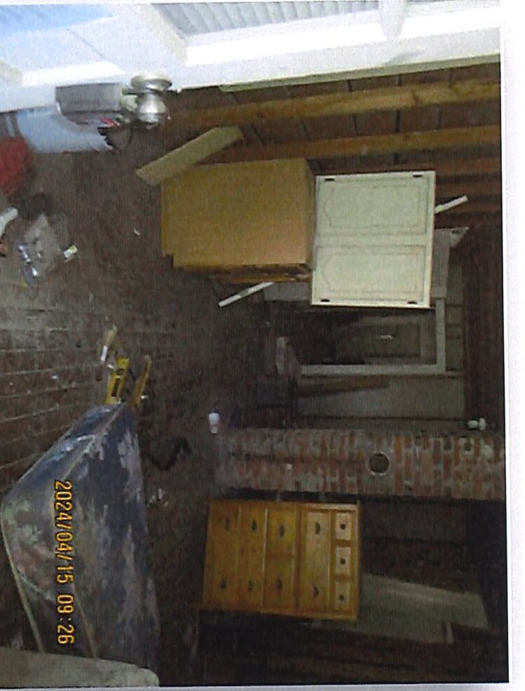
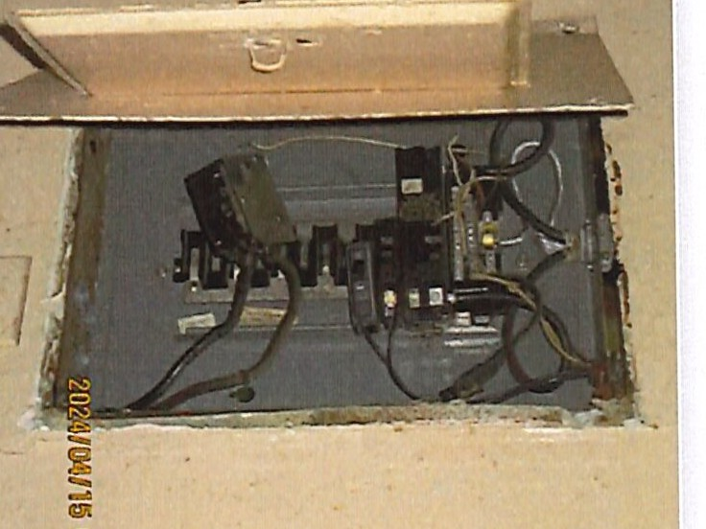
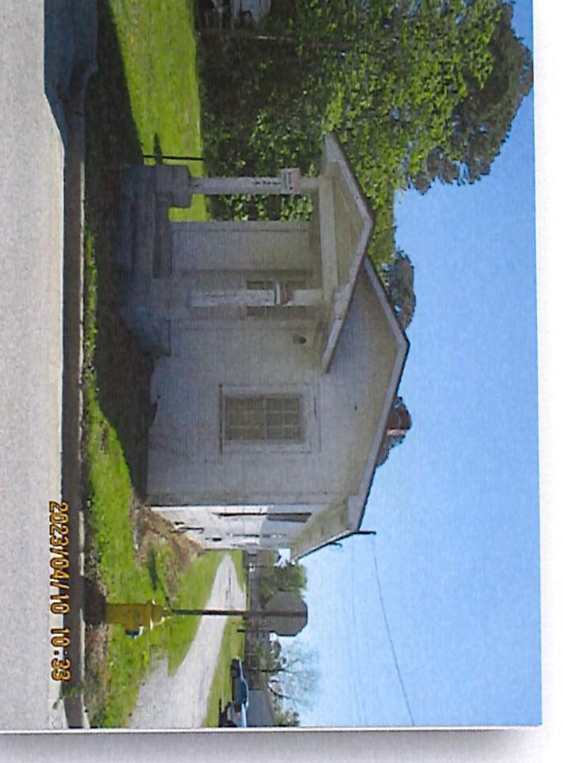
I\)
c.n
CJ)
'O
-·
""I:
::::s
00.
c:,
'"'I:
!l)
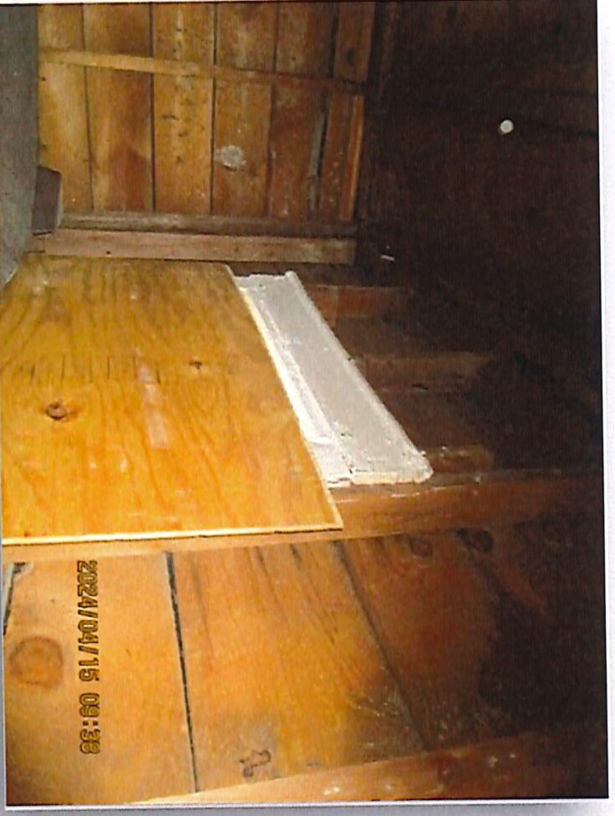
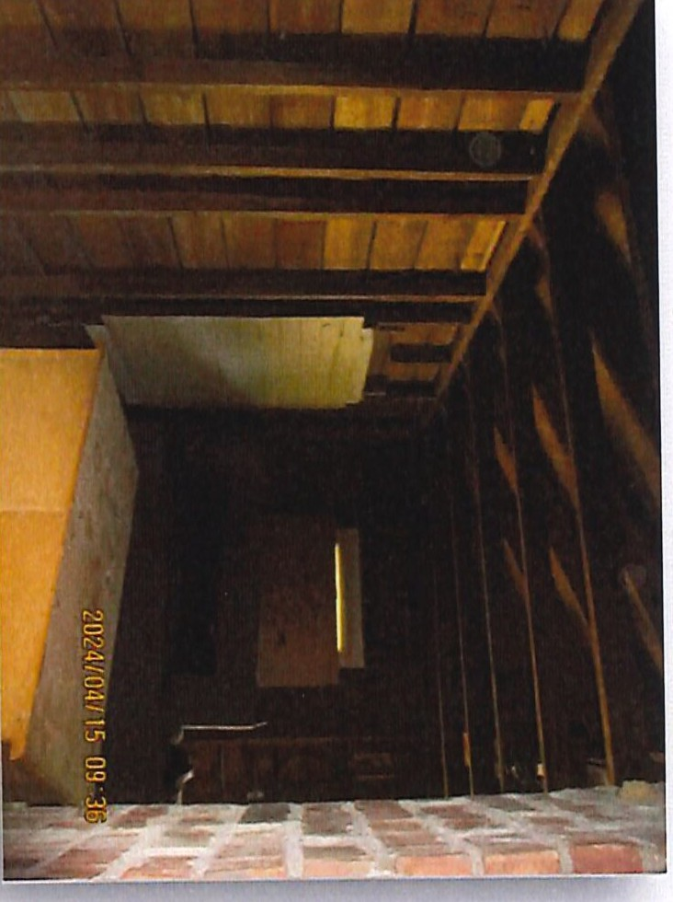
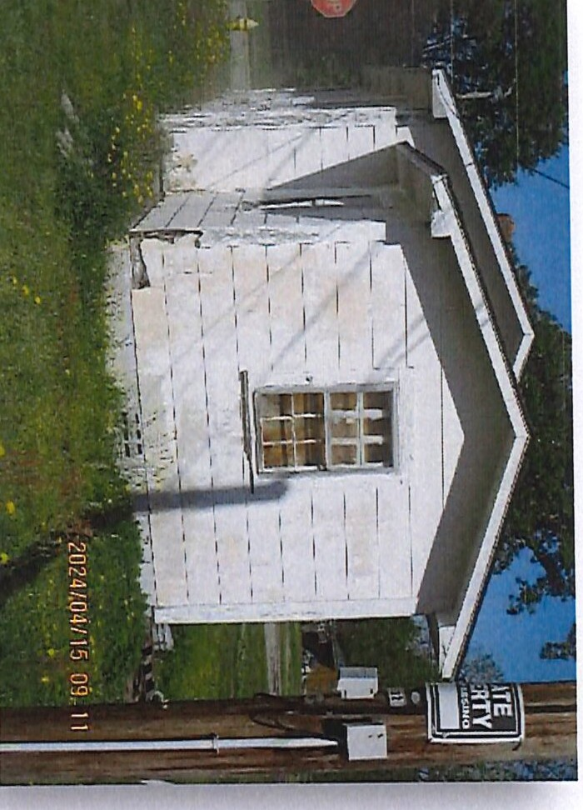
::::s
(')
:::r
=a
0
!l)
0..

11/26/24, 9:50AM Harnett County Parcel Report

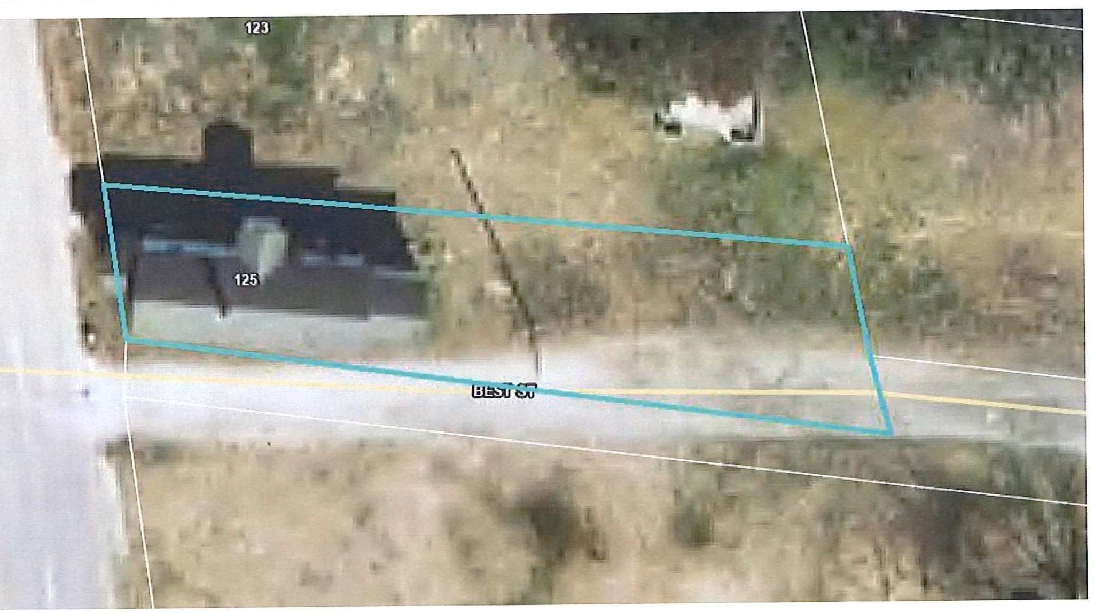
I
Harnett
J( COUNTY
Harnett County: GIS
,- NORTH C/,ROll/lA
PIO: 02151612170035 01
PIN: 1516-74-5198.000
Building Value: $0
Parcel Outbuilding Value: $1270
Account Number: 1500001408
Parcel Land Value: 10450
Owner: HARPER STACEY
Mailing Address: 3916 MORVAN WAY RALEIGH, NC 27612-3728
Physical Address: 125 SPRING BRANCH RD DUNN, NC 28334 ac Description: LOT#15 RICHARD BEST S/D 33X143
Market Value: $11720
Surveyed/Deeded Acreage: 1
Deferred Value: $0
Total Assessed Value: $11720
Zoning: SINGLE FAMILY - 0.1 acres (100.0%)
Zoning Jurisdiction: Dunn
Calculated Acreage: 0.1
Wetlands: No
Deed Date: 1299474000000
Deed Book/Page: 2844 - 0420
Plat(Survey) Book/Page: - Last Sale: 2011 - 3
FEMA Flood: Minimal Flood Risk Within 1ml of Agriculture District: No Elementary School: Dunn Elementary
Middle School: Dunn Middle
Sale Price: $20000
High School: Triton High
Qualified Code: Q
Fire Department: Dunn
Vacant or Improved: V Transfer of Split: T Actual Year Built:
Heated Area : SqFt
EMS Department: Medic 15,015 EMS Law Enforcement: Dunn Police
Voter Precinct: East Averasboro
County Commissioner: Barbara McKay
Building Count: O
School Board Member: Sharon Gainey
I

https://gis.harnett.org/E911App/Parcels/ParcelReport.aspx?pin=1516-74-5198.000 1/1

r.mlDlJNN
- _{NORTH} _{CAROLINA} City Council Agenda Item

Meeting Date: December 10, 2024
SUBJECT TITLE | Consideration of Ordinance to Demolish - 824 E,Divine  Street. (PIN# 1516-84-4796.000)
PRESENTER/DEPARTMENT | Assistant City Manager, Billy Godwin and Code Administrator, John Ganus
ATTAC!fMENT(S) | Demolition Memorandum & Ordinance to Demolish
PUBLIC HEARING PUBLISH DATES I | November 29, 2024 / December 3, 2024

I

PURPOSE:
- Public Hearing: Consideration of Ordinance to Demolish Dilapidated Structure - (PIN# 1516-84- 4796.000). The Public Hearing was advertised on November 29, 2024 and December 3, 2024
- Purpose: Code Administrator, John E. Ganus, has conducted an inspection at 824 E Divine Street based upon his observations, the structure is unsafe, dilapidated and uninhabitable.
The owner of the property has failed to comply with Code Administrators order and according to
N.C.G.S. 160D-1123 the City Council has the power to proceed with the demolition of this property.
Should Council decide to proceed with the demolition of the structure at 824 E Divine Street an ordinance would need approval directing the Code Administrator to remove or demolish said structure.
BACKGROUND:
On March 21, 2023, the Housing Standards case was opened on the above property concerning the conditions of the structure and the living conditions. A request for inspection was issued and the inspection was scheduled on April 10, 2023. The owner called and requested the inspection be postponed until April 24, 2023, as he is out of town until just prior to that date. During the inspection, it was observed that the structure was vacant, and the owners had conducted various activities of demolition, and it was an open shell. The structure is considered dilapidated, unsafe and uninhabitable in its present condition. The owner requested a delay in the hearing as he would be out of town for a short while and then would obtain the required permits. Agreed to delay for a while. A Complaint and Notice of Hearing was issued for November 13, 2023, by Certified and First-Class mailing with a copy posted on the structure. The Certified and the First-Class mailings were both returned as "Attempted/Not Known". On February 20, 2024, after confirmation ofa new mailing address, a Complaint and Notice of Hearing was issued for March 11, 2024, by Certified and First-Class mailing with a copy posted on the structure. The Ce1tified mailing was returned as "Unclaimed" and the First-Class mailing was not returned. A Hearing was held to determine the fitness for human habitation of the dwelling, but the owners did not attend. Following the hearing, a Finding of Fact and Order was issued by Certified and First-Class mail with a copy posted on the structure. The Certified mailing and the First-Class mailing were not returned. The Order required the owners to bring the structure into compliance with the City of Dunn Minimum Housing Code by repairing, altering, improving, or vacating and demolishing the structure by a date not later than July 7, 2024. To date the owners have not complied with the order of the Code Administrator and there is of work being completed without any current permits. The last active permits were issued in 2016.
The Vacant, severely dilapidated structure poses hazards to the health and safety of the community due to defects increasing the potential for accidents and fires.
BUDGET IMPACT: None

RECOMMENDED
MOTION/ACTION | Motion to adopt the ordinance directing the Code Administrator to proceed with the
REQUESTED OF | demolition of the structure located at 824 E Divine Street (PIN#1516-84-4796.000)
COUNCIL

lnDlJNN '
PLANNING AND INSPECTIONS
102 N Powell Ave • PO Box 1065 • Dunn, North Carolina 28335 (910) 230-3505 • CityofDunn.org

MEMORANDUM

TO: FROM: DATE: RE:
Mayor, City Council, and Town Manager John E. Ganus, Code Administrator October 14, 2024
Request adoption of an Ordinance to Demolish and Remove the Dilapidated Dwelling at 824 East Divine Street (PIN - 1516-84-4796.000), Case# HC-23-03

BACKGROUND:
On March 21, 2023, the Housing Standards case was opened on the above property concerning the conditions of the structure and the living conditions. A request for inspection was issued and the inspection was scheduled on April 10, 2023. The owner called and requested the inspection be postponed until April 24, 2023, as he is out of town until just prior to that date. During the inspection, it was observed that the structure was vacant, and the owners had conducted various activities of demolition, and it was an open shell. The structure is considered dilapidated, unsafe and uninhabitable in its present condition. The owner requested a delay in the hearing as he would be out of town for a short while and then would obtain the required permits. Agreed to delay for a while. A Complaint and Notice of Hearing was issued for November 13, 2023, by Certified and First-Class mailing with a copy posted on the structure. The Ce1iified and the First-Class mailings were both returned as "Attempted/Not Known". On February 20, 2024, after confirmation of a new mailing address, a Complaint and Notice of Hearing was issued for March 11, 2024, by Ce1iified and First-Class mailing with a copy posted on the structure. The Certified mailing was returned as "Unclaimed" and the First-Class mailing was not returned. A Hearing was held to determine the fitness for human habitation of the dwelling, but the owners did not attend. Following the hearing, a Finding of Fact and Order was issued by Ce1iified and First-Class mail with a copy posted on the structure. The Ce1iified mailing and the First-Class mailing were not returned. The Order required the owners to bring the structure into compliance with the City of Dunn Minimum Housing Code by repairing, altering, improving, or vacating and demolishing the structure by a date not later than July 7, 2024. To date the owners have not complied with the order of the Code Administrator and there is of work being completed without any current permits. The last active pe1mits were issued in 2016.

PROBLEM:
The vacant, severely dilapidated structure poses hazards to the health and safety of the community due to defects increasing the potential for accidents and fire.

FINDINGS AND CONCLUSIONS:
The dilapidated structure is vacant and continues to deteriorate. The total assessed value of the building is $39,982 per the county tax office. The estimated cost of repairs exceeds $24,000 for HVAC system, a bathroom, a kitchen, basic appliances, flooring, sheetrock. total replacement of the plumbing or electrical materials minus installation. The actual cost of all repairs is estimated in excess of the reasonable cost percentage of 50% of the present value of this structure.
1Uhere communit3 kl8!Jjnsl

It appears the owner has not intended to comply with the Order; therefore, it is recommended that the following Ordinance directing the Code Administrator to demolish and remove the dilapidated structure be adopted by the Council.

POLICY IMPLICATIONS:
None.

FINANCIAL IMPACT:
It is unknown what the cost of demolition and clearance will be, however, a competitive bid process will be used to obtain the lowest responsible bid. Funds for such demolition and clearance are provided in the City budget. All related costs will constitute a lien against the real property.

CHECKLIST OF WHO HAS REVIEWED:
Steven Neuschafer, City Manager Billy Godwin, Assistant City Manager Slater Johnson, Building Inspector 3
Stephen Hodges, Code Enforcement Officer John E Ganus, Code Administrator

OWNERS OF RECORD
Zelm LLC & Co.
c/o Lee Alexander Brown 105 Wade Avenue
Dunn, North Carolina 28334

LEGAL NOTICE
NOTICE IS HEREBY GIVEN THAT THE CITY COUNCIL OF THE CITY OF DUNN, NORTH CAROLINA, UNDER AUTHORITY OF CHAPTER 160D, SECTION 601 OF THE GENERAL STATUTES OF NORTH CAROLINA, WILL HOLD A PUBLIC HEARING AT 6:30 P.M. ON DECEMBER 10, 2024 IN THE COURTROOM OF THE DUNN MUNICIPAL BUILDING LOCATED AT 401 E. BROAD ST.

THE FOLLOWING ITEMS WILL BE DISCUSSED:

PUBLIC HEARING:

- A HEARING WAS HELD ON JUNE 24, 2024 IN REFERANCE TO THE STRUCTURE LOCATED AT 125 SPRING BRANCH ROAD. AT SAID HEARING, EVIDENCE WAS GIVEN TO SHOW THAT THE PROPERTY IS IN VIOLATION OF THE CITY OF DUNN MINIMUM HOUSING CODE AND
N.C.G.S. 160D-ARTICLE 12. AN ORDER WAS ALSO PLACED TO OWNER STACEY HARPER, TO DEMOLISH SAID STRUCTURE. TO DATE NO RESPONSE HAS BEEN MADE. THEREFORE, IT WILL GO BEFORE THE CITY OF DUNN COUNCIL TO ADOPT AN ORDINACE TO HAVE THE STRUCTURE REMOVED AND ALL COST INCURRED BE A LIEN AGAINST THE PROPERTY.

- A HEARING WAS HELD ON MARCH 11, 2024 IN REFERANCE TO THE STRUCTURE LOCATED AT 824 EAST DIVINE STREET. AT SAID HEARING, EVIDENCE WAS GIVEN TO SHOW THAT THE PROPERTY IS IN VIOLATION OF THE CITY OF DUNN MINIMUM HOUSING CODE AND
N.C.G.S. 160D-ARTICLE 12. AN ORDER WAS ALSO PLACED TO OWNER ZELM LLC C/O LEE ALEXANDER BROWN, TO REPAIR OR DEMOLISH SAID STRUCTURE. TO DATE NO RESPONSE HAS BEEN MADE. THEREFORE, IT WILL GO BEFORE THE CITY OF DUNN COUNCIL TO ADOPT AN ORDINACE TO HAVE THE STRUCTURE REMOVED AND ALL COST INCURRED BE A LIEN AGAINST THE PROPERTY.
- A HEARING WAS HELD ON JULY 23, 2024 IN REFERANCE TO THE STRUCTURE LOCATED AT 407 WEST JOHNSON STREET. AT SAID HEARING, EVIDENCE WAS GIVEN TO SHOW THAT THE PROPERTY IS IN VIOLATION OF THE CITY OF DUNN MINIMUM HOUSING CODE AND
N.C.G.S. 160D-ARTICLE 12. AN ORDER WAS ALSO PLACED TO OWNER JOSE WAN CORREA, TO REPAIR OR DEMOLISH SAID STRUCTURE. TO DATE NO RESPONSE HAS BEEN MADE. THEREFORE, IT WILL GO BEFORE THE CITY OF DUNN COUNCIL TO ADOPT AN ORDINACE TO HAVE THE STRUCTURE REMOVED AND ALL COST INCURRED BE A LIEN AGAINST THE PROPERTY.

- A HEARING WAS HELD ON MARCH 25, 2024 IN REFERANCE TO THE STRUCTURE LOCATED AT 410 SOUTH FAYETTEVILLE AVENUE. AT SAID HEARING, EVIDENCE WAS GIVEN TO SHOW THAT THE PROPERTY IS IN VIOLATION OF THE CITY OF DUNN MINIMUM HOUSING CODE AND N.C.G.S. 160D-ARTICLE 12. AN ORDER WAS ALSO PLACED TO OWNER WINGED WARRIOR LLC, TO REPAIR OR DEMOLISH SAID STRUCTURE. TO DATE NO RESPONSE HAS BEEN MADE. THEREFORE, IT WILL GO BEFORE THE CITY OF DUNN COUNCIL TO ADOPT AN ORDINACE TO HAVE THE STRUCTURE REMOVED AND ALL COST INCURRED BE A LIEN AGAINST THE PROPERTY.
ALL PERSONS DESIRING TO BE HEARD EITHER FOR OR AGAINST THE PROPOSED ITEM(S) SET FORTH ABOVE ARE REQUESTED TO BE IN ATTENDANCE AT THE TIME AND DATE STATED ABOVE.

JOHN E. GANUS HOUSING INSPECTOR CITY OF DUNN

Adve1iise:
November 29, 2024 and December 3, 2024

CITY OF DUNN
401 East Broad Street
Dunn, North Carolina 28334
-Verses­
Zelm LLC & Co.,
c/o Lee Alexander Brown
105 Wade Avenue
Dunn, North Carolina 28334
File Number: HC-23-03

Ordinance

AN ORDINANCE DIRECTING THE CODE ADMINISTRATOR TO REMOVE OR DEMOLISH THE PROPERTY HEREIN DESCRIBED AS UNFIT FOR HUMAN HABITATION AND DIRECTING THAT A NOTICE BE PLACED THEREON THAT THE SAME MAY NOT BE OCCUPIED

WHEREAS, the City Council of the City of Dunn finds that the structure described herein is unfit for human habitation under the City Minimum Housing Code and that all of the procedures of the Minimum Housing Code have been complied with; and
WHEREAS, this dwelling should be removed or demolished as directed by the Code Administrator and should be placarded by placing thereon a notice prohibiting use for human habitation; and WHEREAS, the owner of this structure has been given a reasonable opportunity to bring the structure up to the standards of the City of Dunn Minimum Housing Code in accordance with NCGS 160D Article 12 pursuant to an order issued by the Code Administrator on April 1, 2024 and the owner has failed to comply with the Order;
NOW, THEREFORE, BE IT ORDAINED by the City Council of the City of Dunn, that:
Section 1. The owner of such building(s), dwelling(s) and premises is hereby ordered to vacate any occupants and/or personal property therein on or before December 29, 2024.
Section 2. The Code Administrator is hereby authorized and directed to place placards containing the legend:

"This building is unfit for human habitation. The use or occupation of this building for human habitation is prohibited and unlawful.11
on the building located at the following address:
824 East Divine Street (PIN - 1516-84-4796.000)

Section 3. The Code Administrator is hereby authorized and directed to proceed to remove or demolish the above-described structure in accordance with his order to the owner thereof dated the 1st day of April 2024, the City of Dunn Minimum Housing Code, and NCGS 160D, Article 12; Section 4. (a) The cost of removal or demolition shall constitute a lien against the real property upon which the cost was incurred, as well as any other real property of the owner located within the city limits or within one mile thereof except for the owner's primary residence. The lien shall be filed in the office of the Clerk of the Court, and shall have the same priority and be collected
in the same manner as the lien for special assessments in Article 10 ofNCGS Chapter 160A;
(b) Upon completion of the required removal or demolition, the Code Administrator shall sell the materials of the dwelling and credit the proceeds against the cost of removal or demolition. The Code Administrator shall certify the remaining balance to the Tax collector. If a surplus remains after the sale of the materials and satisfaction of the cost ofremoval or demolition, the Code Administrator shall deposit the surplus in the Superior Court where it shall be secured and disbursed in the manner provided by NCGS 160D, Article 12.
Section 5. It shall be unlawful for any person to remove or cause to be removed the placard from any building to which it is affixed. It shall likewise be unlawful for any person to occupy or to permit the occupancy of any building therein declared to be unfit for human habitation.
Section 6. This Ordinance shall become effective upon its adoption.

ADOPTED this day of _

William P. Elmore Jr., Mayor
ATTEST:

Melissa R. Matti, City Clerk

11/26/24, 9:51 AM Harnett County Parcel Report

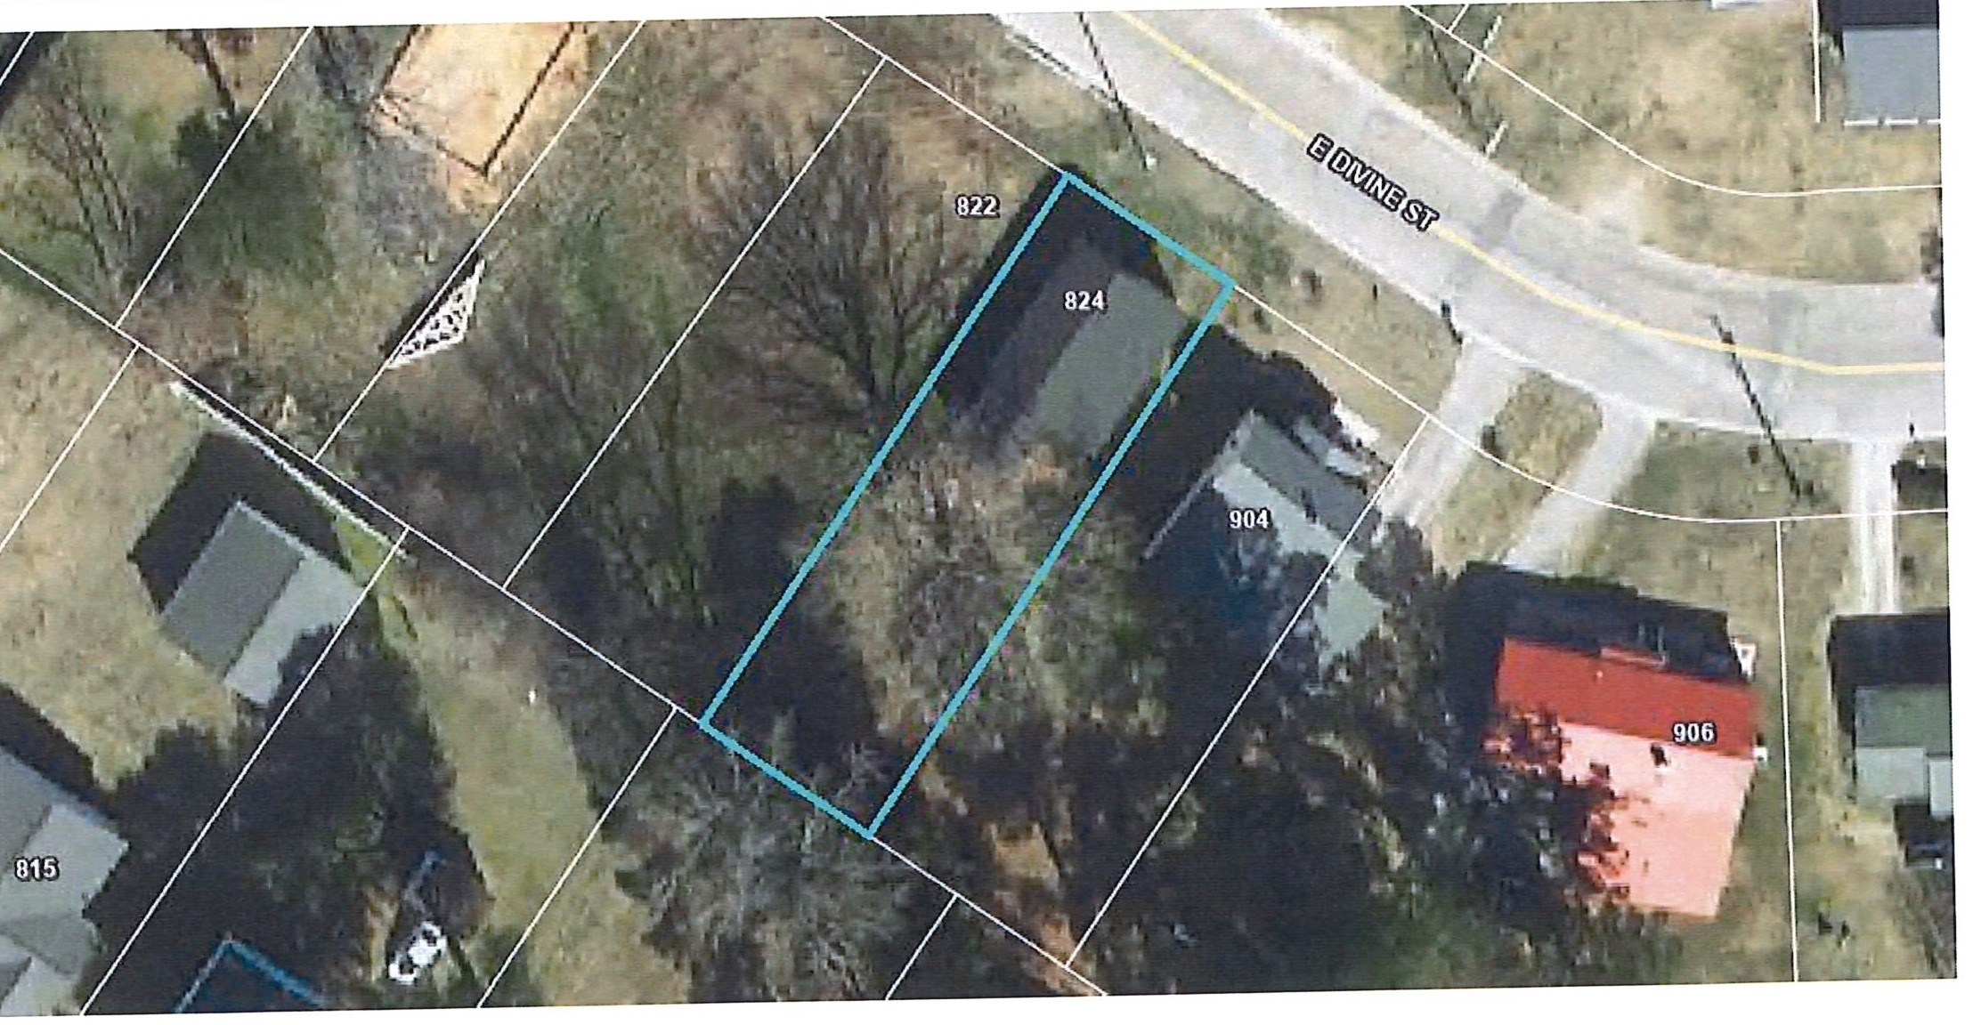
Harnett
(' COUNTY
,,l..
Harnett County: GIS
ORHI C/,ROllllA
PID: 02151612110006
Building Value: $39982
PIN: 1516-84-4796.000
Parcel Outbuilding Value: $0
Account Number: 1500019006
Parcel Land Value: 13300
Owner: ZELM LLC & C/O LEE ALEXANDER BROWN Mailing Address: 105 WADE AVE DUNN, NC 28334-2633
Physical Address: 824 E DIVINE ST DUNN, NC 28334 ac
Market Value: $53282 Deferred Value: $0
Total Assessed Value: $53282
Description: 50X140 1 LOT 824 EAST DIVINE ST
Zoning: SINGLE FAMILY- 0.14 acres (100.0%)
Surveyed/Deeded Acreage: 1
Calculated Acreage: 0.14
Zoning Jurisdiction: Dunn
Wetlands: No
Deed Date: 1460610000000
Deed Book/Page: 3392 - 0397
FEMA Flood: Minimal Flood Risk
Within 1mi of Agriculture District: No
Plat(Survey) Book/Page: -
Elementary School: Dunn Elementary
Last Sale: 2016 - 4
Middle School: Dunn Middle
Sale Price: $49000
High School: Triton High
Qualified Code: A
Vacant or Improved: I Transfer of Split: T
Fire Department: Dunn
EMS Department: Medic 15, 015 EMS Law Enforcement: Dunn Police
Actual Year Built: 1930
Voter Precinct: East Averasboro
Heated Area : 1010 SqFt
County Commissioner: Barbara McKoy
BuildIng Count: 1
School Board Member: Sharon Gainey

https://gis.harnett.org/E911App/Parcels/ParcelReport.aspx?pin=1516-84-4796.000 1/1

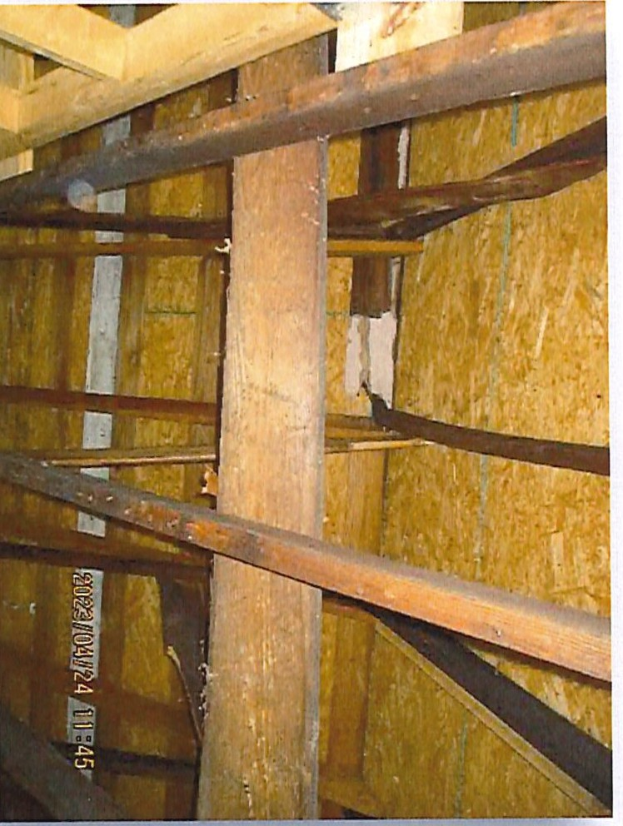
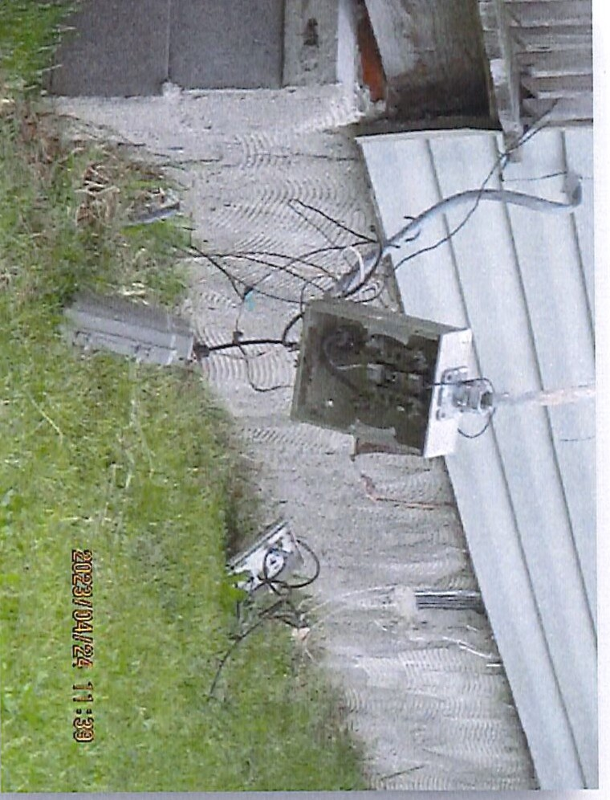
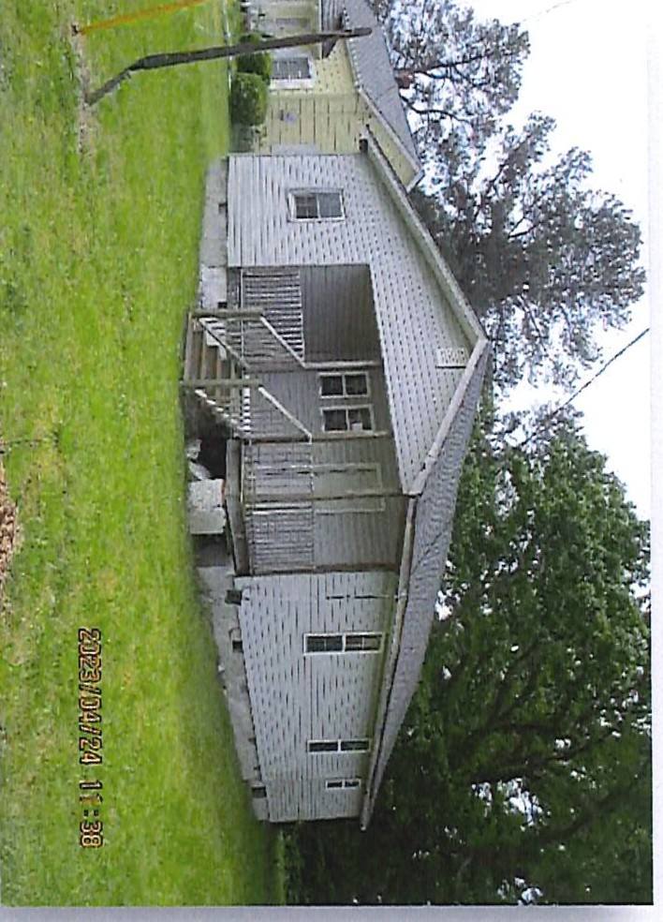
co
I\)
.i::a,.
m
ll>
(/)
r+
^{C}-·
-·
<
::::s
(1)
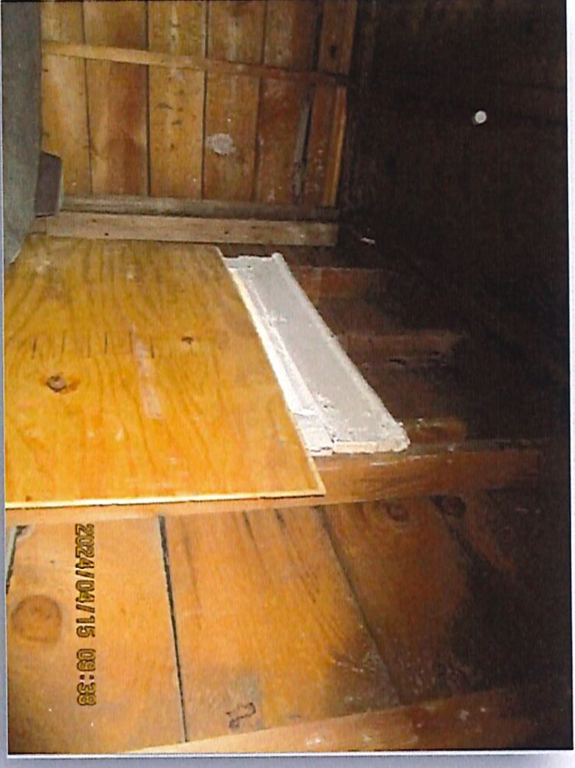
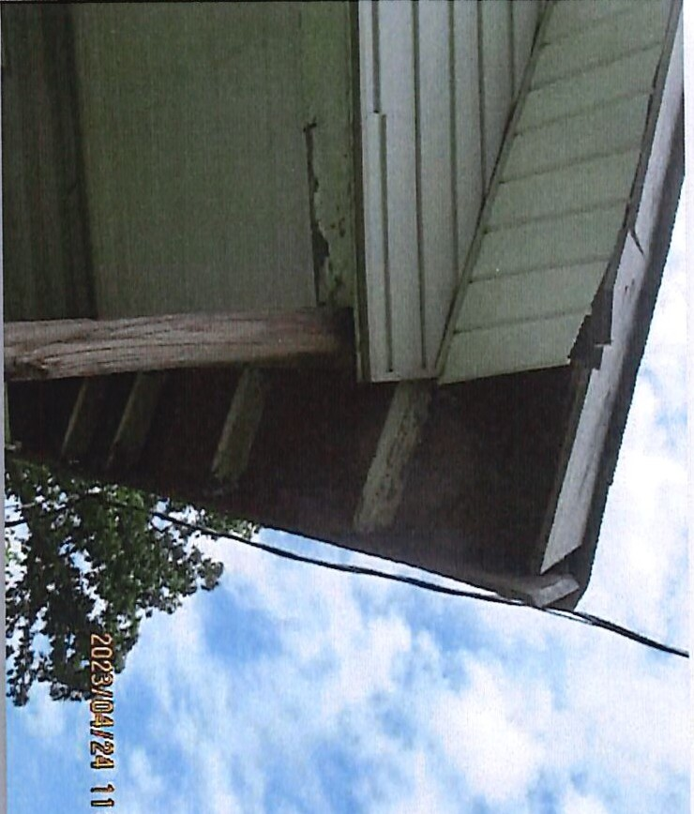
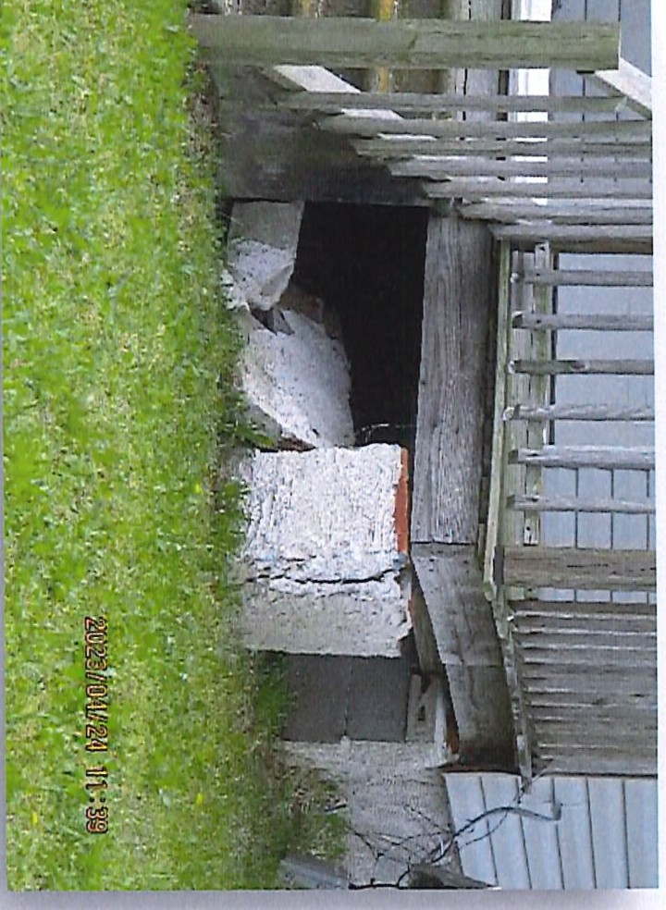
en

"
r+
"C""D
CD
r+

- _{NORTH} _{CAROLINA} City Council Agenda Item
DUNN

Meeting Date: December 10, 2024 .
SUBJECT TITLE | Consideration of Ordinance to Demolish - 407 W Johnson Street. (PIN# 1516-69-3809.000)
PRESENTER/DEPARTMENT | Assistant City Manager, Billy Godwin and Code Administrator, John Ganus
ATTAG_HMENT(S) | Demolition Memorandum & Ordinance to Demolish
PUBLIC HEARING PUBLISH DATES | November 29, 2024 / December 3, 2024

I
I

PURPOSE:
- Public Hearing: Consideration of Ordinance to Demolish Dilapidated Structure - (PIN# 1516-69- 3809.000). The Public Hearing was advertised on November 29, 2024 and December 3, 2024
- Purpose: Code Administrator, John E. Ganus, has conducted an inspection at 407 W Johnson Street
based upon his observations, the structure is unsafe, dilapidated and uninhabitable.

The owner of the property has failed to comply with Code Administrators order and according to
N.C.G.S. 160D-1123 the City Council has the power to proceed with the demolition of this property.

Should Council decide to proceed with the demolition of the structure at 407 W Johnson Street an ordinance would need approval directing the Code Administrator to remove or demolish said structure.
BACKGROUND:
On April 10, 2023, the Housing Standards case was opened on the above property concerning the conditions of the structure, fire damage to the roof, and the unsafe living conditions. A request for inspection was issued and the inspection was scheduled for November 13, 2023. The owner did not show for the inspection. Later research found that the owner had submitted an engineer's letter, applied for permits and failed multiple inspections by the County Building Inspections department. A second attempt for an inspection was on June 24, 2024, and the owner did not show again. Observations of the house showed that the structure had been gutted and it was determined to be dilapidated, unsafe and uninhabitable in its present condition.
A Complaint and Notice of Hearing was issued for July 23, 2024, by Certified and First-Class mailing, with a copy posted on the structure. The Ce1tified mailing was received by the owner on June 27, 2024, per the USPS. The First­ Class mailing was not returned. A Hearing was held to determine the fitness for human habitation of the dwelling, and the owners were in attendance. At the completion of the hearing, the Finding of Fact and Order was issued to the owner in person. The Order required the owners to bring the structure into compliance with the City of Dunn Minimum Housing Code by repairing or demolishing the structure by a date not later than October 23, 2024. To date the owners have not complied with the order of the Code Administrator.
The Vacant, severely dilapidated structure poses hazards to the health and safety of the community due to defects increasing the potential for accidents and fires.
BUDGET IMPACT: None
RECOMMENDED
MOTION/ACTION | Motion to adopt the ordinance directing the Code Administrator to proceed with the
REQUESTED OF | demolition of the structure located at 407 W Johnson Street (PIN#1516-69-3809.000)
COUNCIL


l1ll81.!.IJ,htiJi

mlDlJNN
PLANNING AND INSPECTIONS
102 N Powell Ave • PO Box 1065 • Dunn, North Carolina 28335 (910) 230-3505 • CityofDunn.org

MEMORANDUM

TO: FROM: DATE: RE:
Mayor, City Council, and Town Manager John E. Ganus, Code Administrator October 31, 2024
Request adoption of an Ordinance to Demolish and Remove the Dilapidated Dwelling at 407 West Johnson Street (PIN - 1516-69-3809.000), Case# HC-23-25

BACKGROUND:
On April 10, 2023, the Housing Standards case was opened on the above property concerning the conditions of the structure, fire damage to the roof, and the unsafe living conditions. A request for inspection was issued and the inspection was scheduled for November 13, 2023. The owner did not show for the inspection. Later research found that the owner had submitted an engineer's letter, applied for permits and failed multiple inspections by the County Building Inspections department. A second attempt for an inspection was on June 24, 2024, and the owner did not show again. Observations of the house showed that the structure had been gutted and it was determined to be dilapidated, unsafe and uninhabitable in its present condition.

A Complaint and Notice of Hearing was issued for July 23, 2024, by Ce1iified and First-Class mailing, with a copy posted on the structure. The Certified mailing was received by the owner on June 27, 2024, per the USPS. The First-Class mailing was not returned. A Hearing was held to dete1mine the fitness for human habitation of the dwelling, and the owners were in attendance. At the completion of the hearing, the Finding of Fact and Order was issued to the owner in person. The Order required the owners to bring the structure into compliance with the City of Dunn Minimum Housing Code by repairing or demolishing the structure by a date not later than October 23, 2024. To date the owners have not complied with the order of the Code Administrator.

PROBLEM:
The vacant, severely dilapidated structure poses hazards to the health and safety of the community due to defects, increasing the potential for accidents and fire.

FINDINGS AND CONCLUSIONS:
The dilapidated structure is vacant and continues to deteriorate. It is estimated the repairs cannot be made at a reasonable cost percentage of the present value ($3,623) of the dwelling structure. It appears the owner does not intend to comply with the Order; and therefore, it is recommended the following Ordinance directing the Code Administrator to demolish and remove the dilapidated structure be adopted by the City Council.

Where communi{_J hBJins!

POLICY IMPLICATIONS:
None.

FINANCIAL IMPACT:
It is unknown what the cost of demolition and clearance will be, however, a competitive bid process will be used to obtain the lowest responsible bid. Funds for such demolition and clearance are provided in the City budget. All related costs will constitute a lien against the real property.

CHECKLIST OF WHO HAS REVIEWED:
Steven Neuschafer, City Manager Billy Godwin, Assistant City Manager Slater Johnson, Building Inspector 3
Stephen Hodges, Code Enforcement Officer John E Ganus, Code Administrator

OWNERS OF RECORD
Jose Juan Correa
1009 North Fayetteville Avenue Dunn, North Carolina 28334

LEGAL NOTICE
NOTICE IS HEREBY GIVEN THAT THE CITY COUNCIL OF THE CITY OF DUNN, NORTH CAROLINA, UNDER AUTHORITY OF CHAPTER 160D, SECTION 601 OF THE GENERAL STATUTES OF NORTH CAROLINA, WILL HOLD A PUBLIC HEARING AT 6:30 P.M. ON DECEMBER 10, 2024 IN THE COURTROOM OF THE DUNN MUNICIPAL BUILDING LOCATED AT 401 E. BROAD ST.
THE FOLLOWING ITEMS WILL BE DISCUSSED:

PUBLIC HEARING:

- A HEARING WAS HELD ON JUNE 24, 2024 IN REFERANCE TO THE STRUCTURE LOCATED AT 125 SPRING BRANCH ROAD. AT SAID HEARING, EVIDENCE WAS GIVEN TO SHOW THAT THE PROPERTY IS IN VIOLATION OF THE CITY OF DUNN MINIMUM HOUSING CODE AND
N.C.G.S. 160D-ARTICLE 12. AN ORDER WAS ALSO PLACED TO OWNER STACEY HARPER, TO DEMOLISH SAID STRUCTURE. TO DATE NO RESPONSE HAS BEEN MADE. THEREFORE, IT WILL GO BEFORE THE CITY OF DUNN COUNCIL TO ADOPT AN ORDINACE TO HAVE THE STRUCTURE REMOVED AND ALL COST INCURRED BE A LIEN AGAINST THE PROPERTY.

- A HEARING WAS HELD ON MARCH 11, 2024 IN REFERANCE TO THE STRUCTURE LOCATED AT 824 EAST DIVINE STREET. AT SAID HEARING, EVIDENCE WAS GIVEN TO SHOW THAT THE PROPERTY IS IN VIOLATION OF THE CITY OF DUNN MINIMUM HOUSING CODE AND
N.C.G.S. 160D-ARTICLE 12. AN ORDER WAS ALSO PLACED TO OWNER ZELM LLC C/O LEE ALEXANDER BROWN, TO REPAIR OR DEMOLISH SAID STRUCTURE. TO DATE NO RESPONSE HAS BEEN MADE. THEREFORE, IT WILL GO BEFORE THE CITY OF DUNN COUNCIL TO ADOPT AN ORDINACE TO HAVE THE STRUCTURE REMOVED AND ALL COST INCURRED BE A LIEN AGAINST THE PROPERTY.
- A HEARING WAS HELD ON JULY 23, 2024 IN REFERANCE TO THE STRUCTURE LOCATED AT 407 WEST JOHNSON STREET. AT SAID HEARING, EVIDENCE WAS GIVEN TO SHOW THAT THE PROPERTY IS IN VIOLATION OF THE CITY OF DUNN MINIMUM HOUSING CODE AND
N.C.G.S. 160D-ARTICLE 12. AN ORDER WAS ALSO PLACED TO OWNER JOSE JUAN CORREA, TO REPAIR OR DEMOLISH SAID STRUCTURE. TO DATE NO RESPONSE HAS BEEN MADE. THEREFORE, IT WILL GO BEFORE THE CITY OF DUNN COUNCIL TO ADOPT AN ORDINACE TO HAVE THE STRUCTURE REMOVED AND ALL COST INCURRED BE A LIEN AGAINST THE PROPERTY.

- A HEARING WAS HELD ON MARCH 25, 2024 IN REFERANCE TO THE STRUCTURE LOCATED AT 410 SOUTH FAYETTEVILLE AVENUE. AT SAID HEARING, EVIDENCE WAS GIVEN TO SHOW THAT THE PROPERTY IS IN VIOLATION OF THE CITY OF DUNN MINIMUM HOUSING CODE AND N.C.G.S. 160D-ARTICLE 12. AN ORDER WAS ALSO PLACED TO OWNER WINGED WARRIOR LLC, TO REPAIR OR DEMOLISH SAID STRUCTURE. TO DATE NO RESPONSE HAS BEEN MADE. THEREFORE, IT WILL GO BEFORE THE CITY OF DUNN COUNCIL TO ADOPT AN ORDINACE TO HAVE THE STRUCTURE REMOVED AND ALL COST INCURRED BE A LIEN AGAINST THE PROPERTY.

ALL PERSONS DESIRING TO BE HEARD EITHER FOR OR AGAINST THE PROPOSED ITEM(S) SET FORTH ABOVE ARE REQUESTED TO BE IN ATTENDANCE AT THE TIME AND DATE STATED ABOVE.

JOHN E. GANUS HOUSING INSPECTOR CITY OF DUNN
Advertise:
November 29, 2024 and December 3, 2024

CITY OF DUNN
401 East Broad Street
Dunn, North Carolina 28334
-Verses­
Jose Juan Correa
1009 North Fayetteville Avenue Dunn, North Carolina 28334
File Number: HC-23-25

Ordinance

AN ORDINANCE DIRECTING THE CODE ADMINISTRATOR TO REMOVE OR DEMOLISH THE PROPERTY HEREIN DESCRIBED AS UNFIT FOR HUMAN HABITATIONANDDIRECTINGTHATANOTICEBEPLACEDTHEREONTHATTHE SAME MAY NOT BE OCCUPIED
WHEREAS, the City Council of the City of Dunn finds that the structure described herein is unfit for human habitation under the City Minimum Housing Code and that all of the procedures of the Minimum Housing Code have been complied with; and
WHEREAS, this dwelling should be removed or demolished as directed by the Code Administrator and should be placarded by placing thereon a notice prohibiting use for human habitation; and WHEREAS, the owner of this structure has been given a reasonable opportunity to bring the structure up to the standards of the City of Dunn Minimum Housing Code in accordance withNCGS 160D Article 12 pursuant to an order issued by the Code Administrator on July 23, 2024, and the owner has failed to comply with the Order;
NOW, THEREFORE, BE IT ORDAINED by the City Council of the City of Dunn, that:
Section 1. The owner of such building(s), dwelling(s) and premises is hereby ordered to vacate any occupants and/or personal property therein on or before December 29, 2024.
Section 2. The Code Administrator is hereby authorized and directed to place placards containing the legend:

"This building is unfit for human habitation. The use or occupation of this building for human habitation is prohibited and unlawful."
on the building located at the following address:
407 West Johnson Street (PIN - 1516-69-3809.000)

Section 3. The Code Administrator is hereby authorized and directed to proceed to remove or demolish the above-described structure in accordance with his order to the owner thereof dated the 23rd day of July 2024, the City of Dunn Minimum Housing Code, and NCGS 160D, Article 12; Section 4. (a) The cost of removal or demolition shall constitute a lien against the real property upon which the cost was incun-ed, as well as any other real property of the owner located within the city limits or within one mile thereof except for the owner's primary residence. The lien shall be filed in the office of the Clerk of the Court, and shall have the same priority and be collected
in the same manner as the lien for special assessments in Article 10 of NCGS Chapter 160A;
(b) Upon completion of the required removal or demolition, the Code Administrator shall sell the materials of the dwelling and credit the proceeds against the cost of removal or demolition. The Code Administrator shall certify the remaining balance to the Tax collector. If a surplus remains after the sale of the materials and satisfaction of the cost of removal or demolition, the Code Administrator shall deposit the surplus in the Superior Court where it shall be secured and disbursed in the manner provided by NCGS 160D, Article 12.
Section 5. It shall be unlawful for any person to remove or cause to be removed the placard from any building to which it is affixed. It shall likewise be unlawful for any person to occupy or to permit the occupancy of any building therein declared to be unfit for human habitation.
Section 6. This Ordinance shall become effective upon its adoption.

ADOPTED this· day of , _

William P. Elmore Jr., Mayor
ATTEST:

Melissa Matti, City Clerk

11/20/24, 9:50AM Harnett County Parcel Report

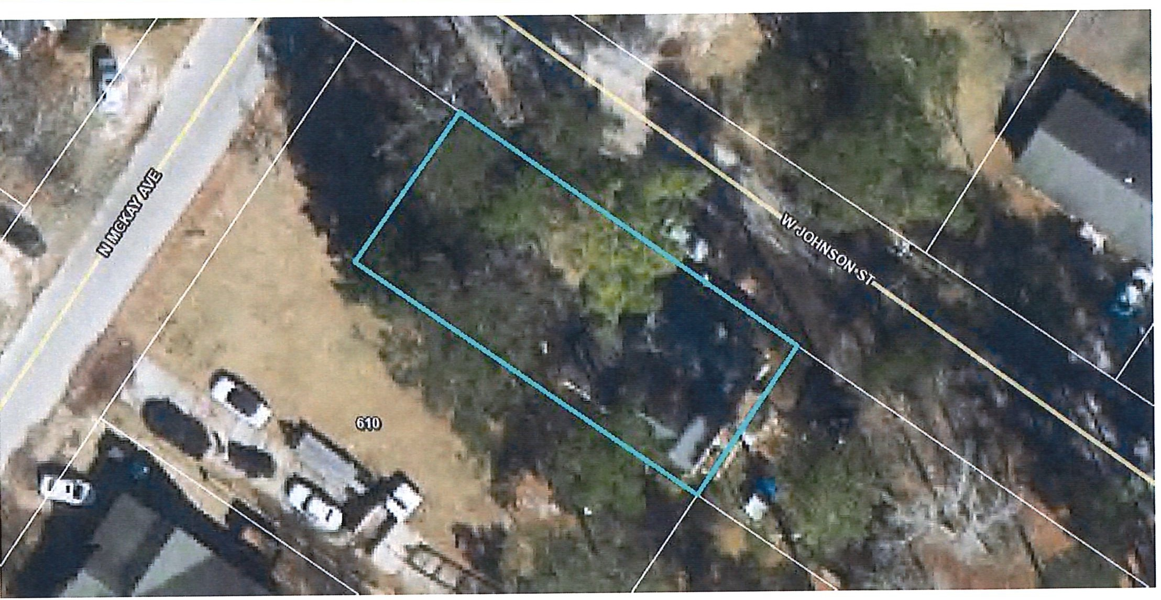
Harnett
"""'( COUNTY
,J_
Harnett County: GIS
NORTH CAROLINA
PIO: 02151607340008
PIN: 1516-69-3809.000
Building Value: $3623
Parcel Outbuilding Value: $250
Account Number: 1500017746
Parcel land Value: 10080
Owner: CORREA JOSE JUAN
Market Value: $13953
Mailing Address: 407 W JOHNSON ST DUNN, NC 28334-3318
Physical Address: 407 W JOHNSON ST DUNN, NC 28334 ac Description: PT LOTS#11&12115X50 407 W JOHNSON ST
Deferred Value: $0
Total Assessed Value: $13953
Zoning: R-10 SINGLE FAMILY-0.13 acres (100.0%)
Surveyed/Deeded Acreage: 1
Calculated Acreage: 0.13
Zoning Jurisdiction: Dunn
Wetlands: No
Deed Date: 1449032400000
Deed Book/Page: 3359 - 0133
FEMA Flood: Minimal Flood Risk
Plat(Survey) Book/Page: -
last Sale: 2015 - 12
Within 1ml of Agriculture District: No
Elementary School: Dunn Elementary Middle School: Dunn Middle
Sale Price: $49000
High School: Triton High
Qualified Code: A
Fire Department: Dunn
Vacant or Improved: I Transfer of Split: T Actual Year Built: 1934
Heated Area: 1328 SqFt
EMS Department: Medic 15, 015 EMS law Enforcement: Dunn Police
Voter Precinct: West Averasboro
County Commissioner: Barbara McKay
Building Count: 1
School Board Member: Sharon Gainey

https://gis.harnett.org/E911App/Parcels/ParcelReport.aspx?pin=1516-69-3809.000 1/1

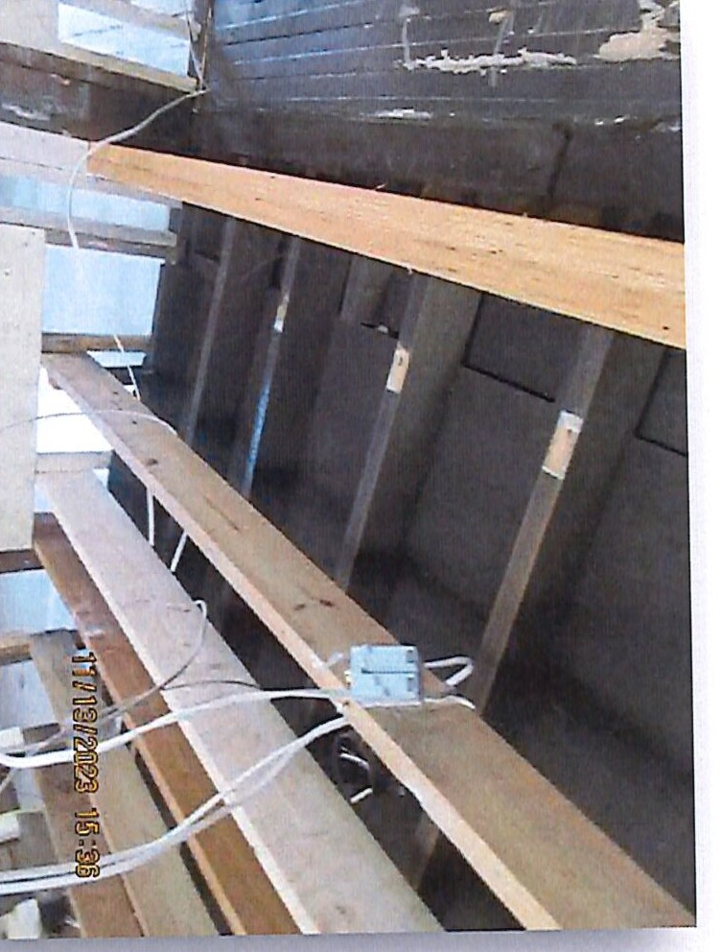
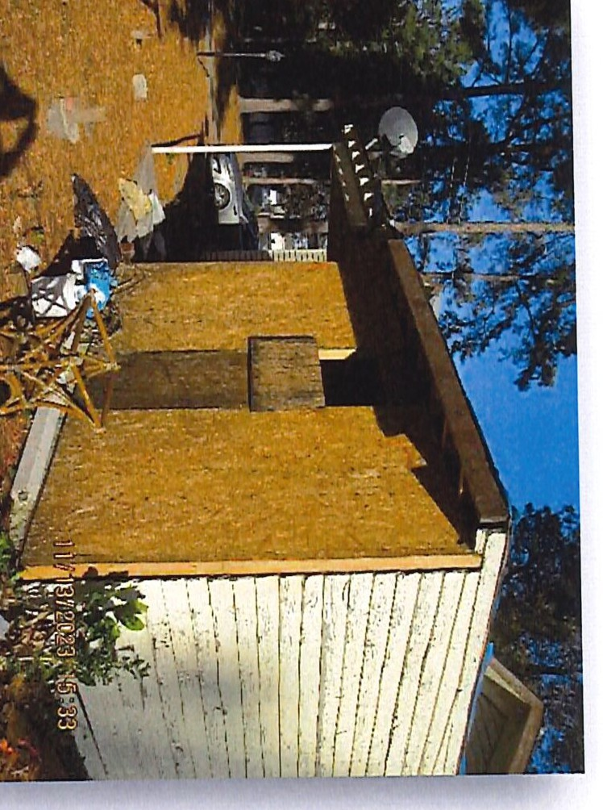
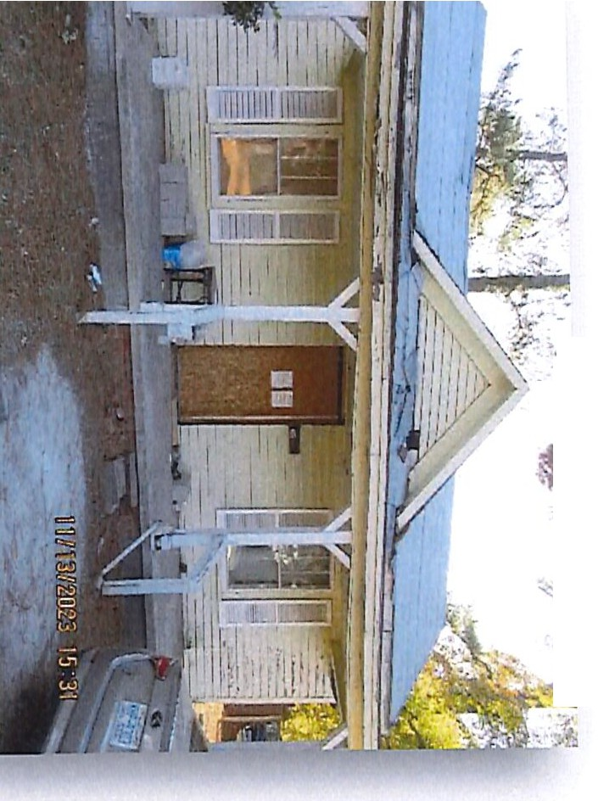
0..... CD
·•---:.
{ \
; •i/
( .
t\

\
,t.i)...
'--
0
::r
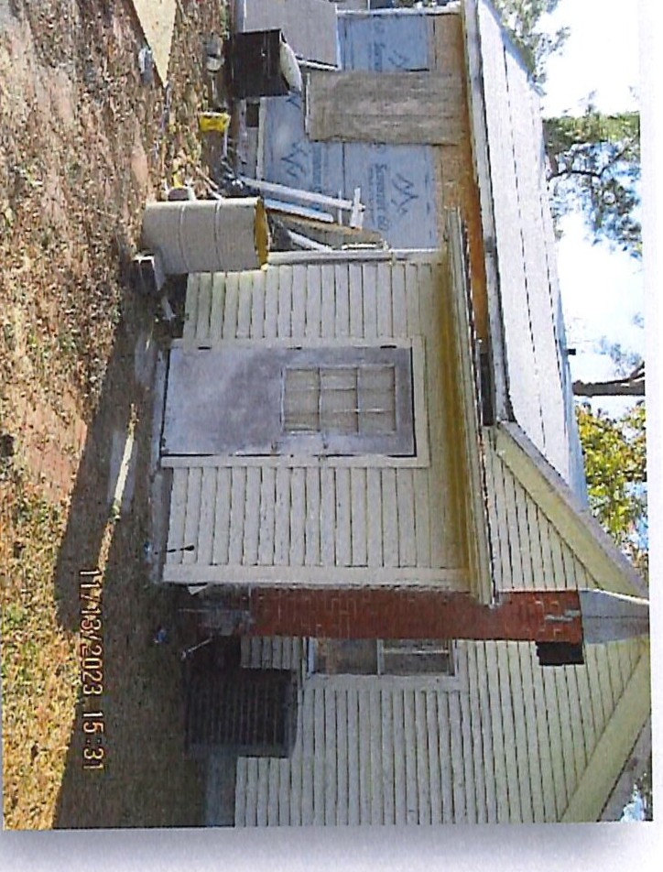
:::l
ti)
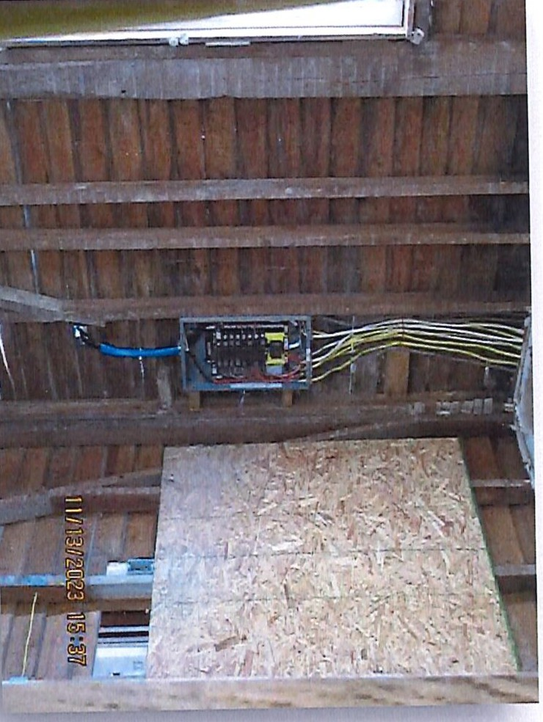
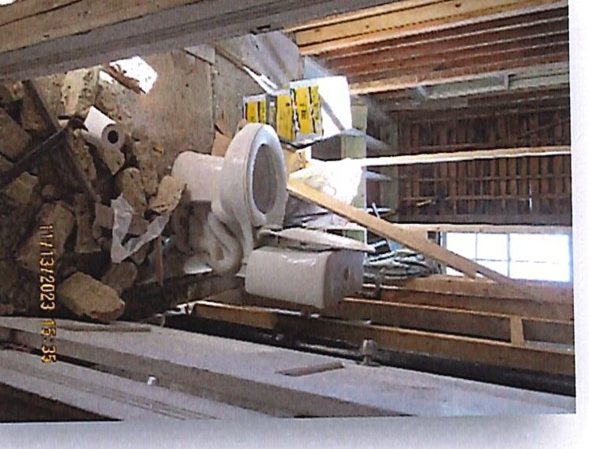
0
:::l
,e..n..
"C""D
,C..D..


.•.,.illl■r.i .-'l"r.JlffliH

- _{NORTH} _{CAROLINA} City Council Agenda Item
=DUNN

Meeting Date: December 10, 2024
SUBJECT TITLE | Consideration of Ordinance to Demolish - 410 S Fayetteville  Avenue. (PIN# 1516-56-0439.000)
PRESENTER/DEPARTMENT | Assistant City Manager, Billy Godwin and  Code Administrator, John Ganus
_TTACHMENT(S) | Demolition Memorandum & Ordinance to Demolish
PUBLIC HEARING PUBLISH DATES I | November 29, 2024 / December 3, 2024

I

PURPOSE:
- Public Hearing: Consideration of Ordinance to Demolish Dilapidated Structure - (PIN# 1516-56- 0439.000). The Public Hearing was advertised on November 29, 2024 and December 3, 2024
- Purpose: Code Administrator, John E. Ganus, has conducted an inspection at 407 W Johnson Street based upon his observations, the structure is unsafe, dilapidated and uninhabitable.
The owner of the property has failed to comply with Code Administrators order and according to
N.C.G.S. 160D-1123 the City Council has the power to proceed with the demolition of this property.
Should Council decide to proceed with the demolition of the structure at 410 S Fayetteville Avenue an ordinance would need approval directing the Code Administrator to remove or demolish said structure.
BACKGROUND:
On October 23, 2023, the Housing Standards case was opened on the above property concerning the conditions of the vacant structure and the living conditions. A request for inspection was issued and the inspection was scheduled on January 8, 2024. The owner did not show for the inspection but called after the scheduled time, stating he was out of country and would contact us upon his return. After no further contact from the owner, a second inspection request was scheduled for March 11, 2024, and the owner did not show again. Observations of the house showed that the structure had been gutted and it was dete1mined to be dilapidated, unsafe and uninhabitable in its present condition.
A Complaint and Notice of Hearing was issued for March 25, 2024, by Certified and First-Class mailing with a copy posted on the structure. The Certified mailing was returned as "Unable to Forward" on March 21, 2024. The First­ Class mailing was not returned. A Hearing was held to determine the fitness for human habitation of the dwelling, but the owners did not attend. Following the hearing, a Finding of Fact and Order was issued by Certified and First-Class mail with a copy posted on the structure. The Certified mailing was returned "Unable to Forward" and the First-Class mailing was not returned. The Order required the owners to bring the structure into compliance with the City of Dunn Minimum Housing Code by demolishing the structure by a date not later than October 4, 2024. To date the owners have not complied with the order of the Code Administrator.

The Vacant, severely dilapidated structure poses hazards to the health and safety of the community due to defects increasing the potential for accidents and fires.
BUDGET IMPACT: None
RECOMMENDED
MOTION/ACTION | Motion to adopt the ordinance directing the Code Administrator to proceed with the
REQUESTED OF COUNCIL | demolition of the structure located at 410 S Fayetteville Avenue (PIN#1516-56- 0439.000)

..

mlDlJNN
PLANNING AND INSPECTIONS
102 N Powell Ave • PO Box 1065 • Dunn, North Carolina 28335 (910) 230-3505 • CityofDunn.org

MEMORANDUM

TO: FROM: DATE: RE:
Mayor, City Council, and Town Manager John E. Ganus, Code Administrator October 31, 2024
Request adoption of an Ordinance to Demolish and Remove the Dilapidated Dwelling at 407 West Johnson Street (PIN - 1516-69-3809.000), Case# HC-23-25

BACKGROUND:
On April 10, 2023, the Housing Standards case was opened on the above property concerning the conditions of the structure, fire damage to the roof, and the unsafe living conditions. A request for inspection was issued and the inspection was scheduled for November 13, 2023. The owner did not show for the inspection. Later research found that the owner had submitted an engineer's letter, applied for permits and failed multiple inspections by the County Building Inspections depaiiment. A second attempt for an inspection was on June 24, 2024, and the owner did not show again. Observations of the house showed that the structure had been gutted and it was dete1mined to be dilapidated, unsafe and uninhabitable in its present condition.

A Complaint and Notice of Hearing was issued for July 23, 2024, by Certified and First-Class mailing, with a copy posted on the structure. The Certified mailing was received by the owner on June 27, 2024, per the USPS. The First-Class mailing was not returned. A Hearing was held to determine the fitness for human habitation of the dwelling, and the owners were in attendance. At the completion of the hearing, the Finding of Fact and Order was issued to the owner in person. The Order required the owners to bring the structure into compliance with the City of Dunn Minimum Housing Code by repairing or demolishing the structure by a date not later than October 23, 2024. To date the owners have not complied with the order of the Code Administrator.

PROBLEM:
The vacant, severely dilapidated structure poses hazards to the health and safety of the community due to defects, increasing the potential for accidents and fire.

FINDINGS AND CONCLUSIONS:
The dilapidated structure is vacant and continues to deteriorate. It is estimated the repairs cannot be made at a reasonable cost percentage of the present value ($3,623) of the dwelling structure. It appears the owner does not intend to comply with the Order; and therefore, it is recommended the following Ordinance directing the Code Administrator to demolish and remove the dilapidated structure be adopted by the City Council.

Where communH3 he_Jins!

POLICY IMPLICATIONS:
None.

FINANCIAL IMPACT:
It is unknown what the cost of demolition and clearance will be, however, a competitive bid process will be used to obtain the lowest responsible bid. Funds for such demolition and clearance are provided in the City budget. All related costs will constitute a lien against the real property.

CHECKLIST OF WHO HAS REVIEWED:
Steven Neuschafer, City Manager Billy Godwin, Assistant City Manager Slater Johnson, Building Inspector 3
Stephen Hodges, Code Enforcement Officer John E Ganus, Code Administrator

OWNERS OF RECORD
Jose Juan Conea
1009 North Fayetteville Avenue Dunn, North Carolina 28334

LEGAL NOTICE
NOTICE rs HEREBY GIVEN THAT THE CITY COUNCIL OF THE CITY OF DUNN, NORTH CAROLINA, UNDER AUTHORITY OF CHAPTER 160D, SECTION 601 OF THE GENERAL STATUTES OF NORTH CAROLINA, WILL HOLD A PUBLIC HEARING AT 6:30 P.M. ON DECEMBER 10, 2024 IN THE COURTROOM OF THE DUNN MUNICIPAL BUILDING LOCATED AT 401 E. BROAD ST.

THE FOLLOWING ITEMS WILL BE DISCUSSED:

PUBLIC HEARING:

- A HEARING WAS HELD ON JUNE 24, 2024 IN REFERANCE TO THE
STRUCTURE LOCATED AT 125 SPRING BRANCH ROAD. AT SAID HEARING, EVIDENCE WAS GIVEN TO SHOW THAT THE PROPERTY rs IN VIOLATION OF THE CITY OF DUNN MINIMUM HOUSING CODE AND
N.C.G.S. 160D-ARTICLE 12. AN ORDER WAS ALSO PLACED TO OWNER STACEY HARPER, TO DEMOLISH SAID STRUCTURE. TO DATE NO RESPONSE HAS BEEN MADE. THEREFORE, IT WILL GO BEFORE THE CITY OF DUNN COUNCIL TO ADOPT AN ORDINACE TO HAVE THE STRUCTURE REMOVED AND ALL COST INCURRED BE A LIEN AGAINST THE PROPERTY.

- A HEARING WAS HELD ON MARCH 11, 2024 IN REFERANCE TO THE STRUCTURE LOCATED AT 824 EAST DIVINE STREET. AT SAID HEARING, EVIDENCE WAS GIVEN TO SHOW THAT THE PROPERTY IS IN VIOLATION OF THE CITY OF DUNN MINIMUM HOUSING CODE AND
N.C.G.S. 160D-ARTICLE 12. AN ORDER WAS ALSO PLACED TO OWNER ZELM LLC C/O LEE ALEXANDER BROWN, TO REPAIR OR DEMOLISH SAID STRUCTURE. TO DATE NO RESPONSE HAS BEEN MADE. THEREFORE, IT WILL GO BEFORE THE CITY OF DUNN COUNCIL TO ADOPT AN ORDINACE TO HAVE THE STRUCTURE REMOVED AND ALL COST INCURRED BE A LIEN AGAINST THE PROPERTY.
- A HEARING WAS HELD ON JULY 23, 2024 IN REFERANCE TO THE STRUCTURE LOCATED AT 407 WEST JOHNSON STREET. AT SAID HEARING, EVIDENCE WAS GIVEN TO SHOW THAT THE PROPERTY IS IN VIOLATION OF THE CITY OF DUNN MINIMUM HOUSING CODE AND
N.C.G.S. 160D-ARTICLE 12. AN ORDER WAS ALSO PLACED TO OWNER JOSE JUAN CORREA, TO REPAIR OR DEMOLISH SAID STRUCTURE. TO DATE NO RESPONSE HAS BEEN MADE. THEREFORE, IT WILL GO BEFORE THE CITY OF DUNN COUNCIL TO ADOPT AN ORDINACE TO HAVE THE STRUCTURE REMOVED AND ALL COST INCURRED BE A LIEN AGAINST THE PROPERTY.

- A HEARING WAS HELD ON MARCH 25, 2024 IN REFERANCE TO THE STRUCTURE LOCATED AT 410 SOUTH FAYETTEVILLE AVENUE. AT SAID HEARING, EVIDENCE WAS GIVEN TO SHOW THAT THE PROPERTY IS IN VIOLATION OF THE CITY OF DUNN MINIMUM HOUSING CODE AND N.C.G.S. 160D-ARTICLE 12. AN ORDER WAS ALSO PLACED TO OWNER WINGED WARRIOR LLC, TO REPAIR OR DEMOLISH SAID STRUCTURE. TO DATE NO RESPONSE HAS BEEN MADE. THEREFORE, IT WILL GO BEFORE THE CITY OF DUNN COUNCIL TO ADOPT AN ORDINACE TO HAVE THE STRUCTURE REMOVED AND ALL COST INCURRED BE A LIEN AGAINST THE PROPERTY.

ALL PERSONS DESIRING TO BE HEARD EITHER FOR OR AGAINST THE PROPOSED ITEM(S) SET FORTH ABOVE ARE REQUESTED TO BE IN ATTENDANCE AT THE TIME AND DATE STATED ABOVE.

JOHN E. GANUS HOUSING INSPECTOR CITY OF DUNN
Advertise:
November 29, 2024 and December 3, 2024

CITY OF DUNN
401 East Broad Street
Dunn, North Carolina 28334
-Verses­
Jose Juan Correa
1009 North Fayetteville Avenue Dunn, North Carolina 28334
File Number: HC-23-25

Ordinance

AN ORDINANCE DIRECTING THE CODE ADMINISTRATOR TO REMOVE OR DEMOLISH THE PROPERTY HEREIN DESCRIBED AS UNFIT FOR HUMAN HABITATIONANDDIRECTINGTHATANOTICEBEPLACEDTHEREONTHATTHE SAME MAY NOT BE OCCUPIED

WHEREAS, the City Council of the City of Dunn finds that the structure described herein is unfit for human habitation under the City Minimum Housing Code and that all of the procedures of the Minimum Housing Code have been complied with; and
WHEREAS, this dwelling should be removed or demolished as directed by the Code Administrator and should be placarded by placing thereon a notice prohibiting use for human habitation; and WHEREAS, the owner of this structure has been given a reasonable opportunity to bring the structure up to the standards of the City of Dunn Minimum Housing Code in accordance with NCGS 160D Article 12 pursuant to an order issued by the Code Administrator on July 23, 2024, and the owner has failed to comply with the Order;
NOW, THEREFORE, BE IT ORDAINED by the City Council of the City of Dunn, that:
Section 1. The owner of such building(s), dwelling(s) and premises is hereby ordered to vacate any occupants and/or personal property therein on or before December 29, 2024.
Section 2. The Code Administrator is hereby authorized and directed to place placards containing the legend:

"This building is unfit for human habitation. The use or occupation of this building for human habitation is prohibited and unlawful."
on the building located at the following address:
407 West Johnson Street (PIN - 1516-69-3809.000)

Section 3. The Code Administrator is hereby authorized and directed to proceed to remove or demolish the above-described structure in accordance with his order to the owner thereof dated the 23rd day of July 2024, the City of Dunn Minimum Housing Code, and NCGS 160D, A.liicle 12; Section 4. (a) The cost of removal or demolition shall constitute a lien against the real property upon which the cost was incurred, as well as any other real property of the owner located within the city limits or within one mile thereof except for the owner's primary residence. The lien shall be filed in the office of the Clerk of the Court, and shall have the same priority and be collected
in the same manner as the lien for special assessments in Article 10 ofNCGS Chapter 160A;
(b) Upon completion of the required removal or demolition, the Code Administrator shall sell the materials of the dwelling and credit the proceeds against the cost of removal or demolition. The Code Administrator shall certify the remaining balance to the Tax collector. If a surplus remains after the sale of the materials and satisfaction of the cost of removal or demolition, the Code Administrator shall deposit the surplus in the Superior Court where it shall be secured and disbursed in the manner provided by NCGS 160D, Article 12.
Section 5. It shall be unlawful for any person to remove or cause to be removed the placard from any building to which it is affixed. It shall likewise be unlawful for any person to occupy or to permit the occupancy of any building therein declared to be unfit for human habitation.
Section 6. This Ordinance shall become effective upon its adoption.

ADOPTED this day of , _

William P. Elmore Jr., Mayor
ATTEST:

Melissa Matti, City Clerk

11/20/24, 9:50AM Harnett County Parcel Report

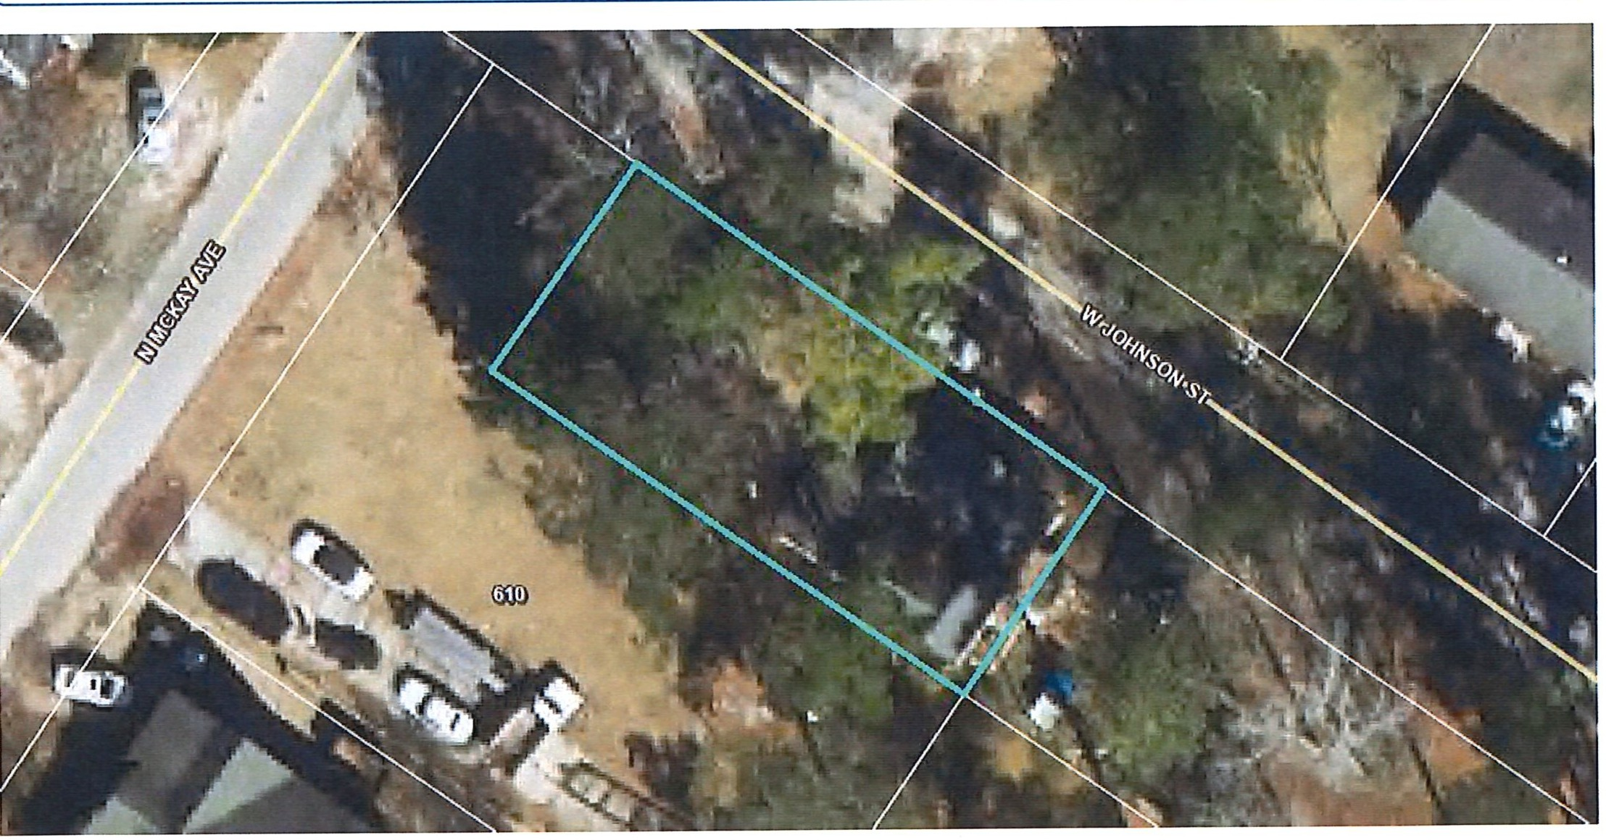
Harnett
J(-, COUNTY
Harnett County: GIS
- NORTH CAROLI/IA
PID: 02151607340008
PIN: 1516-69-3809.000
Account Number: 1500017746
Building Value: $3623
Parcel Outbuilding Value: $250 Parcel Land Value: 10080
Owner: CORREA JOSE JUAN
Mailing Address: 407 W JOHNSON ST DUNN, NC 28334-3318
Physical Address: 407 W JOHNSON ST DUNN, NC 28334 ac Description: PT LOTS#11 &12 115X50 407 W JOHNSON ST
Market Value: $13953
Deferred Value: $0
Surveyed/Deeded Acreage: 1
Calculated Acreage: 0.13
Total Assessed Value: $13953
Zoning: R-10 SINGLE FAMILY- 0.13 acres (100.0%)
Zoning Jurisdiction: Dunn Wetlands: No
Deed Date: 1449032400000
Deed Book/Page: 3359 - 0133
FEMA Flood: Minimal Flood Risk
Within 1ml of Agriculture District: No
Plat(Survey) Book/Page: -
Last Sale: 2015 - 12
Sale Price: $49000
Elementary School: Dunn Elementary Middle School: Dunn Middle
High School: Triton High
Qualified Code: A Vacant or Improved: I Transfer of Split: T Actual Year Built: 1934
Heated Area : 1328 SqFt
Fire Department: Dunn
EMS Department: Medic 15, D15 EMS Law Enforcement: Dunn Police
Voter Precinct: West Averasboro
County Commissioner: Barbara McKay
Building Count : 1
School Board Member: Sharon Gainey

https://gis.harnett.org/E911App/Parcels/ParcelReport.aspx?pin=1516-69-3809.000 1/1

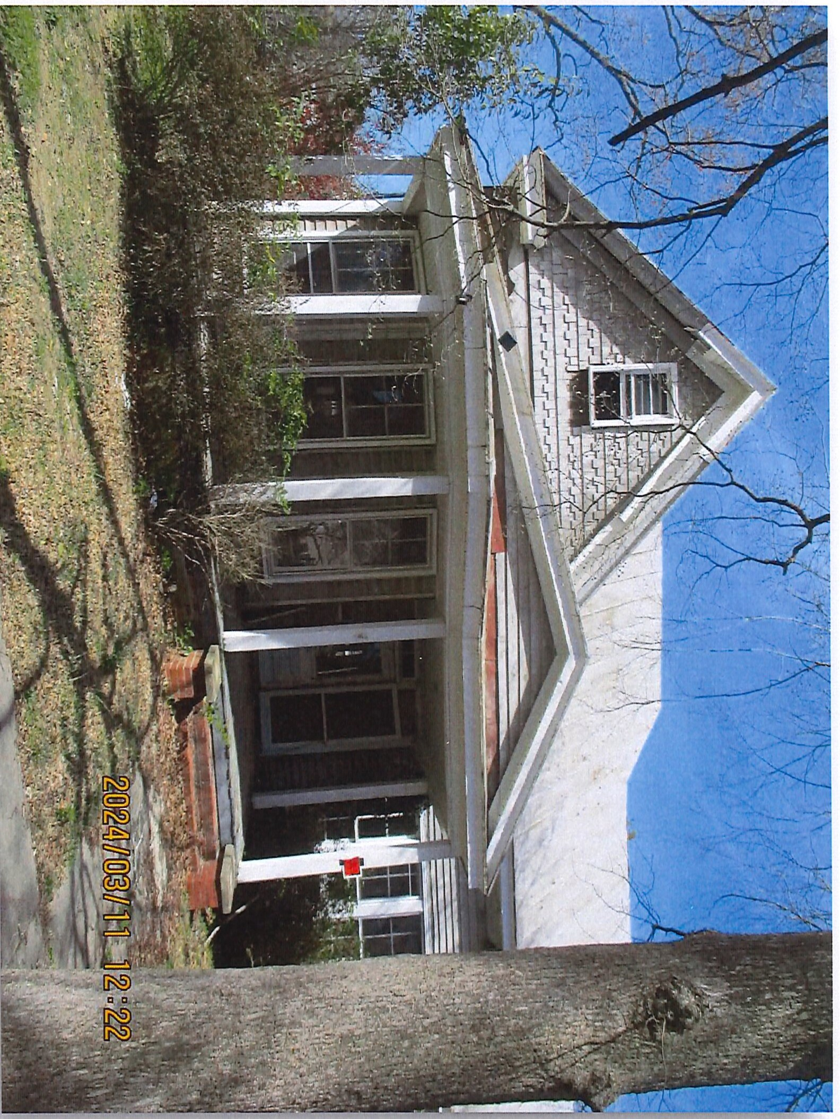

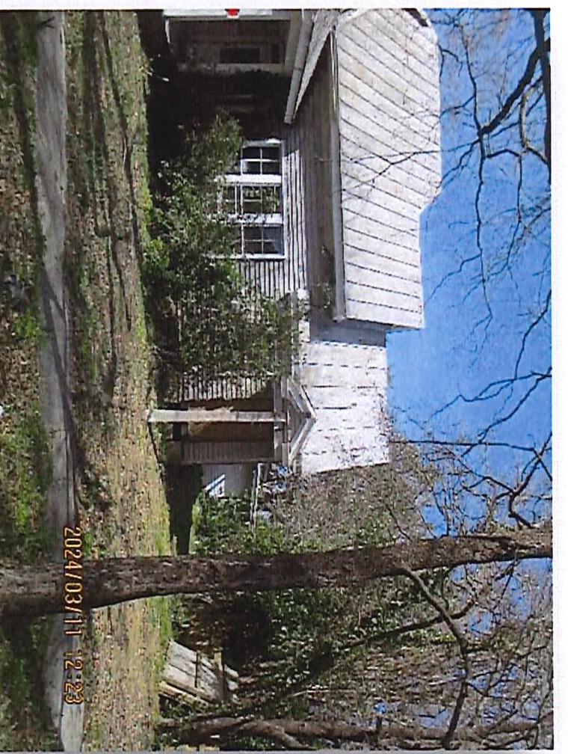
.i:=.
0
en
0
C:
,-+
::::r
"T1
D>
'<
CD
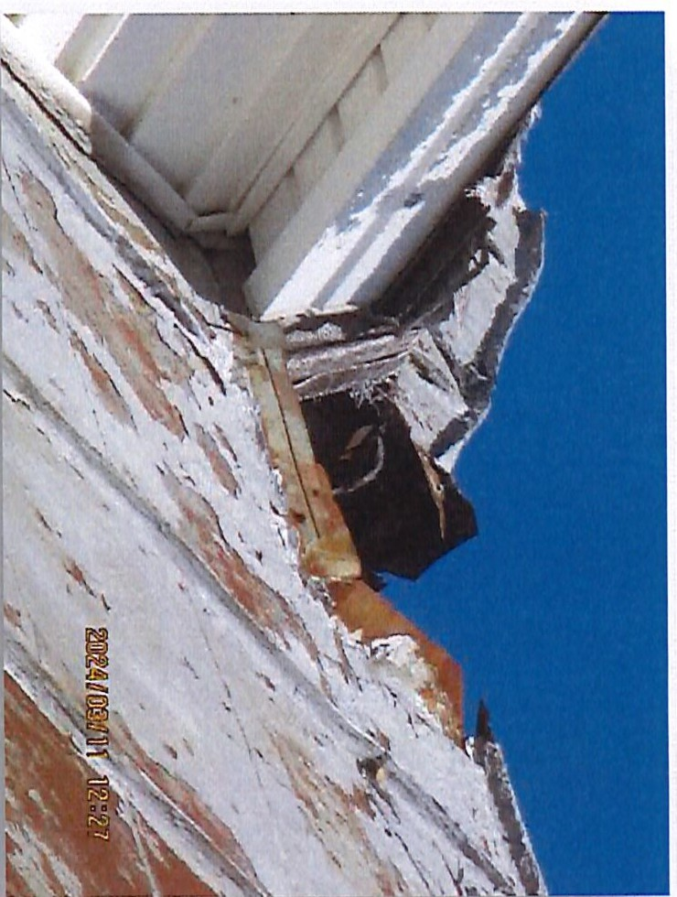
,-+
,-+
-
CD
-
=::.
CD
)>
<
CD
:::::s C: CD

- _{NORTH} _{CAROLINA} City Council Agenda Item
mlDlJNN

Meeting Date: December 10, 2024
SUBJECT TITLE | Consideration of Resolution Directing Clerk to Investigate  Voluntary Annexation Petition ANX-03-24, owned by Gabrielle Jones
PRESENTER/DEPARTMENT I | City Manager Neuschafer
ATTACHM NJ( ) I | Resolution and Petition
PUBLIC HEARING PUBLISH DATES

I

PURPOSE:
To consider a petition requesting the voluntary contiguous annexation of property located at 504 Moon Circle near the intersection of Moon Circle and Jupiter Drive, PIN #1526-39-2104.000, with 1.21+/- acres. This petition was received under NC General Statute 160A-31.

BACKGROUND:
This petition was received on November 12, 2024.

BUDGET IMPACT:

RECOMMENDED
MOTION/ACTION | Motion to adopt the Resolution Directing the City Clerk to Investigate the Voluntary
REQUESTED OF | Annexation Petition ANX-03-24 as presented.
COUNCIL

&mDUNN
  - • NORTH CAROLI NA

RESOLUTION DIRECTING THE CLERK TO INVESTIGATE
A PETITION RECEIVED UNDER G.S. 160A-31
WHEREAS, a petition was received on November 12, 2024 by the Dunn City Council, requesting annexation of a contiguous area described in said petition located at 504 Moon Circle, at the intersection of Moon Circle and Jupiter Drive, Dunn, NC, PIN # 1526-39- 2104.000, owned by Gabrielle Jones; and

WHEREAS, G.S. 160A-31 provides thatthe sufficiency of the petition shall be investigated by the City Clerk before further annexation proceedings may take place; and

WHEREAS, the City Council of the City of Dunn, deems it advisable to proceed in response to this request for annexation;

NOW, THEREFORE, BE IT RESOLVED by the City Council of the City of Dunn that the City Clerk is hereby directed to investigate the sufficiency of the above described petition and to certify as soon as possible to the Dunn City Council the result of the investigation.

Adopted this 10th day of December, 2024.

ATTEST:

Melissa R. Matti, CMC City Clerk
William P. Elmore Jr. Mayor

Where communi{_J hBjinsl

PETITION FOR ANNEXATION-CONTIGUOUS PROPERTY INDIVIDUAL
Date: 1ovembt:P . l )QocQ4

TO: City of Dunn City Council Attn: Planning Director PO Box 1065
Dunn NC 28335
RE: Petition Requesting Annexation By the City of Dunn
Contiguous Property

Pursuant to the provisions of Sections 160A-31 of the North Carolina General Statutes, we the undersigned owners of all the real property described below do hereby request that said property
a
Located at: 504 N\00O CJct[e, I Ounn NC, 334
PIN Number(s): lt)@(o 39·:ao\4
Lot(s): l D±* d}
be annexed into the City of Dunn.
We certify: that the property to be annexed is contiguous to the present corporate limits of the City of Dunn and the annexation would, therefore, be a contiguous annexation; that a legal description (metes and bounds - submitted electronically) is attached as "Exhibit A" and a survey map of said property showing the proposed contiguous area in relation to the primary corporate limits of the City of Dunn is attached and denoted as "Exhibit B".
All individuals hose names appear on the deed to the propertydJ.shaillgn:_
1. Gabnc\\e JvnLS _J)_ [\0y J)
Printed Name S gnature
lMe,Cat\s ue-
51 G. 8/15Jl 910-toS:t· Or:7,55
Address Primary Telephone

2. ,,,-.,----,..,..,.-------------------,-,----------------
Printed Name Signature

Address Primary Telephone

3,P-ri=nt-ed,N,a-me-,---:-:-,,-------------------Si-gn-a=tur-e=-----:------------------

Address Primary Telephone
Sworn to and subscribed by me on this the:2_li day of /{/Qvf.41f Lj .
U:- ,G¥'6:i
,,,,,,,,nnru,,,,,;
,,,,'2_, POAl'; ,,,,,,

,'.:c-' r'-•"·:':\ -.f.i...A...R ,;,•,,·tr,. .,.,,,
:
-----"-,,<; f-"'- -------------

N§'i 'ffed1 ••••.. \. Notary Public
[ My commission expires: (JV:'? 12-, Jo]:8
\ --\. /r_\§
,o... ;-
-:.-:. ••. P.
Dat& ! 'ming Dept. By: •
o/Ylit£
Date R ce ij 'by••City Clerk I I /12 /;io:;iq By:J'{l
1 Annexation Fee: $125 per parcel
Fee Paid: $ / :J.'Sl Receipt# IPS!,J 0 _

Matthew S. Willis Register of Deeds Harnett County, NC
Electronically Recorded
04/06/2023 03:59:04 PM NC Rev Stamp: $70.00 Book: 4188 Page: 1139 -1140 (2) Fee: $26.00
Instrument Number: 2023005304

HARNETT COUNTY TAX ID#
021537 0080 04
04-06-2023 BY SM

-- ·-=--
Excise Tax $70.00

NORTH CAROLINA GENERAL WARRANTY DEED
Tax Block: Lot: 2 Parcel Identifier No.: 021537008004 This Instrument preparedi,y John B. South, Jr., a licensed North Carolina attorney.
Delinquent truces, if any, to be paid by the closing attorney to the county tax collector upon disbursement of closing proceeds
The South Law Finn, PLLC, 3725 National Drive Suite 215, Raleigh, NC 27612
Return to: Grantee
*This property e primary residence of the Grantor.

Brief descriptionI
t1 o_r_th_e_Jn_d_e_x
Lot 2, 1.22 acres I

IBIS DEED made this h #- day of t/r r; I , 2023, by and between
GRANTOR
MICHAEL EARL HERRING
(unmarried)
GRANTEE
GABRIELLE JONES
(unmarried)
3104 Olde Birch Dr. Ralefah, NC 27610
I
Mailing Address: 51 B. Lane Coats1 NC 27521
The designation Grantor and Grantee as used herein shall include said parties, their heirs, successors, and assigns, and shall include singular, plural, masculine, feminine or neuter as required by context.
WITNESSETH, that the Grantor, for a valuable consideration paid by the Grantee, the receipt of which is hereby acknowledged, has and by these presents does grant, bargain, sell and convey unto the Grantee in fee simple, all that certain lot or parcel of land situated in HARNETT County, North Carolina and more particularly described as follows:
BEING all of that parcel of land designated as Lot 2 and containing 1.22 acres as described on Plat dated August 31, 2006 and prepared by Jordan-Tew & Associates, PA, entitled "Division Map prepared for WIiliam D. & Betty Ray and John L. & Patricia B. Young and recorded In Map Book 2006, Page 780, Harnett County Register of Deeds for more complete description by metes and bounds.

Submitted eleetronlcelk hr South Law Firm In comollance with North Carolina stntutes governing NC:4>relable cliicuments RRd the te1'JJls of'the sub111ift!ll' agreement with the Harnett County Register of Deeds,

Docuslgn Envelope ID: 4EA294Da-3031-4533-8918-F749141434CC
..

- ;.?
r#­<tJ
;;­:;."'-
=,,.
--
it
,.,JFl'
•
a:...-
i

.;.''''''"£jl'/I'''',,,
:f \
f,;- -
J
\ /

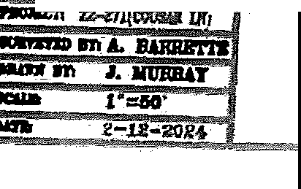


IJ ,,,,,,,,.M.....,,,,'" ......

,:.=.TclAfl:W
S1lb:Y CI-II All Dl91lNO $!RUT,

lii:lldi.U it #Miii;ii. Pis L-4817 Rll'
m, 11/1111 CILY lnElm> f?lll 11£ l'M1Q
LA .:ffl WI"'
fQR
11B IIAI> IIAY IIOt KA CUl1nD lUIVltV NIO
AH'/

.:· ·I ==:.:
•11-1 IIGUI,IIEIIOfll FIii l'IAl!.

- WlllinY MAP (NTS) §!E!'Jr'"
...
=-
.;f:: N!I-
--tWmEDI lllllf:llm IOI CClll'!JAll!:t

I
I

\ •;"••'",'f;\f ""'"R'A'"l m l'lta,-• *
- WII.IJAM"&'

. .;.,?;•,!.,,:-,.'.'.1.:,...1 D:07M!N3GP·RG,1403?
-
l.,, ...
i·,·il·1i.•,llj
, Ji,:t; . D--.8--.2-R2A0Y,!.E,,r.T•Y• '

l :::: • -,,,'6"' • • • .--, , -, I FM
•
·
-,,1..:@• ------ I '•tM Ell

. -TLa.·;iuii l,.-::.-w._.,.*.
.\ ,,..,,.,, I
.1 !

'T\ .
- ! i'.f•
\2 '_I. \ 0 OA ln,fa.4I.E.GlDN
7,rii·:'
lOt 2 J
f zrml>IO:R..al'
191 J.. 01/1111

1,!IJU \ et I .\C1NJ ,.,..-.;.-·-·
ff ;,t4;!i I 1\ \ ZIIIIIIIClifl-»a,r ) 11.1
I / \ H/F
1
I MOO,J,78

- ·1·:i ;: .,
·11= .
'
.;;;:.
•\ \' / /
// //
D,.,t1M,PO.ffil
\ ZOfllllG!MO
'\
\

•. ,,,...,, ,!
) / _,/-
d
,
'

1.,1 ;;:;11: l I J{ // ;..._, • // / ,.. '\

. ! l1 .I•Y••.-•...1.l-.1...
\
'f /
-,··:/

..J.·•'niui,if!••1.·I...,. -= A // .-• \
\
- §:.. ... 1I1 ..../ ,:.··!;•;li1 \
\
. 1••; .,. / '--.. •••,, :':,r,}. '\
l -/.
. ......:., =-

·.•·• ··:·;•.-
/ J/'•/
.......

.I,
..· I / ·'

.:_
..:•1a:. I
/ //Fr';/
_.....,...,
D..IB...I.7J7.C8.,P.AG.S.'.5

'=';*.'.lf..· ,'I V #
/
- :'•-
L-&•.l,=rit."(I,,2.;.

4 :· -.
/-.,•M
i
-lif-i-ffl-1'f-ir ­--"'

).'.-''r{",...
V '
ra-

GRAPHIC SCALE

1 lllch • llO ft,
wm,oys MU HOUSE Z480 SO.FT. DRI\£ lO R/W 1,7.28 SQ.fT. W.w< 87 SQ.FT.
TOTAL 4,285 SO.FT.

PRELIMINARY

CLAYTON HOMES
CSQ41,1QOffcmcu:
-- ,.&ftlfl,P

.,._,.,.._,_,, !;
----­
, :r Nr ll'f
ftl'"lii"iiiiiiiw-•

ECLS'
.. l-..U.. '.i=

LOT 2, WWAM D RAY
AVEl'fAS8CIRO 'n'IP,. HARN£Tr CO., NC
,_.,,
t• N"-'N &.&¥11'_1'

P.8. 2006, f'o. 7!0 Pfh1m-H-2104
tO.••"·

- :I

BK 4188 PG 1140 DOC# 2023005304

TO HAVE AND TO HOLD the aforesaid lot or parcel of land and all privileges and appurtenances thereto belonging to the Grantee in fee simple.
And the Grantor covenants with the Grantee, that Grantor is seized of the premises in fee simple, has the right to convey the same in fee simple, that title is marketable and free and clear of all encumbrances, and that Orantor will warrant and defend the title against the lawful claims of all persons whomsoever except for the exceptions hereinafter stated.
Title to the property bereinabove described is subject to the following exceptions:
Subject to ad valorem taxes; all applicable zoning and land use ordinances, statutes and regulations; and to the provisions of all applicable restrictive covenants and utility easements of record.
IN WITNESS WHEREOF, the Orantor has hereunto set his hand and seal.

(™LJ
••.....-.... .. _,.. •.,.,._......,. '"T- i:-1 ••~...,.,.. -•• ~•••

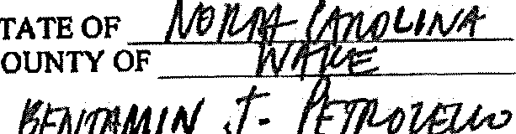
' a Notary Public for W>1tte County, State of

R'"t;flii[ -. V ' .. ,, ., vyvr -
{d_l..t/f certify that MICHAEL EARL HERRING personally appeared before me
this day and acknowledged the execution of the foregoing instrument. ..
Witness my hand and official seal, this the b flt day of lr:/Ml ,2023.
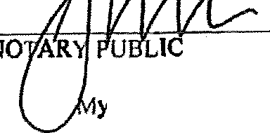
k\ A A
'''"'"'''
[Official SJ'.\ PEr11,111,,,
........... 0. 3

',::!.!:.-•"z••slon i,.••..•"<' -:'-
o,-

:SwI :t 'Wir \\'.oS:
y Commission expires:
U ...2tJU

, :.co' "ue\.'l::
·-- !;!\:;- ".'."'ti."$'
co\l \,'"
.,.,,,i,t,,,,m,,,,,

Harnett County Parcel Report https://gis.harnett.org/E911App/Parcels/ParcelReport.aspx?pin...

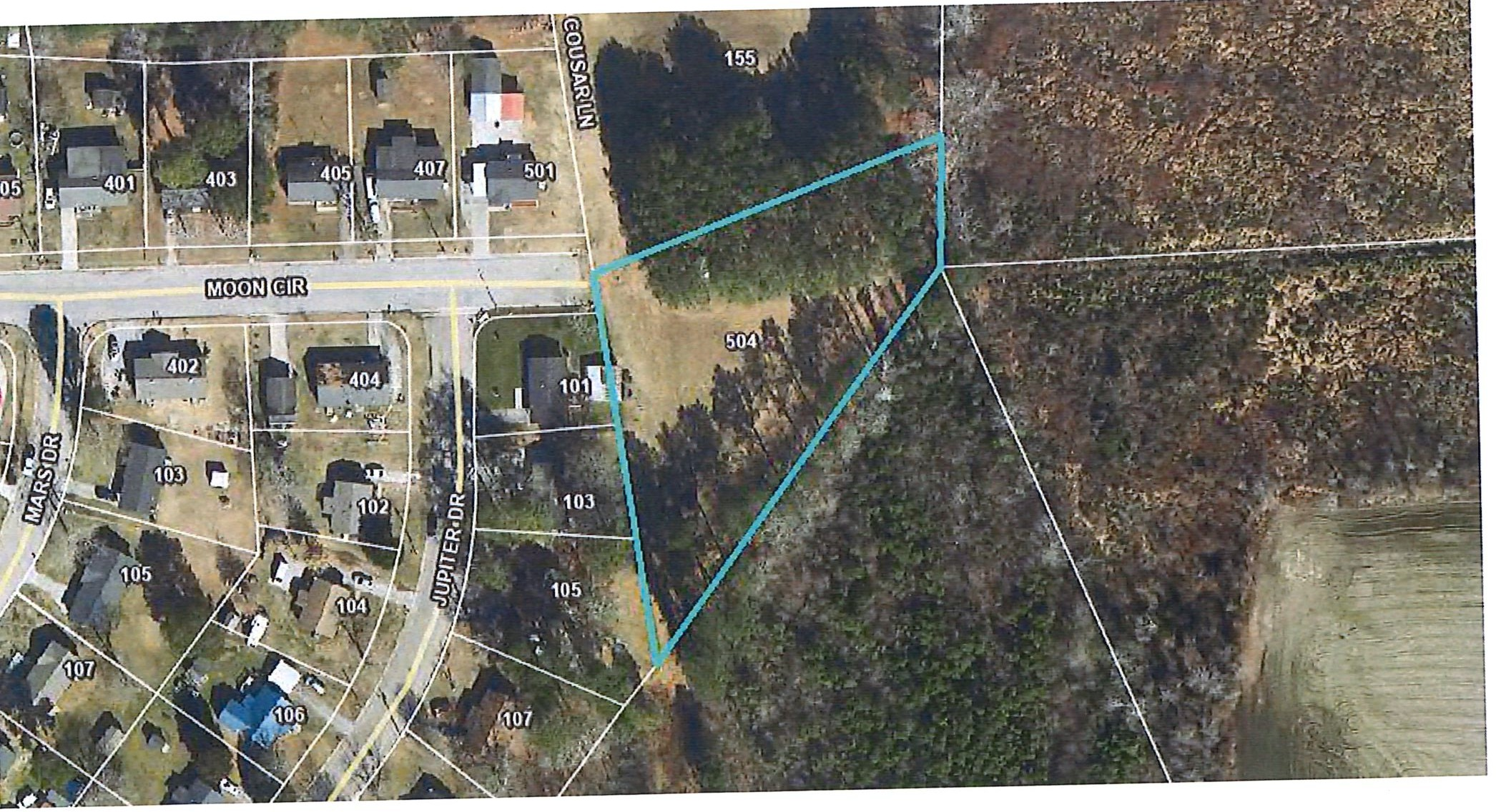
Harnett
(---, COUNTY
.J_
Harnett CountY. GIS
NORTII CAROLI/IA
PID: 021537 0080 04
Building Value: $0
PIN: 1526-39-2104.000
Parcel Outbuilding Value: $0
Account Number: 1500055612
Parcel Land Value: 28300
Owner: JONES GABRIELLE
Market Value: $28300
Mailing Address: 51 B LN COATS, NC 27521-8701
Deferred Value: $0
Physical Address: 504 MOON CIR DUNN, NC 28334 ac
Total Assessed Value: $28300
Description: LOT#2 WILLIAM DRAY 1.22AC MAP#2006-780
Zoning: R-20 SINGLE FAMILY - 1.21 acres (100.0%)
Surveyed/Deeded Acreage: 1.22
Zoning Jurisdiction: Dunn
Calculated Acreage: 1.21
Wetlands: No
Deed Date: 1680757200000
FEMA Flood: Minimal Flood Risk
Deed Book/Page: 4188 - 1139
Within 1mi of Agriculture District: No
Plat(Survey) Book/Page: 2006 - 780
Elementary School: Dunn Elementary
Last Sale: 2023 - 4
Middle School: Dunn Middle
Sale Price: $35000
High School: Triton High
Qualified Code: Q
Fire Department: Dunn
Vacant or Improved: V
EMS Department: Medic 15, D15 EMS
Transfer of Split: T
Law Enforcement: Hamett County Sheriff
Actual Year Built:
Voter Precinct: East Averasboro
Heated Area : Sqft
County Commissioner: Barbara McKay, WIiiiam Morris
Building Count : 0
School Board Member: Joey Powell, Sharon Gainey

I of 1 11/8/2024, 8:22 AM

- _{NORTH} _{CAROLINA} City Council Agenda Item
mlDlJNN

Meeting Date: December 10, 2024
SUBJECT TITLE  PRESENTER/DEPARTMENT | To approve the purchase of Body-Worn cameras and storage  Chief Cary A. Jackson
ATTACHMENT(S) | Budget Amendment
PUBLIC HEARING PUBLISH DATES | I N/ A

I

PURPOSE:
To authorize the Police Department to purchase body-worn cameras and storage for video files.

BACKGROUND:
The Police Department currently requires the use of body-worn cameras by all officers as mandated by departmental policy. This policy follows State and National standards that align with those required by our GALEA accreditation. Body-worn cameras are a critical tool for gathering evidence, providing transparency, and ensuring accountability.

The current WatchGuard body camera system was purchased in 2018 and includes a server for video storage and both body-worn and in-car video systems. The current cameras have offered reliable service; however, many of the devices have become non-operational or damaged, requiring replacement. At the end of 2022, the WatchGuard company was acquired by Motorola and currently only offers·refurbished cameras as replacements for non-operational cameras. The department has replaced seven cameras since January 2024 at a cost of $3,500.00 for the refurbished replacements. Therefore, it is necessary for the department to upgrade devices to continue to comply with departmental policies and national standards. This will help our agency maintain the high level of integrity and accountability.

The purchase of the camera systems from Motorola Solutions will allow us to maintain high quality equipment from a company who has historically provided good customer service.

BUDGET IMPACT:
The total cost for the purchase of the body-worn cameras and the video evidence management system is
$282,172.50 to be paid over a five-year period. The first installment will cost the city $93,038.11, of which
$16,338 will be funded from a Small Rural Tribal grant.

RECOMMENDED
MOTION/ACTION | Motion to approve the purchase of body-worn cameras and video evidence
REQUESTED OF | management system and the related budget amendment.
COUNCIL

CITY OF DUNN BUDGET .ORDINANCE AMENDMENT Department Police
Budget Amendment#: 17
FISCAL YEAR ENDING: 6/30/2025 Date: 12/10/2024

 | 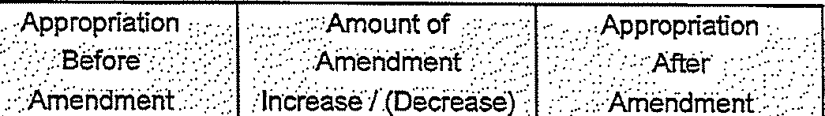
General | 010-0510-4500 | Contract Services | 80,370.02 | 93,038.00 | $ 173,408.02
General | 010-0900-9509 | USDA FY24 Police Veh-Principal | 52,000.00 | (52,000.00)
General | 010-0900-9609 | USDA FY24 Police Veh-lnterest | 10,500.00 | (10,500.00)
General | 010-0900-9521 | USDA FY24 PW Veh-Principal | 29,800.00 | (14,200.00) | 15,600.00
 |  | 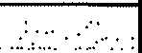  EXPENDITURE TOTAL: |  | .:::.:_16;338.00 | $ .. J89,008.02 •

  General General | 010-0359-0000 | Federal Grants $ 25,000.00 $ 16,338.00 $ 41,338.00  $



REVENUE TOTAL:· ..•· •• : 5,000.00 $ :·•

CERTIFICATION: I certify this requested budget amendment was approved by the City Council on:

City Manager: 12/10/2024
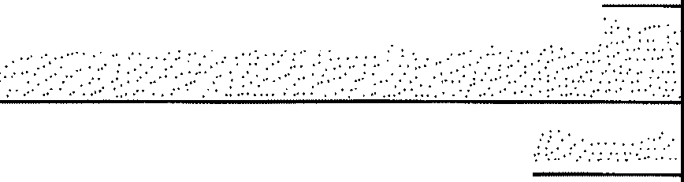
Rnance Director: 12/10/2024
JUSTIFICATION: Allocate funding for the police body camera !video as a service" agreemeiiL • • •
FUNDING SOURCE: FY 4: Debt ?ervice budget that is not needed 1Jntil.FY2.6..

Body Camera Upgrades
MO•TOROLA

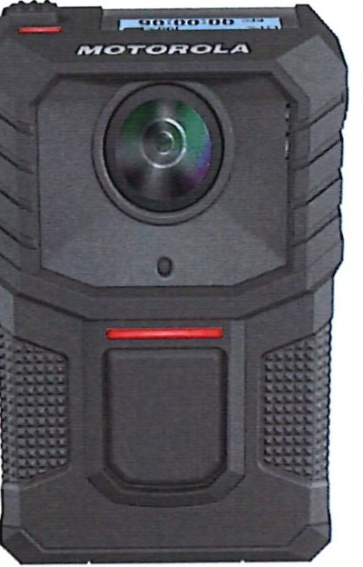
SOLUTIONS

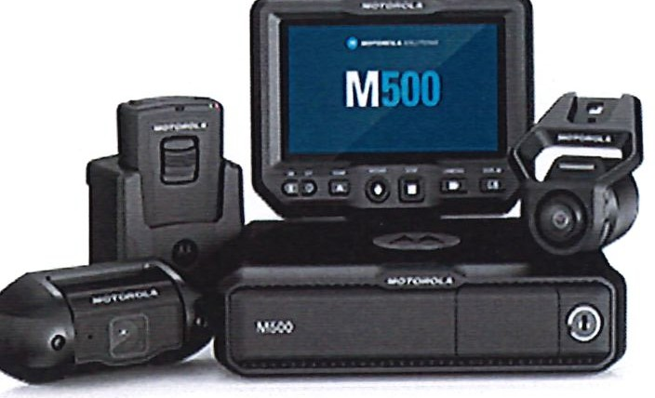

- Upgrade 50 body worn cameras total cost $282,172.50. Total amount to be paid over a period of 5 years. This price includes a discount of $75,991.25. Breakdown listed below:

  - Year 1 upfront equipment cost and subscription fee $93,038.11
    - Upfront cost includes cost of hardware, accessories and implementation.

  - Year 2 Subscription Video as a Service $56,035.52

  - Year 3 Subscription Video as a Service $56,035.52
    - Brand new camera refresh at year 3. All cameras will be replaced with new equipment. This is included in the price.

  - Year 4 Subscription Video as a Service $38,531.68

  - Year 5 Subscription Video as a Service $38,531.68
- Unlimited Cloud Storage of Video footage
- Any damages to the camera or repairs for a faulty device is covered at no expense during the 5-year period.
- The cameras and operating system will integrate with our current fleet of in-car cameras. It also includes unlimited storage for our in-car fleet for 3 years.
- The operating system and cloud will also integrate with our interview/interrogation room system

DUNN··
CITY OF
- NORTH CAROLINA City Council Agenda Item

Meeting Date: December 10, 2024

SUBJECT TITLE | I Pearsall Street Culvert Replacement Project - Bid Award
PRESENTER/DEPARTMENT | I Billy Godwin -Assistant City Manager
ATTACHMENT($)  PUBLIC HEARING PUBLISH DATES | Bid Documents/Resolutions/Project Ordinance Amendment  N/A

PURPOSE: To tentatively award the Pearsall Street Culvert Project.

BACKGROUND: This project replaces two failed box culverts over the West Pearsall Street crossing of Juniper Creek with a 57 foot constructed bridge. Other improvements include upgrading the existing sewer line crossing the creek from a vitrified clay pipe (VCP) to a steel­ encased ductile iron pipe (DIP); relocating existing gas lines; and regrading and replacing certain sections of the existing gabion wall.
This project was bid twice because only one bid was received on October 31, 2024. Two bids were received at the second bid on November 19, 2024, at which time, T2 Contracting, Inc., was the low bidder with a base bid of $1,979,188.00 with a bid alternative of $10,800.00 for enhanced railing. With the alternative, the bid is $1,989,988.00.
The tentative bip award is to allow for the State of North Carolina Department of Environmental Quality (DEQ) to concur with the bidding process, associated approvals, and the funding allocation.

BUDGET IMPACT: With the alternative bid of $1,989,988.00, the total overall budget for this project is $2,655,650.00. Funding consists of $490,340.00. from a Local Assistance for Stormwater Infrastructure Improvement (LASII) Construction Grant; $329,000.00 from a LASII Planning Grant; $151,000.00 from the remaining balance of an ARPA stormwater mapping project; $1,685,310.00 will come from the City's Funds.

RECOMMENDED MOTION/ACTION REQUESTED OF COUNCIL
Motion to approve the following as presented:
- The Resolution tentatively awarding the Pearsall Street Culvert Replacement Project to T2 Contracting, Inc., in the alternate bid amount of $1,989,988.00;
- The Amended Capital Project Ordinance; and
- The Reimbursement Resolution.

Docusign Envelope ID: 1858207F-6E0B-49BD-9393-24D77572A108

Project Bid Tabulation December 3, 2024  City of Dunn: West Pearsall Culvert Replacement Project City of Dunn, NC  WithersRavenel Project No. 23-0017-007, DWI# SRP-SW-ARP-0030 |  |  |  | Engineer's Opinion of Cost |  | Sanford Contractors, Inc. |  | T2 Contracting
Item No. | Item Description | Unit | Est. Quan. | Unit Price | Extended Total Price | Unit Price | Extended Total Price | Unit Price | Extended Total Price
Culvert Replacement
1 | Mobilization | 1 | LS | $80,822.00 | $80,822.00 | $140,000.00 | $140,000.00 | $85,000.00 | $85,000.00
2 | Comprehensive Grading | 1 | LS | $53,425.00 | $53,425.00 | $275,000.00 | $275,000.00 | $110,000.00 | $110,000.00
3 | Traffic Control | 1 | EA | $8,400.00 | $8,400.00 | $15,500.00 | $15,500.00 | $15,000.00 | $15,000.00
4 | Demolition & Haul Away of Existing Gabion Baskets | 130 | LF | $16.00 | $2,080.00 | $266.35 | $34,625.50 | $300.00 | $39,000.00
5 | Foundation Conditioning Material, Minor Structures | 3 | TN | $53.00 | $159.00 | $34.50 | $103.50 | $200.00 | $600.00
6 | 15" RCP Drainage Pipe, Class Ill | 23 | LF | $142.00 | $3,266.00 | $520.09 | $11,962.07 | $350.00 | $8,050.00
7 | Box Culvert Removal | 1 | EA | $12,600.00 | $12,600.00 | $200,000.00 | $200,000.00 | $45,000.00 | $45,000.00
8 | 18" Prestressed Precast Concrete Cored Slabs Bridge | 1 | EA | $653,470.00 | $653,470.00 | $1,179,227.92 | $1,179,227.92 | $980,000.00 | $980,000.00
9 | Asphalt Concrete Surface Course, Type SF 9.SA | 32 | TN | $131.00 | $4,192.00 | $237.00 | $7,584.00 | $400.00 | $12,800.00
10 | Asphalt Concrete Intermediate Course, Type S 9.5B | 65 | TN | $131.00 | $8,515.00 | $229.00 | $14,885.00 | $400.00 | $26,000.00
11 | Asphalt Concrete Base Course, Type B 25.0C | 73 | TN | $131.00 | $9,563.00 | $232.00 | $16,936.00 | $400.00 | $29,200.00
12 | Concrete Driveway | 13 | LF | $16.00 | $208.00 | $484.77 | $6,302.01 | $800.00 | $10,400.00
13 | Asphalt Binder for Plant Mix | 5 | TN | $945.00 | $4,725.00 | $625.00 | $3,125.00 | $400.00 | $2,000.00
14 | ABC Stone Base | 167 | TN | $51.00 | $8,517.00 | $25.50 | $4,258.50 | $140.00 | $23,380.00
15 | Frame with Grate, Std. 840.16 | 8 | EA | $1,050.00 | $8,400.00 | $1,605.00 | $12,840.00 | $3,954.00 | $31,632.00
16 | Double Width Catch Basin, SW-10.2 | 4 | EA | $6,300.00 | $25,200.00 | $4,280.00 | $17,120.00 | $18,503.00 · | $74,012.00
17 | 2'6" Concrete Curb and Gutter, Std. 300.9 | 232 | LF | $40.00 | $9,280.00 | $130.75 | $30,334.00 | $95.00 | $22,040.00
18 | 2'6" Concrete Curb and Gutter Driveway Transition | 18 | LF | $40.00 | $720.00 | $350.11 | $6,301.98 | $95.00 | $1,710.00
19 | GabionWall | 188 | LF | $16.00 | $3,008.00 | $1,800.00 | $338,400.00 | $664.00 | $124,832.00
20 | 11<emove t:X1st1ng a-men vvaternne ano 1<ep1ace o-mcn uw r-1....:>::>u-upen 1...ut  In-•-'-'- \Al-•-•_,_,_ | 77 | LF | $147.00 | $11,319.00 | $604.50 | $46,546.50 | $250.00 | $19,250.00
21 | Connection to Existing 6-inch Potable Water Main | 2 | EA | $5,250.00 | $10,500.00 | $9,076.26 | $18,152.52 | $5,676.00 | $11,352.00
22 | ,1 -,-...L.,u-men v1...r- ;:,amtary ;:,ewer "'rav1ty Lme ana 1<ep1ace w1rn J.u uw  <emove | 105 | LF | $179.00 | $18,795.00 | $571.11 | $59,966.55 | $355.00 | $37,275.00
23 | ns"'11at1on or:.:u-mcn u..:lt::> men I mcK;:,i:ee11...asmgwn:n 1u-mcn Ult-'  - .J.. ·--! ·- h!- | 60 | LF | $525.00 | $31,500.00 | $764.66 | $45,879.60 | $858:00 | $51,480.00
24 | nsta11at1on or.q-rooi: u1ameter iv1anno1e w1m vvarerngm King ano 1...over lU-  - non+hl | 1 | EA | $7,350.00 | $7,350.00 | $14,865.02 | $14,865.02 | $20,322.00 | $20,322.00
25 | Installation of Watertight Ring and Cover on Existing Manhole | 1 | EA | $2,100.00 | $2,100.00 | $3,324.77 | $3,324.77 | $3,200.00 | $3,200.00
26 | Pipe Connection to Existing Manhole | 1 | EA | $5,250.00 | $5,250.00 | $9,545.46 | $9,545.46 | $3,556.00 | $3,556.00
27 | Remove and Replace 4-inch Sewer Lateral | 1 | EA | $5,250.00 | $5,250.00 | $11,187.66 | $11,187.66 | $6,276.00 | $6,276.00

Docusign Envelope ID: 1858207F-6EOB-49BD-9393-24D77572A108

Project Bid Tabulation December 3, 2024  City of Dunn: West Pearsall Culvert Replacement Project City of Dunn, NC  WithersRavenel Project No. 23-0017-007, DWI# SRP-SW-ARP-0030 |  |  |  | Engineer's Opinion of Cost |  | Sanford Contractors, Inc. |  | T2 Contracting
Item  No. | Item Description | Unit | Est. Quan. | Unit Price | Extended Total  Price | Unit Price | Extended Total Price | Unit Price | Extended Total Price
28 | Remove and Replace Unsuitable Bedding Material with #57 Stone | so | or | $1,050.00 | $52,500.00 | $168.02 | $8,401.00 | $200.00 | $10,000.00
29 | Pump Around Operations | 1 | LS | $48,930.00 | $48,930.00 | $150,069.44 | $150,069.44 | $86,760.00 | $86,760.00
30 | Tree Protection Fencing | 505 | LF | $2.00 | $1,010.00 | $5.00 | $2,525.00 | $20.00 | $10,100.00
31 | Inlet Protection | 8 | EA | $315.00 | $2,520.00 | $1,000.00 | $8,000.00 | $1,538.00 | $12,304.00
32 | Construction Entrance | 2 | EA | $4,200.00 | $8,400.00 | $5,855.00 | $11,710.00 | $4,239.00 | $8,478.00
33 | Concrete Washout Station | 1 | EA | $1,050.00 | $1,050.00 | $321.00 | $321.00 | $3,076.00 | $3,076.00
34 | Seeding and Mulching | 1 | AC | $4,200.00 | $4,200.00 | $5,000.00 | $5,000.00 | $12,103.00 | $12,103.00
35 | Allowance for 3rd Party Materials Testing | 1 | LS | $5,250.00 | $5,250.00 | $40,000.00 | $40,000.00 | $18,000.00 | $18,000.00
36 | Allowance for Relocation of Overhead Utilites | 1 | LS | $0.00 | $0.00 | $50,000.00 | $50,000.00 | $25,000.00 | $25,000.00
TOTAL CONSTRUCTION BID COST |  |  |  | $1,112,474.00 |  | $2,800,000.00 |  | $1,979,188.00
Alternate
1 | Furnish and Install Decorative Railing (Refer to Specification Seeton  01 01 00 Part 1 1.02All |  |  |  |  | $117,S01.00 | $117,501.00 | $10,800.00 | $10,800.00
TOTAL ALTERNATE BID COST |  |  |  | $0.00 |  | $117,501.00 |  | $10,800.00
A | Total Construction Base Bid |  |  | $1,112,474.00 |  | $2,800,000.00 |  | $1,979,188.00
B | Total Construction Base Bid+ Alternate |  |  |  |  | $2,917,501.00 |  | $1,989,988.00


QSlgnedby:

By:
038190551A55439...
David Perry, PE

Date: December 3, 2024

WithersRavenel
Our People. Your Success.

December 2, 2024

Steven Neuschafer, City Manager City of Dunn
PO Box 1065
Dunn, NC 28335

RE: Bid Evaluation and Recommendation of Award West Pearsall Street Culvert Replacement Project WR Project No. 23-0017-007

Dear Mr. Steven Neuschafer:

The intent of this letter is to present our evaluation of the bids and make a recommendation for award. At the first potential bid opening date of October 31, 2024, at 10:00 AM, less than three bids were received, so no bids were opened. At the second bid opening on Tuesday November 19, 2024, at 10:00 am, two (2) bids were received for the referenced project, opened, and read publicly.

EVALUATION OF BIDS
Two (2) bid packages were received. The bids were delivered to the City of Dunn before the scheduled bid opening. Bids received were as follows:

Bidder | Base Bid | Alternate Bid
Sanford Contractors, Inc. | $2,800,000.00 | $117,501.00
T2 Contracting, Inc. | $1,979,188.00 | $10,800.00

Individual unit price bid amounts are provided in the attached Certified Bid Tabulation. A review of the bid submittal package for T2 Contracting, Inc. revealed that the bid was complete, and the required supporting documentation was provided.
T2 Contracting, Inc. of Fuquay Varina, NC was the apparent lowest responsible and responsive bidder with a bid of $1,979,188.00 for the Base Bid and $10,800 for the alternate bid.

RECOMMENDATION
Based on our review of the bids, WithersRavenel recommends that the City of Dunn tentatively award the contract to T2 Contracting, Inc. in the amount of $1,979,188.00

115 MacKenan Drive I Cary, NC 27511
t: 919.469.3340 I www.withersravenel.com I License No. F-1479
Asheville I Cary I Charlotte I Greensboro I Pittsboro I Powells Point I Raleigh I Southern Pines I Wilmington

contingent upon the Division of Water lnfrastructure1s (NCDWl1s) approval of the bid package.

The City may also choose to award the bid alternate for furnishing and installing decorative railing in the amount of $10,800.00.

Below and attached are budget summaries showing the total project budget with NCDWI funds and City funds based on the bid received and bid alternate. NCDWI allows for a construction contingency amount of approximately 5%.

Funding Source | Amount($}*
DEQ Funding LASII Construction (DWI# SRP-SW-ARP-0030) | 490,340.00
DEQ Funding LASII Planning (DWI# SRP-SW-ARP-0098) | 329,000.00
DEQ Funding LASII Earmark S.L. 2021-180 (DWI# SRP-SW-ARP- 0003) | 151,000.00
City Funds | 1,685,309
Total | 2,655,649

If the project is awarded to the apparent lowest and responsive and responsible bidder at the original price, including the bid alternate, the project costs and budget are as follows.

Description | Amount($)*
Base Bid price | 1,989,988
Contingency (5%) | 99,499
Engineering (LASII Planning) | 329,000
Engineering (City Funds) | 199,900
Permit (City Funds) | 1,251
Easement Acquisition (City Funds) | 34,950
Newspaper Advertisements (City Funds} | 1,061
Total Project Cost | 2,655,649
DEQ Funding LASII Construction (DWI# SRP-SW-ARP-0030) (Construction) | 490,340
DEQ Funding LASII Planning (DWI# SRP-SW-ARP-0098)  (Engineering) | 329,000
DEQ Funding LASII Earmark S.L. 2021-180 (DWI# SRP-SW-ARP-  0003) (Construction) | 151,000
Total Project DWI Funds | 970,340
City Funds (Engineering, Construction, Easement Acquisition,  Newspaper, and Permit Fees) | 1,685,309
*Dollar amounts are rounded up to nearest whole dollar

If you have any questions or need additional information, please call 704-351-6495 and 1
will be glad to assist you. Sincerely, WithersRavenel
J-- ., -- t0l

David Perry, PE, CFM
Senior Project Manager - Stormwater

Attachments:
- Certified Bid Tabulation
- NCDWI Grant Budget
- Resolution of Tentative Award
- MWBE Certification for City Signature
- Debarment Certification for City signature

r.r.lDUNN
NORTH CAROLINA
401 E Broad St • PO Box 1065 • Dunn, North Carolina 28335 (910) 230-3500 • CityofDunn.org

CAPITAL PROJECT ORDINANCE AMENDMENT III
PEARSALL STREET STORMWATER CULVERT
LOCAL ASSISTANCE FOR STORMWATER INFRASTRUCTURE INVESTMENT PROGRAM (LASH)
FY22 AMERICAN RESCUE PLAN ACT GRANT (ARPA) PROJECT# SRP-SW-ARP-0003 PROJECT# SRP-SW-ARP-0030 PROJECT# SRP-SW-ARP-0098

WHEREAS, the City Council for the City of Dunn, on June 13, 2023, adopted the annual budget ordinance number 02023-13 for the fiscal year beginning July 1, 2023; and,

WHEREAS, the City Council, on June 13, 2023, adopted the capital improvements plan for fiscal year 2023-24; and,

WHEREAS, the City Council, on December 12, 2023, approved a grant capital project ordinance for the Pearsall Street Culvert Project with a budgeted amount of $400,000; and,

WHEREAS, the City Council, on March 26, 2024, approved a capital project ordinance amendment to increase the project budget by $490,340 for construction costs to be funded from the North Carolina Department of Environmental Quality (NCDEQ) Division of Water Infrastructure (DWI) grant funding from the Local Assistance for Stormwater Infrastructure Investments (LASH) American Rescue Plan Act; and,

WHEREAS, on August 27, 2024, the City Council approved an amendment to the capital project ordinance to increase the project's budget by $870,560; and,

WHEREAS, it is necessary to amend this project's capital project ordinance to increase the project's budget by $894,750 to provide adequate funding to complete the project; and,

NOW THEREFORE, BE IT ORDAINED by the City Council of the City of Dunn, North Carolina, that pursuant to section 13.2 of Chapter 159 of the General Statutes of North Carolina, the following Grant Project Ordinance amendment is hereby adopted.

Section 1: The Pearsall Street Culvert Capital Project is to be amended to include $230,102 offunding from the Water and Sewer Fund for related utility costs, $956,208 in funding from the General Fund for street and bridge related costs, and $499,000 of installment
Where communif:j 0e_Jinsl

lnilDUNN
NORTH CAROLINA
401 E Broad St • PO Box 1065 • Dunn, North Carolina 28335 (910) 230-3500 • CityofDunn.org

CAPITAL PROJECT ORDINANCE AMENDMENT III PEARSALL STREET STORMWATER CULVERT
LOCAL ASSISTANCE FOR STORMWATER INFRASTRUCTURE INVESTMENT PROGRAM (LASH)
FY22 AMERICAN RESCUE PLAN ACT GRANT (ARPA) PROJECT# SRP-SW-ARP-0003 PROJECT# SRP-SW-ARP-0030 PROJECT# SRP-SW-ARP-0098

WHEREAS, the City Council for the City of Dunn, on June 13, 2023, adopted the annual budget ordinance number 02023-13 for the fiscal year beginning July 1, 2023; and,

WHEREAS, the City Council, on June 13, 2023, adopted the capital improvements plan for fiscal year 2023-24; and,

WHEREAS, the City Council, on December 12, 2023, approved a grant capital project ordinance for the Pearsall Street Culvert Project with a budgeted amount of $400,000; and,

WHEREAS, the City Council, on March 26, 2024, approved a capital project ordinance amendment to increase the project budget by $490,340 for construction costs to be funded from the North Carolina Department of Environmental Quality (NCDEQ) Division of Water Infrastructure (DWI) grant funding from the Local Assistance for Stormwater Infrastructure Investments (LASH) American Rescue Plan Act; and,

WHEREAS, on August 27, 2024, the City Council approved an amendment to the capital project ordinance to increase the project's budget by $870,560; and,

WHEREAS, it is necessary to amend this project's capital project ordinance to increase the project's budget by $894,750 to provide adequate funding to complete the project; and,

NOW THEREFORE, BE IT ORDAINED by the City Council of the City of Dunn, North Carolina, that pursuant to section 13.2 of Chapter 159 of the General Statutes of North Carolina, the following Grant Project Ordinance amendment is hereby adopted.

Section 1: The Pearsall Street Culvert Capital Project is to be amended to include $230,102 of funding from the Water and Sewer Fund for related utility costs, $956,208 in funding from the General Fund for street and bridge related costs, and $499,000 of installment
Where communif_}j hBJins!

financing for stormwater related costs not covered by grants. The project is authorized to be undertaken until all project activity is completed.

Section 2: The officers of this unit are hereby directed to proceed with the grant project within the terms of the board resolution, grant documents, the rules and regulations of the Division of Water Infrastructure (DWI), and the budget contained herein, until all project activity is completed and is adopted as noted in Section 3.

Section 3: The amount of funding appropriated, and amounts budgeted for engineering and construction are approved as follows:

Funding Appropriations | Previous  Budget | Budget  Amendments | Revised  Budget
NCDWI ARPA Grant 0098 | $ 329,000 |  | $ 329,000
NCDWI ARPA Grant 0030 | $ 490,340 |  | $ 490,340
NCDWI ARPA Grant 0003 | $ 151,000 |  | $ 151,000
Transfer fr the Water & Sewer Fund | $ 249,784 | $ (19,682) | $ 230,102
Transfer from the General Fund | $ 78,669 | $ 877,539 | $ 956,208
Installment Financing-Stormwater $ 462,107 $ 36,893 $ 499,000
Total Funding | $1,760,900 | $ 894,750 | $2,655,650
Expenditures:
Administration | $ 38,375 | $ (36,463) | $ 1,912
Engineering | $ 498,900 | $ 30,400 | $ 529,300
Easements |  | $ 34,950 | $ 34,950
Construction | $1,223,625 | $ 766,363 | $1,989,988
Contingency |  | $ 99,500 | $ 99,500
Total Expenditures $1,760,900 $ 894,750 $2,655,650

Section 4: The finance officer is hereby directed to maintain within the Pearsall Street Culvert Project, sufficient specific detailed accounting records to satisfy the requirements of the grantor agency, the grant agreements, and federal regulations.

Section 5: Funds may be advanced from the General Fund and/or Stormwater Fund for the purpose of making payments as due. Reimbursement requests should be made to the State grantor agency in an orderly and timely manner. Compliance with all federal and state procurement regulations is required.

Section 6: The finance officer is directed to report, on a quarterly basis, on the financial status of each project element in section 3 and on the total grant revenues received or claimed.

Section 7: Within five (5) business days after this ordinance is adopted, the City Clerk shall file a copy of this ordinance with the City of Dunn Finance Director.

A_dopted this, the 10th day of December 2024 in the City of Dunn, North Carolina.

William P. Elmore Jr., Mayor

ATTEST:

Melissa R. Matti City Clerk

rnmlDUNN
NORTH CAROLINA
401 E Broad St • PO Box 1065 • Dunn, North Carolina 28335 (910) 230-3500 • CityofDunn.org
Mayor William P. Elmore Jr. Moyor Pro Tcm
J. Wesley Sills Council Members April L. Gaulden Raquel McNeil
Billy Tart Alan Hargis
Dr. David L. Bradham
City Monoger
Steven Neuschafcr

RESOLUTION DECLARING OFFICIAL INTENT TO REIMBURSE EXPENDITURES FROM PROCEEDS OF BORROWING

WHEREAS; the City of Dunn desires to undertake ce1iain improvements for the replacement and improvements of the Pearsall Street and Culve1i, and
WHEREAS; it is the intent of the City to finance those improvements through a long term loan or other suitable financing and that the financing will be obtained as a result of a process involving Local Government Commission oversight, if necessary, and approval by the City Council, and
WHEREAS; this Resolution and declaration (the "Declaration") is made pursuant to the requirements of the United States Treasury Regulations Section 1.150-2 and is intended to constitute a Declaration of Official Intent to Reimburse under such Treasury Regulations Section, and
WHEREAS: the City Council of the City of Dunn is authorized to resolve and declare the official intent of the City of Dunn, North Carolina with respect to the matters contained herein.
NOW THEREFORE BE IT RESOLVED; that the City of Dunn proposes to unde1take the Project as described below, to incur the related and necessary project expenditures, and to finance the cost of the Project with the proceeds of debt to be issued by the City for the project all as described below:
- Expenditures to be incurred. The City of Dunn anticipates incurring maximum expenditures (the "Expenditures") of $2,655,650 for the Pearsall Street Culvert Project of the City of Dunn.
- Plan of Finance. The City intends to finance the project costs with the proceeds of a long-term loan or other suitable form of debt, to be issued by the City (the "Borrowing"), the interest on which is to be excluded from gross income for Federal income tax purposes.
- Maximum Principal Amount of Debt to be issued. The maximum principal amount of the Bonowing to be incurred by the City to finance the Project is $499,000.
- Declaration of Official Intent to Reimburse. The City of Dunn, NC, hereby declares its official intent to reimburse itself with the proceeds of the Borrowing for any of the Expenditures incurred by it prior to the issuance of the Borrowing.
- Unavailability of Long-Term Funds. No funds for payment for the Pearsall Street Culvert project, from sources other than the borrowed funds, are or are reasonably expected to be, reserved, allocated on a long-term basis, or otherwise set aside by the City pursuant to its budget or financial policies.
- Public Availability of Official Intent Resolution. The Resolution shall be made available for public inspection at the·office of the City Finance Officer within 30 days after its
Where communi{_J he_Jim!

approval in compliance with the applicable state law governing the availability of records of official acts and shall remain available for public inspection until the bo1rnwed funds are issued.
, 7. Effective Date. This Resolution shall be effectiv upon its adoption and approval by the City Council.
BE IT FURTHER RESOLVED, that such evidence of debt, checks, and drafts will be signed or authorized by any two of said officials.

Adopted this, the 10th day of December 2024 at City of Dunn, North Carolina.

William P. Elmore, Jr. Mayor
Attest:

Melissa R. Matti City Clerk

_{NORTH} _{CAROLINA} City Council Agenda Item
mlDlJNN

Meeting Date: December 10, 2024

SUBJECT TITLE | Funding Offer Acceptance, Capital Project Ordinance Budget Amendment, and Tentative Bid Award for the  Sewer Collection System Rehab Project
PRESENTER/DEPARTMENT | Cary McNallan/Finance Department
ATTACHMENT(S) | Resolution to Accept State Funding Offer Capital Project Ordinance Amendment  Resolution to Tentatively Award Construction Contract  Borrowing Resolution
PUBLIC HEARING PUBLISH DATES I | N/A
PURPOSE: To accept a funding offer from the North Carolina Department of Environmental Quality (NCDEQ), approve a capital project ordinance amendment, and tentatively award a construction contract for the Sewer Collection System Rehab (SCSR) Project.
BACKGROUND: Bids were received by the City of Dunn on October 22, 2024, for the SCSR Project. The following three bids were received:

Comuan)l | Base Bid | Alternate Bid | Total Bid
Bio-Nomic Services, Inc | $8,564,061.70 | $164,102.40 | $ 8,728,164.10
North American Pipeline Mgmt, Inc | $9,672,066.00 | $208,350.00 | $9,880,416.00
lnsituform Technologies, LLC | $9,675,811.10 | $310,657.90 | $9,986,469.00

City staff recommend including the alternate bid and tentatively awarding the contract to the lowest bidder, Bio-Nomic Services, Inc in the amount of $8,728,164.10. The tentative award is to allow for the NCDEQ to concur with the bidding process, associated approvals, and funding allocation of the project.
Additional loan funding has been requested from the NCDEQ Division of Water Infrastructure and the approval of this funding request is to be determined on the morning of December 10th at the State Water Infrastructure Authority (SWIA) meeting. If approved, funding for the project would include $9,166,274 in low-interest loan funding and $500,000 in NCDEQ grant funds.
Currently, the city has a funding offer of $7,000,000 from NCDEQ. If the additional funds are not approved at the SWIA meeting, city staff recommend that the project bid be value-engineered to reduce the scope of the project to $7M.
Depending on the results of the SW/A meeting, the appropriate attachments will be presented to the City Council at the meeting.
BUDGET IMPACT: The funding and expenditure budgets for the project will be amended to account for the total cost of the project and future debt service payments will be budgeted in the Water and Sewer Fund.

RECOMMENDED
MOTION/ACTION | Motion to approve the funding offer resolution, the capital project
REQUESTED OF | ordinance amendment, a borrowing resolution, and the tentative award
COUNCIL | resolution to Bio-Nomic Services, Inc in the amount of $8,728,164.10
 | for the Sewer Collection System Rehab Project.

_{NORTH} _{CAROLINA} City Council Agenda Item
lmDlJNN

Meeting Date: December 12, 2024
SUBJECT TITLE | I Engineering Services for Paving Rehabilitation Project
PRESENTER/DEPARTMENT | Billy Godwin -Assistant City Manger
ATTACHMENT(S) I | Transystem's RFQ Submittal
PUBLIC HEARING PUBLISH DATES | IN/A

I

PURPOSE: To authorize the City Manager to negotiate a contract for engineering services with
Transystems for the design, implementation, and management of a paving rehabilitation project.

BACKGROUND: In 2021, the City retained SEPI Engineering and Construction, Inc. (SEPI), to perform a Pavement Condition Survey on the City's 66 miles of paved streets. The Report found that 3% (2.01 miles) were in Excellent condition, 26% (17.27miles) were in Good condition, 67% (44.18 miles) were in Fair Condition, 3% (2.27 miles) in Poor Condition, and 1% (0.39 mile) in Failed condition. SEPI recommended a pavement management system to prioritize the Preservation/Preventive/Rehabilitation of the City's streets with an estimated cost of $15,717,120. In 2023, a Phase I paving project was implemented costing $1,200,000 funded by a $1,000,000 loan with the balance from the City's general fund reserves.

To further implement SEPl's recommendations, the City, on August 6, 2024, issued a Request for Qualifications (RFQ) for engineering services to design, implement and manage a Phase II paving project based on the 2021 study. The scope of services would also include a recommended prioritization of streets with the final decision to be made by the City Council.

Two engineering firms responded to the RFQ and upon review of the submitted statements of qualifications, Transystems, the successor to SEPI, was selected to design, implement, and manage Phase II of the paving project. In selecting engineering services, State law requires that once a qualified firm is selected, the costs of those services is then negotiated between the local government and the engineering firm. A contract must now be negotiated between the City and Transystems.

BUDGET IMPACT: The cost of Transystems' engineering services is unknown and must be negotiated with the City. The funding source will, however, be paid from Powell Bill monies. For the underlying Phase II paving project, it is anticipated that the City will apply for a USDA loan to fund the paving project.

RECOMMENDED | Motion to authorize staff to negotiate a contract of engineering services
MOTION/ACTION | with Transystems to design, develop, and implement a paving project
REQUESTED OF | throughout the City of Dunn.
COUNCIL

r.;ii1DUNN
NORTH CAROLINA
Where communi{_J kJBjinsl City Manager's Office

Request for Qualifications

Engineering Services for Street Paving Projects:

August 6, 2024
The City of Dunn (City) is soliciting engineering services for design and implementation of a paving rehabilitation project. Qualified firms will have experience in pavement evaluation, design and registered as an Engineer in the state of North Carolina. Interested firms are invited to submit a proposal including a Statement of Qualifications (SOQ) for consideration by 2:00 PM on September 19th, 2024. Questions should be directed to Jeremy Martin, Project Manager, jmartin@dunn-nc.org. All questions shall be submitted by August 30th, 2024 by 4:00pm. Any addenda and answer to the questions will be sent out by September 3rd, 2024 and posted on the City website under Bid Notices.

Background Information:
In January of 2021, the City of Dunn had a City - Wide Street Pavement Condition Study completed. The selected firm went through and ranked all 66 miles of City owned streets. It is the expectation that the data collected will be used as the basis for the new project scope. The City would like the newly selected firm to identify the remedies needed to preserve the streets in a cost-effective way, whether that be a full-depth mill paving operation, crack seal and surly, or patching. Other modifications may be needed; manhole/valve cover adjustments, correction of grades on streets and some curb and gutter replacement. Correct and/or install pedestrian amenities.
In addition to improving the identified road conditions, there is infrastructure under these roads that may need to be assessed and considered as a part of the project. The main purpose of the project funds is to pave as many roads as possible, but the City of Dunn would like to take proactive measures by replacing parts of old water/sewer mains or drainage pipes in the identified areas, if the available funds allow.
Due to the financial background of the project, the qualified firm will be expected to have USDA loan experience and understanding of the process that comes with that loan. It will be the engineer's responsibility to help the City maintain compliance with the loan. Also the selected firm will be expected to conduct the required geotechnical reports, field survey the selected areas for drainage, prepare plans, provide bid assistance and construction administration.

City Of Dunn
PO Box l 065 Dunn, NC 28335 1 (910) 230-3500 1
www.cityofdunn.org

Scope of Services:
The scope of services will be as follows:
Identification Of Project Scope
- Surveying
Design Criteria and Plan Development
USDA Loan Experience
- Coordination with NCDOT (if necessary)

- Project Budget Development
- Construction Administration
- Geotechnical Testing
- Water/Sewer/Drainage design capabilities

Submittal Package Requirements & Evaluation Criteria:

The RFQ shall not exceed ten (10) single-sided, 8.5' x 11" pages and shall include the following:
- A clear and concise introduction identifying the scope of services for which the firm is submitting qualifications and a summarization of why the City should select your firm.
- Identification of the project team, including the role and relevant experience of each team member.
- A detailed narrative based on the Scope of Services demonstrating an understanding of the City's needs and describes how those needs would be met.
- Description of the firm's experience with pavement condition rehabilitation projects for municipalities, with at least 3 of those done for a municipality in the state of North Carolina.
- Description of the firm's experience with USDA Community Enhancement Loans. Please provide project examples associated with the loan experience. (Pavement specific projects are not required but would be recommended.)
- Progress schedule that identifies key project milestones and target completion dates.
- Fee Schedule breakdown for design and construction administration.
- All RFQ's shall be at the attention of the City Manager.
Submittal will be evaluated, and a consultant selected based on the following criteria:
  - 40% - Qualifications & Experience
  - 40% - Project Approach & Understanding
  - 20% - Creative Transportation Solutions
The submittal package must be delivered both in hardcopy and electronically (PDF) by 2:00 PM on September 19, 2021.
Hardcopy Submittal: three (3) hardcopies of the Proposal shall be in a sealed package delivered to City Clerk, 401 East Broad Street, Dunn NC 28334. (City Hall/Administration). The name and address of the submitting firm and the RFP title shall be clearly visible on the package.

City Of Dunn
PO Boxl065 Dunn, NC 28335 1 (910) 230-3500 1
www.cityofdunn.org

-^{I.}-^{I}-^{N}-^{T}-^{R}-^{O}-^{D}-^{U}-^{C}-^{T}-^{I}-^{O}-^{N}----------------
October 30, 2024
Steven Neuschafer, City Manager
City of Dunn I 401 East Broad Street, Dunn NC 28334
Re: Request for Qualifications (RFQ) for Engineering Services for Street Paving Projects

Dear Mr. Neuschafer + Selection Committee Members,
The City of Dunn is soliciting engineering services for design and implementation of a paving rehabilitation project. The TranSystems team understands the City has a vision of improving its street network and water/sewer network through strategic
rehabilitation, maintenance, and preservation. We believe for a community to thrive and prosper, timely investments to improve, sustain, and strengthen infrastructure are paramount.
TranSystems offers the right fit for this important endeavor because of our previous work with the City including completing the 2021 City-Wide Pavement Condition Survey; development of the City's S-year Pavement Implementation Plan; and providing contract document preparation, bid support, construction engineering and inspection, and contract administration services to deliver Year 1 of the City's Pavement Implementation Plan. Along with our in-house expertise in pavement management, roadway and drainage design, contract administration, and construction inspection, we have bolstered our capabilities with The Wooten Company (Wooten) for Water and Sewer Design and USDA Loan Support as well as Trimat for Geotechnical Testing.
COMMITMENT+ AVAILABILITY The TranSystems team will commit capable, experienced, and knowledgeable professionals to this project and will work in close partnership with the City. We are primed to deliver all of the requested services, to begin work once a Notice-to-Proceed is issued, and to maintain project schedules with the availability and depth of our staff. Further, TranSystems has the capability to provide additional resources to meet future needs and the ability to respond quickly to these demands given the proximity of our staff.
EXPERIENCED PROJECT TEAM Our project team has a existing relationship with the City of Dunn in delivering pavement management and utility design services. This experience, familiarity, and insight into the City's infrastructure allows for an efficient and successful delivery of the planned paving rehabilitation project.
PROVEN MUNICIPAL TRACK RECORD TranSystems has a long history of consistently meeting our client's expectations and schedules as evidenced by our engineering, design work, and pavement condition surveys with clients including the Cities of
Dunn, Winston-Salem, Salisbury, Kannapolis, Raleigh, Durham, Greenville, Wilson, Fayetteville, and Jacksonville, and the Towns of Cary, Louisburg, Wake Forest, Landis, Southern Shores, China Grove, Franklinton, Wrightsville Beach, Carolina Beach, and Leland, among others.
COST EFFECTIVE SERVICES Through experience on similar projects, the TranSystems team is well equipped to meet potential project challenges and to provide the City with quality survey, engineering, design, pavement condition ratings, treatment recommendations, construction design document creation, and construction management through our extensive project management best-practices.
TRANSYSTEMS
1 Glenwood Avenue, Suite 600
Raleigh, NC 27603
919.789.9977
www.transystems.com

MANAGEMENT I will serve as Principal-in-Charge for this contract, allocating staff to manage concurrent tasks if conditions warrant. Chris Pendergraph, PE, CPM will serve as our Project Manager and Primary Point-of-Contact.
Chris has over 27 years of road maintenance and asset management experience. Prior to joining TranSystems, he served as the NCDOT Division 4 Division Maintenance Engineer managing all aspects of maintenance on 6,000+ miles of roads in six counties, 350+ employees, and an approximate
$100 million per year maintenance budget. Chris managed Division 4's resurfacing and pavement preservation programs; bridge maintenance programs; bridge replacement program; all bridge maintenance crews and operations; roadside environmental programs; traffic services programs; and county road maintenance programs. He also served as a District Engineer, County Maintenance Engineer, and Assistant District Engineer.
Chris is highly experienced in planning and supervising contractors and construction operations; adhering to standards and safety procedures; and overseeing large project operations including scheduling and technician oversight. He has a wealth of experience managing projects and working with municipal and county personnel.
ADDENDA We acknowledge receipt of Addendum No. 1 dated 10/21/24.
SUMMATION The TranSystems team offers the City:
» A strong team with pavement management experience, technical expertise, innovative solutions, and proven project delivery
» One Point-of-Contact: Project Manager Pendergraph, PE, CPM with a blend of interpersonal + technical skill set
» Experienced Pavement Engineers
» A team who views each new project as a unique opportunity to enhance the quality of life for your community
» Positive interactions with the public
» The ability to develop alternate cost-saving options
» Unsurpassed experience managing road systems
We ask for your strong consideration of our qualifications as you make your selection. Please do not hesitate to contact me by phone at 252.394.4052 or via email at aroper@transystems.com if you have any questions regarding our response.

.
Anthony Roper, PE, CPM
Principal-in-Charge/Senior Vice President I Asset Management+ Maintenance Director

City of Dunn • Engineering Services for Street Paving Projects // 1

PROJECT TEAM
  - ORGANIZATIONAL CHART
The TranSystems team provides a staff of highly qualified professionals with sufficient available capacity required to provide timely and responsive service to the City. In the event that our team encounters personnel changes or any other changes of significance, the City will be notified immediately.
wlDCiNN

cuy of dunn

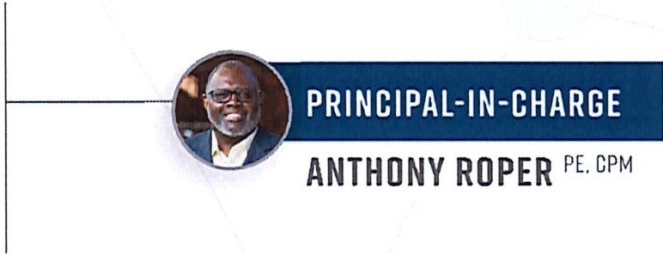
TEAM KEV
- TRANSYSTEMS (Prime)
- TRIMAT
- WOOTEN

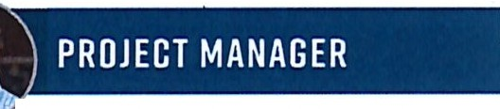
PRIMARY CONTACT

CHRIS PENDERGRAPH PE,CPM

CHRIS CORRIHER PE

{i.)Hl,11111
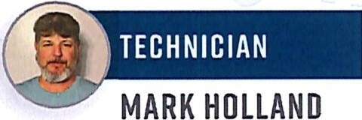
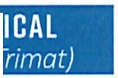
WILL POPE PE
®'WPi


AUSTIN CARTER 

  - TEAM MEMBER OUALIFICATIONS

CHRIS PENDERGRAPH PE, CPM I PROJECT MANAGER
EDUCATION BS, Civil Engineering
REGISTRATIONS PE, NC (#027420); Certified Public Manager, NC
RELEVANT EXPERIENCE
27 years of road maintenance+ asset management experience
    - Prior NCDOT D4 Division Maintenance Engineer managing all aspects of maintenance on 6,000+ miles of roads in 6 counties, 350+ employees, and± $100 M per year maintenance budget
    - Managed Division 4's resurfacing and pavement preservation programs; roadside environmental programs; traffic services programs; and county road maintenance programs
    - Also served with NCDOT as a District Engineer, County Maintenance Engineer, and Assistant District Engineer
    - NCDOT, State Maintenance Operations + Chief's Office Support
    - NCDOT, Division 6, District Office Support

ANTHONY ROPER PE, CPM I PRINCIPAL-IN-CHARGE
EDUCATION BS, Civil Engineering
REGISTRATION PE, NC (#021141); Certified Public Manager, NC
RELEVANT EXPERIENCE
    - 34+ years of experience in project administration, project management, and leadership in the public+ private sectors
    - Responsible for overseeing asset inventory and asset management services, maintenance operations, contract administration, and life-cycle cost analysis procedures
    - City of Dunn, 2021 Pavement Condition Survey/Pavement Asset Management Plan
    - City of Mount Holly, Street Improvement Projects
    - City of Salisbury, PCS, Paved Street CIP, + Parking Lot Assessment
    - City of Wilson, Pavement Condition Survey, 2017

CHRIS CORRIHER PE I OA/OC MANAGER
EDUCATION BS, Civil Engineering
REGISTRATION PE, NC (#019324)
RELEVANT EXPERIENCE
36+ years of experience in field operations/maintenance, project development, project administration,+ project management
    - Highly experienced in planning, managing,+ supervising highway maintenance+ construction operations; adhering to standards and safety procedures; and overseeing large project operations including scheduling and technician oversight
    - Wealth of experience managing projects and working with municipality and county personnel
    - City of Dunn, 2021Pavement Condition Survey/Pavement Asset Management Plan
    - City of Mount Holly, Street Improvement Projects
    - City of Salisbury, PCS, Paved Street CIP, + Parking Lot Assessment

TRANSYSTEMS City of Dunn • Engineering Services for Street Paving Projects II 2





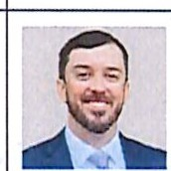
MARK HOLLAND
TECHNICIAN
CERTIFICATIONS ABC Nuclear Density; ABC Sampling; Borrow Pit Sampling; Concrete Field Testing; Conventional Density; Film Badge Recipient; Nuclear Safety/Hazardous Materials; QMS Density Gauge; QMS Roadway; Erosion & Sediment Control Level II
RELEVANT EXPERIENCE
- 28 years of transportation construction + surveying experience.
- Lead Project Inspector for urban widening projects that provide capacity improvements, have utility coordination and installation, significant storm water, concrete flat work, asphalt paving, pavement markings and signage, and signal installations.
- Extremely proficient at sedimentation + erosion control observation and monitoring of traffic control devices
- Strong leadership in claims avoidance and project closeout
- City of Dunn, 2023 Street Improvements
- NCDOT, NC 24 Widening Sections A+ B

TYLER OVERBY PE
DRAINAGE DESIGN
. EDUCATION BS, Biological Engineering, Environmental Concentration
REGISTRATION PE, NC (#052042)
CERTIFICATION Erosion & Sediment Control Level Ill, NC (#4140) RELEVANT EXPERIENCE
- 9 years of experience in the hydrologic + hydraulic engineering
- Experience designing_open + closed drainage systems, storm drain pipe systems, ditches, culverts, hydraulic modeling, water/sewer utility construction plans+ design, erosion control measures, plan preparation, redline drainage plans
- City of Raleigh, Barwell Road Improvements
- Town of Cary, Intersection Improvements
- NCDOT, NC 87/NC 11 Intersection Upgrade to Interchange
FABIEN LUKEBA PLS

SURVEY
EDUCATION AS, Civil Engineering; AS, Surveying REGISTRATION PLS, NC (#L-5448)
RELEVANT EXPERIENCE
- 25 years of surveying experience managing design + constructions projects for municipalities, NCDOT, federal, and private sector clients
- Retired 23 years with NCDOT, and has significant knowledge of the processes, procedures,and NCDOT requirements
- Strong program + project management
- City of Raleigh, Avent Ferry Road
- Town of Garner, Garner Road and Aversboro Road Sidewalk
- Wake County, Louis Stephens Road Design Survey
- NCDOT, Wake Forest Bypass Location Surveys
- NCDOT, Morganton Road, HD Laser Scanning

AUSTIN CARTER
GEDTECHNICAL TESTING fTRIMATJ
CERTIFICATIONS Concrete Field; QMS Roadway; QMS Nuclear Gauge; Conventional Density; ACI Concrete Field
RELEVANT EXPERIENCE
- Exceptional knowledge of construction materials testing in the field for asphalt, soils, and concrete
- Extensive experience in concrete testing, asphalt roadway operations, and asphalt paving
- Serves as Asphalt QC Technician performing QA/QC for asphalt construction including monitoring asphalt placement, ambient/asphalt temperatures, subgrade suitability, and checking density, taking cores
- NCDOT, US 70 Bypass
- RDU, Park and Ride 3
- RDU, Taxiway E
WILL POPE PE
DESIGN CRITERIA & PLAN DEVELOPMENT
EDUCATION BS, Civil Engineering REGISTRATION PE, NC (#052550)
RELEVANT EXPERIENCE
- 7 years of experience as a transportation designer and utility coordinator
- Experienced in managing/ preparing land use+ transportation plans
- Experience in access management design, including roadway widenings, corridor and area plans, sidewalks, multi-use paths, greenways, and protected bike lanes
- Coordinates+ develops utility relocation plans
- NCDOT, U-5729 US 421Carolina Beach Road Improvements
- City of Concord, Pedestrian Improvement Project

BRIAN OSCHWALO PE
WATER/ SEWER (WOOTEN)
EDUCATION BS, Civil Engineering REGISTRATION PE, NC (#038689)
RELEVANT EXPERIENCE
- 17+ years of experience industry experience
- Experience with NC municipal governments+ utilities
- Personally vested in managing successful projects on time and within budget, recognizing the equal importance of technical expertise and fostering trusted relationships
- Led projects for both new and rehabilitated wastewater conveyance systems, includes collection and interceptor sewer mains, and wastewater pump stations and force mains
- Brian is invested in community well-being beyond ensuring reliable public infrastructure, serving on the Salvation Army of Wake County's Advisory Board

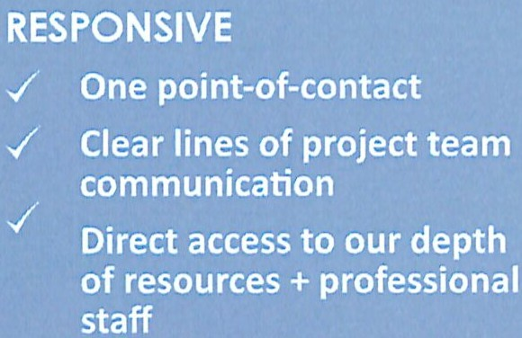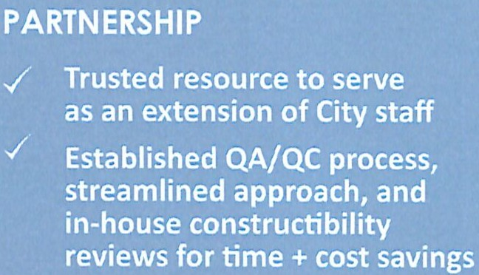
EXPERIENCED PROJECT TEAM
if!)

TRANSYSTEMS City of Dunn • Engineering Services for Street Paving Projects // 3

SCOPE OF SERVICES
  - PROJECT UNDERSTANDING
The TranSystems team understands the City of Dunn has a vision of improving both its street network and water/sewer network by improving both through strategic rehabilitation, maintenance, and preservation. Dunn recognizes the City can increase and improve the connectivity to the community, improve the visual vibrancy downtown, and maintain a
high quality of life through strong leadership and strategic planning. We believe for a community to thrive and prosper, timely investments to improve, sustain, and strengthen infrastructure are paramount.
TranSystems also understands the City is seeking a licensed and well-qualified engineering firm to provide timely,
cost-effective professional design services for a pavement
rehabilitation program based on their 2021 Pavement Condition Survey (PCS). This would include evaluating and analyzing pavement repairs, general street repairs including curb and gutter and ADA ramp compliance, sidewalks, pavement preservation techniques, and various asphalt treatment recommendations.
TranSystems is an industry leader in providing transportation infrastructure asset management to include paved streets and construction oversight. We offer an experienced
team with a vested interest in the City's success. We fully understand and support the City's need for proven project management and development, verifying the right repairs for each street, and technical expertise on this project. You can count on the TranSystems team to provide first class subject matter expertise to City staff from Notice-to-Proceed through project completion.
The TranSystems team visited several streets listed in the PCS to increase our understanding of the failures, repair recommendations, identify potential key challenges,
and develop the best approach to achieve successful completion of the projects.
This project will have construction limits through neighborhoods and will affect the safety and mobility of the residents, businesses, churches, schools, and/or other entities that rely upon access to these streets. Additionally, the TranSystems team is aware that water and sewer utility improvements are also planned and, provided that funding is available, the street improvements/utility improvements should be fully coordinated to provide the City the most value for the dollar amount spent. The TranSystems team has the requisite experience to lead the design, planning, and construction of the improvements in a manner that
will reflect well on the City and have as minimal impacts to the traffic flow as possible.

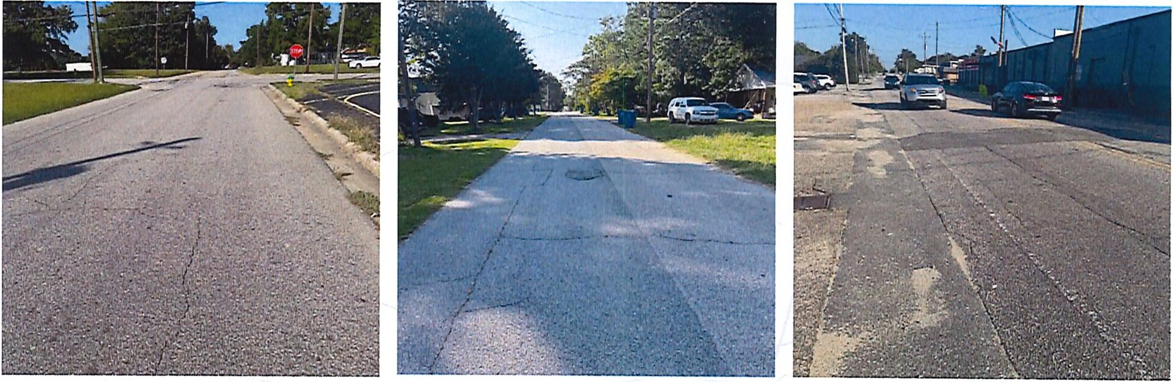
For this project, Chris Pendergraph, PE, CPM will serve as the Project Manager and Chris Corriher, PE will provide QA/ QC management and pavement design technical expertise.
Prior to joining TranSystems in April 2023, Chris Pendergraph spent over 27 years with NCDOT in the roadway and pavement management field. He has extensive experience in leading teams and projects, stormwater drainage, project budgeting, pavement management, and pavement preservation.
His experience in selecting and applying the right surface treatments on the right roads at the right time will certainly be an asset to this project.
Chris Corriher has 36 years of experience including 31+ years with NCDOT serving the last 23 years of his NCDOT career as a District Engineer in the Salisbury Office. He has extensive experience in developing projects, writing contracts, contract
administration, project management, pavement management, and pavement preservation. Since joining TranSystems, Chris has managed several Pavement Condition Survey projects, as well as assisted municipalities with contract resurfacing, pavement repairs, and technical assistance. His most
recent project experience involved evaluating the proposed treatments from a PCS including crack seals, patching, preservation, rehabilitation and reconstruction of streets in Mount Holly. He also evaluated drainage pipe and structures, curb and gutter repairs, and identified the proper ADA compliant ramp treatments for sidewalk sections.
Will Pope, PE will lead the Design Criteria & Plan Development phase of this project. Will has over seven years of experience in leading and designing public and private transportation projects. He is experienced in managing and preparing transportation plans for roadway, pedestrian, and bicycle facilities as well as feasibility studies. He also has
experience coordinating and developing utility relocation plans.
The TranSystems team has substantial experience in providing the required scope of services on similar NCDOT and municipal projects. From initial pavement evaluation through

construction and final acceptance of the project, our team's collective experience in pavement treatment and reclamation applications, design, permitting, bidding, and contract administration will prove valuable throughout the life of this project.
TranSystems is excited about the opportunity to assist the City of Dunn again. Ourteam is comprised of experienced professionals to provide the necessary expertise for any challenges as the scope of work for this project is built out.

- KEY CHALLENGES
Our team conducted a site visit and has identified certain challenge areas associated with the successful completion of the projects included in the City's RFQ. Our experienced team members are familiar with recognizing areas of concern for the City of Dunn and will work to implement a response-conscious and solutions-based approach in resolving potential challenges.

UNDERSTANDING SITE CHALLENGES/ TranSystems
conducted a site visit to better understand the severity and extent of the pavement distresses that were present. TranSystems also reviewed the city's utility improvement plan to get a better understanding of the type and location of the utility improvement projects.
BENEFIT TO CITY/ TranSystems offers experienced engineers and technical experts who recognize various distresses and recommend different pavement repair solutions. The team recognizes if funding is available, making the utility improvements prior to repaving the streets is a cost saving method that will save the City not only financially but also strategically. The public
certainly has no desire to see a newly paved road, shortly thereafter, cut open for utility work.

TRANSYSTEMS City of Dunn • Engineering Services for Street Paving Projects // 4

Key challenge areas include:
SAFETY
POTENTIAL CHALLENGE Safety is our number one priority. Our company safety culture is the essential component in all our projects. Our technicians are trained and experienced in industry safety and OSHA requirements. Working closely with the contractor(s) and the City, we will strive to maintain the highest standards in safety for the project team and public. Our goal is that everyone that enters our work zones returns home at the end of the workday the same way they came
to work that morning. We take to heart the saying "Safety is Everyone's Responsibility".
Residents+ Pedestrians Safety. TranSystems' safety awareness, and our safety culture, extends to everyone that accesses any of our projects -the residents who live within the project limits, pedestrians who walk on the sidewalks or streets, contractor personnel, and all inspection staff (City/CEI). Our team will serve as an extension of the City's staff to monitor safe, adequate points of access to reduce conflicts within the project work zones.
TRAFFIC CONTROL/ CONSTRUCTION PHASING
POTENTIAL CHALLENGE Many of the proposed projects will be constructed within residential communities and the proposed street improvements will cause disruption to each neighborhood during construction. Specifically, significant utility repairs and/or mill and fill repairs are very disruptive and can cause substantial impacts to access and traffic flow. The TranSystems team will work closely with the City to coordinate and to provide timely communication with the affected residents.
In prior contracts TranSystems has identified areas where more restrictive work times may be necessary. Delaying lane closures until after the peak hour is sometimes a viable option as is opening lanes back up for the PM peak hour traffic. TranSystems will work with the City to identify and address these type concerns.
Providing safe ingress and egress points to the multiple residents and businesses along each street project will be the primary point of emphasis of the traffic control plan. Our project staff will be informed and prepared to adapt to changing field conditions or stakeholder needs. We will ensure that consistent communication and coordination between TranSystems staff, the contractor, the City, and key stakeholders be a part of the traffic control plan.
EXISTING UTILITIES/UTILITY UPGRADES
POTENTIAL CHALLENGE The project will encounter existing utility conflicts as the corridor contains underground utilities and the City plans underground utility upgrades primarily water and sewer. We also know how imperative it is to not cause any disruptions with the existing utilities.
With some major reconstruction being considered for various street improvements, TranSystems understands special care will be required due to the presence of the sewer, water, and stormwater infrastructure under the pavement. We also note multiple places where utility repairs have already occurred, highlighting the fragile nature of these assets.
Regarding underground utilities, unexpected interruptions in service are unacceptable to the residents, churches, and businesses within the area. Our team will work diligently to
communicate with the citizens, the City Public Works, and the contractors throughout the life of the project to ensure that available precautions are taken to avoid service disruption.
The utility providers will be included in each phase of the project, planning, design, and construction.

  - APPROACH
TranSystems understands the project consists of the review and evaluation of areas identified in the PCS and the staff's recommendations. After discussing the report with City staff, we will begin to prepare contract documents suitable for competitive bidding. This will be followed closely by leading the City in securing bids, analyzing bids, and letting the contracts.
The TranSystems team's overall objective is to assist the City of Dunn in delivering this project within scope while staying on schedule and within budget. We will accomplish this by acting as an extension of City staff by managing the design, the contract document development, the bidding process, the contract administration, and the construction management while working with City staff and key stakeholders.
By following a deliberate process of project management, we help ensure the project meets the time and budget expectations. We use a combination of tools to maintain project schedules and budgets including an internal Project
Planning Tool, a combination of internal and external meetings,
and by establishing intermediate deadlines during the overall process to allow checks on the overall progress of the work.
As the Project Manager, Chris Pendergraph, PE will serve as the primary Point-of-Contact for all communication. He will
keep team members informed of the current project status and maintain open communication with the City. Chris is diligent in answering questions and resolving issues/concerns quickly and efficiently to maintain the project's schedule and progress.
PAVEMENT ANALYSIS
Chris Pendergraph and Chris Corriher will lead and collaborate the TranSystems team's review and analysis of the City's proposed pavement treatment recommendations/repairs. They will provide the City with well reasoned and thoughtful lists of pavement treatment recommendations that will provide the most benefit to the City's street network.
TranSystems will utilize the 2021 Dunn Citywide PCS data, the repair recommendations from the PCS report, and the
5-year Pavement Implementation Plan to aid in the design and implementation of the City's rehabilitation project. Field visits to evaluate any changes in deterioration and field conditions will be incorporated as needed.
We will identify the existing pavement structure and work with City staff to determine maintenance history for each street. When necessary, this will include the identification of existing pavement structure and subgrade characteristics
through coring and dynamic cone penetrometer testing. Coring of the pavement structure allows us to positively identify
the pavement types and thicknesses present. Dynamic cone penetrometer testing with hand auger borings will allow us to identify the underlying subgrade characteristics as they pertain to pavement support and drainage characteristics. TranSystems prior work in Dunn has shown our team to expect a nominal pavement thickness in many areas of the City.
After thoroughly identifying the existing conditions of the pavement, we will discuss any maintenance activities that have occurred to understand how previous activities have performed. Having a thorough understanding of the pavement service life history will help ensure the proper treatment is selected. The final step in our evaluation is to identify the
expected traffic loading conditions and drainage characteristics of each road. Traffic loading will be utilized for analysis in later steps of the process for treatment type selection.
The TranSystems team will provide geotechnical services and testing on an as-needed basis. These services may be needed to confirm existing pavement and roadway base conditions. The results of these investigations will be utilized to properly develop or confirm maintenance/rehabilitation procedures and materials to provide pavement designs.
CREATIVE SOLUTIONS: PAVEMENT REPAIR SELECTION
PROCESS Considered to be pavement management experts across North Carolina, the TranSystems team has provided its clients with successful pavement management strategies
addressing numerous pavement condition scenarios. Members of our team have been responsible for the design, construction, and management of various pavement systems including neighborhood streets and interstate highways.
Our successes can be attributed to complete designs rooted in experience and a thorough understanding of what works. A big part of this understanding includes how to balance performance with budgetary realities. Our team understands that the most effective pavement management approach
includes the right treatment on the right road at the right time. What is "right" is highly dependent on numerous factors, some that are easily measured such as road class,.distress type, and severity, versus budgetary requirements. Other factors can
be more experience-based, such as contractor availability, local experience with materials, performance expectations,

TRANSYSTEMS City of Dunn • Engineering Services for Street Paving Projects // 5

INNOVATIVE METHODS:
Contract Methods
TranSystems can develop and present to the City different contracting methods that can be incorporated in the bid documents in a way that can reduce risk for the City while lowering the overall cost to the project. Contracting methods like floating availability dates have proven beneficial on other projects.

achieving an appropriate blend of treatment types for short­ term and long-term goals, and the creation of reoccurring maintenance demands.
Our engineers will also work with the City to find the best alternate methods of repair. These methods will be approved by the City prior to being incorporated into the
plan. Our prior experience working in Dunn provides us with the knowledge of the local contractors capabilities, some of which specialize in various seals. The seals include slurry seals, microsurfacing, AST and Cape seals (combination of AST with slurry on top.) Certain seal combinations will prevent further cracking and provide a smooth riding surfacing without the expense of milling and repaving every street - one of the most expensive solutions available.
Our Asset Management and Maintenance philosophy of choosing the right treatment for the road at the right time has and will serve us well when reviewing the roads proposed to be repaired or resurfaced. With extensive knowledge gained from the Pavement Condition Survey and the 2023 paving contract, combined with the knowledge of Dunn's utility improvement plan makes us confident we can lead the City through the process efficiently and effectively.
SURVEY
TranSystems offers comprehensive surveying services for a wide range of projects for public and private sector clients. We have performed numerous types of surveys
including boundary, topographic, aerial, wetland locations, utility locations, route locations, monitoring, scanning and construction layout. We are proud to have some of the most talented survey/professionals and technicians in the industry on staff.
DRAINAGE DESIGN
The TranSystems team will draw upon our extensive understanding in hydraulic analysis and design from NCDOT and municipal roadway projects. The priority will be to select the appropriate design to maintain existing drainage patterns while at the same time minimizing impacts on
adjacent properties. We are very familiar with NCDOT policies, procedures, and expectations regarding the preparation of hydraulic design and drainage studies (Tier I and Tier II) as well as Erosion Control design guidelines.
UTILITY DESIGN+COORDINATION
Both TranSystems and Wooten are experienced in providing utility design and coordination services. Although every effort will be made to avoid, minimize, or mitigate utility conflicts, our team is prepared to design any required water or sewer utility relocation or upgrade required as a result of the paving rehabilitation project. Wooten will lead any required water and sewer design effort in conjunction with TranSystems overall project oversight. Wooten has completed water and sewer projects for multiple municipalities including Dunn and are familiar with all phases of the utility design process to include scoping, permitting, and contract bid document preparation.
DESIGN PLANS,SPECIFICATIONS,+ESTIMATES
Our team will develop a distinct set of contract documents for obtaining bids and performing the construction of the improvements mentioned in this RFQ. The improvements contained in the documents will include the pavement recommendations from the pavement analysis as well as any
needed drainage, water, or sewer infrastructure. Included with the documents will be an estimate of probable construction cost. This estimate will be utilized by the City to assist in balancing the cost between each set of documents and to maintain the project cost within approved City budgets. The following tasks will be part of our approach:
CONSTRUCTION PLANS+ SPECIFICATIONS
Construction plans and specifications will be prepared for and it is understood that the following items may be included:
» Full-depth reconstruction and paving
» Pavement mill patching- surface and full-depth
» Pavement removal/replacement including subgrade failure repairs
» Crack seals and preservation (not to include AST)
» Evaluating other innovative means of street preservation including slurries, micro surfacing, and Cape seals
» Asphalt overlays including thick overlays and thin lifts
» Crack sealing and repairs
» Any other repair activity included in staff recommendations or the City PCS
» Drainage, water, and sewer infrastructure repairs or upgrades as needed.
PLANS
Plans will be incorporated into the project for bidding and construction purposes. The plans will include the estimated quantities of materials to be utilized to complete the repairs and maintenance procedures. Plans to be reviewed and approved by the City.
PLAN SUBMITTALS The TranSystems team can deliver plan submittals electronically or in hard copy format. Included with each submittal will be an estimate of probable construction cost based on the progress plans developed. Plan submittals will include any approved changes recommended by the TranSystems pavement evaluation team.
BID DOCUMENTS
The TranSystems team is well equipped to prepare bidding documents for each construction project. We can coordinate with the City and will conduct a pre-bid meeting with perspective bidders if needed. Our team can issue plans to bidders, address technical questions from bidders through the bidding process, publicly open bids for each project if appropriate and needed, develop a bid tabulation, and make recommendations to the City regarding award to the lowest qualified bidder.
CONTRACT DOCUMENTS
The TranSystems team will prepare documents for the City to enter into a contract for construction with successful bidders. The final design plans and specific2tions that are 100% complete, with the final engineer's opinion of cost for the construction contracts, will address the City staff's goals,
comments, questions, and concerns. Chris Corriher will assist
Chris Pendergraph in preparing the bid package and leading the City through the letting process. Previously in Dunn, Chris Corriher developed the resurfacing projects list, prepared
the contract documents, let and administered the contracts for resurfacing for the City. His expertise in developing contracts, familiarity with Dunn area contractors, and contract administration will be an asset to this project.

- CONSTRUCTION ASSISTANCE
GENERAL REVIEW
TranSystems recommends the City's investment in pavement repairs and reconstruction be protected with certified, thorough, QA/QC using certified asphalt technicians/ inspectors. TranSystems can provide a general review of City staff should they be those inspectors. We will monitor and discuss project progress and work quality/issues in progress meetings with the City and Contractor. If the City does not have inspectors, TranSystems can provide the correct number of inspectors and experience as described below.
CEIAPPROACH
The TranSystems team is capable of providing experienced, qualified, and knowledgeable technicians to inspect the contractor's work daily to help ensure compliance with contract documents. This ensures the contractor's quality control is sustained. Our electronic record keeping and

TRANSYSTEMS City of Dunn • Engineering Services for Street Paving Projects // 6

document control allow the City access to all project files at any time, providing a current and accurate overview of project progress and the City's immediate notification in the event of any deviation from the original contract quantities.
Personnel assigned to the project are properly trained and certified by NCDOT in the required sampling and testing tasks to which they are assigned. They are knowledgeable on proper inspection duties, preparation of daily diaries, maintaining neat and accurate pay record books/reports, and sampling/ testing procedures. Technicians are competent in performing field measurements of quantities and reviewing monthly pay applications for accuracy.
The TranSystems team's overall objective is to be an extension to the City acting on their behalf to ensure the project is constructed in accordance to plans and specifications. We
will ensure proper documentation is obtained and processed, project issues are corrected, and resolutions obtained quickly while delivering the project within scope, on schedule, and on budget. We will accomplish this by managing the following:
EXPERIENCED LEADERSHIP The TranSystems Project Management team is particularly experienced in drafting RFl's, work change directives, and change orders to help ensure any construction changes are negotiated in the best interest of the citizens of Dunn.
PRECONSTRUCTION CONFERENCE The preconstruction conference sets the tone of the project and organizes all pertinent information while identifying project roles and documentation requirements. It also assigns contractor responsibilities and identifies the project progress schedule. Our team will:
» Conduct and produce preconstruction meeting minutes
» Produce attendees list
» Prepare a concise description of project specifics
» Review and transmit contractor project schedule
» Review and assemble contractor submittals
» Identify project issues raised at this meeting
» Record action items
» Prepare emergency contact lists
CITIZEN CONCERNS The TranSystems team is willing and ready to meet with the citizens of Dunn as questions arise. Our engineers and technicians conduct themselves in a polite and professional manner. They will know the project and its details and be familiar with the affected citizens that commute and live in the project vicinity. The TranSystems team will provide answers to their questions and, if necessary, direct them to the next level in the Chain of Command to help meet their needs.
DAILY REPORTS+ DOCUMENTATION Our technicians have the experience to produce daily inspection reports, materials tracking/certification, certified payrolls, DBE compliance, and provide project documentation control in accordance with
NCDOT standards. The TranSystems team is currently utilizing a SharePoint website to share timely, transparent, responsive, and accurate project information, photo logs, note damaged areas, track documentation, and manage correspondence and approvals between our staff and City personnel. We convert all paper documents digitally for easy file sharing. We also have a
project spreadsheet to log material submittals and Requests for Information (RFls) denoting those items that are time-sensitive and require approval alerts to keep information flowing. Project submittals are identified, entered, and noted for resolution. All documentation identified and necessary for project closeout
is logged. We also specify if the document is for informational purposes or will require further approval authority.
Our technicians are efficient in determining project pay quantities with the appropriate method of measurement and payment.
Payment quantities are confirmed with contractor personnel prior to monthly pay dates for accurateness and to manage project quantities to avoid overruns. We are also well versed in documenting appropriate project material certifications and verification.
REVIEW MATERIAL SUBMITTALS Coordinated with our management information system, project submittals are identified, entered, and noted for resolution. All
documentation identified by the NCDOT and necessary for project closeout is logged. We also specify if the document is for informational purposes or will require further approval authority.
PROGRESS MEETINGS The TranSystems project management team is extremely skilled at conducting pre- and post-paving inspection, and the regularly scheduled progress meetings.
TranSystems is prepared to conduct project meetings to address project issues, scheduling, review submittals, review contractor payment requests, and predict potential issues. Project meeting minutes will be prepared and submitted to the City. The TranSystems team is uniquely qualified for this service and will be readily available and responsive to your needs.
ISSUES MANAGEMENT The TranSystems team employs constructability reviews of existing plans, project manual, and special provision to address any contract administration deficiencies in design; potential construction conflicts; quantity overruns; and potential future maintenance issues.
We have learned if we can identify these issues early, they can be addressed to minimize project delays and avoid project overruns.
The TranSystems team will utilize this process at the construction plan/document phase through constructability reviews, as well as during construction once field conditions are identified.
SCHEDULE Monitoring project scheduling will be ongoing.
It will be formally addressed at our progress meetings to proactively address project concerns. In the event that project staff encounter ope·rations that may negatively impact either project, we will communicate with City staff immediately and respond with a proposed action plan.
COST CONTROL Project cost reviews will be monitored as the monthly estimates are submitted and paid. Project staff will provide careful oversight of project material usage to prevent quantity overruns. If project quantities have been
underestimated, we will alert the City immediately. These line items are often caught in our constructability reviews.
CHANGE ORDERS Our team has the expertise to identify potential change orders and the knowledge of municipal and NCDOT processes in addressing limits of approval. If contract items are overlooked, or if extra work is identified, we can provide resolution and develop project estimates that can be utilized as a change order with the City's best interest in mind.
CLAIMS AVOIDANCE Every project typically has some type of dispute ranging from a small quantity discrepancy to a
claim by the contractor that the scope of a project or item has been changed from what was bid. Our team is experienced in resolving disputes. It is our philosophy that disputes are best resolved at the lowest level possible; then elevated as needed to resolve. Our team will look to resolve a dispute at the project level first involving the inspection team and contractor personnel. Then, if needed, will be elevated to the TranSystems Project Manager and the contractor Project Manager/ Superintendent. Larger more complex issues are elevated
to include TranSystems project management, contractor management, and City personnel to try and resolve the issue. Our team has been very successful at dispute resolution with only a small handful of disputes making it to the final step.
MATERIALS TESTING+ REPORTING Our NCDOT-certified
technicians will adhere to the sampling and testing frequencies and perform materials tests per the NCDOT Standard Specifications and Minimum Sampling Guide. Our team will then work to ensure all construction materials incorporated in the project are approved with appropriate documentation. All materials incorporated into the project will have a proper bill of lading, invoicing, and certifications prior to being installed
and accepted for payment to the contractor. Field sampling and materials testing of all construction materials is included in our technician rates.
In addition, our team member Trimat will be performing construction materials testing at their NCDOT-accredited laboratory in the Research Triangle.

TRANSYSTEMS City of Dunn • Engineering Services for Street Paving Projects // 7

PROJECT EXPERIENCE
CITY OF DUNlt 2021 PAVEMENT CONDITION SURVEY
DESCRIPTION TranSystems provided all labor, equipment, and engineering supervision necessary to perform a City-wide street PCS Study for the approximate 66-miles of City-maintained streets. The project included the evaluation of all City-maintained streets, preparation of a final report including recommended maintenance activities, and presentation of the
PCS findings to the City Council. The TranSystems assessment team utilized the Long-Term Pavement Performance (LTPP) method to collect the distresses. The QA/QC team verified results in the field.
COMPLETION 10/2021 CONTACT Steven Neuschafer, 910.230.3500, sneuschafer@dunn-nc.org

DESCRIPTION In this street improvement phase, the City asked Transystems staff to develop a pavement management strategy implementing several strategies to improve the street system. This strategies included patching, crack sealing, milling and resurfacing, and alternate paving methods with a goal of utilizing the most mileage. Staff
worked with the City on options which avoided already scheduled utility improvement projects.
COMPLETION 10/2022 CONTACT Steven Neuschafer, 910.230.3500, sneuschafer@dunn-nc.org
IrmQQNiiN•i•ii11iiiiitA•tfiii@i•Wij;i@HMit..-
OESCRIPTION After developing a plan to improve Dunn's street system,
the City asked Transystems to develop bid documents to let a contract for the proposed work, including searching for interested contractors, holding a prebid meeting, providing plans, bid documents, and answering questions. After the bid opening, Transystems reviewed and verified the bids and made a recommendation of award.
Transystems then held a preconstruction meeting with the contractor and City establishing a schedule for the work. While managing the contract, Transystems worked with the City on any desired changes, documented inspection of contraction materials and construction methods, provided claims avoidance, coordinated with the City the work schedule, and provided QA/QC.
COMPLETION 6/2023 CONTACT Steven Neuschafer, 910.230.3500, sneuschafer@dunn-nc.org

CITY OF DUNN,
-
--
WATER/SEWER CAPITAL
IMPROVEMENTS
DESCRIPTION Wooten prepared a water/wastewater CIP and proposed a water/sewer fee system to fund costs attributed to new development (System Development Fees). 100+ water/sewer projects were scored, estimated for cost, and analyzed with the City's future growth and development plans. After significant coordination with City staff, 18 wastewater and 30 water projects were analyzed for engineering feasibility and included in a 20 year CIP. The approved CIP, water/sewer operating costs, revenues, and other City supplied data were used to produce a System Development Fee schedule using AWWA Ml approved methodologies. The CIP and System Development Fee schedules were presented to the City council for adoption and incorporation into the City's budget and future growth plans. The City is moving forward with the CIP and System Development Fee schedule.
COMPLETION DATE 9/2022 CONTACT Heather Adams, 910.892.2948, hadams@dunn-nc.org

DESCRIPTION The project included crosswalk improvements, River Park improvements, Belmont/Mount Holly sidewalk improvements, and Blanche Avenue to Beatty Road drainage improvements. The improvements included grading, drainage installation, sidewalk, concrete curb and
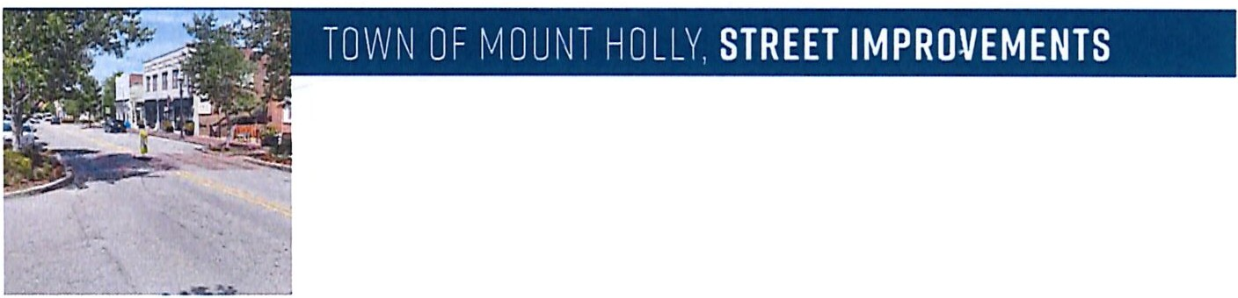
gutter, milling, asphalt paving, asphalt patching, asphalt crack sealing, asphalt surface treatment, thermoplastic pavement markings, and erosion control installation. TranSystems' CEI services included QA/QC oversight,
construction materials testing, document control, contract administration, quantity verification, erosion control inspections, traffic control inspections, project claims avoidance, and project closeout. Numerous plan errors were found with the proposed designed drainage to be installed on the project. The Transystems team notified the City immediately of the plan issues so they could contact the engineer of record to review the design and make any needed plan revisions and to also minimize any delay to the project.
COMPLETION 7/2024 CONTACT Tony Walker, 980.214.1332, tony.walker@myholly.us

DESCRIPTION TranSystems provided all labor, equipment, and engineering supervision necessary to conduct a PCS for all asphalt pavement street segments within the corporate Town limits. This consisted of all Town­ owned/maintained streets totaling 37 centerline miles. TranSystems provided QA/QC through field inspection and follow-up throughout the project. The Long-Term Pavement Performance (LTPP) PCS Rating Method recommended by the FHWA was used to collect the following distresses:
structural (alligator) cracking, transverse cracking, block cracking, patching/potholes, surface defects (raveling), rutting/roughness, and reflecting cracking. All data was collected/compiled into a comprehensive summary report that provided a PCI Rating for each street segment and an overall
PCI Rating for the whole street system. TranSystems developed a 10-year CIP and presented findings/ results to Town Council.
"TheTown of Southern Shores isfortunate to have the relationship with TranSystems [formerly SEP/] that it does. For many years we were planning street improvement projects without a true assessment of the pavement condition. TranSystems has a tremendous amount of talented and professional staff that have guided us through the o new process of implementing a plan based off a PC/. The C/P that they put together will allow us to improve more streets with lessfunding. The extra care they take to insure project success goes along way towards educating staff and elected officials. We look forward to working with TranSystems in thefuture." - Cliff Ogburn, ICMA-CM, Town Manager
COMPLETION 8/2021 CONTACT Cliff Ogburn, 252.261.2394, cogburn@southernshores-nc.gov

DESCRIPTION TranSystems conducted a PCS on all City-maintained streets using the LTPP Methodology. The street system consists of 170+ miles of
paved streets and roads of varying conditions and configurations including both asphalt and asphalt surface treatment (AST) pavements and streets with and without curb and gutter. TranSystems also evaluated all (SO+) City-maintained parking lots including pavement rating and evaluation as well as provided proposed repair and maintenance recommendations for each asset. Lastly, TranSystems developed a five-year CIP including up-to-date cost estimates for each recommended treatment.
COMPLETION 1/2023 CONTACT Chris Tester, 704.638.5260, ctest@salisburync.gov

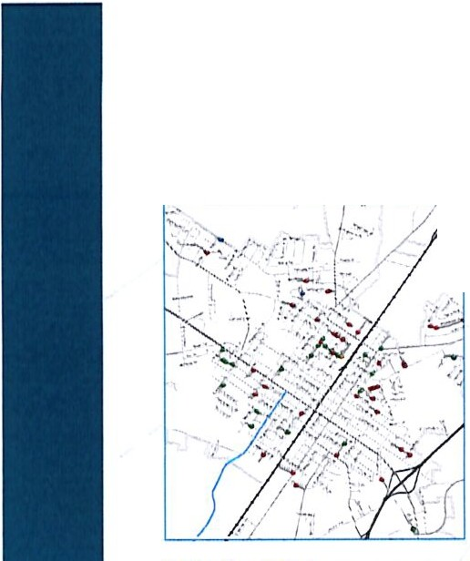
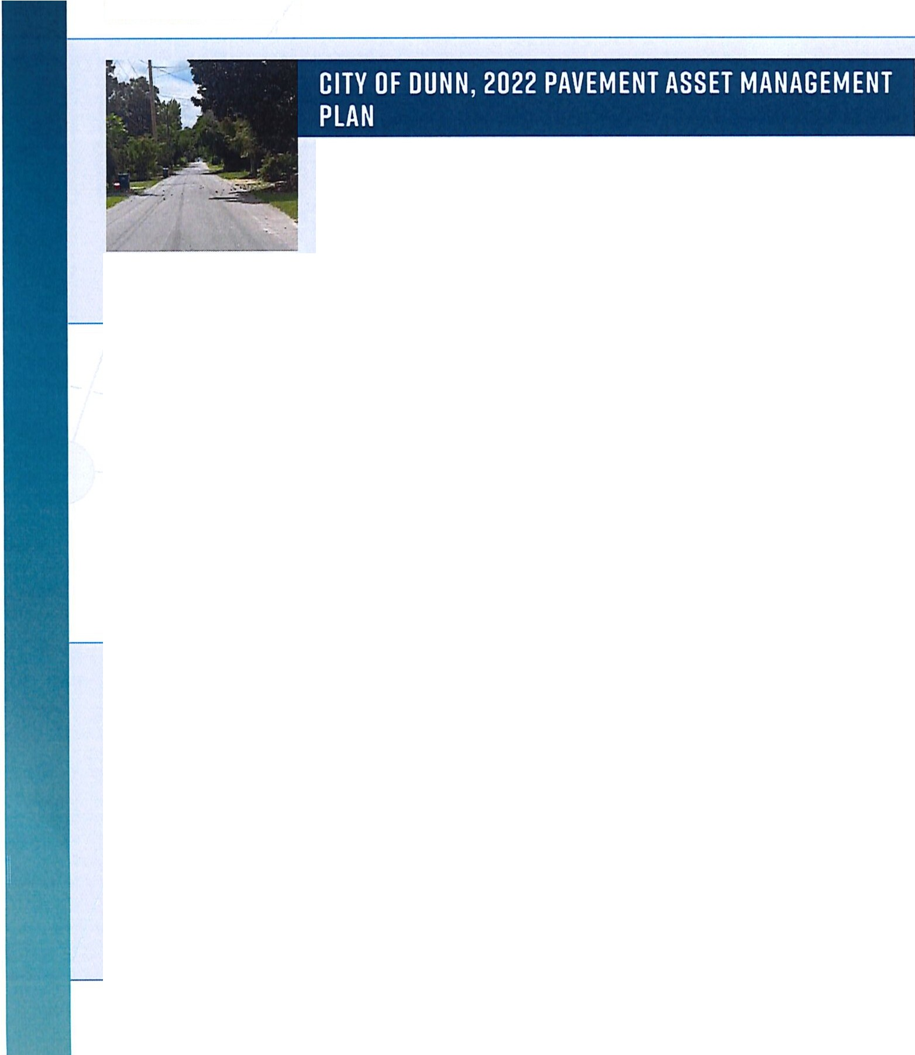
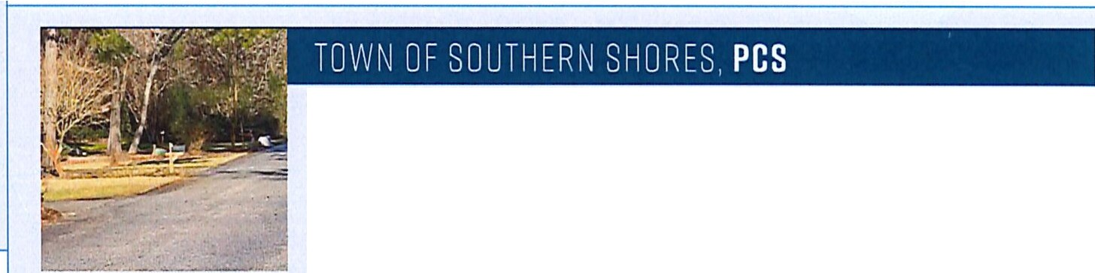
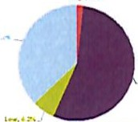

TRANSYSTEMS City of Dunn • Engineering Services for Street Paving Projects // 8

USDA COMMUNITY ENHANCEMENT LOAN EXPERIENCE
Wooten provides an important value-added service by assisting clients in the acquisition of State and Federal funds to help finance the construction of projects. Wooten has successfully obtained financial assistance from the Rural Economic Development Program since its inception. Wooten's experience with USDA-Rural Development dates back to the 1960's and USDA-RD's current grant/loan program continues to be a stable and reliable source of funding for community facilities, as well as water and sewer facilities.
Wooten has extensive experience in project development and grant writing for the following programs:
» USDA-Rural Development » HUD » US Economic Development Administration

» NC Clean Water Bond
» CDBG-I
» CDBG- NR/ CDBG-ED/ CDBG-CV
» NC Industrial Development Fund
» NC Department of Commerce - Rural Economic Development Division
» Golden LEAF Foundation
» NC Division of Water Infrastructure (Water/Wastewater/Stormwater/Lead Service Line)

.......................................................................................................................
RECENT USDA PROJECTS:

» Jones County EMS+ EOC
» Beaufort County Skills Training Center
» Beaufort County Community College-Allied Health Building

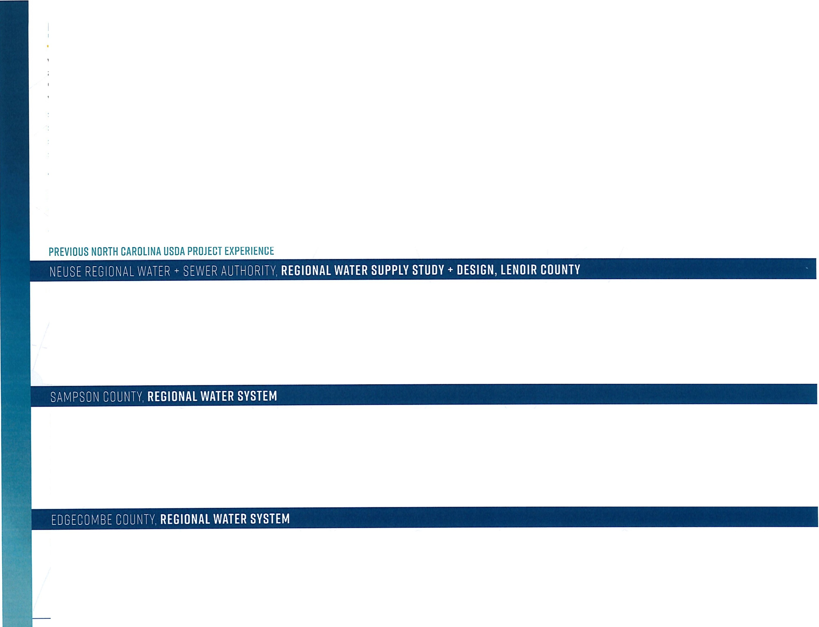
.......................................................................................................................

WINNER OF A 2005 ENGINEERING EXCELLENCE AWARD FDR STUDIES, RESEARCH ANO CONSULTING ENGINEERING SERVICES FROM THE AMERICAN COUNCIL OF ENGINEERING COMPANIES
DESCRIPTION The Neuse Regional Water and Sewer Authority (NRWASA) in NC provides treated water at wholesale rates to its eight member entities (retail providers) within Lenoir and Pitt Counties serving approximately 38,000 customers. Wooten facilitated a transmission main project for the authority which consisted of 38 miles of 42 inch through 30 inch mains extending from the 15 mgd regional water treatment plant on the Neuse River just west of Kinston, N.C. to the vicinity east of Ayden in the Eastern Pine Water Corporation service area. The project also included approximately 33 miles of 8, 12, 16 and 20 inch mains to deliver water at selected points within the eight member service area. In addition to the piping, the regional delivery system project included three elevated tanks (1.5 MG, 1.0 MG, and 0.75 MG), four booster pumping stations, 18 pressure reducing valves and metering stations with related appurtenances. Wooten saw the project through from inception to completion as it provided not only design services, but also construction contract administration and construction observation for the 1,200 pipes, 36 elevated tanks, 64 well pumps, and 7 booster pumping stations as they were installed. The
$66 million project's design was initiated in the last half of 2002 and construction was fully completed in 2008.

DESCRIPTION The Regional Water System project for Sampson County, NC received grant funding assistance from DENR, USDA-RD, the EDA, and the N.C. Rural Center. Wooten prepared a study in the early 1990's that covered all of Sampson County, the largest county in the state. The study addressed providing water in at least 4 phases. Water and Sewer District I was formed to provide water service along the NC Highway 24 corridor from county line to county line. District II was subsequently formed and three separate, but contiguous, project areas were identified. The District II-Phase I project consisting of about 135 miles of line was placed in service in 1998 and 2000. The Phase I (Part 2) project, consisting of 69 miles of 3" through 12." mains was placed in service in 2001. Construction of the District II-Phase II project consisted of 125 miles of 4" through 12" water transmission and distribution mains, an elevated storage tank and two booster pumping stations. Finally, the District II-Phase Ill and IV projects involved the design, bidding, and construction of over 100 miles of 4" through 12" water transmission and distribution mains and a 200,000-gallon elevated storage tank that serves approximately 950 customers. Overall, the Sampson County Water System consists of more than 550 miles of transmission and distribution mains. The total investment by Sampson County was approximately $31 million, of which approximately
$15 million were grant funds

DESCRIPTION Wooten assisted Edgecombe County in developing the first two phases of a county-wide water distribution system. Edgecombe County currently purchases water at a wholesale rate from the City of Rocky Mount and the Town ofTarboro for resale to county residents. Two Water and Sewer Districts have been formed and the construction of transmission and distribution lines in District 1 has been completed, costing approximately $4.S million. Funding was secured for District 2 and for a third service area in the County. The primary funding sources for the project were USDA Rural Development and the Clean Water Bond Grant fund. The organizational/management arrangement is to provide service to Edgecombe County through interlocal agreements and for the County not to compete in water and wastewater treatment. As a result, the County's resources have been used to provide service to as many residents as feasible.

TRANSYSTEMS City of Dunn • Engineering Services for Street Paving Projects // 9

PROGRESS SCHEDULE

PAVING PROJECTS
ENGINEERING SERVICES FOR STREET
NTP / Preparatory Work/ Project Kick-Off/ Project Setup
Review of PCS Recommendations & Proposed Utilitylmp_r_ov_e_m_e_nt_s
-->------;---

-J,---+----+----,,---li-
-
l J_ EXPERIENCED TEAM
-

Develop Maintenance/Repair Plan/ I
Resurfacing Recommendations _
Review Recommendations with City Staff
Prepare Project Documents/Bid Proposal/Advertise for Bids/Conduct PreBid Meeting
[
Open Bids/Make Recommendation of Award

I RESPONSIVE
One point-of-contact
Clear lines of project team communication
-
Direct access to our depth of
l resources+ professional staff

0
* *

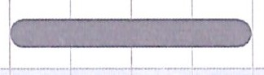
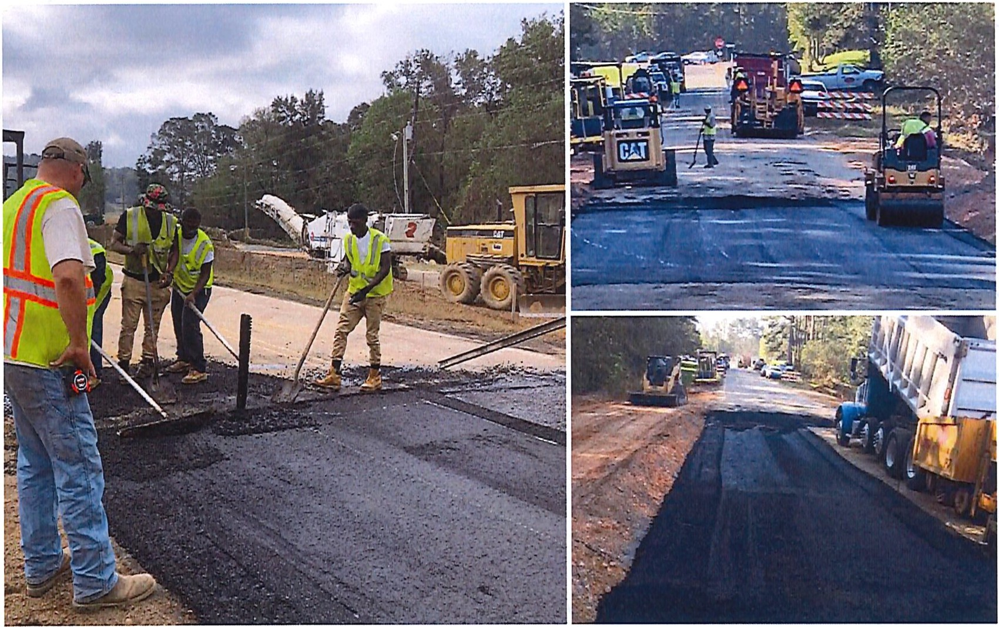
EXPERT
Innovative solutions, scaled to best fit specific project needs
Decades of experience in assessments, planning, design, and repair projects

o..Q. o
mm
PARTNERSHIP
Trusted resource to serve as an extension of City staff
Established QA/QC process, streamlined approach, and in-house constructibility reviews for time+ cost savings

TRANSYSTEMS City of Dunn • Engineering Services for Street Paving Projects // 10

- _{NORTH} _{CAROLINA} City Council Agenda Item
nlDlJNN

Meeting Date: December 10, 2024
I
SUBJECT TITLE | Administrative Reports
PRESENTER/DEPARTMENT | I City Manager Neuschafer
ATTACHMENT{S) I | Monthly Reports
PUBLIC HEARING PUBLISH DATES I | N/A

PURPOSE:
1)
2)
3)

City Manager's Report/Update on Council Goals Financial Report/ Assessment Update
Monthly Departmental Reports Included:

- Planning & Inspections Report
- Public Works Reports
- Public Utilities Report
- Water Plant Report
- Wastewater Treatment Plant Report
- Parks & Recreation Report
- Police Report

rF.mll)lJNN
NORTH CAROLINA

pdate
Action U
Goals and Objectives

FY2024/2025
November 25, 2024 Funding
Timeline for Start

Primary Goal Plan of or Finish needed
-
1 Infrastructure
1a Wastewater • Sewer Plant Substantial completion Completion Millions
Signed July, 2024
- Sewer Lines (Repairs sized to As Necessary

1b Stormwater •
accommodate growth)
..
Prioritize Long-term ProJects

Received Grant of $500,000 for Summer of 24
..
Millions

- Clear Annual Priorities for Staff
- Fundinq/Budqetinq
Merry Street project - Engineering Pearsall St. Bidding

1c | Water |  | - Complete Planning and Bid for Water Tower US301S  - Create an action plan for the Water Plant | Out for Bid - Jan. '25 | Maximum two years | $3.5 Million
 |  |  |  | Not Assigned | Need to prioritize  progress for decision | Millions
1d | Street Improvements | I • Prioritize street repairs  - Allocate fundinq |  | Preparing engineer selection process & USDA application | RFQ Selection  process started. | Approved $4- 5M Debt.
1e | Private Property utility  Issues |  | - Finish Ordinance and Adopt  - Plan for implementation |  | Spring of 2025 to adoption | Time  $100,000
2 |  |  | Public Relations
2a | Improve Public Relations |  | - Training for applicable employees  - Research PIO position  - Monthly Update of PR Activities  - Signage for Active City Projects -  Public Works and Utilities | In House Existing Personnel |  | $75,000
 |  |  |  | In Staff Activity Reports | Signage for City projects Summer  24/ | $1,000
 |  |  |  | Complete

^{llPage} 1Uhere communi{_J he_Jins!

DUNN
NORTH CAROLINA
Goals and Objectives

FY2024/2025
November 25, 2024

Funding
Timeline for Start
Primary Goal Plan of Action Update or Finish needed

2b Regional • Communication with Local Marketing Plan Businesses early when hosting
Recreation & Tourism are working Creation of to prepare proposal for community recreation
$10,000

for Sports Sporting Events benefit. marketing 24/25

Events

I
- Reach out to sporting organizations (baseball, softball) to increase future travel ball events
- Market to regional sporting organizations to host major events

3 City Hall Renovations
Plumbing Repairs
I
4 UJ)date UDO
!spot locations for repairs.

24/25 budget I$65,000 year

- Text Amendments to correct typos ongoing Time and implement newer growth
recommendation in land use plan
- More focus on land use and growth issues during work sessions

5 |  | Business Recruitment and Investments
 |  | - Actively Recruit Businesses working in partnership with  Downtown, the Chamber and Tourism |  | Ongoing - participate with tourism efforts | $50,000
 |  | - Market Plan for Business Recruitment  - Create and Fund Incentive Programs for orivate sector |  | 24/25 budget for  incentive | $25- $50,000  year

^{21Page} Where communif:!j Ge:;ins!

miDlJNN
NORTH CAROLINA
Goals and Objectives

FY2024/2025
November 25, 2024

I
Timeline for Start
Funding
Primary Goal Plan of Action Update or Finish needed
- ~ - - -
Annual Alliance dues
$55,000
24/25 budget for
extending $10-20,000
electrical access
investments specifically for
restaurants (fa9ade grants, permit fee reductions, etc.)
- Continue support and involvement with 195/140 Alliance
- Research Electricity Accessibility for Food Trucks and Conforming Ordinance
G |  | Community Character and Beautification

Ga Gateways
- Work with NCDOT to add additional signage through 195 project
- Increase Code Enforcement efforts

In Process
24/27 depending $250,000
on
1-95 project
ongoing Time

---i----- ---,..--'-'-a_lo ng_gateway'-s---------r------------ --1---------+ '
Gb Wayfinding
Bid Awarded In Production
Spring of 2025
completion
ongoing

Ge Reuse of City­ owned properties
- Bid and proceed with Phase 1
- Develop strategies and funding for future hases--
Identify Issues and Create Action
Plan/updating Council regularly
$250,000
budgeted
--
Undetermined

Gb | Beautification Efforts | - Look for funding and develop plan for specific projects  - Seek community involvement and business participation  - Look at Public Art Program -  partner with schools ... | Committee Meetin Prioritizing projects | Need plan to direct funding 24/25 | Undetermined

Ge Redevelopment Develop plan and Study feas1b1llty for
Zone Redevelo ment Zone

^{3IPage} 1Uhere communi{_J 6e.3ins!
Researching for Retreat Consensus to
move forward
Undetermined

Goals and Objectives
- DUNN
NORTH CAROLINA

FY2024/2025
November 25, 2024

Funding
Timeline for Start
Primary Goal Plan of Action Update or Finish needed
and determine
 | area
7 | Upgrade City Technology

7a | Update Payroll Software and Water Bill  Pa ment more user friendI | Purchased | Project Accting module | $17,000
7b | Update Permitting Software | In Process | Active in  November | $21,000
7c | Prepare Plan for Physical Hardware  u grades | Met with Harnett IT to discuss  Hardware Plan | 3 yr. computer repIacement pIan | $60,000
8 |  | Senior Citizens Transportation
 |  | Research Grant for funding I I 24/25 I $60,000
9 |  | Increase Walkabilitv/Connectivitv

9a Park to Park Trail
  - Prepare Plan for Phase 2
  - Funding and Implementation
24/25 develop route
$500,000+

9b | Updates | Identify small and less expensive  projects that can be completed in- house | Proposed $25,000 in annual budget | Ongoing | Budget maintenance of sidewalk
10 |  | Parks and Recreation
10a | Codrington Park Improvements | - Upgrade Basketball Court Facilities  - Complete Needs Survey for Parks and Recreation  - Create plan for renovations  - Burke St Improvements | Ribbon Cutting for Basketball  Court was held at the Juneteenth Celebration | Complete  Survey feedback to direct plan 25/26 | $100,000

1Oa Cemeteries • Address Aesthetic Concerns
Berms

^{41Page} Where communifJ 6e:;ins!
Removal of Mound & Construction Complete
of Berm at Resthaven Com lete.
Time

rimilDlJNN
NORTH CAROLINA
Goals and Objectives

FY2024/2025
November 25, 2024

Primary Goal | Plan of Action | Update | Timeline for Start or Finish | Fupding needed
 | - Fencing and Lighting |  | 24/25 budget | $20,000
• Paving Re airs Pavement crack sealed Summer 24 $50,000

11 I
11a Water Plant
[Facilities ' ' ' '
  - Develop Plan Set as Priority Millions

 |  | - Find Funding
11b | Public  Works/Public  Utilities Complex | - Develop Plan  - Find Funding | USDA Grant Application Nearing  Completion.  Phase II EPA Testing | Grant Application  Summer 24  In process | Phase $12M

SI Page Where communf{_J he_Jins!

NORTH CAROLINA
r.;:;DUNN
401 E Broad St • PO Box 1065 • Dunn, North Carolina 28335 (910) 230-3500 • CityofDunn.org

MEMORANDUM
Mayor
William P. Elmore Jr.
Mayor Pro Tem
J. Wesley Sills Council Members April L. Gaulden Raquel McNeil
Billy Tart Alan Hargis
Dr. David L. Bradham
City Manager
Steven Neuschafer

To: From: Subject: Date:
Honorable Mayor, City Council Members Cary McNallan, Finance Director
November 2024 Financial Report (unaudited) December 2, 2024

    - Cash & Investment Balances: Cash and investment balances for all funds totaled
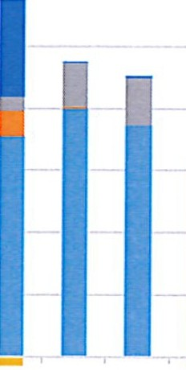

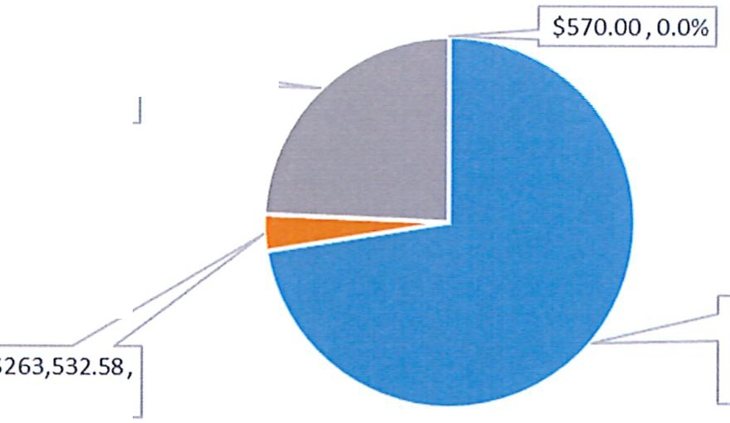
$8,305,381 as of November 30, 2024, compared to $3,863,979 a year ago. The increase is primarily due to the timing ofreimbursements of water and sewer project expenditures.
;·pp ; & & ; &
IIII

I
$16,000,000

$14,000,000

$12,000,000

$10,000,000
Cash Balances by Fund

$8,000,000

$6,000,000

$4,000,000

$2,000,000

$0
-s2,ooo,o&oo 1' '[<- ,-f&' 1'&

·r&?-

&
&

1' \ '[<-&

1' '[<-& 1' '[<- 1' , &
; ; & ; & &
_.

'[<-&

-r- &

\ ¥
-$4,000,000
      - General & Grant Funds+ Misc Projs ■Powell Bill ■Sewer/Water Ops & Projs ■Stormwater Fund ■ ARPA Fund

Cash and Investments

$2,020,987.25, --
24.3%

3.2%
$6,020,291.35, 72.5%

        - NCCapital Mgmt Trust ■ First Citizen Bank ■ KSTrust Investments ■ Misc Other

1Uhere communH3 0B_Jins!

- The benchmark for this period is 41.7% of the budget, however, revenues and expenditures will continue to be recorded for the next few weeks.

- General Fund Property Taxes collected by the County for the month of October 2024 totaled $296,000 compared to $278,827 for October 2023. FY25 year to date property tax revenues received are $1,140,987. Our total estimated taxes for 2025 are $5,759,728. These totals include taxes for Property, Motor Vehicles, and Downtown Service District.

Ad Valorem Tax Revenues by Month Collected
$2,000,000.00
$1,800,000.00
$1,600,000.00
$1,400,000.00
$1,200,000.00
$1,000,000.00
$800,000.00
$600,000.00

$400,000.00
I
$200,000.00
$-
0

I I I • • •
I II I

I I • • ■
III

>u >wm
o OJN OJ ro C.ro C:N::::,
c.O
>uc
o OJ ro
OJ ro c>.
w>
ro C:"5::::,
c.O

zoc 2 2 > zo 2 2
ro -

- For Sales Taxes, our August receipts were $285,026. This is $23,471 less than the same period last year. Our budget for sales tax revenue for FY25 is set at $3,310,000, and so far, this year we have recorded $569,395, or 17.2%. Sales Tax Reports from the Department of Revenue are provided at least two months behind actual collections. Our next sales tax deposit will be December 15th.

$400,000.00
$350,000.00
$300,000.00
$250,000.00
$200,000.00
$150,000.00
$100,000.00
$50,000.00
$-

Sales Tax Collections by Month

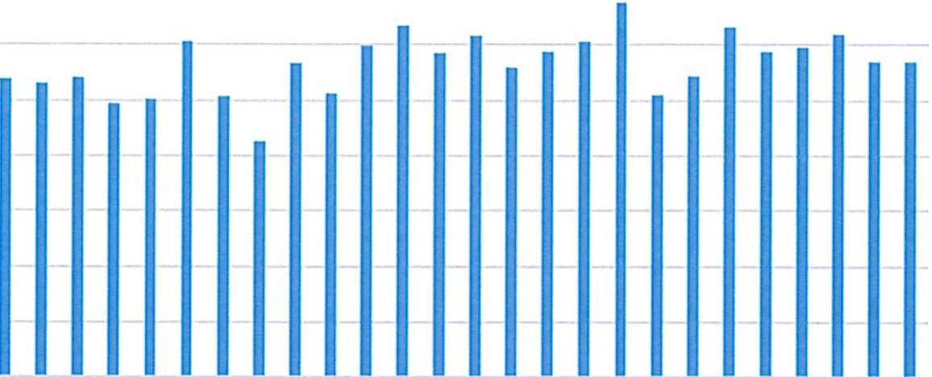
N 0.0....,...., > urn.c "- "- >crfl 0.0 ..... ...., > u .c "- "- >c-.::t-o.o
N::, O OJN QJ CO ::,N::, OWN QJ «I 0.(tl ::,N :J
a.u a.co o.u
>< Ozac 2<2 >< 0zac 2<2 ><
- ro - ro -

- Building Permit Fees for the month of November were $8,234. To date we have collected a total of $51,655 or 32.3% of the budget. At the same time last year, our year-to-date revenue was $80,732. The budget for the 2025 budget year is $160,000.

- The following charts and graphs include Budgeted and Actual, Revenue and Expenditures for the General Fund, Water & Sewer Fund, Stormwater Fund, and the Powell Bill Fund.

EY.25 YI!.'! A'1uals i,rs Budgets- Ei11eodituces EY2!1YI!.'! Aiauals vs Budgets - Ei11eni:!ituci:s

:All Funds - FY25 November FY25 November FY24
l.'!eganmentslEumls EY25 Budget MIi.'! A'1uals YI!.'! Actuals .%..QiBJ1gt EY2!1Budget MIi.'! Actuals YI!.'! Actuals .%..QiBJ1gt
General Govt | 3,153,165.15 | 130,454.36 | 1,081,166.71 | 34.3% |  | 2,911,563.22 | 189,519.86 | 1,224,889.96 | 42.1%
Public Safety | 5,220,746.10 | 343,742.30 | 2,114,702.30 | 40.5% |  | 5,087,426.02 | 359,186.38 | 2,014,507.28 | 39.6%
Public Works | 1,988,845.23 | 134,678.39 | 813,412.76 | 40.9% | Public Works | 2,128,977.22 | 141,818.34 | 976,945.78 | 45.9%
Sanitation & Waste Removal | 857,000.00 | 65,653.16 | 271,504.74 | 31.7% | Sanitation & Waste Removal | 841,000.00 | 72,471.92 | 271,624.46 | 32.3%
Parks, Recreation, & Cemetery | 1,535,981.75 | 89,882.97 | 684,181.26 | 44.5% | Parks, Recreation, & Cemetery | 1,435,022.50 | 107,089.33 | 541,496.75 | 37.7%
Library | 4,482.00 | 150.00 | 2,046.57 | 45.7% | Library | 103,547.00 | 49.00 | 415.51 | 0.4%
GF Debt Service | 1,270,499.00 | 48,609.60 | 560,160.31 | 44.1% | GF Debt Service | 1,095,864.00 | 7,140.92 | 515,261.47 | 47.0%
GF Operating Trfs Out & Resrvs | 306,169.00 | 23,404.30 | 131,329.30 | 42.9% | GF Operating Tris Out & Resrvs | 764,435.62 | 14,875.00 | 64,650.00 | 8.5%
General Fund Totals | 14,336,888.23 | 836,575.08 | 5,658,503.95 | 39.5% | General Fund Totals | 14,367,835.58 892,150.75 5,609,791.21 |  |  | 39.0%
W&S Admin & Finance | 1,201,600.81 | 75,398.33 | 516,157.51 | 43.0% | W&S Admin & Finance | 1,122,655.73 | 65,938.89 | 358,897.28 | 32.0%
W&S Distribution/Collection | 2,345,780.60 | 106,063.77 | 1,326,110.01 | 56.5% | W&S Distribution/Collection | 1,825,127.93 | 135,202.41 | 682,916.51 | 37.4%
Water Treatment Plant | 2,247,896.69 | 100,981.96 | 819,927.14 | 36.5% | Water Treatment Plant | 2,262,739.03 | 92,004.73 | 937,472.91 | 41.4%
Sewage Treatment Plant | 2,113,966.56 | 150,252.30 | 969,849.74 | 45.9% | Sewage Treatment Plant | 2,082,096.56 | 183,321.37 | 614,203.44 | 29.5%
W&S Debt Service | 1,643,553.00 | 38,143.36 | 314,805.99 | 19.2% | W&S Debt Service | 2,871,668.00 | 15,112.33 | 175,925.93 | 6.1%
W&SOperating Tris Out & Resrvs | 327,284.00 |  |  | 0.0% | W&S Operating Trfs Out & Resrvs | 633,803.00 | 90,888.56 | 90,888.56 | 14.3%
W&S Fund Totals | 9,880,081.66 | 470,839.72 | 3,946,850.39 | 39.9% | W&S Fund Totals | 10,798,090.25 582,468.29 2,860,304.63 |  |  | 26.5%
Stormwater Operations | 424,994.50 | 27,050.20 | 207,661.06 | 48.9% | Stormwater Operations | 373,211.00 | 113,414.86 | 165,104.58 | 44.2%
Stormwater Debt Service | 52,630.00 |  | 2,754.92 | 5.2% | Stormwater Debt Service | 52,629.00 |  | 2,732.53 | 5.2%
St/W Operating Tris Out & Resrvs | 44,000.50 |  | 0.50 | 0.0% | St/W Operating Tris Out & Resrvs |  |  |  | #DIV/0!
StormwaterTotals | 521,625.00 | 27,050.20 | 210,416.48 | 40.3% | Stormwater Totals | 425,840.00 | 113,414.86 | 167,837.11 | 39.4%
Powell Bill Operations | 296,247.00 |  | 13,835.06 | 4.7% | Powell Bill Operations | 269,748.00 | 488.14 | 13,248.34 | 4.9%
Powell Bill Debt Service  PB Operating Trfs Out &.Resrvs | 665,253.00 |  | 107,625.88 | 16.2%  #DIV/0! | Powell Bill Debt Service  PB Operating Tris Out & Resrvs | 215,252.00 |  | 107,625.88 | 50.0%  #DIV/0!
Powell BillTotals | 961,500.00 |  | 121,460.94 | 12.6% | Powell BillTotals | 485,000.00 | 488.14 | 120,874.22 | 24.9%

Budget to Actual - FY25 Expenditures

General Govt Public Safety Public Works
Sanitation & Waste Removal Parks, Recreation, & Cemetery
Library
GF Debt Service GF OperatlngTrfs Out & Resrvs
W&S Admln & Finance Ei7ii?liiiiliiiili.i.i.i _
W&S Distribution/Collection Water Treatment Plant Sewage Treatment Plant W&S Debt Service
W&S Operating Trfs Out & Resrvs _
Stormwater Operations -
Stormwater Debt Service •
St/W OperatlngTrfs Out & Restvs ■
Powell Bill Operations Powell Bill Debt Service
PB Operatlnglrfs Out& Resrvs
$0 $1,000,000 $2,000,000 $3,000,000 $4,000,000 $5,000,000 $6,000,000
- YTDActuals ■ FY25 Budget

FY25 YID Actuals vs Budgets - Revenues EY24 YIP Actuals vs Budgets - Revenues

All Funds· FY25  Revenue Category/Fund | FY25 Budget | November  MH! Actuals | FY25  YTDActuals | 0/Qof Bdgt | All Funds· FY24  Revenue Categorylfund | FY24Budget | November  MID Actuals | FY24  YTDActuals | ⁰£J1of Bdgt
GF-Ad Valorem Taxes | 5,759,728.00 | 296,000.00 | 1,208,022.72 | 21.0% | GF-Ad Valorem Taxes | 5,563,300.00 | 278,826.81 | 1,018,630.52 | 18.3%
GF-Sales Taxes | 3,341,000.00 | 287,960.57 | 579,632.92 | 17.3% | GF-Sales Taxes | 3,125,000.00 | 311,280.01 | 612,659.32 | 19.6%
GF-OtherTaxes | 718,150.00 | 1,723.23 | 1,723.23 | 0.2% | GF-Other Taxes | 703,500.00 | 1,713.61 | 1,713.61 | 0.2%
GF-Licenses & Permits | 548,650.00 | 19,592.70 | 211,758.80 | 38.6% | GF-Licenses & Permits | 575,200.00 | 43,159.00 | 263,034.00 | 45.7%
GF-Charges for Services | 1,563,524.00 | 123,828.50 | 671,982.53 | 43.0% | GF-Charges for Services | 1,470,324.00 | 103,914.55 | 617,751.45 | 42.0%
GF-Other Revenue | 2,285,330.23 | 46,950.32 | 444,041.20 | 19.4% | GF-Other Revenue | 2,922,280.66 | 290,708.68 | 638,822.99 | 21.9%
GF-Operating Trfs In | 120,506.00 |  |  | 0.0% | GF-OperatingTrfs In | 8,230.92 |  |  | 0.0%
General Fund Totals | 14,336,888.23 | 776,055.32 | 3,117,161.40 | 21.7% | General Fund Totals | 14,367,835.58 | 1,029,602.66 | 3,152,611.89 | 21.9%
W&S Utility Chgs-Water | 4,312,325.00 | 379,750.12 | 1,703,677.09 | 39.5% | W&S Utility Chgs-Water | 4,555,700.00 | 349,875.29 | 1,660,786.38 | 36.5%
W&S Utility Chgs-Sewer | 3,857,450.00 | 324,617.95 | 1,470,173.22 | 38.1% | W&S Utility Chgs-Sewer | 3,890,700.00 | 296,491.66 | 1,383,451.38 | 35.6%
W&S Utility Other Rev | 1,710,306.66 | 35,923.78 | 205,242.76 | 12.0% | W&S Utility Other Rev | 2,351,690.25 | 6,317.67 | 89,752.00 | 3.8%
W&S Utility Oper Trfs In #DIV/0! W&S Utility Oper Trfs In #DIV/0!
W&S Fund Totals | 9,880,081.66 | 740,291.85 | 3,379,093.07 | 34.2% | W&S Fund Totals | 10,798,090.25 | 652,684.62 | 3,133,989.76 | 29.0o/o
Stormwater Revenues | 521,625.00 | 19,772.20 | 149,148.54 | 28.6% | Stormwater Revenues | 425,840.00 | 30,655.10 | 98,748.49 | 23.2%
Stormwater Totals | 521,625.00 | 19,772.20 | 149,148.54 | 28.6% | StormwaterTotals | 425,840.00 | 30,655.10 | 98,748.49 | 23.2%
Powell Bill Revenues | 961,500.00 | 207.21 | 307,151.60 | 31.9% | Powell Bill Revenues | 485,000.00 | 15,161.94 | 210,952.89 | 43.5%
Powell Bill Totals | 961,500.00 | 207.21 | 307,151.60 | 31.9% | Powell BillTotals | 485,000.00 | 15,161.94 | 210,952.89 | 43.5%

Budget to Actual - FY25 Revenues

GF-Ad Valorem Taxes GF-Sales Taxes GF-OtherTaxes -
GF-Licenses & Permits ....

GF-Charges for Services
GF-Other Revenue 11CZJ•• ­
GF-Operating Trfs In ■
W&S Utility Chgs-Water W&S Utility Chgs-Sewer
W&S Utility Other Rev fflllill
W&S Utility OperTrfs In Stormwater Totals
Powell BillRevenues ■ ■
$0 $1,000,000 $2,000,000 $3,000,000 $4,000,000 $5,000,000 $6,000,000 $7,000,000
  - YTD Actuals ■FY25 Budget

PLANNINGANDIIISPECllOtlS
DUNN
NOVEMBER 2024 I Monthly Development Report '
Planning & Inspections Department I 102 N. Powell Ave., Dunn, NC 28334 I phone 910-230-3503 I fax 910-230- 9005 I www.dunn-nc.org
Code Enforcement Type Number


Minimum Housing/Water Cut On Inspections
Non-Residential 'Inspections Improper refuse in container JI O
Junk & Debris Violations 3
hold/ln oor Furniture"ll,r? hides 2
hides Removed by City ]fo
ooaed Lot Violations [_g
Dvergro wth ILO

Dead
nsafe Trees fQ
pla ts/Publi-culs nce !I

D pi lilg .......,......., 0
g ns !IQ
Plantings in right of W. Y. 0
Large Limbs -

Va-rd\r..iaste/rrash Can- 0
[

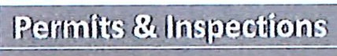

Permits 'Issued
l:=;,a=: =;;=;=========ll Permit F e Collected
Inspections Performed

Plans Reviewed
25

$27,706
T 25
Initial 64:6 %
re-ins_pection 35.4 %

Dem0litions ll
= Certificate of Occupancy's Issued 5
-:
: j, Food TruckPermits. _ l.[Q
t=· ====-=;;;; :::;========:=.ii Food TruckRen_ewals , O

Ir====:::;=::::::!!;::;,;;:::::::;==;;;;;;;;;;= f============
_ ABC Permits _ ll 0
Tent Permits 0

-----------'' Special Eve12!fNoise PerD']it _ JI $55
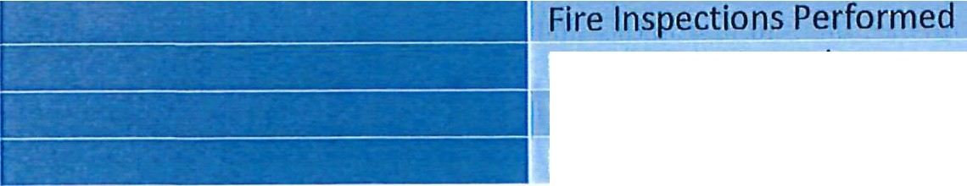
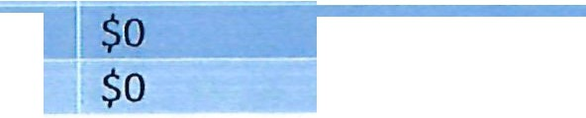
Fire Inspections & Permits

Fire Permits Issued
! e lnvoicesDue/u,!1P,!!d
Fire Inspection Fees Collected

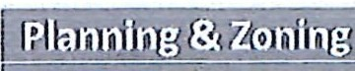
Development Permits 1
I
I
$ so
t, Deck/Carport/Pergola/Garage-

fF.fflouNN
PLMlflllJGMII)IMSPECIIOMS

Screened Porch- O Storage Bldg/Barn.- 2
C
l
Fences- 2
New Residential Construction- 6 New Commercial Construction- 1 Addltlon-0
Parking Lot/driveway/slteplan -
1 Other/elec veh charging station- O Swimming Pool- O

Sign Permits 1

Wall-
Wall w/elec­ Freestanding­
$ 200

Plats/Recombination Approved Minor Subdivision
Major Subdivision Annexation Easement
Zoning Violations/citations­ Zoning Verifications­ Rezoning/variance­ Conditional/Special Use­ Business Registration
I
New-0
Renewals- 0
I I
Home Occupation- 0
Freestanding w/elec- 1
Hlghrlse-
Face Replace- (no fee) Yard-
Temp Banner- 1
Temp- BIiiboard­
Biiiboard w/elec­ lnterstate w/elec­ Ground-
Political-
Special Event- 1
$0
$100
$0
$0
$0
$0
$0
$0
$
$0
$0
$0
$0

Code Enforcement MaQ

**Please note, that these are all NEW code enforcement items. This does not include items that were followed up on, or are at a later stage in enforcement. **

CITY OF DUNN 11/25/2024

Case Number | Violation Address | Owner or Occupant | Status or Conditions
MINIMUM HOUSING STANDARDS
HC-23-02 | 125 Sorina Branch Road | Stacev Hamer | Abandoned, ubstandard housing. Inspection conducted on 04-15-24 with a warrant. Hearing conducted on 06-24-24 and owner did not show. Findings of Fact and Order issued with deadlne of 09-29-24.  Memorandum and Odinance to Demolish to be presented to Council on 12-10-24. Letter of  Intent issued.
HC-23-03 | 824 East Divine Street | Zelm LLC & Co.,  c/o Lee Alexander Brown | Substandard housing. Conducted inspection. Hearing postponed per request of owner. Heaing has been rescheduled for 03-11-24 and owner did not show. Findings of Fact and Order issued to Repair or Demolish by a dated not later than 07-07-24.. Owner is working without permits. Memorandum and Odinance to Demolish to be presented to Council in 12-10-24.  Letter of Intent issued.'
HC-23-07 | 101 West Bav Street | William Randv Lucas (Deceased) | Substandard housing conditions. Owner is deceased. Conducting further investigation.

CODE ADMINISTRATION SERVICES REPORT 1 of 8 JOHN E. GANUS

CITY OF DUNN 11/25/2024

HC-23-08 | 211 South Maanolia Avenue | Theodore L Williams Jr & Virginia Williams | Substandard housing conditions.  Will obtain a title search and schedule Inspection upon receipt.
HC-23-09 | 401 South Washington Avenue | Theodore L Williams Jr & Virginia Williams | Substandard housing conditions. Will obtain a title search and schedule Inspection upon receipt. Condemned by Building Inspections. Pending.
HC-23-10 | 403-405 South Washington Avenue | Theodore L Williams Jr & Virginia Williams | Substandard housing conditions. Will obtain a title search and schedule Inspection upon receipt. Condemned by Building Inspections. Pending.
HC-23-11 | 407 South Washington Avenue | Theodore L Williams Jr & Virginia Williams | Substandard housing conditions. Will obtain a title search and schedule Inspection upon receipt. Condemned by Building Inspections. Pending.
HC-23-12 | 804 South Washington Avenue | Theodore L Williams Jr & Virginia Williams | Substandard housing conditions. Will obtain a title search and schedule Inspection upon receipt.
HC-23-15 | 811 East Cumberland Street | John Davis Sutton | Substandard housing conditions. Pending Inspection.

CODE ADMINISTRATION SERVICES REPORT 2 of 8 • JOHN E. GANUS

CITY OF DUNN 11/25/2024

HC-23-16 | 305 West Greenwood Street | Frederick E McNeil | Substandard housing conditions. Hearing held with potential buyers and owner did not attend. Have spoken with owner several times. Order issued to Repair or Demolish the structure by a date not later that 01-06-2025. Owner has decided to keep the house and conduct repairs. Pending permits, contractors and action.
HC-23-21 | 604 East Townsend Street | Tony W Surles | Substandard housing conditions. Pending Inspection.
HC-23-22 | 309 North Wilson Avenue | Kris Dolan & David Bero (04-12-23) | Substandard housing conditions. Inspection conducted and hearing held. Request to continue as a triplex was denied. Working on converssion to SFR and total renovation. Permits were obtained and work is progressing with permit inspection being conducted. WIii continue to monitor and inspect.
HC-23-23 | 307 South Washington Avenue | Thomas E Strickland (Life Estate) Robbie A Edwards (Grantee) | Substandard housing conditions. lnspecton scheduled for 10-14-24 and owners did not show. Pending inspection with warrant.

CODE ADMINISTRATION SERVICES REPORT 3 of 8 JOHN E. GANUS

CITY OF DUNN 11/25/2024

HC-23-24 | 404 North Maanolia Avenue | Rov & ROI (new owners) | Substandard housing. Inspection conducted. Hearing postponed . New owners have obtained permits and are progressing with the renovations. Will continue to  monitor.
HC-23-25 | 407 West Johnson Street | Jose Juan Correa | Substandard housing conditions. Owner appears to have abandoned the intent to renovate the structure. Also has failed multiple county inspections in the past. Housinjg inspection conducted and Hearing held on 07-23-24. Order issued to Repair or Demolish by a date not later than 10-23-24. Drafted Memorandum and Ordinance to Demolish for City Council on 12-10-  24. Letter of Intent issued.
HC-23-26 | 408 North Maanolia Avenue | The Finn Grouo LLC | Substandard housing. Inspection conducted. Hearing postponed and will be rescheduled.
HC-23-27 | 502 East Surles Street | Euaenia McMillian | Substandard housing conditions. Pending Inspection.
HC-23-28 | 611 North Wilson Avenue | Frank & Lula Clark | Substandard housing conditions. Will schedule inspection soon.
HC-23-29 | 711 North Maanolia Avenue | James N Wvnn | Substandard housing conditions.  Pendina Inspection.
HC-23-31 | 807 North Lavton Avenue | Clavton Davis | Substandard housing conditions.  Pendina Inspection.

CODE ADMINISTRATION SERVICES REPORT 4 of8 JOHN E. GANUS

CITY OF DUNN 11/25/2024

HC-23-32 | 1114 South Clinton Avenue | RCC Dawson LLC  c/o Pyraona Chhasatiya | Substandard housing. Inspection conducted and hearing held including requirement of conversion to current permitted uses required. Order issued to Repair or Demolish and the architect/engineers have provided the owner full set of documents. Follow up letter and email sent to owner with no permit application to date. Pending other enforcement actions.
HC-23-33 | 413 South Maqnolia Avenue | Anchor Investment Properties LLC | Substandard housing conditions.  Pendina lnsoection.
HC-23-34 | 202 South Sampson Ave | Caesar A Brewinqton Jr. | Substandard housing conditions.  PendinQ Inspection.
HC-23-35 | 1607-1609-1611 Erwin Rd | Minnie F Webb | Substandard housing conditions.  Pendinq Inspection of apartments.
HC-23-37 | 1001-1003 N Fayetteville Av | Chelsi Fawn Boulware c/o Fon I Boulware | Abandoned, substandard housing. Inspection scheduled with no one attending. Made contact with owner's Dad who will have the property manager contact me to arrange for inspection and further actions. Pending.
HC-23-38 | 901 East Johnson Street | Anthony B & Robert L Ross | Substandard housing conditions.  Pendinq Inspection.

CODE ADMINISTRATION SERVICES REPORT 5 of 8 JOHN E. GANUS

CITY OF DUNN 11/25/2024

HC-23-40 | 205 North WashinQton Ave | NW Real Estate Investments LLC (11-28-2023) | Substandard housing. Hearing conducted and Order issued to Repair or Demolish by 11-15-23. Property has now changed ownership to NW Real Estate Investments LLC. Met with new owners and working with Zoning on some issues. Permits have been  issued.
HC-23-42 | 1600 Erwin Road | West Properties of NC LLC (11-28-  2023) | Substandard housing conditions. Pendina inspection.
HC-23-43 | 123 Bruce Drive | Salvador Macias Cardenas | Substandard housing conditions.  Pendina inspection.
HC-23-44 | 1009 West Harnett Street | VillaQe Capital & Investment LLC | Vacant and substandard housing conditions. Inspection scheduled for 09-11-23 with no one showing. Ownership changed by Trustee Deed on 12-15-23. Owners have obtained required permits and the structure is under full renovation. Will continue to monitor.
HC-23-45 | 910 East Divine Street | Winselow Tucker Sr | Substandard housing. Inspection conducted. Hearing to be scheduled soon.

CODE ADMINISTRATION SERVICES REPORT 6 of 8 JOHN E. GANUS

CITY OF DUNN 11/25/2024

HC-23-46 | 410 South Fayetteville Avenue | WinQed Warriors LLC | Substandard housing conditions. Hearing conducted and owners did not show. Order issued to Repair or Demolish by a date not later than 10-04-24. Drafted Memorandum and Ordinance to Demolish for City Council on 12-10-24. Letter of  Intent issued.
HC-23-47 | 611 West Pearsall Street | J and T Properties of Holly Springs LLC | Substandard housing conditions. Inspection conducted and Hearing was scheduled. Owner did not show but called later. No further response from owners and no permits obtained. Order issued to Repair or Demolish by a date not later than 08-04-24. Received call from second partner/owner and agreed to meet on site and begin work. Met on site on 06-24-24.  Permits have now been applied for and a crew is on site cleaning out the structure and painting the exterior. No further work completed. Inspection conducted on 11-12-24 with owner, General Contractor and  electrician.
NON-RESIDENTIAL BUILDINGS OR STRUCTURES

CODE ADMINISTRATION SERVICES REPORT 7 of 8 JOHN E. GANUS

CITY OF DUNN 11/25/2024

NR-23-01 | 510 Sprinq Branch Road | New Dunn Hotel LLC c/o Amar N Patel! | Vacant substandard building. Inspection scheduled and owner advised he was out of country. Requested to schedule when he returns. Will reschedule inspection soon.
NR-23-02 | 508 Sprino Branch Road | Munishree LLC c/o Suresh Patel | Vacant substandard building. Inspection conducted with owner. Pending hearing and other actions.
NR-23-04 | 506 North McKay Avenue | C L Tart Jr & Marv Lee Brece Tart | Abandoned storage facility. Inspection conducted with maintenance man concerning the clean up of the property and repair of the building. Follow up visit conducted and observed clean up and maintenance is progressing slowly. Will continue to monitor progress.

CODE ADMINISTRATION SERVICES REPORT 8 of 8 JOHN E. GANUS

PUBLIC WORKS DEPARTMENT NOVEMBER 2024 MONTHLY REPORT
101 E CLEVELAND ST, DUNN NC 28334 PHONE 910-892-2948 FAX 910-892-8871 www.dunn-nc.org

STREET DEPARTMENT | TYPE | NUMBER
 | BRUSH-LIMB PICKUP |  | 193
 | BULK ITEM |  | 114
 | CONSTRUCTION & DEBRIS |  | 1
 | CUT |  | 4
 | DEAD ANIMAL |  | 1
 | DITCH MAINTENANCE |  | 2
 | EROSION |  | 1
 | EVENT |  | 1
 | LEAVES-GRASS |  | 516
 | POTHOLE |  | 61
 | ROAD MAINTENANCE |  | 3
 | SIGN DOWN-DAMAGED |  | 1

TOTAL WORK ORDERS 705

PUBLIC WORKS DEPARTMENT NOVEMBER 2024 MONTHLY REPORT
101 E CLEVELAND ST, DUNN NC 28334 PHONE 910-892-2948 FAX 910-892-8871 www.dunn-nc.org

TONNAGE REPORT TYPE
SOLID WASTE IN TONS YARD WASTE IN TONS RECYCLING WASTE IN TONS GRAND TOTAL TONS

NUMBER

215.83
33.67
33.21
282.71

*Data from Republic Services Report

PUBLIC WORKS DEPARTMENT NOVEMBER 2024 MONTHLY REPORT
101 E CLEVELAND ST, DUNN NC 28334 PHONE 910-892-2948 FAX 910-892-8871 www.dunn-nc.org

CEMETERY DEPARTMENT TYPE FILL GRAVE
GRASS MOWING & WEED EATING OPEN/CLOSE
NUMBER
16
19
13

TOTAL WORK ORDERS 48





rcJCITY OF
2!!

Public Utilities Dept I December 2024 I Monthly Report
101 E. Cleveland St., Dunn, NC 28334 I phone 910-892-2948 I fax 910-892-8871 I www.dunn-nc.org

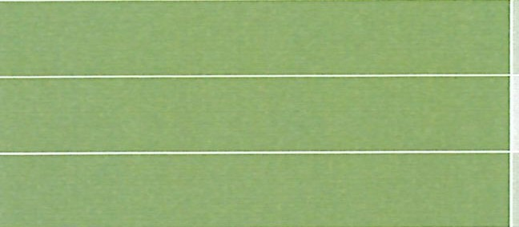
Water/Sewer oe·partment

On Call Leak Repair  Water Tap | I!7  8  II 3
New Sewer Tap
Sewer Tap Renewals
Water Construction
Sewer Stoppage | 18
Sewer Construction
Manhole Inspection | I: 25
Outfall Maintenance
Hydrant Repair
Utility Locates | 743
Water Meter | 11 2
Repair/Investigations
Retire Water and Sewer Services
Valve Maintenance
Taste and Odor Complaint
Water Quality Flushing
Low Pressure Complaint | 2
Other - Water | II 3
Other - Sewer


lril
Public Utilities Dept-WTP I October 2024 I Monthly Report
101 E. Cleveland St., Dunn, NC 28334 I phone 910-892-2948 I fax 910-892-8871 I www.dunn-nc.org

A.B. Uzzle Water Treatment Facility

DLCl a110 oea Bo

Average Million Gallons Per Day
oea

Total Million Gallons Bulk Sales
2.8189

40.789

Water Plant Averages and Total Million Gallons Pumped 2023-2024
120


100


80

VI
C
.2
ro
60
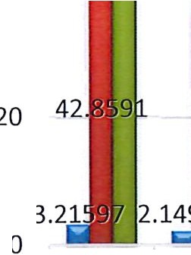
g
t
9
40
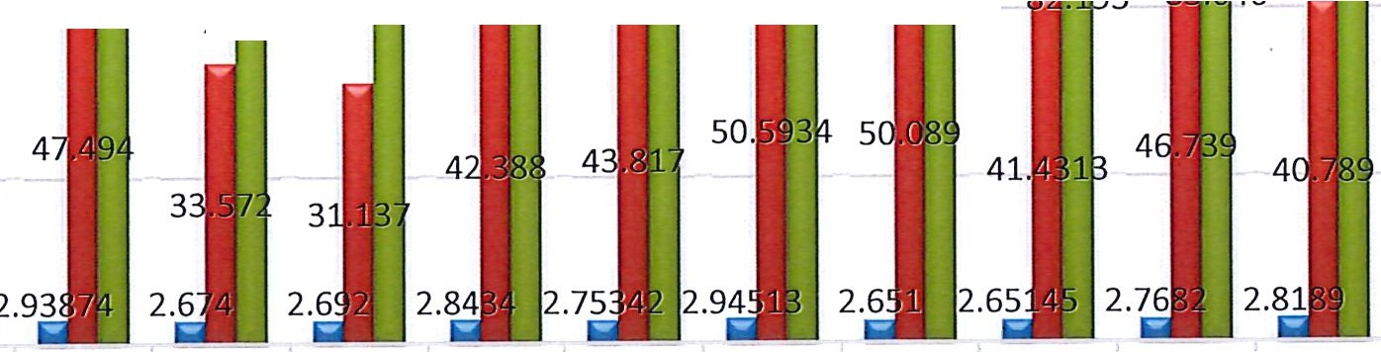
j127 1
J
lf
1 2

sJ4s1 ii2 f1¥6 lf9

- lbs LL a,L 87i?l86

Nov-23 Dec-23 Jan-24 Feb-24 Mar-24 Apr-24 May-24 Jun-24 Jul-24 Aug-24 Sep-24 Oct-24 2023-2024

Iii Daily Average Pumped Iii Total Million Gallons Bulk Sales liiilTotal Million Gallons Pumped


Q

Bulk Chemicals and Rain Fall Totals 2023-2024
90

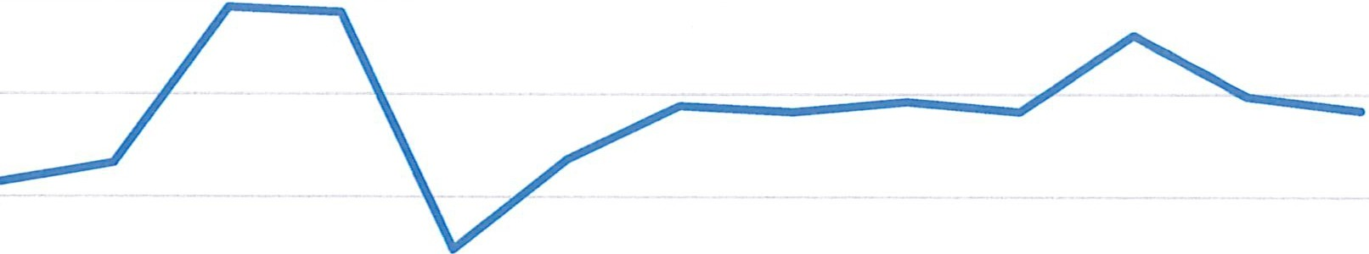
80

70

60

50

40

30

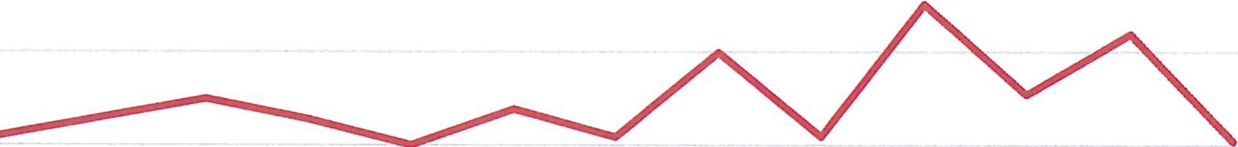
20

10

0
45200 45231 45261 45292 45323 45352 45383 45413 45444 45474 45505 45536 45566
-chemicalsUsed X 1,000lbs -Rain Fall in Inches

*Data from A.B. Uzzle Water Treatment Plant records, and Finance Department billing.

Public Utilities Dept I November 2024 I Monthly Report
101 E. Cleveland St., Dunn, NC 28334 I phone 910-892-2948 I fax 910-892-8871 I www.dunn-nc.org

Black River Wastewater November
Treatment Facility


Total Million Gallons Treated

Average Million Gallons Per Day Treated
57.894

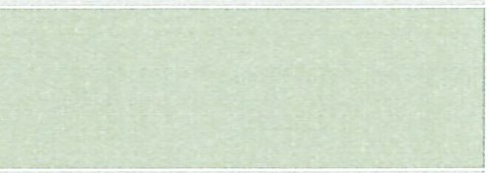
1.929

Rainfall in Inches 3.31

*Data from NC DEQ DMR documents and Black River Wastewater Treatment Plant records

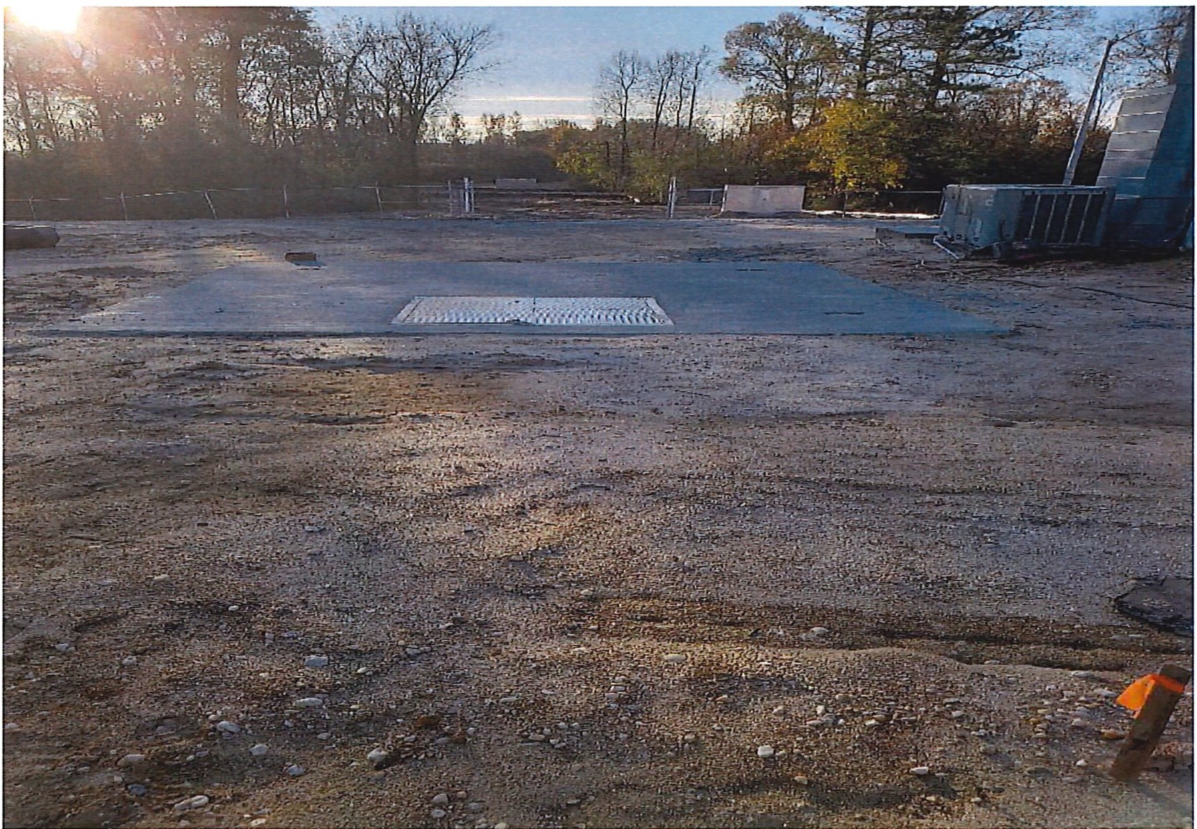

Machine and Welding sewer gravity line coming into the wastewater treatment plant.

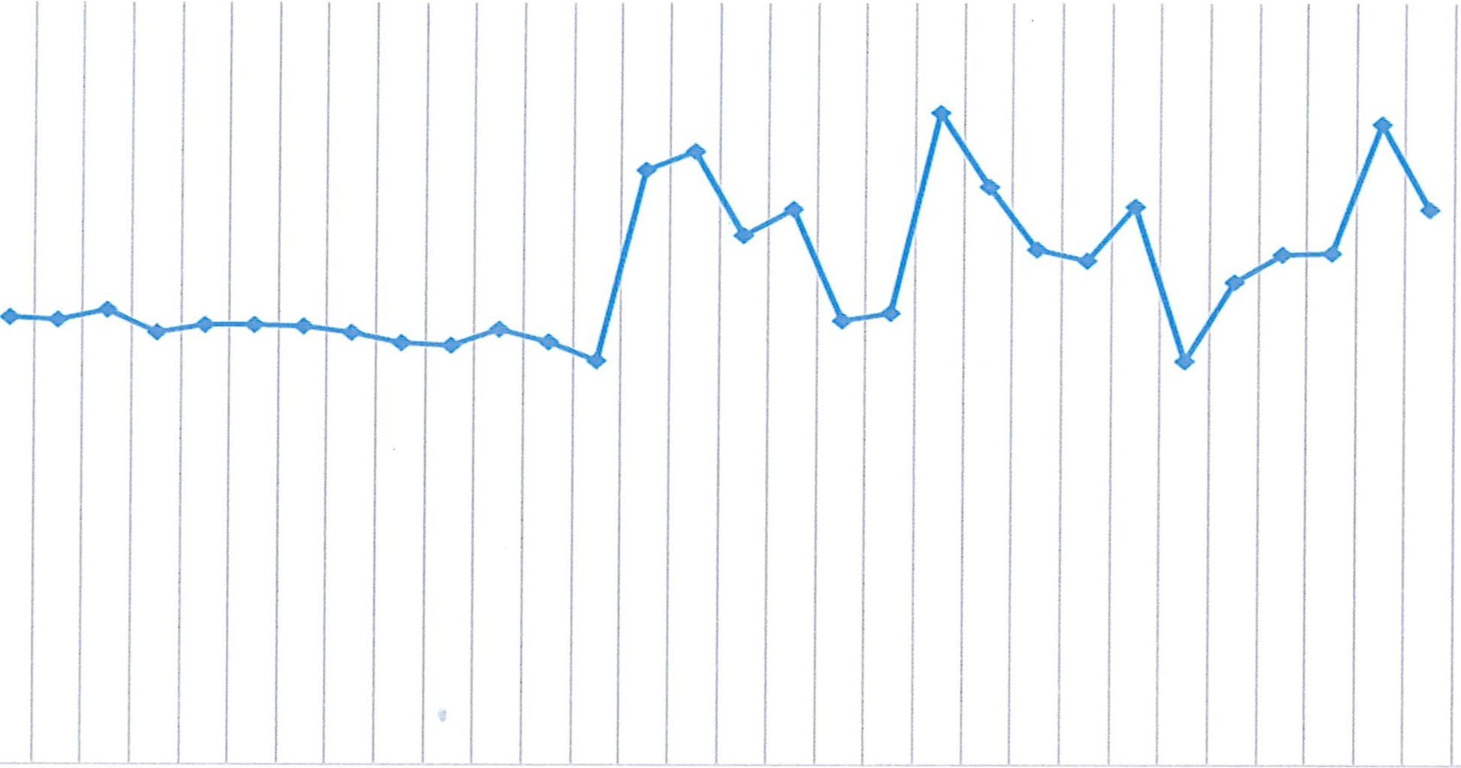
AVERAGE DAILY FLOW
<t:
>-
0
z
0
-'
3
2.5
2
1.5

8 9 10 11 12 13 14 15 16 17 18 19 20 21 22 23 24 25 26 27 28 29 30 31
z
0
::::;
-'
1
0.5
0
1 2 3 4 5 6 7
NOVEMBER

Rain Fall
2

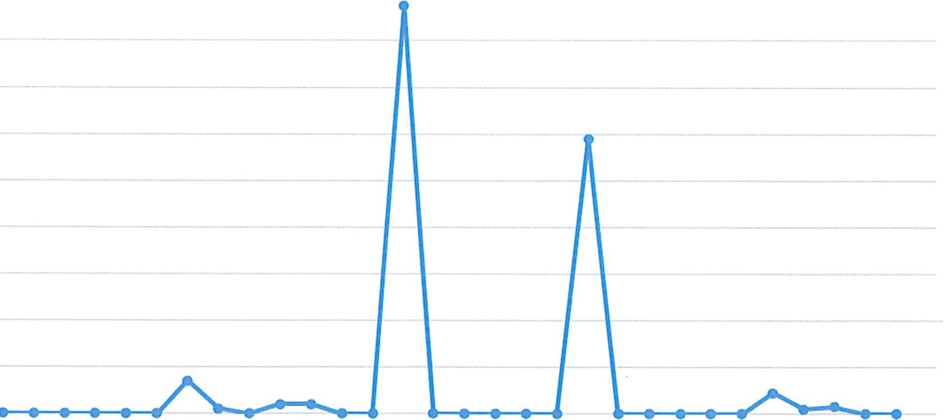
1.8

1.6

1.4
C
ro 1.2
0:::
4-
0 1
(/)
QJ
-£ 0.8
C
0.6

0.4

0.2

0
1 2 3 4 5 6 7 8 9 10 11 12 13 14 15 16 17 18 19 20 21 22 23 24 25 26 27 28 29 30 31
November

Total MillionGallonsTreated
140

V') 120
C
0
-r1o00
<..!J
C so
0

91.157
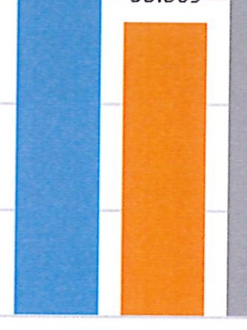
- -----01

""r"l,f,r 11COJ10
121.757

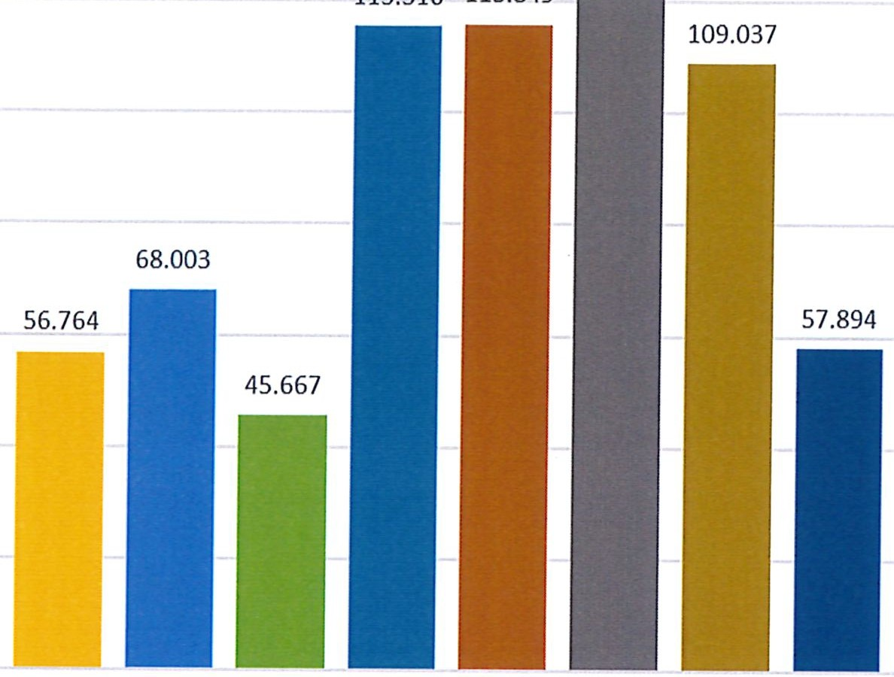
60

40

20

0 I Jan. Feb. March April May June 1 July Aug. Sept. Oct. Nov. Dec.

rnlCITY OF

ON

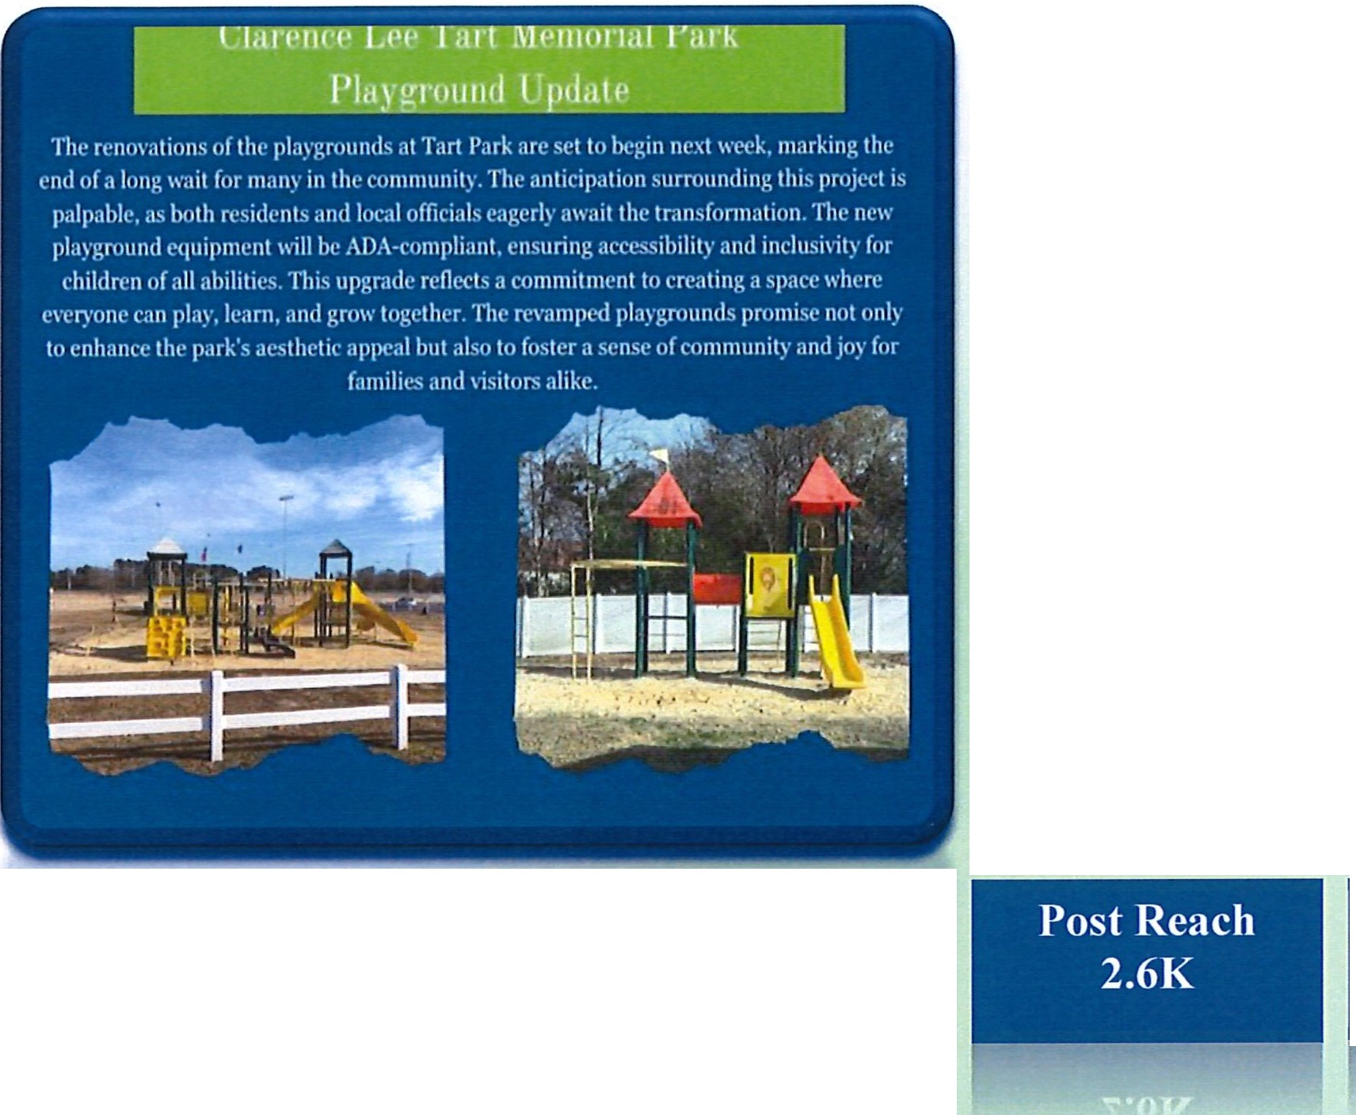
Social Media Activity November 2024

The wait is over!!! The playgrounds at Tart Park are going to be under construction. These areas will be closed to the public until the projects are completed.

Engagement
343

Page Overview Last 28 days

Post Reach
Post Engagement
Page Followers

4.4K lK 4.7K

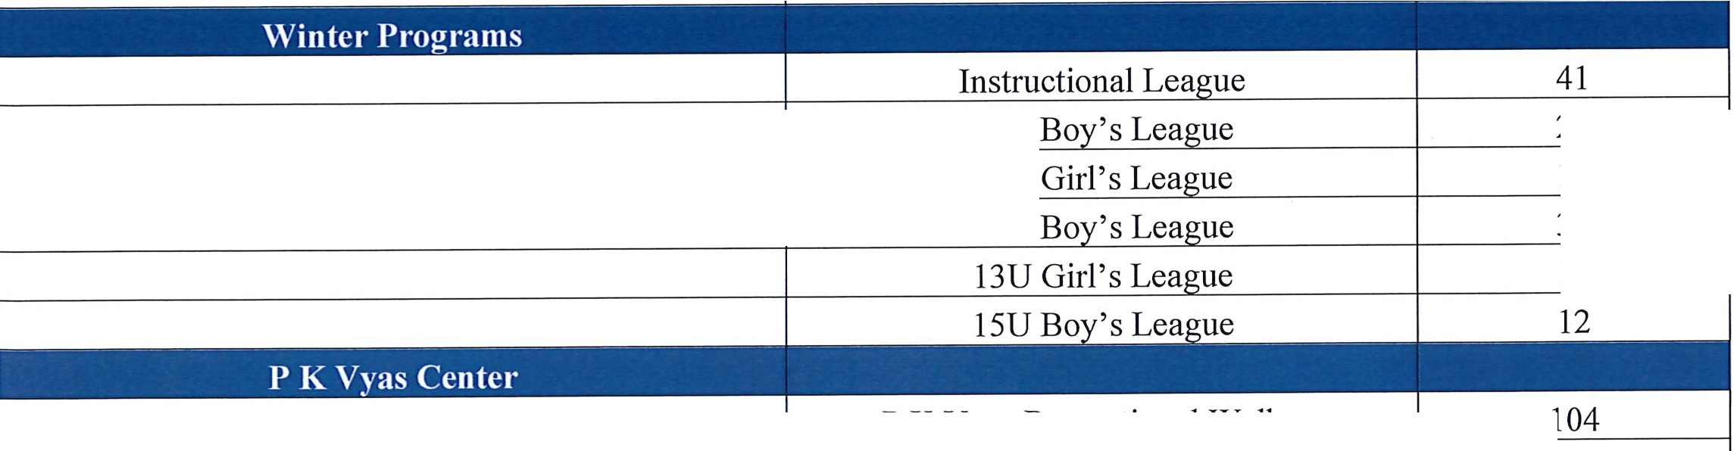

IOU IOU
13U
27
12
32
12
□JDUNN
024
PARKS AND RECREATION
205 Jackson Rd • PO Box 1065 • Dunn, North Carolina 28335 (910) 892-2976 , CityofDunn.org
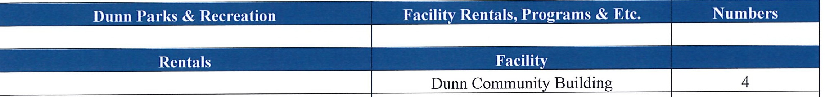
November Monthly Report

 | Clarence Lee Tart Memorial Park | 0
 | Multipurpose Room | 3
 | Codrington Park | 0
 | Nathan Harris Athletic Complex@ Tyler Park | 0
 | Baseball & Softball Field Rentals | 8
 | Tennis Comts | 0
 | Picnic Shelter Rentals

 | PK Vyas Recreational Walkers
 |  | 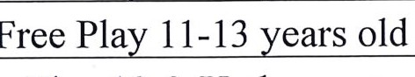  Free Play 14-17 years old |  | 12  21  2  5  1
 | Free Play 10 & Under years old
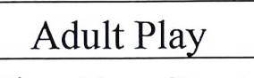
Batting Cage Rentals
 | Pickleball Players |  |  | 50
 | Racquetball Comt |  |  | 0

Cemetery Report
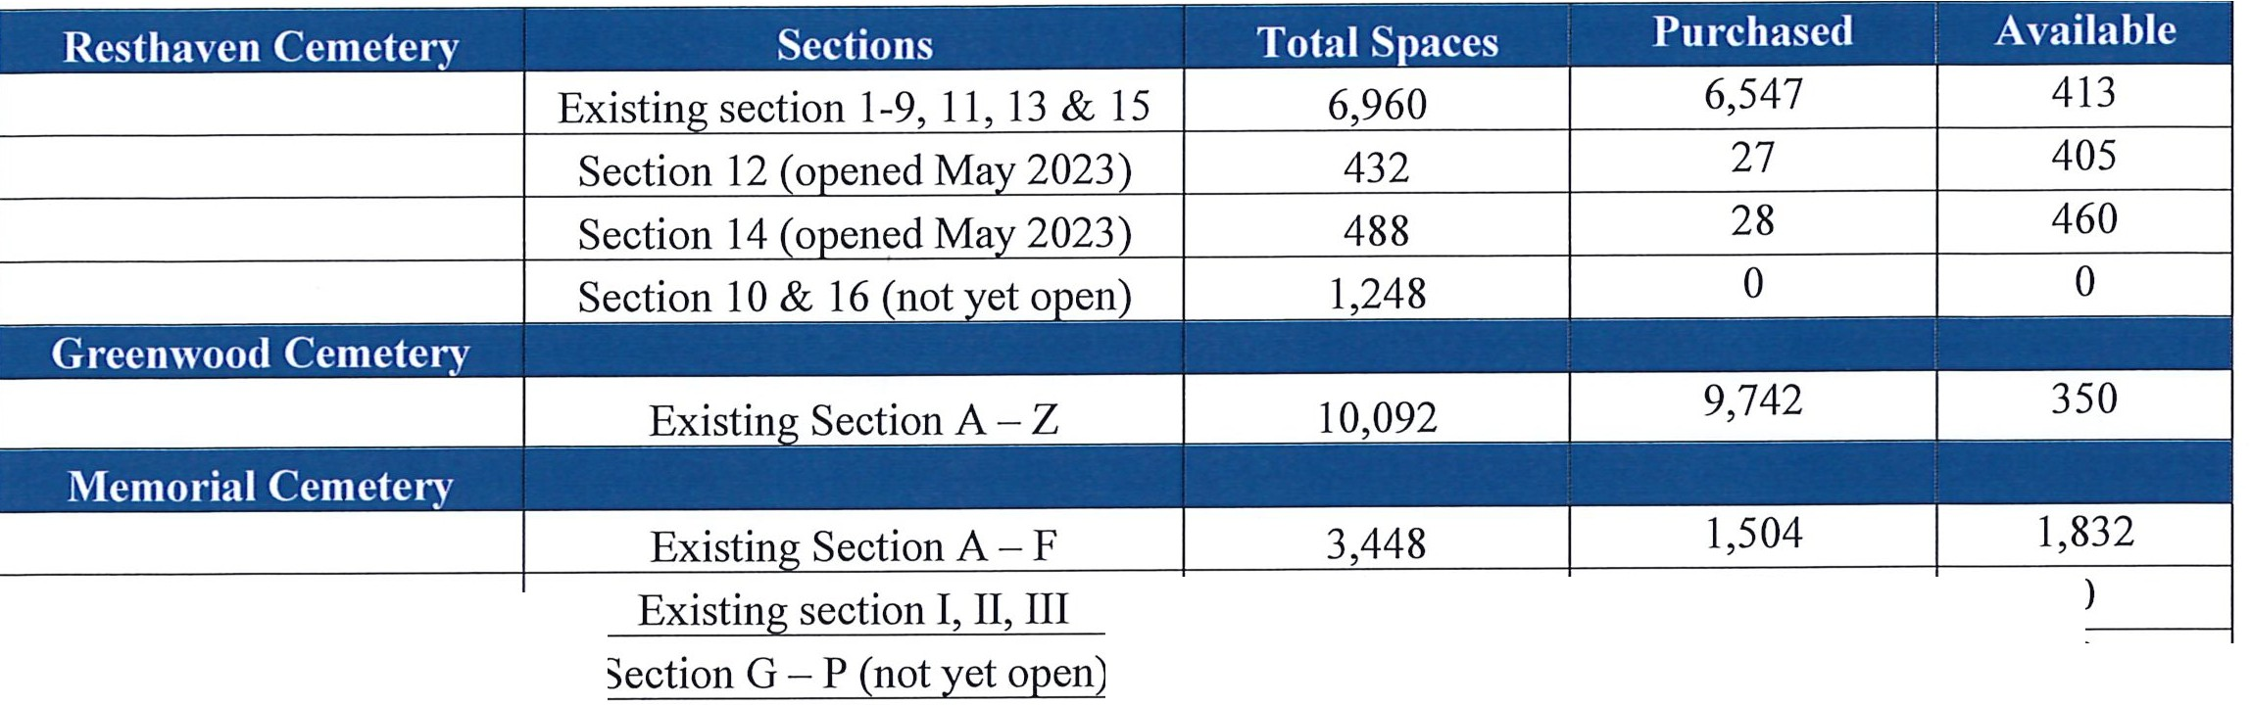
272
3,336
272
0
0

Monthly Recreation Report 2024


!DUNN
□
PARKS AND RECREATION

November Monthly Narrative Report

Basketball Registration
Registration began on September 9th and was extended to November 6th. Instruction league (7U) has a total of 41 players with five teams. Our IOU boy's league has 27 players with three teams, and 13U boy's league has 32 players with four teams. Our IOU and 13U girls' leagues have 12 players with one team in each league. Our 15U boy's league consists of 12 players on one team. Practices began the week of November 11th for older leagues. The instructional league will be posted on Monday, November 25th and begin practices on Saturday, December 7th.
Indoor Soccer
Registration for ages 7-13 begins December 9th and ends January 17th.
Tart Park Playground
All playgrounds and picnic shelters have been officially shut down as park staff disassembled and removed all playground equipment in preparation for new equipment to be installed. Those areas are visibly indicated with orange construction fencing and signage informing the public of its restricted use.
Recreation Advisory Board
The last meeting was held on Tuesday, November 19, at 6:00 p.m. in the Dunn Community Center. The next meeting is on Februa1y 18th and will be held at 6:00 p. m. in the Dunn Community Center.

mlDlJNN
POLICE DEPARTMENT
401 E Broad St . PO Box 1065 . Dunn, North Carolina 28335 (910) 892-2399, CityofDunn.org
Chief of Police Cary Jackson

November 2024 Monthly Crime Stats r11;0112024to11/3o/2024J

Number
2
Crime Homicide Rape
Robbery
0
1
3
Burglary Forcible Entry 6
2

Larceny from Motor Vehicle Larceny all- other
3
21

Simple Assaults 5

Assigned Cases 31

Criminal Investigations Division
Cases Closed Recovered Property Arrests

33 $5,784 17

Search Warrants Executed
13

Cellebrite Forensic Digital Data Extraction Device: 3 Extractions

Dunn Police Arrest & Citation Stats

Month | Felony | Misdemeanor | Citations
November | 40 | 46 | 85

Overdose Stats

Month Fatal | Non-Fatal | Total | DPD Narcan Use
November 0 | 4 | 4 | 0

Total Plate . Hot List Hits
Reads:
Recovered
Property
Leads
Established
Agencies Assisted
1.5 million
235
Recovered Stolen
MV /Rec. Reg. Plate
5
0
Where communHJ 0B_!}insl


Dunn Police Department Community Enhancement Team Monthly Report

Month: November 2024

Arrest Charges: Felony: 35
Misdemeanor: 12
Juvenile: 1 Citations/Written Warnings Issued: 9 Calls for Service (Assist Patrol): 16
Traffic Safety Events: 2 Traffic Checking Stations

Drugs seized:
Methamphetamine | 1qm | $70.00
Heroin | 1qm | $80.00
Crack Cocaine | 1qm | $60.00

Drug Seizure Street Value - $210.00

Community Housing Security Checks: 54

Training:
Sgt. Sikorski attended 16hrs of Canine Training.
Officer J. Hall completed 125 hours of training to include Credible Leadership, Intro to Clandestine Labs, Intro to Illicit Internet Drug Sales, Overview of US CTOC Strategy, Overview of drug Trafficking, Fentanyl Response and Diversification of Drug Trafficking Organizations.
Officer Elliott attended an 8-hour class on Mind of a Violent Offender

Community Events conducted:
11/6/2024 - Officers participated in Coffee with a Cop at Tarts Produce 11/8/2024 - Officers Participated in Bingo for Special Olympics NC 11/20/2024 - Officers participated in Coffee with a Cop at Tarts Produce
11/21/2024 & 11/22/2024 - Officers participated in Operation Cold Turkey. This multi-agency narcotic campaign and warrant roundup resulted in the service of 59 outstanding Felony charges, 39 Misdemeanor charges, and execution of two search warrants. The operation resulted in the seizure of 140 grams of Methamphetamine,
427.5 grams of Marijuana, 64 grams of Fentanyl, 90 grams of Cocaine, 4 grams of

401 East Broad Street • Dunn, NC 28334 • 910-892-2399


-
Crack Cocaine, 5du of Suboxone and 38du of Alprazolam. Additionally, over $28,284.00
in currency and drugs were seized during the campaign, and one firearm was seized

Additional information:
Sgt. Sikorski and Officer Elliott hosted 2 Explorer Post Meetings on 11/11 and
11/25.
Officers also assisted in patrolling and directing traffic at the Dunn Cotton Festival
on 11/2/2024.
K9 Apacs assisted in the seizure of $20,000 worth of controlled substances and money seizures this month. K9 Apacs along with CET Officers also assisted with the service of 3 search warrants this month within Dunn City Limits.

401 East Broad Street • Dunn, NC 28334 • 910-892-2399

Jlnnouncements
<Dunn City Counci[ <M_eeting
<Decem6er 10, 2024

- City of Dunn offices will be closed Tuesday, December 24th through Thursday, December 26th to observe the Christmas Holiday.
- City of Dunn offices will be closed Wednesday, January 1st to observe the New Year Holiday.
- The next Regular Session of the Dunn City Council is scheduled for Tuesday, January 28th at 6:30 p.m.


I

DUNN HOUSING AUTHORITY BOARD OF COMMISSIONERS MEETING MINUTES
MONDAY, OCTOBER 21, 2024

The Commissioners of the Dunn Housing Authority ("DHA") met in regular session at 817 Stewart Street, in Dunn, North Carolina, on Monday, October 21, 2024.

Following "Words of Encouragement" by Eddie Draughon, the meeting was called to order at 4:04pm.

Upon roll call, the following were present and absent: Present: Board Chair Kyle Thrower, Board Vice-Chair Eddie Draughon, Commissioners Sharon Gant, Lois Dail and Angela Inman, and Marsha Bass. Absent: Secretary Felicia Chester

Public CommentPeriod: No Public Comments were recorded.

Approval of Meeting Minutes:
The motion to accept the minutes from the regular September meeting was made by Lois Dail and seconded by Sharon Gant.

Ayes and Nays were as follows:
Ayes
Kyle Thrower Eddie Draughon Lois Dail Sharon Gant Angela Inman

Nays

MINUTES OF THE REGULAR SEPTEMBER 2024 BOARD MEETING WERE READ AND ACCEPTED.

Occupancy and Rent Report through 10/21/2024:
Total dwelling rent charged as of September 30, 2024, was $48,687.00. Based on financial data reported, the total revenue collected was $49,162.00. As of October 21, 2024, there were seven (7) vacant units. The Board was made aware that the units were being painted and the maintenance staff were working in the units as well to prepare them for new move-ins as soon as possible.

The motion to accept the September/October O & R report was made by Angela Inman and seconded by Eddie Draughon.

Ayes and Nays were as follows: Ayes
Kyle Thrower Eddie Draughon Lois Dail
Sharon Gant Angela Inman

Nays

0 & R REPORT AS OF OCTOBER 21₁ 2024 WAS READ AND ACCEPTED.
1

Review of Financial Balance Report:
The monthly financial report ending September 30, 2024 was available for review. Kyle Thrower asked for more information regarding the PILOT amount listed in the report.

The motion to accept the financial report for September was made by Lois Dail and seconded by Eddie Draughon.

Ayes and Nays were as follows:
Ayes
Kyle Thrower Eddie Draughon Lois Dail
Sharon Gant Angela Inman

Nays

FINANCIAL REPORT WAS READ AND ACCEPTED.

Business:
There was no notable discussion on the topics of pay increases and incentives. After a brief closed session, The Board agreed that more information was needed from the Executive Director.

Prior to the meeting, the Board received a copy of the Auditor's Report. It was unanimously agreed to delay any comments or concerns until the next meeting with the Executive Director.
Communication:
Correspondence from the contractor on the mechanical room project was distributed to each board member. The update made the members aware that there was a delay with the supplier and that the project would not begin until January 2025.

Installing dryer connections was a part of the discussion and will remain until a decision is made on a timeframe to begin the process for the installation.

The Board will vote on a decision to sell the 2006 F-150 Ford Truck or scrap it. A review of the Capitalization and Disposition Policy will aid in the decision.

Adjournment:
A motion to adjourn was made by Angela Inman and seconded by Lois Dail. All members were in favor and the meeting was adjourned.

Felicia Chester, Secretary

2

CLOSED SESSION CRITERIA

(Specify one or more of the following permitted reasons for closed sessions)
Move that we go into closed session in accordance with:

[N.C.G.S. 143-318.11(a)(1)]
Prevent the disclosure of privileged information
1 Under the North Carolina General Statutes or regulations.
1 Under the regulations or laws of the United States.

[N.C.G.S. 143-318.11(a)(2)]
Prevent the premature disclosure of an honorary award or scholarship

[N.C.G.S. 143-318.11(a)(3)]
Consult with the Attorney
1 To protect the attorney-client privilege.
To consider and give instructions concerning a potential or actual claim, administrative procedure, or judicial action.
1 To consider and give instructions concerning a judicial action titled
vs

[N.C.G.S. 143-318.11(a)(4)]
To discuss matters relating to the location or expansion of business in the area served by this body.
[N.C.G.S. 143-318.11(a)(5)]
To establish or instruct the staff or agent concerning the negotiation of the price and terms of a contract concerning the acquisition of real property located at
(OR)
To establish or instruct the staff or agent concerning the negotiations of the amount of compensation or other terms of an employment contract.

[N.C.G.S. 143-318.11 (a)(G)]
To consider the qualifications, competence, performance, condition of appointment of a public officer or employee or prospective public officer or employee.
(OR)
To hear or investigate a complaint, charge, or grievance by or against a public officer or employee.
[N.C.G.S. 143-318.11(a)(7)]
To plan, conduct, or hear reports concerning investigations of alleged criminal conduct.
School violence 143-318.11(a)(8) and terrorist activity (9).

