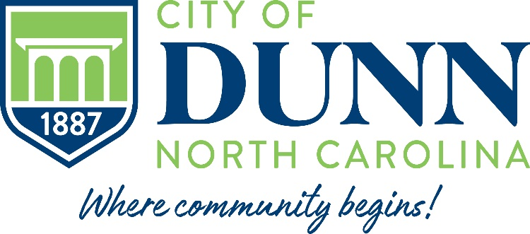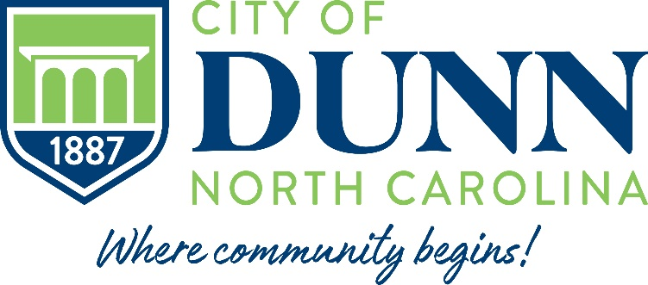

**Notice of Schedule of Regular**

**Public Meetings of the City Council**

Please take notice that the Regular meetings of the City Council of the City of Dunn, County of Harnett, State of NC, are held the fourth Tuesday of each month (exception of November and December) and Work Session are held the second Tuesday of each month (exception of July, November and December) at 6:30 p.m. in Council Chambers at the Dunn Municipal Building located at 401 E. Broad Street.

Meetings of the City Council are open, and the public is encouraged to attend.

**MEETING DATES 2025**

|  |
| --- |
| **January 14, 2025 – Work Session** |
| **January 28, 2025 – Regular Meeting** |
| **February 7-8, 2025 – Budget Retreat** |
| **February 25, 2025 – Regular Meeting** |
| **March 11, 2025 – Work Session** |
| **March 25, 2025 – Regular Meeting** |
| **April 8, 2025 – Work Session** |
| **April 22, 2025 – Regular Meeting** |
| **May 13, 2025 – Work Session** |
| **May 27, 2025 – Regular Meeting** |
| **June 10, 2025 – Work Session** |
| **June 24, 2025 – Regular Meeting** |
| **July 8, 2025 – Regular Meeting** |
| **August 12, 2025 – Work Session** |
| **August 26, 2025 – Regular Meeting** |
| **September 9, 2025 – Work Session** |
| **September 23, 2025 – Regular Meeting** |
| **October 14, 2025 – Work Session** |
| **October 28, 2025 – Regular Meeting** |
| **November 11, 2025 – Regular Meeting** |
| **December 9, 2025 – Regular Meeting** |

Public Notice will be given regarding any changes to the above meeting dates.

Agendas and Minutes of all Council meetings are available on the City of Dunn website at www.cityofdunn.org.