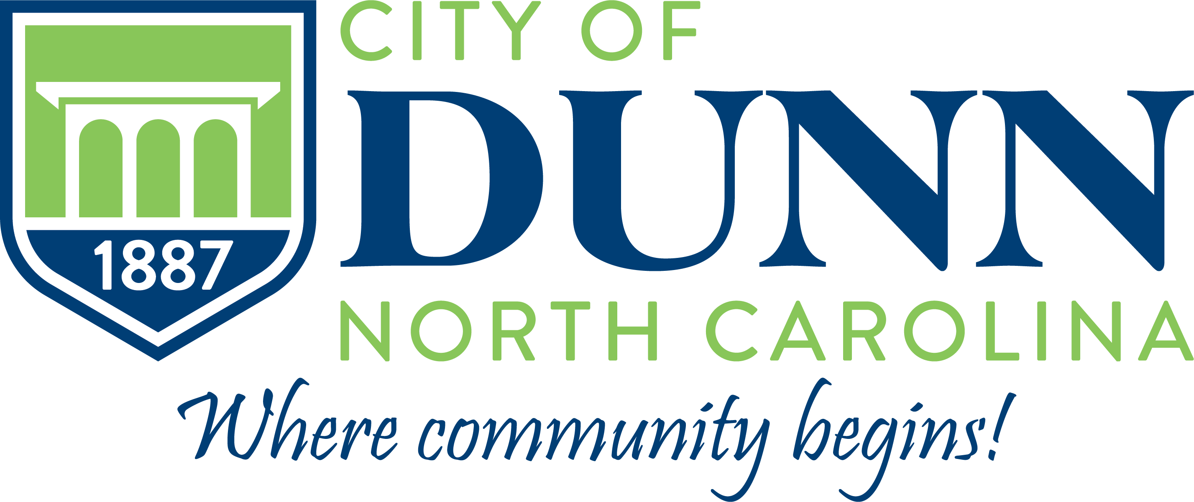

Dunn City Council
Work Session

Tuesday, March 11, 2025
6:30 p.m., Dunn Municipal Building
AGENDA

Call to Order – Mayor William P. Elmore, Jr.
Invocation
Pledge of Allegiance - Raquel McNeil

1) | Adjustment and Approval of the March 11, 2025 meeting agenda
 | PRESENTATIONS
2) | Merry Street/Juniper Creek Stormwater – Dori Sabeh with Withersravenel
CONSENT ITEMS
3) | Consideration of Capital Project Ordinance Amendment – 301 S Highway Water Tower Project
4) | Consideration of Capital Project Ordinance Amendment – Eastside Pumpstation Project
5) | Consideration of Resolution to Accept State Appropriations Funding – Water/Sewer Projects
6) | Consideration of Resolution to Adopt/Reaffirm existing CDBG Compliance Plans and Policies are still active, current, correct, and being implemented

ITEMS FOR DISCUSSION AND/OR DECISION
7) | Conditional Rezoning CZ-07-24 – E. Wake St. and E. Johnson St. Discussion
8) | Parks & Recreation Restroom Renovations with Budget Amendment
9) | End of Year Funding Request Discussion
10) | Consideration of Paving Project Contract - Transystems
11) | Special Event Permits- Temporary Blocking of Street – Policy Proposal for Discussion
12) | Appointment to Mid-Carolina Regional Council Rural Transportation Planning Organization

ANNOUNCEMENTS, INFORMATION, AND CLOSED SESSION
13) | Announcements
14) | Information
15) | Closed Session - If called, the General Statute(s) allowing the Closed Session will be cited in the motion
ADJOURNMENT
“This institution is an equal opportunity provider and employer”

