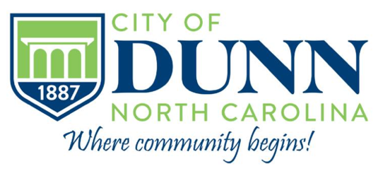 | Contact  Justin Hembree, City Manager  jhembree@dunn-nc.org  910-230-3500

FOR IMMEDIATE RELEASE

City Adopts Stricter Policy for Contaminated Yard Waste Cans

Dunn, North Carolina, May 4, 2026 – The Dunn City Council, at its April 28, 2026 regular meeting, adopted a policy to address an ongoing issue with yard waste cans being used for disposal of ordinary household trash. Yard waste cans are one of three types of waste disposal cans issued to citizens by the City of Dunn with the other two being cans for ordinary household trash and cans for recyclables.

Under the new enhanced screening policy, Republic Services, the City’s vendor for waste disposal, will affix a decal to the lid of each yard waste can to delineate that the can is limited to organic debris such as vegetation, plants, grass clippings, leaves flowers, bushes, and small branches. The decal will also delineate prohibited items such as plastic, rubber, plywood, processed lumber, paper, metal, concrete, dirt, brick, animal/pet waste, and household trash. A second Republic Services crewmember will also be added to the crew to physically inspect each yard waste can for contamination prior to it being emptied into the service truck for delivery to the landfill. Cans containing prohibited items will not be emptied and will be tagged with a notice advising the customer of the contamination. The address of the contaminated can will then be reported the City’s Public Works Department and Code Enforcement officer. Employing a “two-strike” program, a second contamination at the same address will result in removal of the yard waste can.

Enhanced screening of yard waste cans is necessary because permit regulations at Harnett County’s yard waste facility strictly prohibit any household trash and non-organic waste from being mixed in with the yard waste.

Over the course of the last year, the landfill has cautioned Republic Services and the City of Dunn about the ever increasing amount of contaminated yard waste being emptied into the landfill resulting in a possible elimination of landfill privileges for yard waste. To address these concerns, three to four members of the Public Works Department go to the landfill twice a week to manually separate household trash from yard waste. “Using our dedicated public works employees to spend two days a week at the landfill separating trash from yard waste is an unsustainable, and totally unnecessary task and something had to be done so we asked Republic Services for a plan that would preserve the City’s landfill privileges for yard waste, better educate the public on proper use of the yard waste can, and eliminate the need for our employees to go to the landfill twice a week” said Dunn City Manager Justin Hembree.

This enhanced screening program is not without additional costs. Because a second Republic Services crewmember will now be added to the yard waste truck, an additional $1.86 per month will be added to the City’s monthly garbage collection fee. “The additional monthly fee is less than the cost of a cup of coffee and is far less than it would be were the City to lose its landfill privileges” said Hembree. Customers whose cans are removed after two violations will not see a reduction in their monthly garbage fee because the City will still provide that residence with traditional yard waste collection of grass, leaf, and small limb pickup but just without a can.

